Experiment Number : 05 Date: 05/02/2026

INHERITANCE
Aim:
To understand and implement inheritance concepts in Java.
PRE LAB EXERCISE
QUESTIONS
- What is inheritance?
Inheritance is an object-oriented programming concept where one class (child/subclass) acquires the properties and methods of another class (parent/superclass). It helps in creating a hierarchical relationship between classes.

- What is code reusability?
Code reusability is the ability to use existing code in new programs or classes without rewriting it. In inheritance, a subclass can reuse the fields and methods of the parent class, reducing duplication.

- What is the use of extends keyword?
The extends keyword is used in Java to inherit a class from another class. It allows the child class to access and use the properties and methods of the parent class.
IN LAB EXERCISE
Objective:
To implement all types of inheritance.
PROGRAMS:
Student Result System (Single Inheritance)
Question:
A school wants to store student details and calculate marks. Create a base class Student and a derived class Result.
Code:
class Student {
String name;
int rollNo;

void getDetails() {
name = "Anitha";
rollNo = 101;
}
}

class Result extends Student {
int marks = 85;

void display() {
System.out.println("Name: " + name);
System.out.println("Roll No: " + rollNo);
System.out.println("Marks: " + marks);
}
}

public class Main {
public static void main(String[] args) {
Result r = new Result();
r.getDetails();
r.display();
}
}
Output:
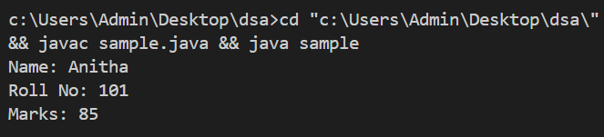
2. Bank Account System (Hierarchical Inheritance)
Question:
A bank has Savings and Current accounts. Both inherit from a common Account class.
Code:
class Account {
void showAccountType() {
System.out.println("Bank Account");
}
}
class SavingsAccount extends Account {
void interest() {
System.out.println("Savings Account gives interest");
}
}
class CurrentAccount extends Account {
void overdraft() {
System.out.println("Current Account supports overdraft");
}
}

public class Main {
public static void main(String[] args) {
SavingsAccount s = new SavingsAccount();
CurrentAccount c = new CurrentAccount();

s.showAccountType();
s.interest();

c.showAccountType();
c.overdraft();
}
}

Output:
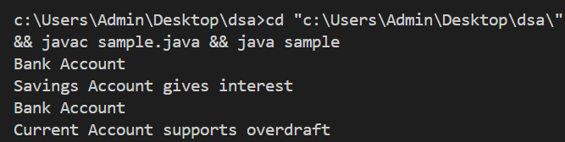
3. Vehicle System (Multilevel Inheritance)
Question:
A company classifies vehicles as Vehicle → Car → ElectricCar.
Code:
class Vehicle {
void start() {
System.out.println("Vehicle starts");
}
}

class Car extends Vehicle {
void fuelType() {
System.out.println("Car uses petrol");
}
}

class ElectricCar extends Car {
void battery() {
System.out.println("Electric car uses battery");
}
}

public class Main {
public static void main(String[] args) {
ElectricCar e = new ElectricCar();
e.start();
e.fuelType();
e.battery();
}
}
Output:
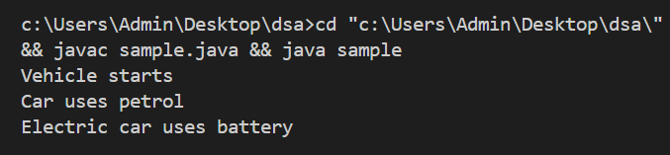
POST LAB EXERCISE
- Why Java does not support multiple inheritance using classes and how it is implemented?
Java does not support multiple inheritance using classes to avoid ambiguity problems (Diamond Problem), where a child class may inherit the same method from multiple parent classes and cause confusion.
Instead, Java implements multiple inheritance using interfaces, where a class can implement multiple interfaces.
- What is the role of the super keyword? Give examples.
The super keyword is used to refer to the parent class members. It is used to:
- Access parent class variables
- Call parent class methods
- Invoke parent class constructor
- Can a child class access private members of the parent class? Why?
No, a child class cannot access private members of the parent class because private members are accessible only within the same class to maintain data security and encapsulation.
- Explain why hybrid inheritance is not supported in Java.
Hybrid inheritance involves a combination of multiple and hierarchical inheritance. Since Java does not support multiple inheritance using classes (to avoid ambiguity), hybrid inheritance is also not supported with classes. However, it can be achieved using interfaces.

Result:

Thus the different types of inheritance were implemented and executed successfully.

ASSESSMENT

Description | Max Marks | Marks Awarded
Pre Lab Exercise | 5
In Lab Exercise | 10
Post Lab Exercise | 5
Viva | 10
Total | 30
Faculty Signature

