Experiment Number : 07 Date: 05/02/2026

METHOD OVERLOADING AND METHOD OVERRIDING
Aim:
To understand and implement method overloading and method overriding.
PRE LAB EXERCISE
QUESTIONS
- What is method overloading?
Method overloading is a feature in Java where multiple methods have the same name but different parameters (number, type, or order of parameters) within the same class. It is used to increase readability and flexibility of the program.

- What is method overriding?
Method overriding occurs when a subclass provides a specific implementation of a method that is already defined in its parent class with the same method name and parameters. It is used to achieve runtime polymorphism.

- Difference between overloading and overriding.
Method Overloading | Method Overriding
Occurs in the same class | Occurs between parent and child class
Method names are same, parameters are different | Method name and parameters are same
Achieved at compile time | Achieved at runtime
Inheritance is not required | Inheritance is required
Improves code readability | Supports runtime polymorphism

IN LAB EXERCISE
Objective:
To demonstrate compile-time and runtime polymorphism.
PROGRAMS:
1.Student Result System (Method Overriding)
Description:
- Base class Student has method displayResult().
- Subclasses UGStudent and PGStudent override the method to show different grading systems.

Code :
import java.util.Scanner;

// Base class
class Student {
String name;

void displayResult() {
System.out.println("Student Result");
}
}

// UG Student subclass
class UGStudent extends Student {
int marks;

UGStudent(String n, int m) {
name = n;
marks = m;
}

@Override
void displayResult() {
double percentage = (marks / 100.0) * 100;
System.out.println("UG Student: " + name);
System.out.println("Marks: " + marks);
System.out.println("Percentage: " + percentage + "%");
}
}

// PG Student subclass
class PGStudent extends Student {
double gpa;

PGStudent(String n, double g) {
name = n;
gpa = g;
}

@Override
void displayResult() {
System.out.println("PG Student: " + name);
System.out.println("GPA: " + gpa + " / 10");
}
}

// Main class
public class Main {
public static void main(String[] args) {
Scanner sc = new Scanner(System.in);

// Input for UG student
System.out.print("Enter UG Student Name: ");
String ugName = sc.nextLine();
System.out.print("Enter UG Student Marks (out of 100): ");
int ugMarks = sc.nextInt();
sc.nextLine(); // consume newline

// Input for PG student
System.out.print("Enter PG Student Name: ");
String pgName = sc.nextLine();
System.out.print("Enter PG Student GPA (0-10): ");
double pgGpa = sc.nextDouble();

// Create objects
Student s1 = new UGStudent(ugName, ugMarks);
Student s2 = new PGStudent(pgName, pgGpa);

System.out.println("\n--- Student Results ---");
s1.displayResult();
System.out.println();
s2.displayResult();

sc.close();
}
}
OUTPUT:
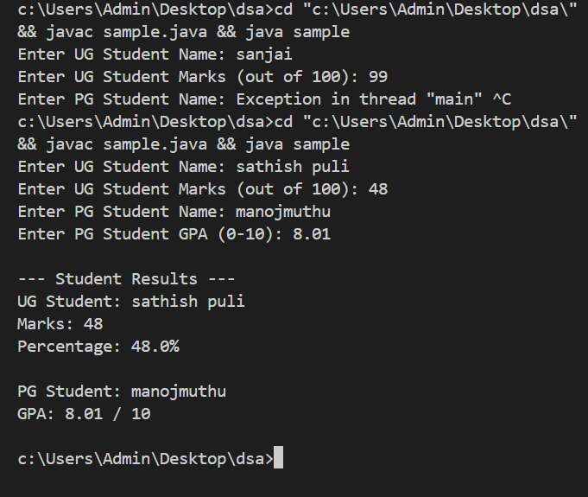
2. Calculator Program (Method Overloading)
Description:
Create a Calculator class with multiple add() methods to calculate:
- Addition of 2 integers
- Addition of 3 integers
- Addition of 2 double numbers
Code:
import java.util.Scanner;
class Calculator {
int add(int a, int b) {
return a + b;
}

int add(int a, int b, int c) {
return a + b + c;
}

double add(double a, double b) {
return a + b;
}
}
public class Main {
public static void main(String[] args) {
Scanner sc = new Scanner(System.in);
Calculator calc = new Calculator();

System.out.print("Enter two integers: ");
int x = sc.nextInt();
int y = sc.nextInt();
System.out.println("Sum of two integers: " + calc.add(x, y));

System.out.print("Enter three integers: ");
int p = sc.nextInt();
int q = sc.nextInt();
int r = sc.nextInt();
System.out.println("Sum of three integers: " + calc.add(p, q, r));

System.out.print("Enter two decimal numbers: ");
double a = sc.nextDouble();
double b = sc.nextDouble();
System.out.println("Sum of two doubles: " + calc.add(a, b));

sc.close();
}
}
Output:
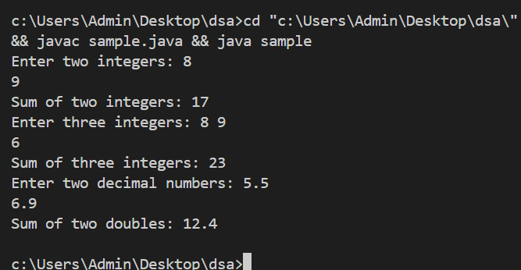

POST LAB EXERCISE
- Is return type important in method overloading and method overriding?
In method overloading, the return type alone is not important because overloading depends mainly on different parameter lists.
In method overriding, the return type must be the same or compatible (covariant) with the parent method.

- Can you overload a method by changing only the return type?
No, a method cannot be overloaded by changing only the return type. The parameter list must also be different, otherwise it causes a compile-time error.

- Can static methods be overridden? Can they be overloaded?
Static methods cannot be overridden because they belong to the class, not to objects. However, static methods can be overloaded by changing their parameter list.
- Can a method be overridden if the parameter list is different?
No, a method cannot be overridden if the parameter list is different. Changing the parameter list results in method overloading, not overriding.
Result:
Thus the method overloading and overriding concepts were implemented and executed successfully.
ASSESSMENT

Description | Max Marks | Marks Awarded
Pre Lab Exercise | 5
In Lab Exercise | 10
Post Lab Exercise | 5
Viva | 10
Total | 30
Faculty Signature

