Experiment Number : 04 Date: 05-02-2026

ARRAYS
Aim:
To understand and implement array operations in Java.
PRE LAB EXERCISE QUESTIONS
1) What is an array?
An array is a collection of elements of the same data type stored in continuous memory locations and accessed using an index.

2) Why are arrays used?
Arrays are used to store multiple values in a single variable name, make data handling easier, reduce code size, and allow easy processing using loops.

3) Difference between array and variable
Variable | Array
Stores only one value | Stores many values
Uses single memory location | Uses multiple continuous locations
Accessed by name | Accessed using index
Example: int x; | Example: int x[5];
IN LAB EXERCISE
Objective:
To perform array operations using simple programs.
PROGRAMS:
1. Program to Read and Print Array Elements
Code:
import java.util.Scanner;
public class ReadPrintArray {
public static void main(String[] args) {
Scanner sc = new Scanner(System.in);
int[] arr = new int[5];
System.out.println("Enter 5 elements:");
for(int i = 0; i < 5; i++)
arr[i] = sc.nextInt();
System.out.println("Array elements are:");
for(int i = 0; i < 5; i++)
System.out.print(arr[i] + " ");
}
}
OUTPUT:
Input:
10 20 30 40 50
Output:
Array elements are:
10 20 30 40 50
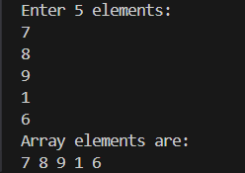

2. Program to Find Sum of Array Elements
Code:
import java.util.Scanner;
public class SumArray {
public static void main(String[] args) {
Scanner sc = new Scanner(System.in);
int[] arr = new int[5];
int sum = 0;
System.out.println("Enter 5 elements:");
for(int i = 0; i < 5; i++)
arr[i] = sc.nextInt();
for(int i = 0; i < 5; i++)
sum += arr[i];
System.out.println("Sum = " + sum);
}
}
OUTPUT:
Input:
5 10 15 20 25
Output:
Sum = 75
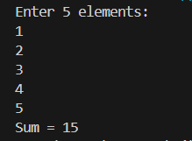
3. Program to Find Largest Element in an Array
Code:
import java.util.Scanner;
public class LargestElement {
public static void main(String[] args) {
Scanner sc = new Scanner(System.in);
int[] arr = new int[5];
System.out.println("Enter 5 elements:");
for(int i = 0; i < 5; i++)
arr[i] = sc.nextInt();
int max = arr[0];
for(int i = 1; i < 5; i++)
if(arr[i] > max)
max = arr[i];
System.out.println("Largest element = " + max);
}
}
OUTPUT:
Input:
12 45 23 9 30
Output:
Largest element = 45
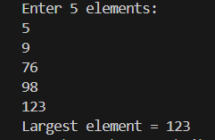
4. Program to Reverse an Array
Code:
import java.util.Scanner;

public class ReverseArray {
public static void main(String[] args) {
Scanner sc = new Scanner(System.in);
int[] arr = new int[5];
System.out.println("Enter 5 elements:");
for(int i = 0; i < 5; i++)
arr[i] = sc.nextInt();
System.out.println("Reversed array:");
for(int i = 4; i >= 0; i--)
System.out.print(arr[i] + " ");
}
}
OUTPUT:
Input:
1 2 3 4 5
Output:
Reversed array:
5 4 3 2 1
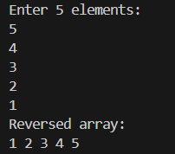
5. Program to Count Even and Odd Numbers
Code:
import java.util.Scanner;
public class EvenOddCount {
public static void main(String[] args) {
Scanner sc = new Scanner(System.in);
int[] arr = new int[5];
int even = 0, odd = 0;
System.out.println("Enter 5 elements:");
for(int i = 0; i < 5; i++)
arr[i] = sc.nextInt();
for(int i = 0; i < 5; i++) {
if(arr[i] % 2 == 0)
even++;
else
odd++;
}

System.out.println("Even = " + even);
System.out.println("Odd = " + odd);
}
}
OUTPUT:
Input:
2 7 4 9 10
Output:
Even = 3
Odd = 2
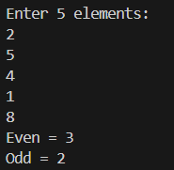
6. Program to Sort Array in Ascending Order
Code:
import java.util.Scanner;
public class SortArray {
public static void main(String[] args) {
Scanner sc = new Scanner(System.in);
int[] arr = new int[5];
int temp;
System.out.println("Enter 5 elements:");
for(int i = 0; i < 5; i++)
arr[i] = sc.nextInt();
for(int i = 0; i < 5; i++) {
for(int j = i + 1; j < 5; j++) {
if(arr[i] > arr[j]) {
temp = arr[i];
arr[i] = arr[j];
arr[j] = temp;
}
}
}
System.out.println("Sorted array:");
for(int i = 0; i < 5; i++)
System.out.print(arr[i] + " ");
}
}
OUTPUT:
Input:
45 12 78 23 9
Output:
Sorted array:
9 12 23 45 78
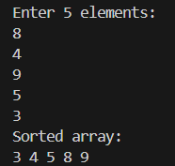
7. Program to Find Second Largest Element
Code:
import java.util.Scanner;
public class SecondLargest {
public static void main(String[] args) {
Scanner sc = new Scanner(System.in);
int[] arr = new int[5];

System.out.println("Enter 5 elements:");
for(int i = 0; i < 5; i++)
arr[i] = sc.nextInt();
int largest = Interger.MIN_VALUE;
int second = Interger.MIN_VALUE;
for(int i = 0; i < 5; i++) {
if(arr[i] > largest) {
second = largest;
largest = arr[i];
}
else if(arr[i]>second && arr[i]!=largest)
{
second=arr[i];
}
}
System.out.println("Second largest = " + second);
}
}
OUTPUT:
Input:
10 45 23 89 67
Output:
Second largest = 67
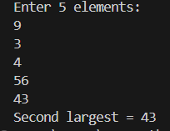
8. Program for Matrix Addition (2D Array)
Code:
import java.util.Scanner;
public class MatrixAddition {
public static void main(String[] args) {
Scanner sc = new Scanner(System.in);
int[][] a = new int[2][2];
int[][] b = new int[2][2];
int[][] sum = new int[2][2];
System.out.println("Enter elements of matrix A:");
for(int i = 0; i < 2; i++)
for(int j = 0; j < 2; j++)
a[i][j] = sc.nextInt();
System.out.println("Enter elements of matrix B:");
for(int i = 0; i < 2; i++)
for(int j = 0; j < 2; j++)
b[i][j] = sc.nextInt();
for(int i = 0; i < 2; i++)
for(int j = 0; j < 2; j++)
sum[i][j] = a[i][j] + b[i][j];
System.out.println("Sum matrix:");
for(int i = 0; i < 2; i++) {
for(int j = 0; j < 2; j++)
System.out.print(sum[i][j] + " ");
System.out.println();
}
}
}
OUTPUT:
Matrix A:
1 2
3 4
Matrix B:
5 6
7 8
Sum matrix:
6 8
10 12
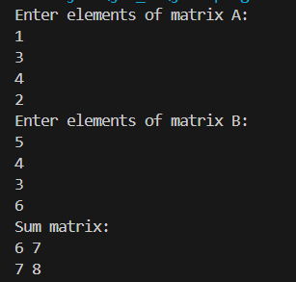

POST LAB EXERCISE
1) Why does array indexing usually start from zero?
Array indexing starts from zero because the index represents the offset from the first memory location.
The first element is at position 0 bytes away from the start.

2) What happens if we access an array element outside its declared size?
Accessing outside the array size causes undefined behavior.
It may give wrong values, crash the program, or corrupt memory.

3) How does memory allocation differ for static and dynamic arrays?
• Static array – Size is fixed at compile time and memory is allocated automatically (stack or data segment).
• Dynamic array – Size is decided at runtime and memory is allocated from the heap using functions like new or malloc.

4) Why is searching faster in arrays than in linked lists?
Arrays allow direct access using an index, so we can reach any element instantly.
Linked lists must be traversed node by node, which is slower.

5) Difference between contiguous and non-contiguous memory allocation
Contiguous Memory | Non-Contiguous Memory
Stored in consecutive locations | Stored in separate locations
Used in arrays | Used in linked lists
Faster access | Slower access
Supports index-based access | No direct indexing

Result:

Thus the array operations were executed successfully.

ASSESSMENT

Description | Max Marks | Marks Awarded
Pre Lab Exercise | 5
In Lab Exercise | 10
Post Lab Exercise | 5
Viva | 10
Total | 30
Faculty Signature

