Experiment Number : 04 Date: 04.02.2026

ARRAYS
Aim:
To understand and implement array operations in Java.
PRE LAB EXERCISE
QUESTIONS
1. What is an array?
- An array is a data structure that is used to store multiple values in a single variable.
- All the elements stored in an array must be of the same data type.
- The elements of an array are stored in contiguous memory locations.
- Each element in an array is accessed using an index, which starts from 0 in Java.

2. Why are arrays used?
- Arrays are used to store many values using a single variable name.
- Arrays make data processing easier because we can use loops to access elements.
- Arrays provide fast access to elements because each element can be accessed using its index.
- Arrays help in organizing related data in a structured and systematic way.

3. Difference between array and variable
Variable:
- A variable is used to store only one value at a time.
- A variable uses only one memory location to store data.
- A variable can hold only a single data item.
- For example, the statement int x = 10; stores only one value in the variable x.
Array:
- An array is used to store multiple values at the same time.
- An array uses multiple contiguous memory locations to store data.
- An array can hold a collection of data items of the same type.
- For example, the statement int[] a = {10, 20, 30}; stores multiple values in the array a.

IN LAB EXERCISE
Objective:
To perform array operations using simple programs.
PROGRAMS:
1. Program to Read and Print Array Elements
Code:
import java.util.Scanner;
public class ReadPrintArray {
public static void main(String[] args) {
Scanner sc = new Scanner(System.in);
int[] arr = new int[5];
System.out.println("Enter 5 elements:");
for(int i = 0; i < 5; i++)
arr[i] = sc.nextInt();
System.out.println("Array elements are:");
for(int i = 0; i < 5; i++)
System.out.print(arr[i] + " ");
}
}
OUTPUT:
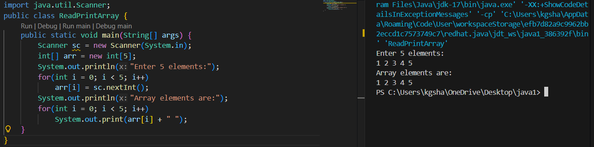
2. Program to Find Sum of Array Elements
Code:
import java.util.Scanner;
public class SumArray {
public static void main(String[] args) {
Scanner sc = new Scanner(System.in);
int[] arr = new int[5];
int sum = 0;
System.out.println("Enter 5 elements:");
for(int i = 0; i < 5; i++)
arr[i] = sc.nextInt();
for(int i = 0; i < 5; i++)
sum += arr[i];
System.out.println("Sum = " + sum);
}
}
OUTPUT:
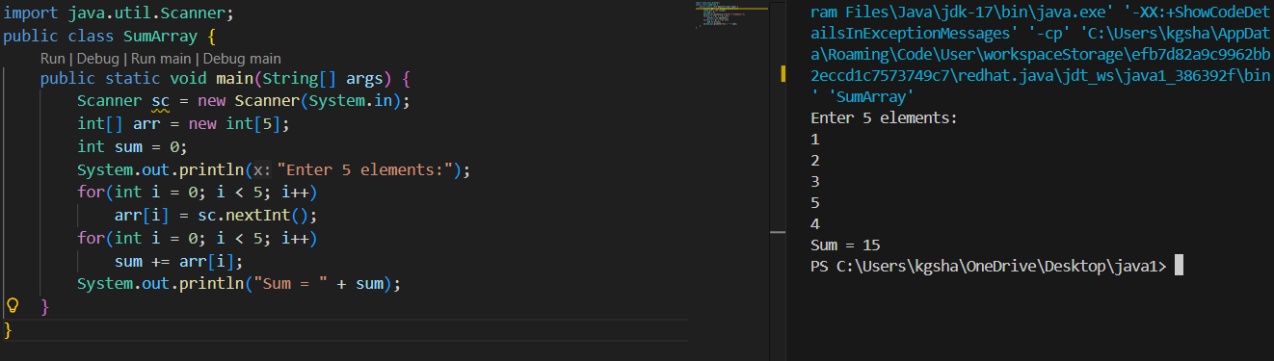
3. Program to Find Largest Element in an Array
Code:
import java.util.Scanner;
public class LargestElement {
public static void main(String[] args) {
Scanner sc = new Scanner(System.in);
int[] arr = new int[5];
System.out.println("Enter 5 elements:");
for(int i = 0; i < 5; i++)
arr[i] = sc.nextInt();
int max = arr[0];
for(int i = 1; i < 5; i++)
if(arr[i] > max)
max = arr[i];
System.out.println("Largest element = " + max);
}
}
OUTPUT:
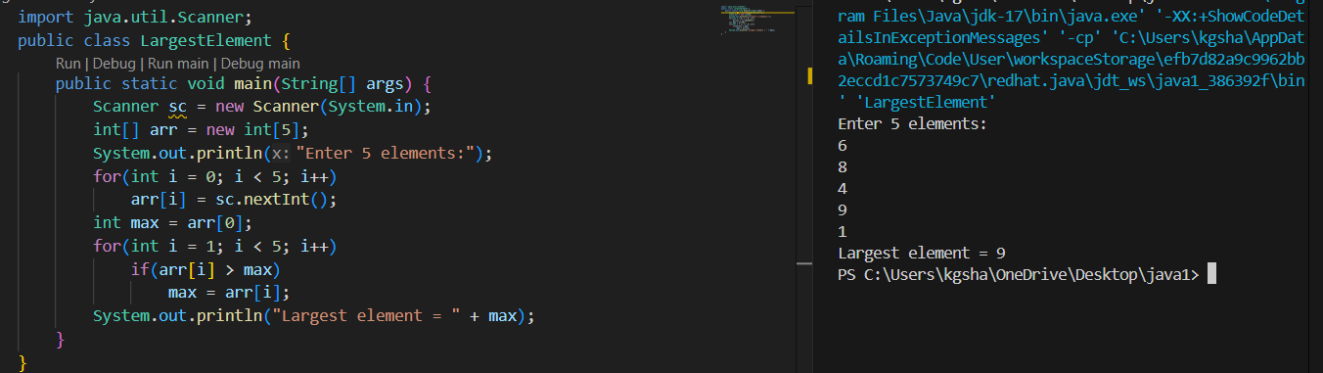
4. Program to Reverse an Array
Code:
import java.util.Scanner;

public class ReverseArray {
public static void main(String[] args) {
Scanner sc = new Scanner(System.in);
int[] arr = new int[5];
System.out.println("Enter 5 elements:");
for(int i = 0; i < 5; i++)
arr[i] = sc.nextInt();
System.out.println("Reversed array:");
for(int i = 4; i >= 0; i--)
System.out.print(arr[i] + " ");
}
}
OUTPUT:
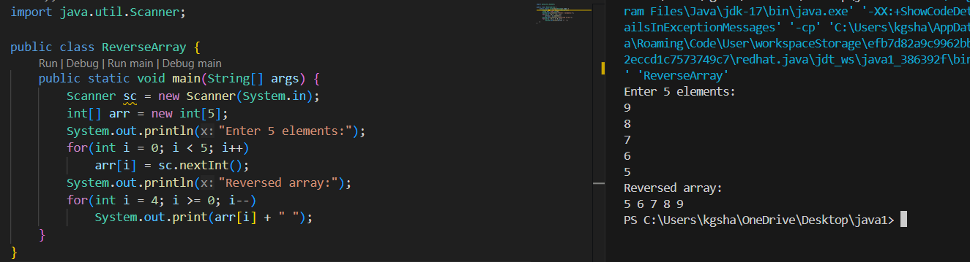
5. Program to Count Even and Odd Numbers
Code:
import java.util.Scanner;
public class EvenOddCount {
public static void main(String[] args) {
Scanner sc = new Scanner(System.in);
int[] arr = new int[5];
int even = 0, odd = 0;
System.out.println("Enter 5 elements:");
for(int i = 0; i < 5; i++)
arr[i] = sc.nextInt();
for(int i = 0; i < 5; i++) {
if(arr[i] % 2 == 0)
even++;
else
odd++;
}

System.out.println("Even = " + even);
System.out.println("Odd = " + odd);
}
}
OUTPUT:
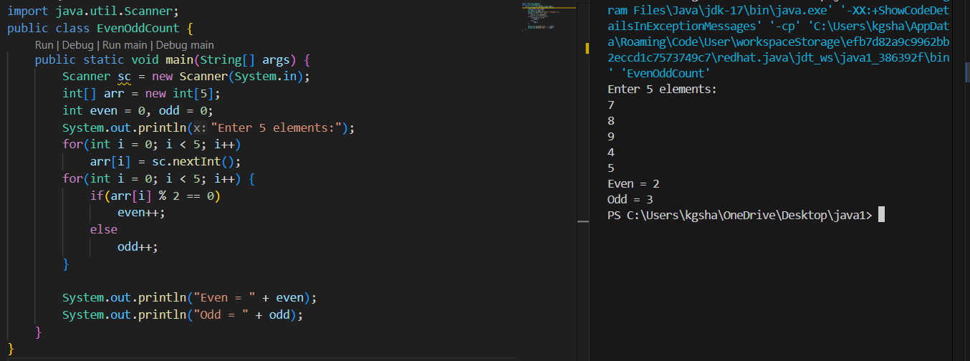
6. Program to Sort Array in Ascending Order
Code:
import java.util.Scanner;
public class SortArray {
public static void main(String[] args) {
Scanner sc = new Scanner(System.in);
int[] arr = new int[5];
int temp;
System.out.println("Enter 5 elements:");
for(int i = 0; i < 5; i++)
arr[i] = sc.nextInt();
for(int i = 0; i < 5; i++) {
for(int j = i + 1; j < 5; j++) {
if(arr[i] > arr[j]) {
temp = arr[i];
arr[i] = arr[j];
arr[j] = temp;
}
}
}
System.out.println("Sorted array:");
for(int i = 0; i < 5; i++)
System.out.print(arr[i] + " ");
}
}
OUTPUT:
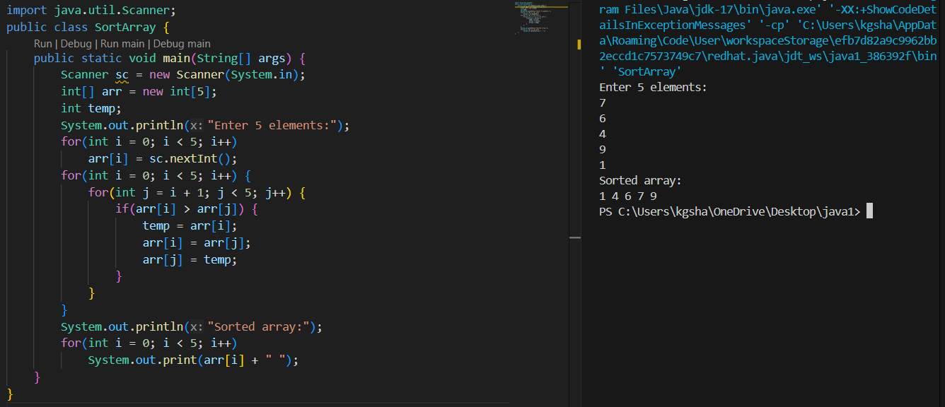
7. Program to Find Second Largest Element
Code:
import java.util.Scanner;

public class SecondLargest {
public static void main(String[] args) {
Scanner sc = new Scanner(System.in);
int[] arr = new int[5];

System.out.println("Enter 5 elements:");
for (int i = 0; i < 5; i++) {
arr[i] = sc.nextInt();
}

int largest = arr[0];
int second = Integer.MIN_VALUE;

for (int i = 0; i < 5; i++) {
if (arr[i] > largest) {
second = largest;
largest = arr[i];
} else if (arr[i] < largest && arr[i] > second) {
second = arr[i];
}
}

System.out.println("Second largest = " + second);
}
}
OUTPUT:
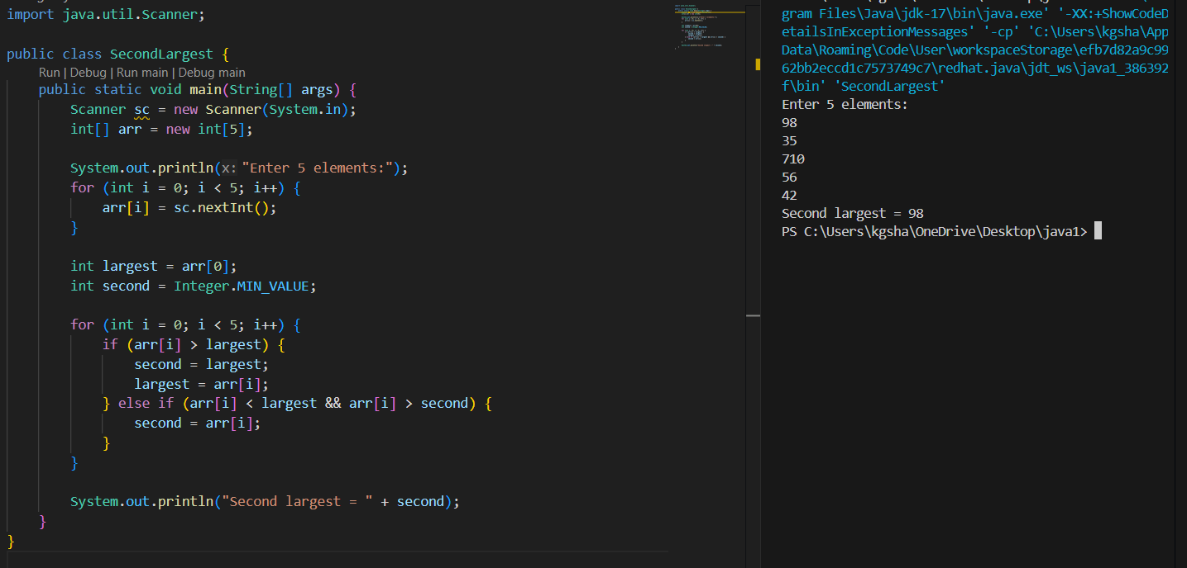
8. Program for Matrix Addition (2D Array)
Code:
import java.util.Scanner;
public class MatrixAddition {
public static void main(String[] args) {
Scanner sc = new Scanner(System.in);
int[][] a = new int[2][2];
int[][] b = new int[2][2];
int[][] sum = new int[2][2];
System.out.println("Enter elements of matrix A:");
for(int i = 0; i < 2; i++)
for(int j = 0; j < 2; j++)
a[i][j] = sc.nextInt();
System.out.println("Enter elements of matrix B:");
for(int i = 0; i < 2; i++)
for(int j = 0; j < 2; j++)
b[i][j] = sc.nextInt();
for(int i = 0; i < 2; i++)
for(int j = 0; j < 2; j++)
sum[i][j] = a[i][j] + b[i][j];
System.out.println("Sum matrix:");
for(int i = 0; i < 2; i++) {
for(int j = 0; j < 2; j++)
System.out.print(sum[i][j] + " ");
System.out.println();
}
}
}
OUTPUT:
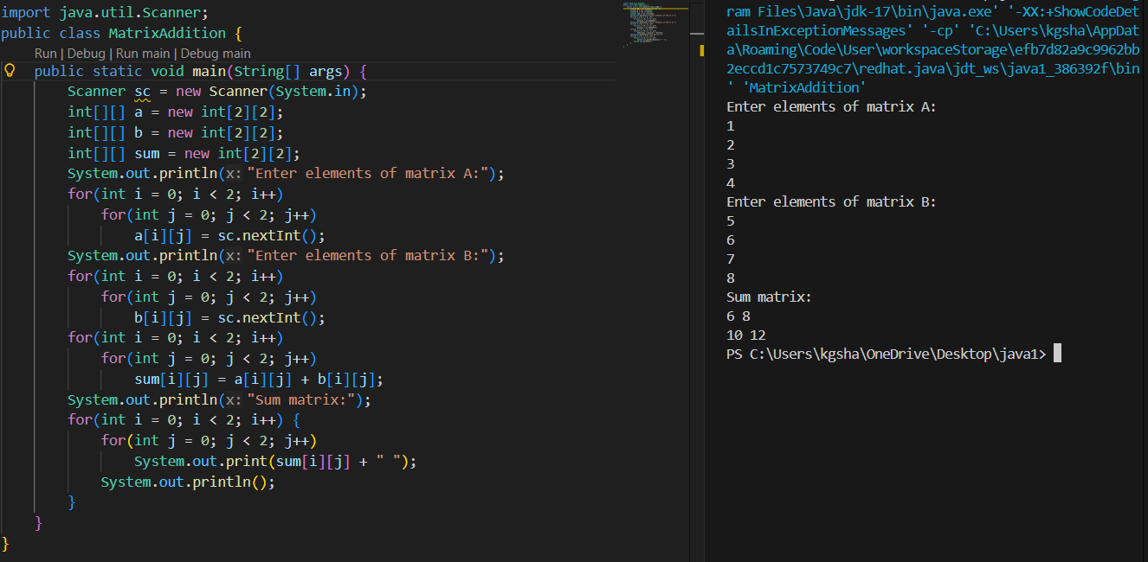

POST LAB EXERCISE
1. Why is array indexing usually started from zero instead of one?
- The array name refers to the base address of the first element.
- Index 0 means no offset from the base address.
- The internal formula base + index * size is simple and efficient.
- Zero-based indexing makes array access faster in Java.

2. What happens if we try to access an array element outside its declared size?
- Java checks array bounds at runtime.
- Accessing an invalid index throws ArrayIndexOutOfBoundsException.
- This prevents illegal memory access and data corruption.
- The program stops unless the exception is handled.

3. How does memory allocation differ for static arrays and dynamic arrays?
- Static arrays have a fixed size decided at creation time.
- Dynamic arrays (e.g., ArrayList) can grow or shrink at runtime.
- Static arrays use a single continuous memory block.
- Dynamic arrays may reallocate memory when resized.

4.Why is searching faster in arrays compared to linked lists?
- Arrays support direct access using index (arr[i]).
- Any element can be accessed in O(1) time.
- Linked lists require sequential traversal from the first node.
- Arrays can use binary search when data is sorted.

5. What is the difference between contiguous and non-contiguous memory allocation?
- Contiguous allocation stores elements in continuous memory locations (arrays).
- Non-contiguous allocation stores elements in separate locations (linked lists).
- Contiguous memory allows faster access using index calculation.
- Non-contiguous memory provides better flexibility in size and memory usage.

Result:

Thus, the array operations were executed successfully.

ASSESSMENT

Description | Max Marks | Marks Awarded
Pre Lab Exercise | 5
In Lab Exercise | 10
Post Lab Exercise | 5
Viva | 10
Total | 30
Faculty Signature

