Experiment Number : 05 Date: 05.02.2026

INHERITANCE
Aim:
To understand and implement inheritance concepts in Java.
PRE LAB EXERCISE
QUESTIONS
1. What is inheritance?
- Inheritance is a feature of object-oriented programming that allows one class to acquire the properties and methods of another class.
- The class that inherits is called the child class, and the class that is inherited from is called the parent class.
- Inheritance helps in reducing code duplication by reusing existing class code.
- In Java, inheritance supports better organization of code and improves maintainability.

2. What is code reusability?
- Code reusability means using the same piece of code in different parts of a program without rewriting it.
- It helps in saving time and effort during program development.
- Code reusability reduces errors because tested code can be used again.
- In Java, code reusability is mainly achieved using concepts like inheritance and methods.

3. What is the use of the extends keyword?
- The extends keyword in Java is used to create a child class from a parent class.
- It allows the child class to inherit the properties and methods of the parent class.
- Using the extends keyword helps in achieving code reusability in Java programs.
- It also helps in implementing the concept of inheritance in object-oriented programming.
IN LAB EXERCISE
Objective:
To implement all types of inheritance.
PROGRAMS:
Student Result System (Single Inheritance)
Question:
A school wants to store student details and calculate marks. Create a base class Student and a derived class Result.
Code:
class Student {
String name;
int rollNo;

void getDetails() {
name = "Anitha";
rollNo = 101;
}
}

class Result extends Student {
int marks = 85;

void display() {
System.out.println("Name: " + name);
System.out.println("Roll No: " + rollNo);
System.out.println("Marks: " + marks);
}
}

public class Main {
public static void main(String[] args) {
Result r = new Result();
r.getDetails();
r.display();
}
}
Output:
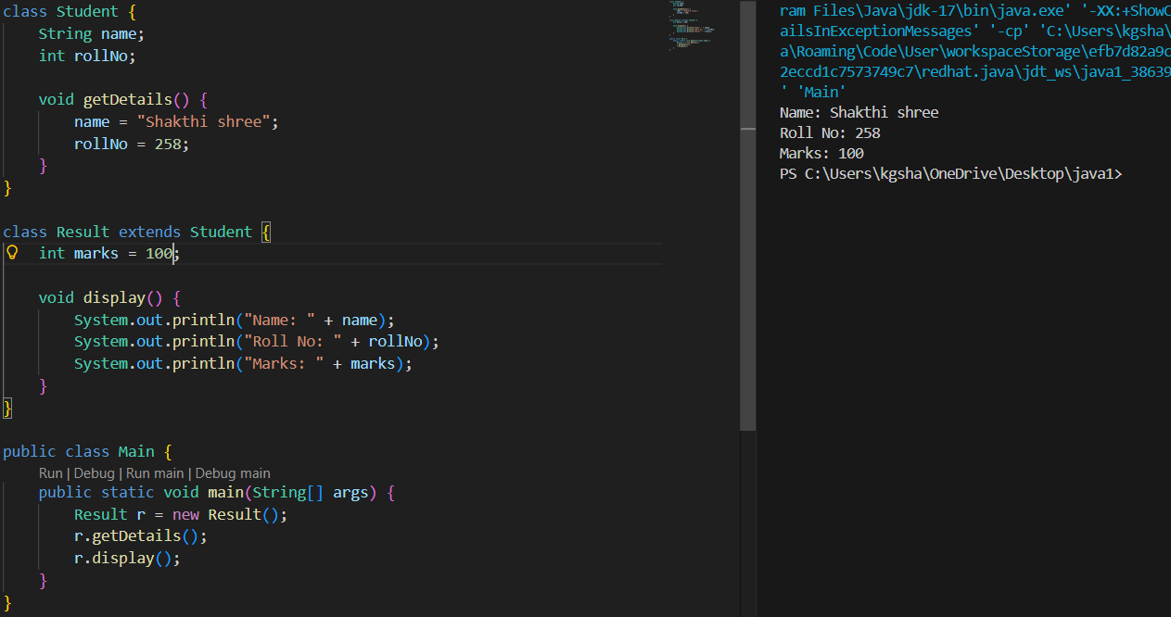
2. Bank Account System (Hierarchical Inheritance)
Question:
A bank has Savings and Current accounts. Both inherit from a common Account class.
Code:
class Account {
void showAccountType() {
System.out.println("Bank Account");
}
}

class SavingsAccount extends Account {
void interest() {
System.out.println("Savings Account gives interest");
}
}

class CurrentAccount extends Account {
void overdraft() {
System.out.println("Current Account supports overdraft");
}
}

public class Main {
public static void main(String[] args) {
SavingsAccount s = new SavingsAccount();
CurrentAccount c = new CurrentAccount();

s.showAccountType();
s.interest();

c.showAccountType();
c.overdraft();
}
}

Output:
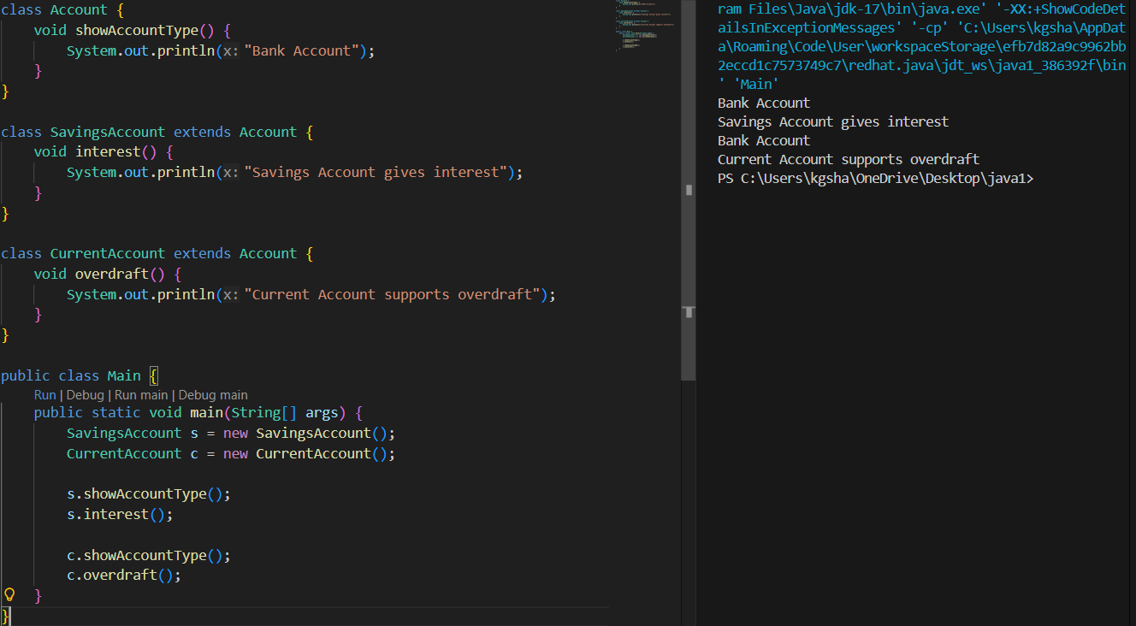
3. Vehicle System (Multilevel Inheritance)
Question:
A company classifies vehicles as Vehicle → Car → ElectricCar.
Code:
class Vehicle {
void start() {
System.out.println("Vehicle starts");
}
}

class Car extends Vehicle {
void fuelType() {
System.out.println("Car uses petrol");
}
}

class ElectricCar extends Car {
void battery() {
System.out.println("Electric car uses battery");
}
}

public class Main {
public static void main(String[] args) {
ElectricCar e = new ElectricCar();
e.start();
e.fuelType();
e.battery();
}
}
Output:
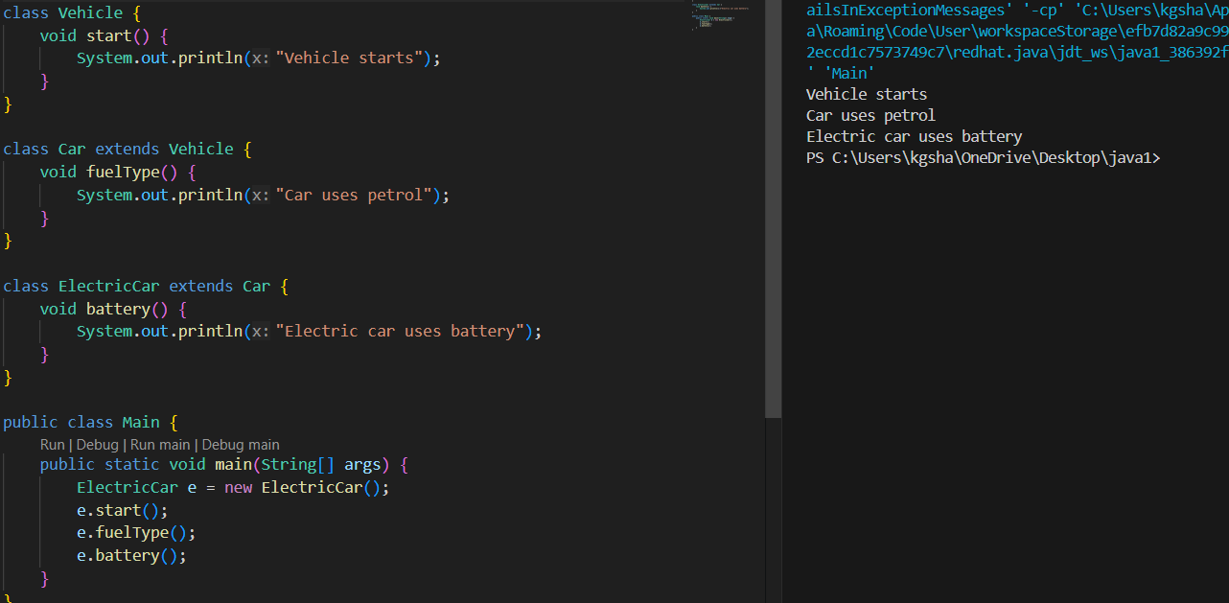POST LAB EXERCISE
1. Why does Java not support multiple inheritance using classes and how it is implemented?
- Java does not support multiple inheritance using classes because it can cause ambiguity when two parent classes have methods with the same name.
- This ambiguity problem is known as the Diamond Problem and it makes the code confusing for the compiler.
- Multiple inheritance using classes can also increase complexity and reduce code maintainability.
- Java solves this problem by allowing multiple inheritance using interfaces instead of classes.

2. What is the role of the super keyword? Give examples.
- The super keyword is used to refer to the parent class object in Java.
- It is used to access parent class variables and methods when they are hidden by child class members.
- It is also used to call the constructor of the parent class from the child class.
- For example, super.x is used to access the parent class variable x when the child class has the same variable name.
class Parent {
int x = 10;
}

class Child extends Parent {
int x = 20;

void display() {
System.out.println(super.x); // prints parent class variable
}

public static void main(String[] args) {
Child obj = new Child();
obj.display();
}
}

3. Can a child class access private members of the parent class? Why?
- A child class cannot directly access the private members of the parent class.
- This is because private members are accessible only within the same class in which they are declared.
- This restriction helps in protecting data and maintaining encapsulation.
- However, the child class can access private members indirectly using public or protected methods of the parent class.

4. Explain why hybrid inheritance is not supported in Java.
- Hybrid inheritance is not supported in Java using classes because it involves multiple inheritance.
- Multiple inheritance can create ambiguity problems such as the Diamond Problem.
- This ambiguity makes the program complex and difficult for the compiler to decide which method to use.
- Java avoids this issue by not supporting hybrid inheritance with classes and instead allows it using interfaces.
Result:

Thus, the different types of inheritance were implemented and executed successfully.

ASSESSMENT

Description | Max Marks | Marks Awarded
Pre Lab Exercise | 5
In Lab Exercise | 10
Post Lab Exercise | 5
Viva | 10
Total | 30
Faculty Signature

