Experiment Number : 04 Date: 04/02/2026

ARRAYS
Aim:
To understand and implement array operations in Java.
PRE LAB EXERCISE
QUESTIONS
- What is an array?
An array is a data structure that stores a fixed number of elements of the same type in contiguous memory locations, accessed using an index (like ‎`a[0]`, ‎`a[1]`, …).

- Why are arrays used?
Arrays are used to:
- Group related data: Store many values under one name (e.g., marks of all students).
- Efficient access: Access any element directly using its index in constant time.
- Easy iteration: Traverse elements using loops for processing, searching, or updating.
- Memory organization: Keep data in contiguous memory, which is cache-friendly and faster.

- What is the difference between array and variable?
- 1. Number of values:
  - Variable: Stores one value at a time.
  - Array: Stores multiple values (same type) at different indices.
- Declaration example (C-style):
  - Variable: ‎`int x;`
  - Array: ‎`int a[5];`
- Access:
  - Variable: Use its name (‎`x`).
  - Array: Use name + index (‎`a[0]`, ‎`a[1]`).
- Use case:
  - Variable: Single piece of data (e.g., one age).
  - Array: Collection of similar data (e.g., ages of many people).

IN LAB EXERCISE
Objective:
To perform array operations using simple programs.
PROGRAMS:
1. Program to Read and Print Array Elements
Code:
import java.util.Scanner;
public class ReadPrintArray {
public static void main(String[] args) {
Scanner sc = new Scanner(System.in);
int[] arr = new int[5];
System.out.println("Enter 5 elements:");
for(int i = 0; i < 5; i++)
arr[i] = sc.nextInt();
System.out.println("Array elements are:");
for(int i = 0; i < 5; i++)
System.out.print(arr[i] + " ");
}
}
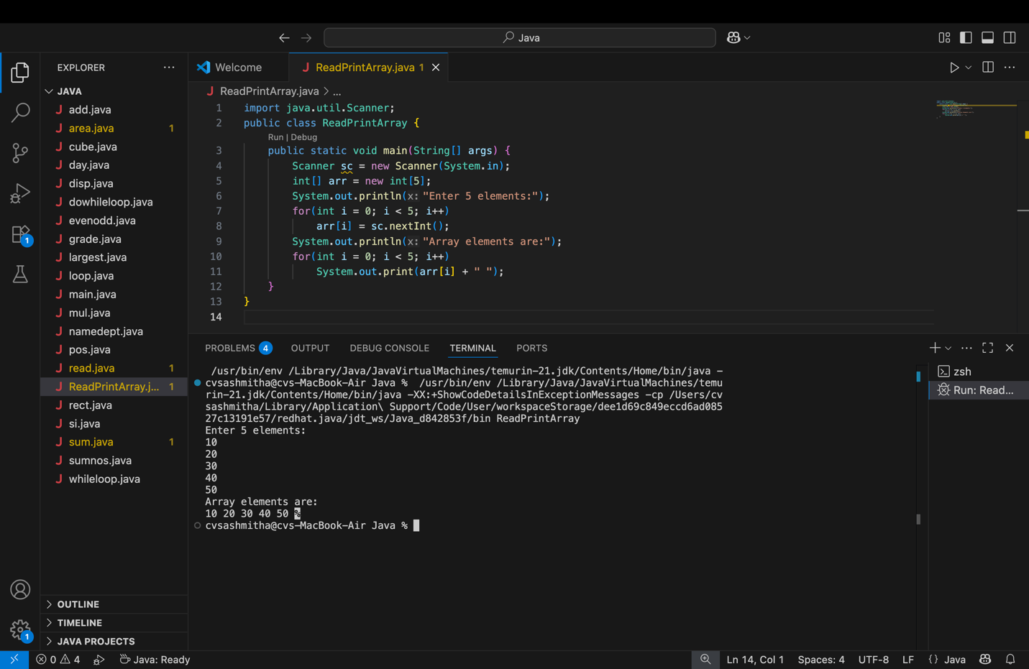
OUTPUT:
Input:
10 20 30 40 50
Output:
Array elements are:
10 20 30 40 50

2. Program to Find Sum of Array Elements
Code:
import java.util.Scanner;
public class SumArray {
public static void main(String[] args) {
Scanner sc = new Scanner(System.in);
int[] arr = new int[5];
int sum = 0;
System.out.println("Enter 5 elements:");
for(int i = 0; i < 5; i++)
arr[i] = sc.nextInt();
for(int i = 0; i < 5; i++)
sum += arr[i];
System.out.println("Sum = " + sum);
}
}
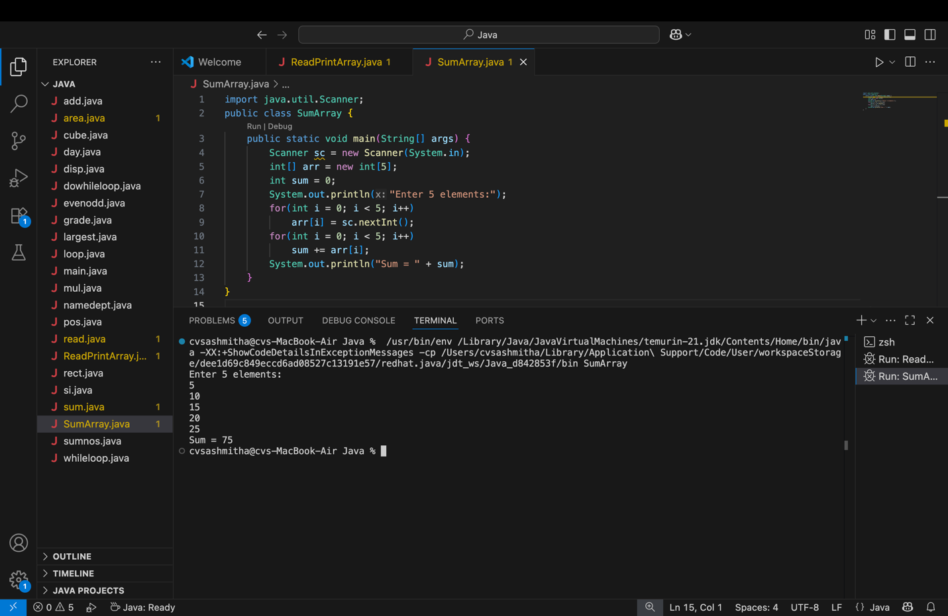
OUTPUT:
Input:
5 10 15 20 25
Output:
Sum = 75

3. Program to Find Largest Element in an Array
Code:
import java.util.Scanner;
public class LargestElement {
public static void main(String[] args) {
Scanner sc = new Scanner(System.in);
int[] arr = new int[5];
System.out.println("Enter 5 elements:");
for(int i = 0; i < 5; i++)
arr[i] = sc.nextInt();
int max = arr[0];
for(int i = 1; i < 5; i++)
if(arr[i] > max)
max = arr[i];
System.out.println("Largest element = " + max);
}
}
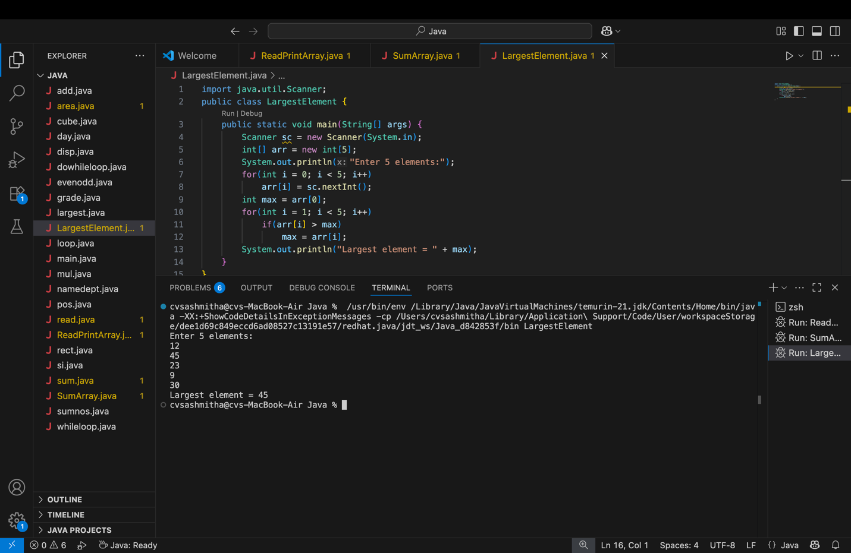

OUTPUT:
Input:
12 45 23 9 30
Output:
Largest element = 45

4. Program to Reverse an Array
Code:
import java.util.Scanner;

public class ReverseArray {
public static void main(String[] args) {
Scanner sc = new Scanner(System.in);
int[] arr = new int[5];
System.out.println("Enter 5 elements:");
for(int i = 0; i < 5; i++)
arr[i] = sc.nextInt();
System.out.println("Reversed array:");
for(int i = 4; i >= 0; i--)
System.out.print(arr[i] + " ");
}
}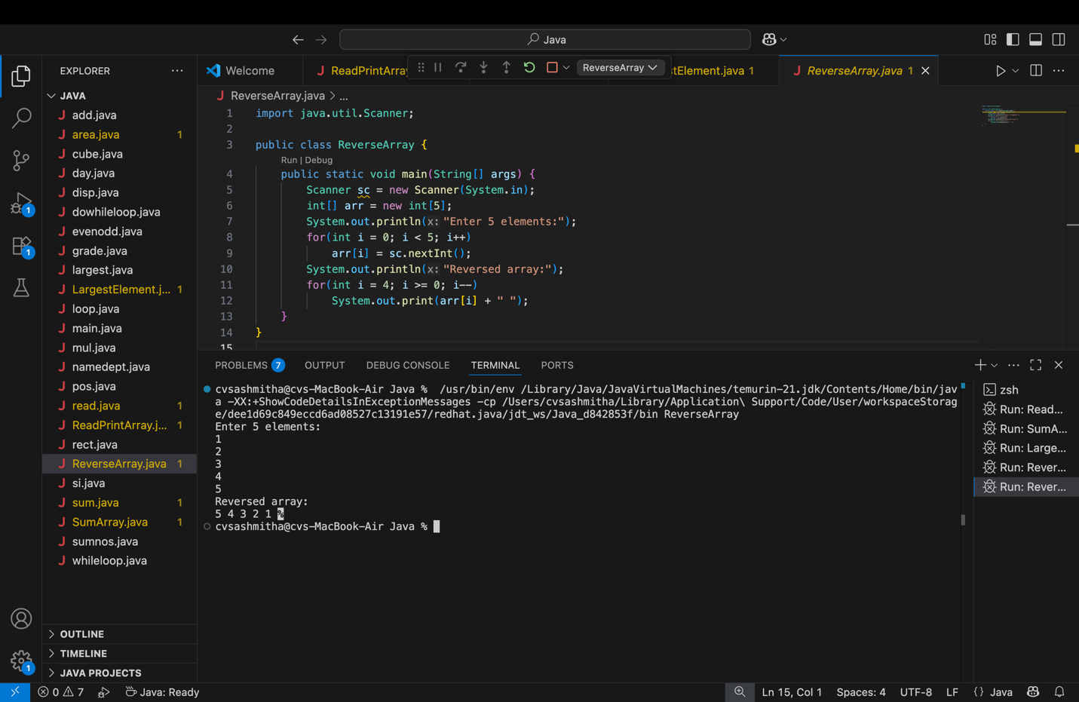

OUTPUT:
Input:
1 2 3 4 5
Output:
Reversed array:
5 4 3 2 1

5. Program to Count Even and Odd Numbers
Code:
import java.util.Scanner;
public class EvenOddCount {
public static void main(String[] args) {
Scanner sc = new Scanner(System.in);
int[] arr = new int[5];
int even = 0, odd = 0;
System.out.println("Enter 5 elements:");
for(int i = 0; i < 5; i++)
arr[i] = sc.nextInt();
for(int i = 0; i < 5; i++) {
if(arr[i] % 2 == 0)
even++;
else
odd++;
}

System.out.println("Even = " + even);
System.out.println("Odd = " + odd);
}
}
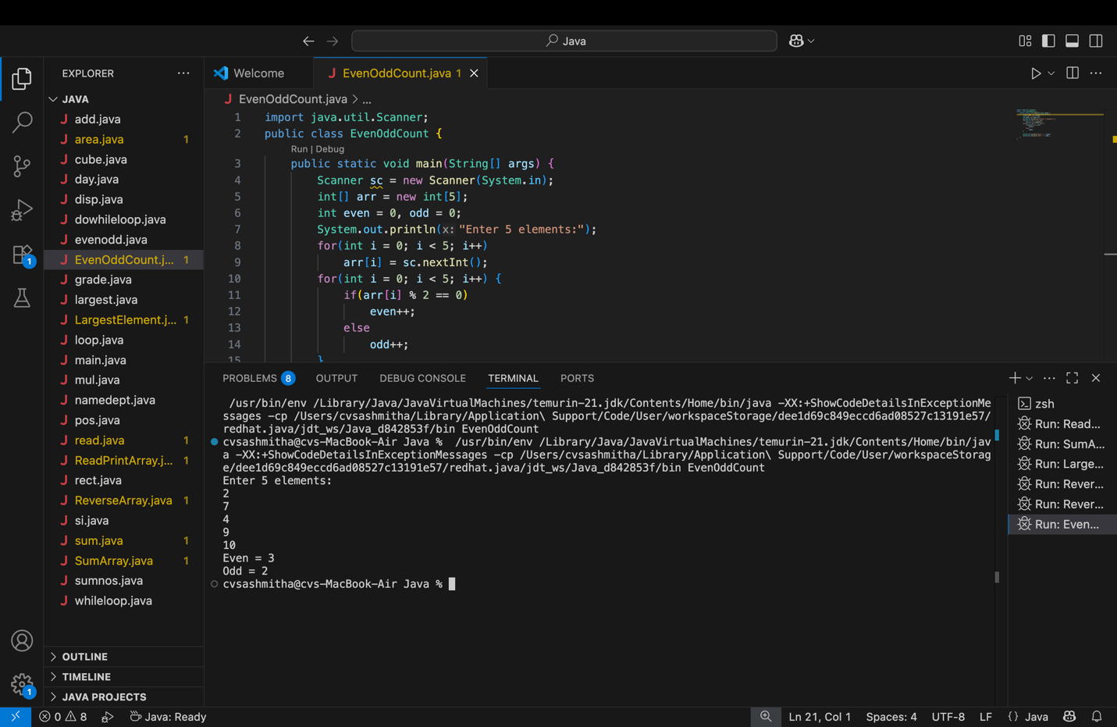
OUTPUT:
Input:
2 7 4 9 10
Output:
Even = 3
Odd = 2

6. Program to Sort Array in Ascending Order
Code:
import java.util.Scanner;
public class SortArray {
public static void main(String[] args) {
Scanner sc = new Scanner(System.in);
int[] arr = new int[5];
int temp;
System.out.println("Enter 5 elements:");
for(int i = 0; i < 5; i++)
arr[i] = sc.nextInt();
for(int i = 0; i < 5; i++) {
for(int j = i + 1; j < 5; j++) {
if(arr[i] > arr[j]) {
temp = arr[i];
arr[i] = arr[j];
arr[j] = temp;
}
}
}
System.out.println("Sorted array:");
for(int i = 0; i < 5; i++)
System.out.print(arr[i] + " ");
}
}
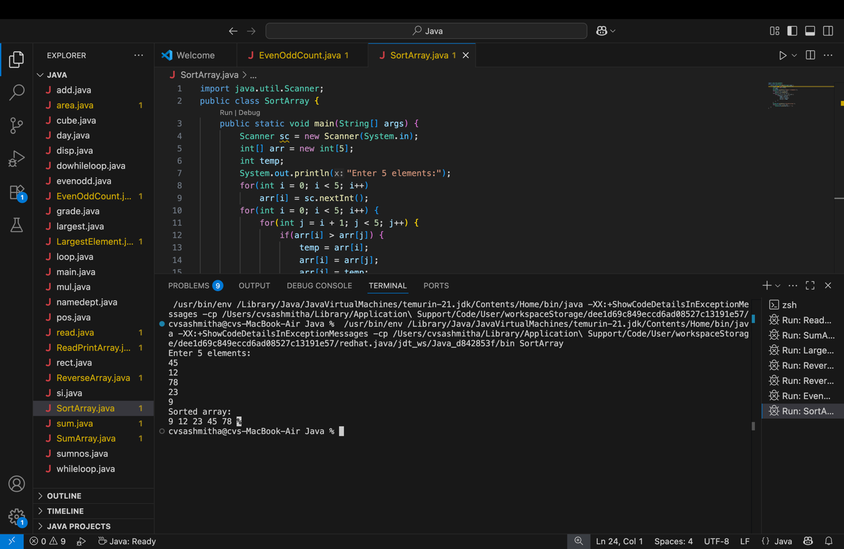
OUTPUT:
Input:
45 12 78 23 9
Output:
Sorted array:
9 12 23 45 78

7. Program to Find Second Largest Element
Code:
import java.util.Scanner;

public class SecondLargest {
public static void main(String[] args) {
Scanner sc = new Scanner(System.in);
int[] arr = new int[5];

System.out.println("Enter 5 elements:");
for (int i = 0; i < 5; i++)
arr[i] = sc.nextInt();

int largest = arr[0];
int second = Integer.MIN_VALUE;

for (int i = 1; i < 5; i++) {
if (arr[i] > largest) {
second = largest;
largest = arr[i];
}
else if (arr[i] > second && arr[i] != largest) {
second = arr[i];
}
}

System.out.println("Second largest = " + second);
}
}
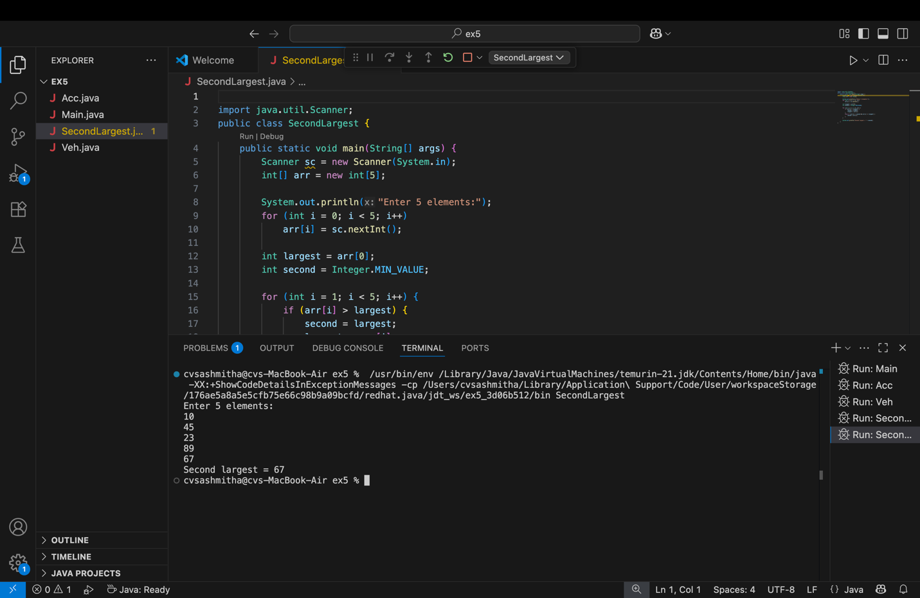
OUTPUT:
Input:
10 45 23 89 67
Output:
Second largest = 67

8. Program for Matrix Addition (2D Array)
Code:
import java.util.Scanner;
public class MatrixAddition {
public static void main(String[] args) {
Scanner sc = new Scanner(System.in);
int[][] a = new int[2][2];
int[][] b = new int[2][2];
int[][] sum = new int[2][2];
System.out.println("Enter elements of matrix A:");
for(int i = 0; i < 2; i++)
for(int j = 0; j < 2; j++)
a[i][j] = sc.nextInt();
System.out.println("Enter elements of matrix B:");
for(int i = 0; i < 2; i++)
for(int j = 0; j < 2; j++)
b[i][j] = sc.nextInt();
for(int i = 0; i < 2; i++)
for(int j = 0; j < 2; j++)
sum[i][j] = a[i][j] + b[i][j];
System.out.println("Sum matrix:");
for(int i = 0; i < 2; i++) {
for(int j = 0; j < 2; j++)
System.out.print(sum[i][j] + " ");
System.out.println();
}
}
}
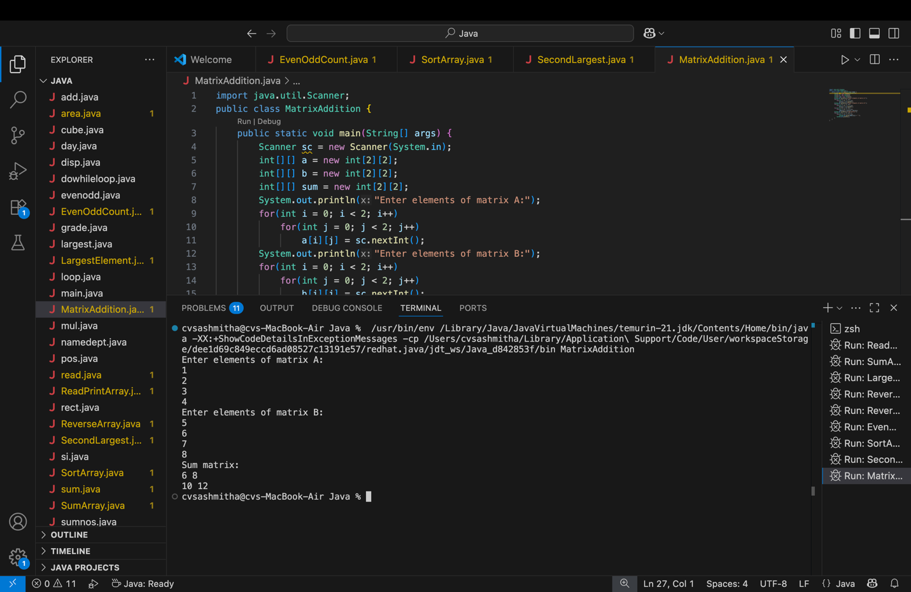
OUTPUT:
Matrix A:
1 2
3 4
Matrix B:
5 6
7 8
Sum matrix:
6 8
10 12

POST LAB EXERCISE
- Why is array indexing usually started from zero instead of one?
Array index 0 is the offset from the start address.
Element at index ‎`i` is stored at: base address + ‎`i * size_of_element`.
If indexing started at 1, the formula would need an extra ‎`-1`, making it slightly less natural and efficient.

- What happens if we try to access an array element outside its declared size?
• In low-level languages like C/C++: undefined behavior (may read/write random memory, crash, or appear to “work” incorrectly).
In high-level languages like Java/Python: a runtime error/exception (e.g., ‎`ArrayIndexOutOfBoundsException`, ‎`IndexError`).

- How does memory allocation differ for static arrays and dynamic arrays?
• Static array:
  - Size is fixed at compile time (or before execution starts).
  - Memory is allocated on the stack or in global memory.
  - Example (C): ‎`int a[10];`
Dynamic array:
  - Size decided at runtime.
  - Memory is allocated on the heap using functions like ‎`malloc`, ‎`new`, or dynamic structures (e.g., ‎`ArrayList` in Java, ‎`list` in Python).
  - Example (C): ‎`int *a = malloc(n * sizeof(int));`

- Why is searching faster in arrays compared to linked lists?
- • Arrays store elements in contiguous memory, so you can access any element in O(1) time using its index.
- Linked lists require following pointers node by node, so accessing the k-th element is O(k).
- For searching:
  - Sequential search: similar O(n) in both, but arrays benefit from better cache locality.
  - Binary search: possible on sorted arrays (O(log n)), but not on linked lists because you can’t jump to the middle directly.

- What is the difference between contiguous and non-contiguous memory allocation?
Contiguous allocation:
  - All elements are stored in adjacent memory locations.
  - Example: arrays.
  - Pros: fast indexing, good cache performance.
  - Cons: requires a large continuous free block, harder to resize.
Non-contiguous allocation:
  - Elements are scattered in memory, connected by pointers/links.
  - Example: linked lists, trees.
  - Pros: easier to grow/shrink, better for frequent insertions/deletions.
  - Cons: slower access (must follow pointers), worse cache performance.

Result:

Thus the array operations were executed successfully.

ASSESSMENT

Description | Max Marks | Marks Awarded
Pre Lab Exercise | 5
In Lab Exercise | 10
Post Lab Exercise | 5
Viva | 10
Total | 30
Faculty Signature

