Experiment Number : 05 Date: 04/02/2026

INHERITANCE
Aim:
To understand and implement inheritance concepts in Java.
PRE LAB EXERCISE
QUESTIONS
- What is inheritance?
Inheritance is an OOP concept where one class (child/subclass) acquires the properties and behaviors (fields and methods) of another class (parent/superclass). It models an “is-a” relationship, like ‎`Dog` inherits from ‎`Animal`.

- What is code reusability?
Code reusability means writing code in a way that it can be used again in different parts of a program or in different programs, without rewriting it. Inheritance, functions/methods, and libraries all help achieve code reusability.

- What is the use of extends keyword?
In languages like Java, the ‎`extends` keyword is used to make one class inherit from another.
Example:
‎`class Dog extends Animal { }`
Here, ‎`Dog` becomes a subclass of ‎`Animal` and can use/override ‎`Animal`’s methods and variables.

IN LAB EXERCISE
Objective:
To implement all types of inheritance.
PROGRAMS:
Student Result System (Single Inheritance)
Question:
A school wants to store student details and calculate marks. Create a base class Student and a derived class Result.
Code:
class Student {
String name;
int rollNo;

void getDetails() {
name = "Anitha";
rollNo = 101;
}
}

class Result extends Student {
int marks = 85;

void display() {
System.out.println("Name: " + name);
System.out.println("Roll No: " + rollNo);
System.out.println("Marks: " + marks);
}
}

public class Main {
public static void main(String[] args) {
Result r = new Result();
r.getDetails();
r.display();
}
}
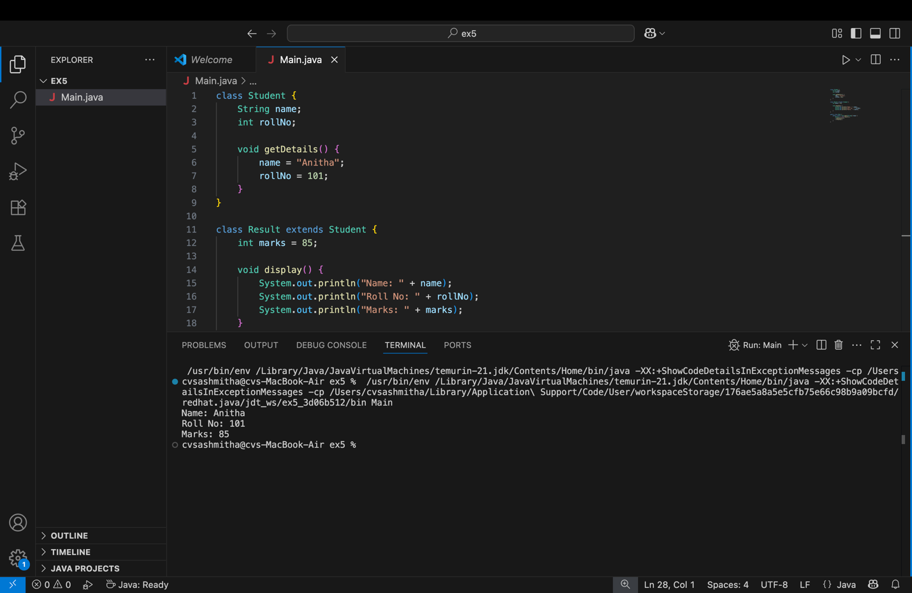
Output:
Name: RAM
Roll No: 101
Marks: 85

2. Bank Account System (Hierarchical Inheritance)
Question:
A bank has Savings and Current accounts. Both inherit from a common Account class.
Code:
class Account {
void showAccountType() {
System.out.println("Bank Account");
}
}

class SavingsAccount extends Account {
void interest() {
System.out.println("Savings Account gives interest");
}
}

class CurrentAccount extends Account {
void overdraft() {
System.out.println("Current Account supports overdraft");
}
}

public class Main {
public static void main(String[] args) {
SavingsAccount s = new SavingsAccount();
CurrentAccount c = new CurrentAccount();

s.showAccountType();
s.interest();

c.showAccountType();
c.overdraft();
}
}
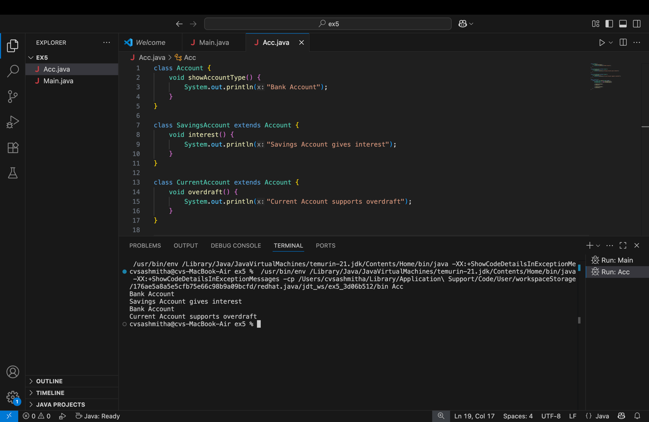
Output:
Bank Account
Savings Account gives interest
Bank Account
Current Account supports overdraft

3. Vehicle System (Multilevel Inheritance)
Question:
A company classifies vehicles as Vehicle → Car → ElectricCar.
Code:
class Vehicle {
void start() {
System.out.println("Vehicle starts");
}
}

class Car extends Vehicle {
void fuelType() {
System.out.println("Car uses petrol");
}
}

class ElectricCar extends Car {
void battery() {
System.out.println("Electric car uses battery");
}
}

public class Main {
public static void main(String[] args) {
ElectricCar e = new ElectricCar();
e.start();
e.fuelType();
e.battery();
}
}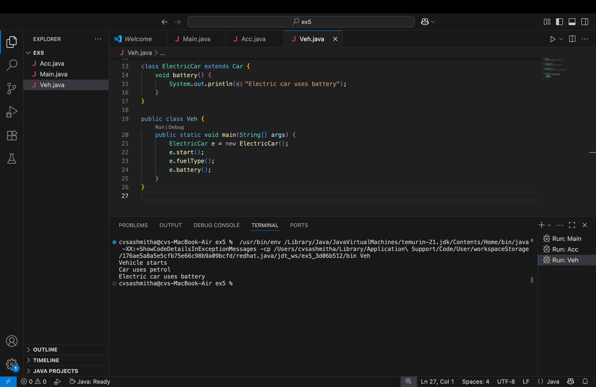

Output:
Vehicle starts
Car uses petrol
Electric car uses battery
POST LAB EXERCISE
- Why Java does not support multiple inheritance using classes and how it is implemented?
Java avoids multiple inheritance with classes to prevent ambiguity and complexity, especially the “diamond problem” (when two parent classes define the same method and the child doesn’t know which one to use).
Instead, Java uses:
- Single inheritance with classes: ‎`class B extends A`
- Multiple inheritance via interfaces: ‎`class C implements I1, I2`
So you can’t ‎`extend` two classes, but you can ‎`implement` many interfaces.

- What is the role of the super keyword? Give examples.
`super` is used to refer to the parent class:
- Call parent constructor (must be first line in child constructor):
class Parent {
Parent(int x) { System.out.println("Parent: " + x); }
}

class Child extends Parent {
Child() {
super(10); // calls Parent(int x)
System.out.println("Child constructor");
}
}
- 2. Access parent’s method/variable when overridden/hidden:
class Parent {
int a = 5;
void show() { System.out.println("Parent show"); }
}

class Child extends Parent {
int a = 10;
void show() {
super.show(); // calls Parent.show()
System.out.println(super.a); // accesses Parent's a
}
}
- Can a child class access private members of the parent class? Why?
No, a child class cannot directly access ‎`private` members of the parent class, because ‎`private` members are only visible inside the class where they are declared.
Access is possible only indirectly through:
- ‎`public` / ‎`protected` getters and setters in the parent
class Parent {
private int secret = 42;
protected int getSecret() { return secret; }
}

class Child extends Parent {
void printSecret() {
System.out.println(getSecret()); // allowed via protected method
}
}
- Explain why hybrid inheritance is not supported in Java.
Hybrid inheritance = combination of multiple inheritance types (e.g., multiple + multilevel) using classes.
Java does not allow this with classes because it would reintroduce the same ambiguity and diamond problem that multiple inheritance causes, making method resolution complex.
Instead:
- Hybrid-like designs are achieved using a single class inheritance chain plus multiple interfaces.
- This keeps the hierarchy simpler and avoids conflicts in method definitions.

Result:

Thus the different types of inheritance were implemented and executed successfully.

ASSESSMENT

Description | Max Marks | Marks Awarded
Pre Lab Exercise | 5
In Lab Exercise | 10
Post Lab Exercise | 5
Viva | 10
Total | 30
Faculty Signature

