Experiment Number : 06 Date: 5/2/2026

ABSTRACT CLASSES
Aim:
To understand and implement inheritance concepts in Java.
PRE LAB EXERCISE
QUESTIONS
- What is an abstract class?
An abstract class is a class that cannot be instantiated and is meant to be inherited. It can contain:
Abstract methods (no body, only declaration)
Non-abstract methods (with body)
Variables, constructors, etc.

- Why are abstract methods used?
Abstract methods are used to:
- Force subclasses to provide implementation for certain behaviors.
- Define a common contract while allowing different subclasses to implement it differently.

- Difference between abstract class and interface.
1) Methods and implementation
- Abstract class: can have both abstract and concrete methods.
- Interface (Java 8+): can have abstract methods, default methods, and static methods, but no instance fields with implementation logic.
2) Variables
- Abstract class: can have instance variables (state).
- Interface: variables are implicitly ‎`public static final` (constants).
3) Inheritance
- Abstract class: a class can extend only one abstract (or normal) class.
- Interface: a class can implement multiple interfaces.
4) Use case
- Abstract class: use when classes are closely related and share state + behavior.
- Interface: use to define a pure contract/ability (e.g., ‎`Runnable`, ‎`Serializable`) that many unrelated classes can implement.

IN LAB EXERCISE
Objective:
To implement abstract class and demonstrate abstraction.
PROGRAMS:
1.University System
Scenario:
A university has different types of courses: Online, Offline, and Hybrid. Each course has a getDetails() method.
Question:
Create an abstract class Course with abstract method getDetails(). Implement OnlineCourse, OfflineCourse, and HybridCourse classes.
Code:
abstract class Course {
abstract void getDetails();
}

class OnlineCourse extends Course {
void getDetails() {
System.out.println("Online Course: Attend via Internet");
}
}

class OfflineCourse extends Course {
void getDetails() {
System.out.println("Offline Course: Attend in classroom");
}
}

class HybridCourse extends Course {
void getDetails() {
System.out.println("Hybrid Course: Combination of online and offline");
}
}

public class Main {
public static void main(String[] args) {
Course c1 = new OnlineCourse();
Course c2 = new OfflineCourse();
Course c3 = new HybridCourse();

c1.getDetails();
c2.getDetails();
c3.getDetails();
}
}
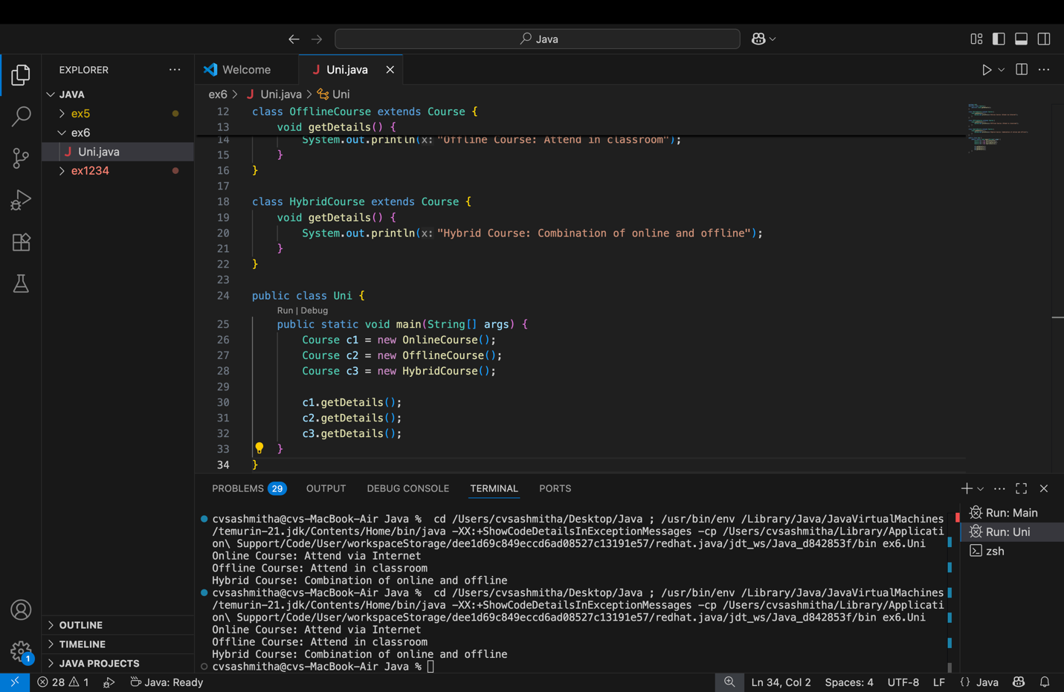
Output:
Online Course: Attend via Internet
Offline Course: Attend in classroom
Hybrid Course: Combination of online and offline
2. Employee Payroll System
Scenario:
A company has different types of employees — Regular and Contract. All employees have a salary, but the calculation differs for each type.
Question:
Design an abstract class Employee with an abstract method calculateSalary(). Implement subclasses RegularEmployee and ContractEmployee to calculate salary differently.
Code:
import java.util.Scanner;
abstract class Employee {
String name;
double baseSalary;

// Abstract method to calculate total salary
abstract void calculateSalary();
}

class RegularEmployee extends Employee {
double bonusRate = 0.1; // 10% bonus

void calculateSalary() {
double totalSalary = baseSalary + (baseSalary * bonusRate);
System.out.println("Regular Employee: " + name);
System.out.println("Base Salary: " + baseSalary);
System.out.println("Total Salary (with 10% bonus): " + totalSalary);
}
}

class ContractEmployee extends Employee {
void calculateSalary() {
System.out.println("Contract Employee: " + name);
System.out.println("Total Salary: " + baseSalary);
}
}

public class Main {
public static void main(String[] args) {
Scanner sc = new Scanner(System.in);

// Input for Regular Employee
System.out.print("Enter Regular Employee Name: ");
String regName = sc.nextLine();
System.out.print("Enter Base Salary: ");
double regSalary = sc.nextDouble();
sc.nextLine(); // Consume newline

// Input for Contract Employee
System.out.print("Enter Contract Employee Name: ");
String conName = sc.nextLine();
System.out.print("Enter Base Salary: ");
double conSalary = sc.nextDouble();

// Create objects
Employee e1 = new RegularEmployee();
e1.name = regName;
e1.baseSalary = regSalary;

Employee e2 = new ContractEmployee();
e2.name = conName;
e2.baseSalary = conSalary;

System.out.println("\n--- Salary Details ---");
e1.calculateSalary();
System.out.println();
e2.calculateSalary();

sc.close();
}
}
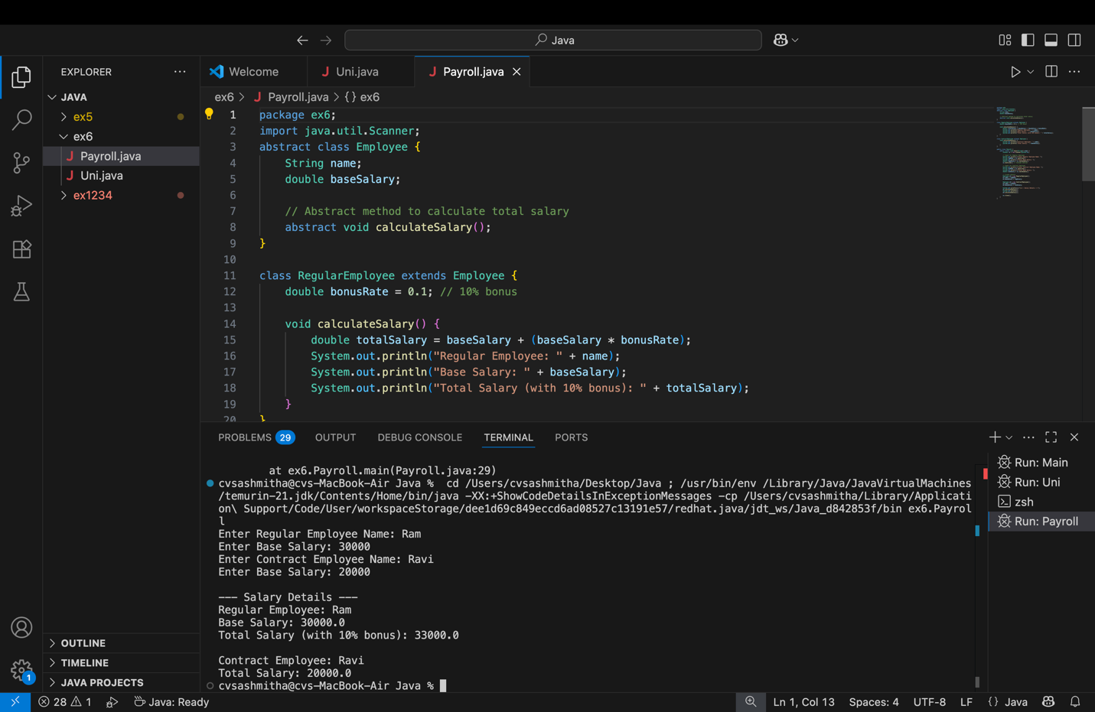
Output:
Enter Regular Employee Name: Ram
Enter Base Salary: 30000
Enter Contract Employee Name: Ravi
Enter Base Salary: 20000

--- Salary Details ---
Regular Employee: Anitha
Base Salary: 30000.0
Total Salary (with 10% bonus): 33000.0

Contract Employee: Ravi
Total Salary: 20000.0
3.Banking System
Scenario:
A bank has different types of accounts: Savings and Current. Both accounts need a method to calculate interest, but the calculation differs for each account type.
Question:
Use an abstract class BankAccount with an abstract method calculateInterest() and implement it in SavingsAccount and CurrentAccount classes.
Code
abstract class BankAccount {
String accountHolder;
double balance;

BankAccount(String name, double bal) {
accountHolder = name;
balance = bal;
}

abstract void calculateInterest(); // Abstract method
}

class SavingsAccount extends BankAccount {
double interestRate = 0.04; // 4% interest

SavingsAccount(String name, double bal) {
super(name, bal);
}

void calculateInterest() {
double interest = balance * interestRate;
System.out.println("Savings Account Interest for " + accountHolder + " = " + interest);
}
}

class CurrentAccount extends BankAccount {
double interestRate = 0.02; // 2% interest

CurrentAccount(String name, double bal) {
super(name, bal);
}

void calculateInterest() {
double interest = balance * interestRate;
System.out.println("Current Account Interest for " + accountHolder + " = " + interest);
}
}

public class Main {
public static void main(String[] args) {
BankAccount acc1 = new SavingsAccount("Ram", 50000);
BankAccount acc2 = new CurrentAccount("Ravi", 80000);

acc1.calculateInterest();
acc2.calculateInterest();
}
}
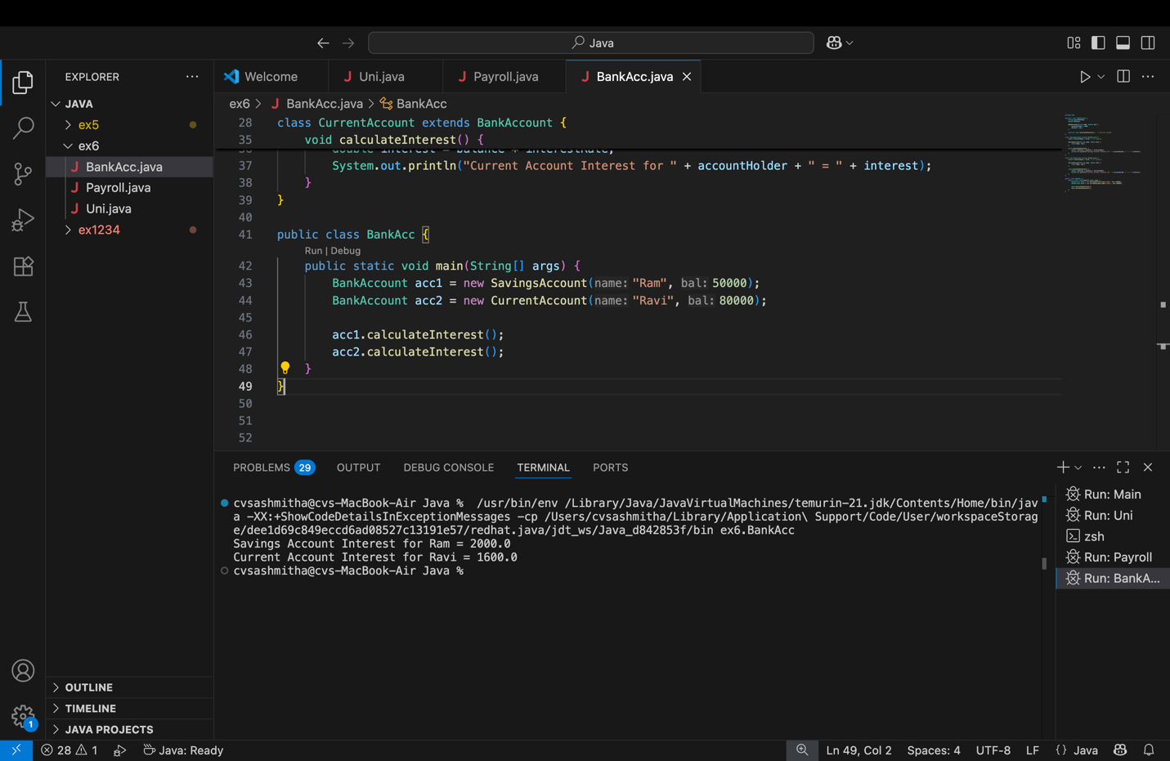

Output
Savings Account Interest for Ram = 2000.0
Current Account Interest for Ravi = 1600.0

POST LAB EXERCISE
- How is an abstract class different from a regular class?
- Regular class: can be instantiated and may have only concrete (fully defined) methods.
- Abstract class: cannot be instantiated and may contain one or more abstract (unimplemented) methods.
- Can you create an object of an abstract class? Why or why not?
No, you cannot create an object of an abstract class, because it may have incomplete (abstract) methods with no body; such a class is only a template for subclasses.

- What happens if a subclass does not implement an abstract method?
If a subclass does not implement all inherited abstract methods, then that subclass must also be declared abstract. Otherwise, the compiler gives an error.

- Can an abstract class exist without any abstract methods?
Yes, an abstract class can exist without abstract methods. It is still marked abstract to prevent direct instantiation and to act as a base class.

- Can an abstract class extend another abstract class?
Yes. An abstract class can extend another abstract class.
It may choose to implement some, all, or none of the abstract methods from the parent; if some remain unimplemented, it stays abstract.

Result:

Thus the abstract classes and methods were implemented and executed successfully.

ASSESSMENT

Description | Max Marks | Marks Awarded
Pre Lab Exercise | 5
In Lab Exercise | 10
Post Lab Exercise | 5
Viva | 10
Total | 30
Faculty Signature

