Experiment Number : 07 Date: 5/2/2026

METHOD OVERLOADING AND METHOD OVERRIDING
Aim:
To understand and implement method overloading and method overriding.
PRE LAB EXERCISE
QUESTIONS
- What is method overloading?
Method overloading means having multiple methods with the same name in the same class but with different parameter lists (different number or types of parameters). Return type may be same or different.

- What is method overriding?
Method overriding means a subclass provides its own implementation of a method that is already defined in its parent class, using same method signature (same name, parameters, and usually same return type).

- Difference between overloading and overriding.
- 1. Concept:
  - Overloading: Same class, same name, different parameters (compile-time polymorphism).
  - Overriding: Parent–child classes, same signature (runtime polymorphism).
- Binding:
  - Overloading: Resolved at compile time.
  - Overriding: Resolved at runtime (based on actual object).
- Location:
  - Overloading: Methods in the same class (or also in subclass but treated as overloads).
  - Overriding: Methods in different classes related by inheritance.
- Purpose:
  - Overloading: To perform similar tasks with different inputs.
  - Overriding: To change or specialize behavior of parent class method in subclass.

IN LAB EXERCISE
Objective:
To demonstrate compile-time and runtime polymorphism.
PROGRAMS:
1.Student Result System (Method Overriding)
Description:
- Base class Student has method displayResult().
- Subclasses UGStudent and PGStudent override the method to show different grading systems.

Code :
import java.util.Scanner;

// Base class
class Student {
String name;

void displayResult() {
System.out.println("Student Result");
}
}

// UG Student subclass
class UGStudent extends Student {
int marks;

UGStudent(String n, int m) {
name = n;
marks = m;
}

@Override
void displayResult() {
double percentage = (marks / 100.0) * 100;
System.out.println("UG Student: " + name);
System.out.println("Marks: " + marks);
System.out.println("Percentage: " + percentage + "%");
}
}

// PG Student subclass
class PGStudent extends Student {
double gpa;

PGStudent(String n, double g) {
name = n;
gpa = g;
}

@Override
void displayResult() {
System.out.println("PG Student: " + name);
System.out.println("GPA: " + gpa + " / 10");
}
}

// Main class
public class Main {
public static void main(String[] args) {
Scanner sc = new Scanner(System.in);

// Input for UG student
System.out.print("Enter UG Student Name: ");
String ugName = sc.nextLine();
System.out.print("Enter UG Student Marks (out of 100): ");
int ugMarks = sc.nextInt();
sc.nextLine(); // consume newline

// Input for PG student
System.out.print("Enter PG Student Name: ");
String pgName = sc.nextLine();
System.out.print("Enter PG Student GPA (0-10): ");
double pgGpa = sc.nextDouble();

// Create objects
Student s1 = new UGStudent(ugName, ugMarks);
Student s2 = new PGStudent(pgName, pgGpa);

System.out.println("\n--- Student Results ---");
s1.displayResult();
System.out.println();
s2.displayResult();

sc.close();
}
}
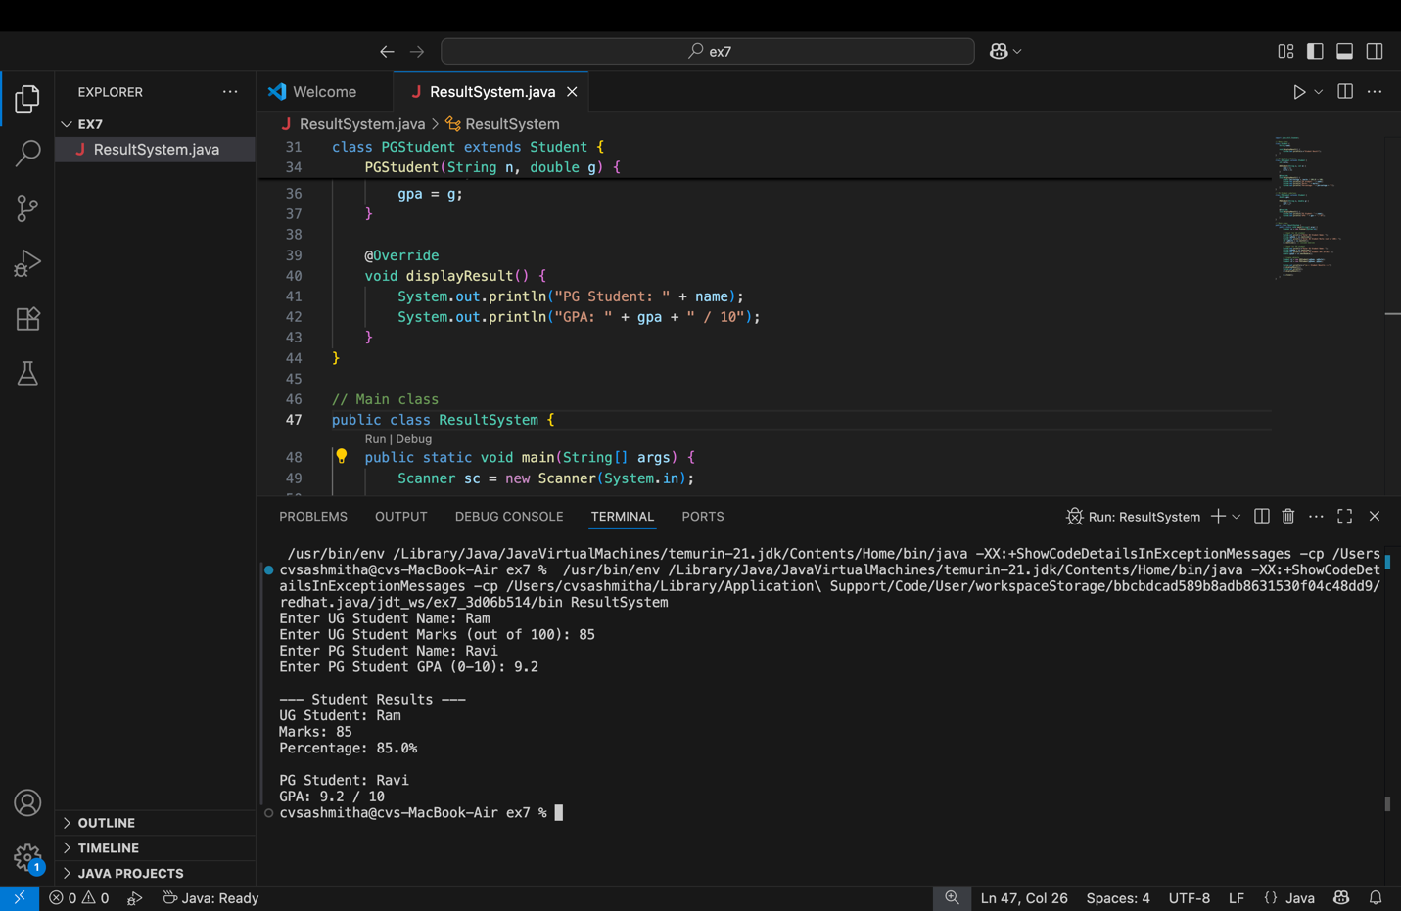
OUTPUT:

Sample Input:
Enter UG Student Name: Ram
Enter UG Student Marks (out of 100): 85
Enter PG Student Name: Ravi
Enter PG Student GPA (0-10): 9.2
Output:
--- Student Results ---
UG Student: Ram
Marks: 85
Percentage: 85.0%
PG Student: Ravi
GPA: 9.2 / 10

2. Calculator Program (Method Overloading)
Description:
Create a Calculator class with multiple add() methods to calculate:
- Addition of 2 integers
- Addition of 3 integers
- Addition of 2 double numbers
Code:
import java.util.Scanner;
class Calculator {
int add(int a, int b) {
return a + b;
}

int add(int a, int b, int c) {
return a + b + c;
}

double add(double a, double b) {
return a + b;
}
}
public class Main {
public static void main(String[] args) {
Scanner sc = new Scanner(System.in);
Calculator calc = new Calculator();

System.out.print("Enter two integers: ");
int x = sc.nextInt();
int y = sc.nextInt();
System.out.println("Sum of two integers: " + calc.add(x, y));

System.out.print("Enter three integers: ");
int p = sc.nextInt();
int q = sc.nextInt();
int r = sc.nextInt();
System.out.println("Sum of three integers: " + calc.add(p, q, r));

System.out.print("Enter two decimal numbers: ");
double a = sc.nextDouble();
double b = sc.nextDouble();
System.out.println("Sum of two doubles: " + calc.add(a, b));

sc.close();
}
}
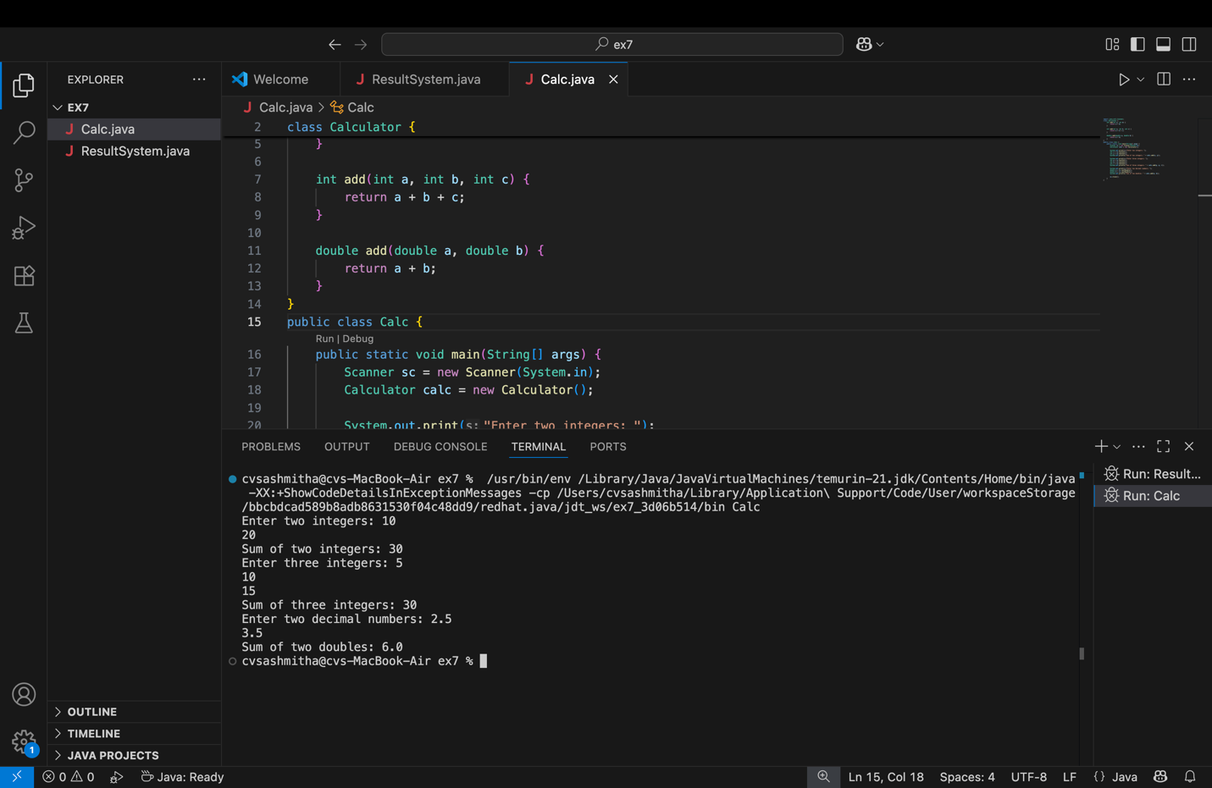
Output:
Sample Input:
Enter two integers: 10 20
Enter three integers: 5 10 15
Enter two decimal numbers: 2.5 3.5
Output:
Sum of two integers: 30
Sum of three integers: 30
Sum of two doubles: 6.0

POST LAB EXERCISE
- Is return type important in method overloading and method overriding?
- • Overloading: Return type is not used to distinguish overloaded methods; only the parameter list matters.
- Overriding: Return type must be same or covariant (compatible subtype) as in the parent method.

- Can you overload a method by changing only the return type?
No.
If two methods have the same name and same parameters, but only different return types, it is a compile-time error. The compiler cannot decide which one to call based only on return type.

- Can static methods be overridden? Can they be overloaded?
- • Overridden: Static methods cannot truly be overridden. They are hidden, not overridden (binding is done at compile time using reference type).
- Overloaded: Static methods can be overloaded like any other method (same name, different parameter list).

- Can a method be overridden if the parameter list is different?
No.
If the parameter list is different, it is not overriding, it becomes overloading.
For overriding, method must have:
- Same name
- Same parameter list
- Compatible return type
- In a subclass

Result:
Thus the method overloading and overriding concepts were implemented and executed successfully.
ASSESSMENT

Description | Max Marks | Marks Awarded
Pre Lab Exercise | 5
In Lab Exercise | 10
Post Lab Exercise | 5
Viva | 10
Total | 30
Faculty Signature

