Experiment Number : 03 Date: 28/01/2026

Control Statements in Java Aim:
To understand and implement decision-making and looping control statements in Java.
PRE LAB EXERCISE
QUESTIONS
1. List different control statements in Java
Control statements are used to control the flow of execution of a program.
Types of Control Statements in Java
- Selection (Decision-making) Statements
Used to make decisions based on conditions.
  - if
  - if–else
  - else–if ladder
  - switch
- Iteration (Looping) Statements
Used to repeat a block of code.
  - for
  - while
  - do–while
- Jump (Branching) Statements
Used to transfer control from one part of the program to another.
  - break
  - continue
  - return
2. Difference between for, while, and do-while loops
Feature | for loop | while loop | do-while loop
Condition check | Before loop starts | Before loop starts | After loop executes
Minimum execution | May not execute | May not execute | Executes at least once
Best used when | Number of iterations is  known | Iterations not  known | Loop must run once
Syntax complexity | Compact | Simple | Simple
Example:
for loop
for(int i = 1; i <= 5; i++) {
System.out.println(i);
}
while loop
int i = 1; while(i <= 5) { System.out.println(i);
i++;
}
do-while loop
int i = 1; do {
System.out.println(i);
i++;
} while(i <= 5);
3. What is the use of break and continue?
break statement
- Used to terminate a loop or switch statement immediately
- Control moves to the statement after the loop Example:
for(int i = 1; i <= 5; i++) {
if(i == 3) {
break;
}
System.out.println(i);
}
Output:
1 2 continue statement
- Used to skip the current iteration
- Control moves to the next iteration of the loop Example:
for(int i = 1; i <= 5; i++) {
if(i == 3) {
continue;
}
System.out.println(i);
}
Output:
1
2
4
5
✓
IN LAB EXERCISE
Objective:
To implement if-else and looping statements.
INPUT STATEMENT:
SCANNER CLASS
- The Scanner class in Java is used to read input from the user through the keyboard.
It is available in the package java.util.
- The Scanner object reads different types of input such as integer, float, double, and string and stores them in variables.
- To use the Scanner class, it must be imported before using it in the program.
SYNTAX:
- Scanner sc = new Scanner(System.in);
Commonly Used Scanner Methods:
- nextInt() – reads an integer value
- nextFloat() – reads a float value
- nextDouble() – reads a double value
- next() – reads a single word
- nextLine() – reads a complete line of text
PROGRAMS:
Program 1: Check Whether a Number is Positive class PositiveNumber {
public static void main(String[] args) { int n = 5; if (n > 0) {
System.out.println("Positive Number");
}
}
}
Output:
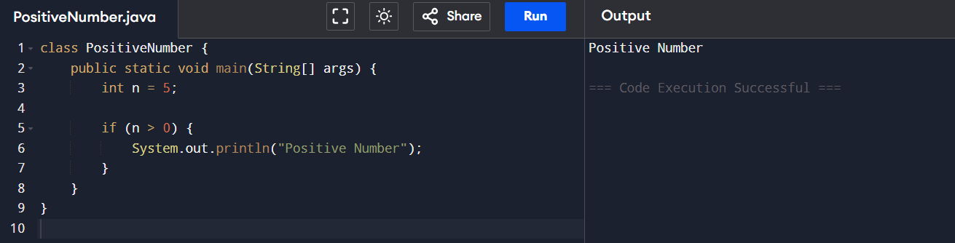
Program 2: Check Whether a Number is Even or Odd class EvenOdd {
public static void main(String[] args) {
int n = 6;

if (n % 2 == 0)
System.out.println("Even Number");
else
System.out.println("Odd Number");
}
}Output:

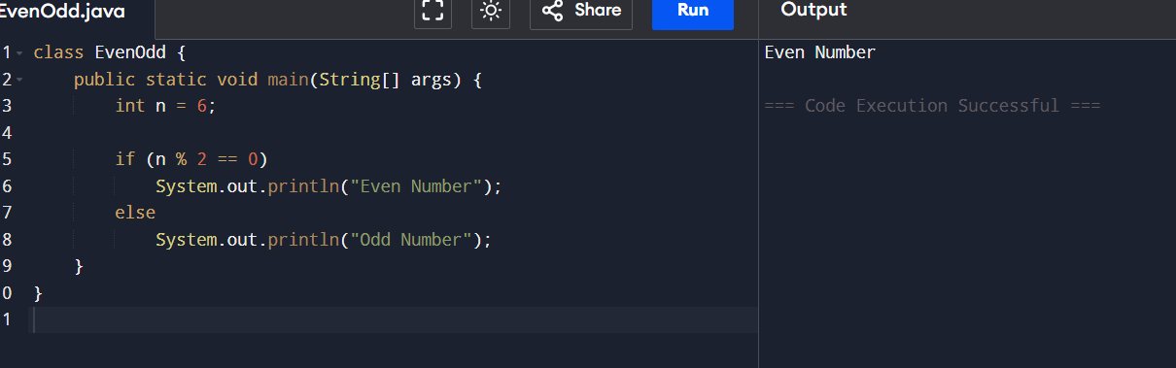
Program 3: Find Largest of Two Numbers class LargestTwo { public static void main(String[] args) { int a = 10, b = 20; if (a > b)
System.out.println("A is largest"); else
System.out.println("B is largest");
}
}
Output:

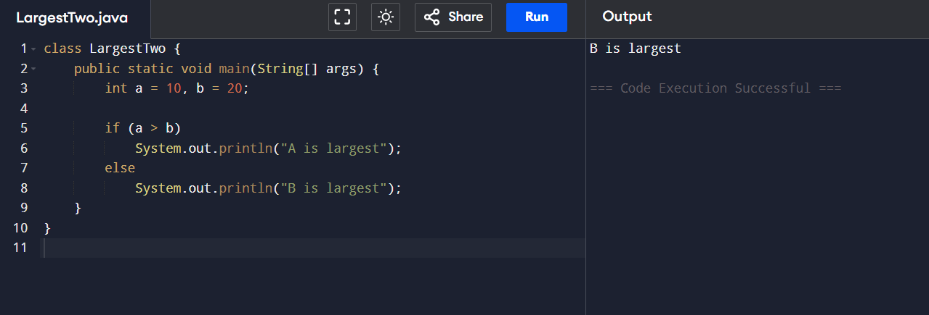
Program 4: Grade Calculation class Grade { public static void main(String[] args) { int marks = 75; if (marks >= 90)
System.out.println("Grade A");
else if (marks >= 75) System.out.println("Grade B"); else if (marks >= 50) System.out.println("Grade C"); else
System.out.println("Fail");
}
}Output:

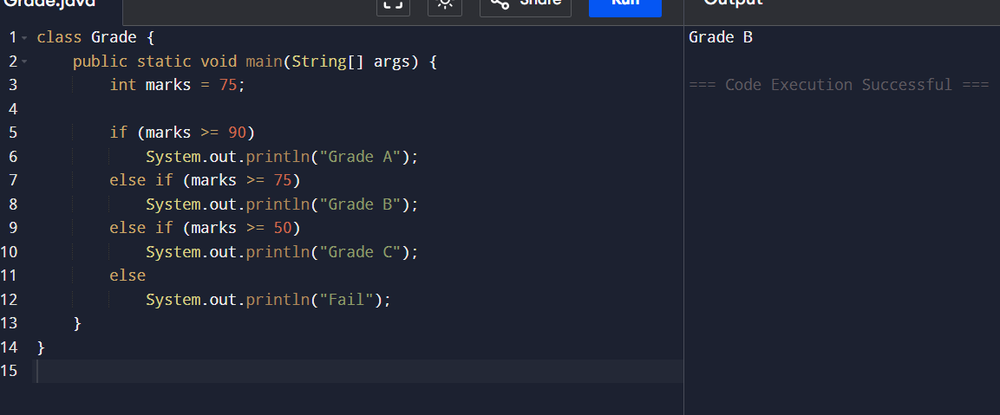
Program 5: Day of the Week class DaySwitch { public static void main(String[] args) { int day = 3; switch (day) {
case 1: System.out.println("Monday"); break; case 2: System.out.println("Tuesday"); break; case 3: System.out.println("Wednesday"); break; case 4: System.out.println("Thursday"); break; case 5: System.out.println("Friday"); break; default: System.out.println("Invalid Day");
}
}
}
Output:
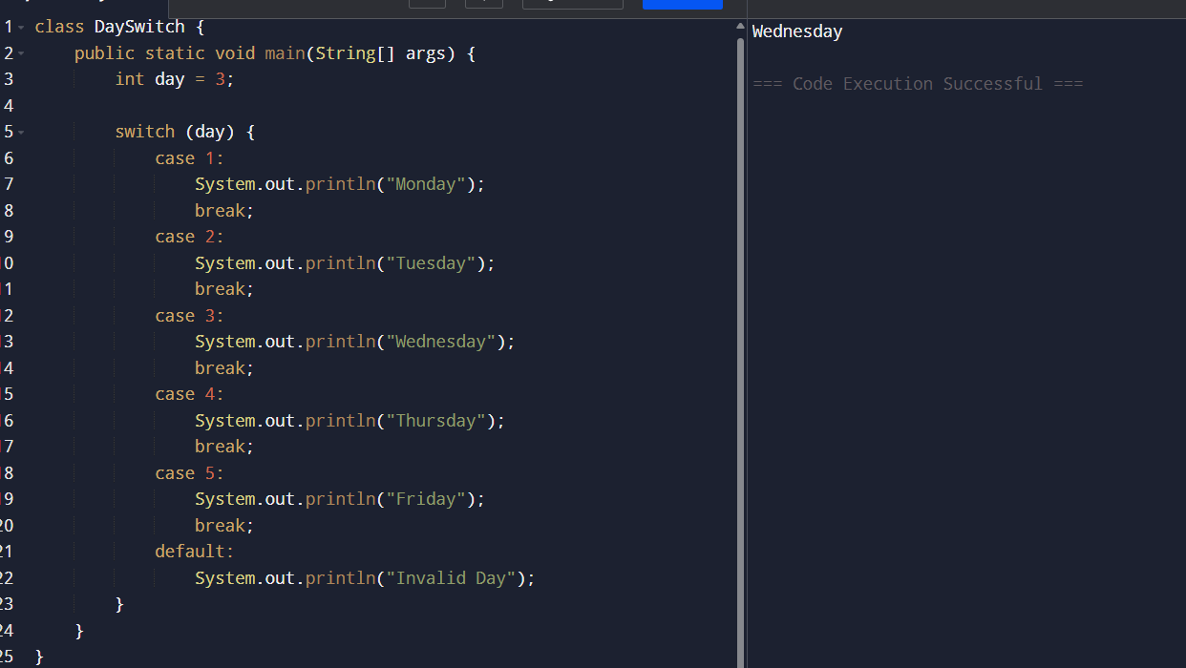
Program 6: Print Numbers from 1 to 5 class ForLoop { public static void main(String[] args) { for (int i = 1; i <= 5; i++) {
System.out.println(i);
}
}
}
Output:

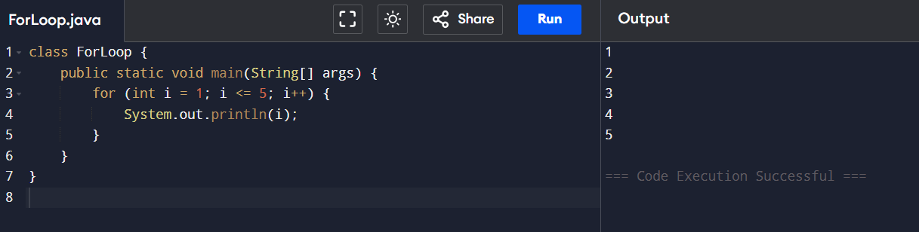
Program 7: Print Numbers from 1 to 5
class WhileLoop { public static void main(String[] args) { int i = 1; while (i <= 5) { System.out.println(i); i++;
}
}
}
Output:

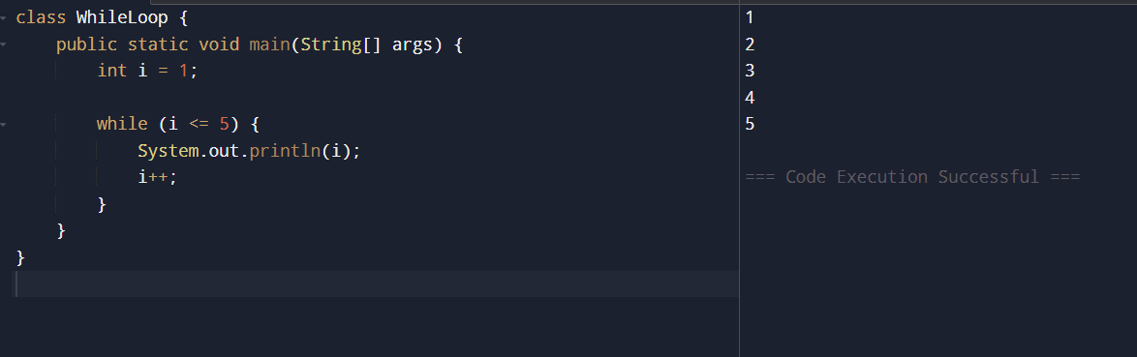
Program 8: Print Numbers from 1 to 5 class DoWhileLoop { public static void main(String[] args) { int i = 1; do { System.out.println(i); i++;
} while (i <= 5);
}
}
Output:

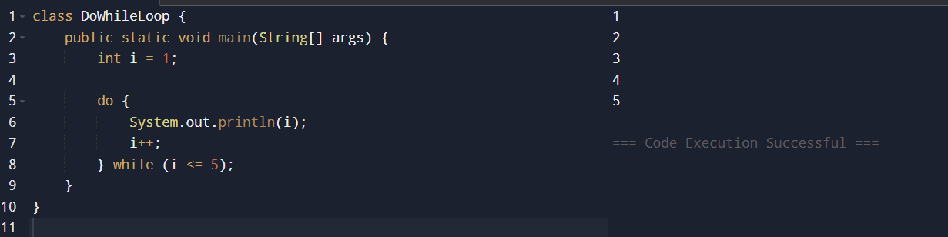
Program 9: Sum of First 5 Natural Numbers class SumNumbers {
public static void main(String[] args) { int sum = 0; for (int i = 1; i <= 5; i++) { sum = sum + i;
}
System.out.println("Sum = " + sum);
}
}
Output:
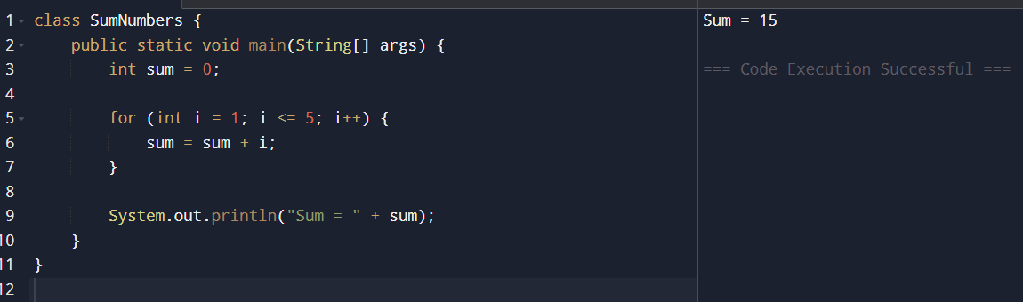
Program 10: Multiplication Table of a Number class MultiplicationTable { public static void main(String[] args) { int n = 5; for (int i = 1; i <= 10; i++) {
System.out.println(n + " x " + i + " = " + (n * i)); }
}
}
Output:

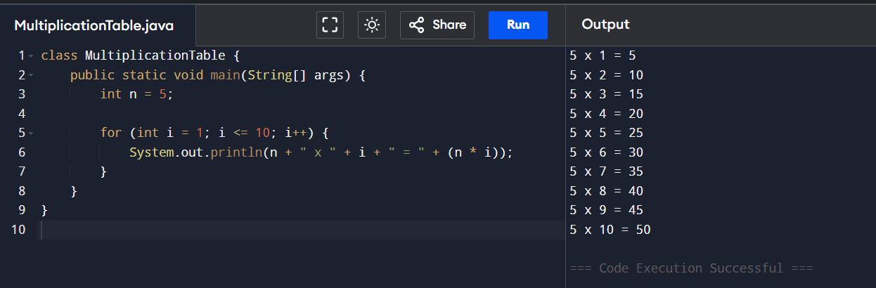
Postlab
- What is the use of if statement?
Answer:
The if statement is used to check a condition and execute a block of code only if the condition is true.
- Difference between if-else and else-if ladder
if-else | else-if ladder
Checks only two conditions | Checks multiple conditions
Has one if and one else | Has multiple else-if conditions
Executes either if or  else | Executes only the first true condition
Used for simple decisions | Used for multiple choices
- Why is switch statement used?
Answer:
The switch statement is used to select one block of code from multiple options based on the value of a variable.
Advantages:
  - Cleaner than multiple if-else
  - Improves readability
  - Faster execution in some cases
- Difference between for, while, and do-while loops
for loop | while loop | do-while loop
Entry-controlled | Entry-controlled | Exit-controlled
Condition checked first | Condition checked first | Condition checked after execution
Used when iterations are known | Used when iterations are unknown | Used when loop must run at least once
- Which loop executes at least once?
Answer:
The do-while loop executes at least once, even if the condition is false.
Reason:
  - The condition is checked after executing the loop body.
Result:
Thus the different control statements were executed successfully with expected output.
ASSESSMENT
Description |  | Max Marks | Marks Awarded
Pre Lab Exercise |  | 5
In Lab Exercise |  | 10
Post Lab Exercise |  | 5
Viva |  | 10
 | Total | 30
 |  | Faculty Signature

