Experiment Number : 04 Date: 05.02.2026

ARRAYS
Aim:
To understand and implement array operations in Java.
PRE LAB EXERCISE
QUESTIONS
- What is an array?
An array is a data structure that stores multiple values of the same data type under a single name. Each value in an array is stored at a specific position called an index.
- Why are arrays used?
Arrays are used to:
- Store large amounts of data efficiently
- Access elements easily using index numbers
- Reduce the need for multiple variables
- Make programs simpler, cleaner, and faster to process data
- What is the difference between array and variable?

Variable | Array
Stores only one value | Stores multiple values
Holds a single data item | Holds a collection of data items
Requires multiple variables for many values | Uses one name to store many values
Example: int a = 10; | Example: int a[] = {10, 20, 30};

IN LAB EXERCISE
Objective:
To perform array operations using simple programs.
PROGRAMS:
1. Program to Read and Print Array Elements
Code:
import java.util.Scanner;
public class ReadPrintArray {
public static void main(String[] args) {
Scanner sc = new Scanner(System.in);
int[] arr = new int[5];
System.out.println("Enter 5 elements:");
for(int i = 0; i < 5; i++)
arr[i] = sc.nextInt();
System.out.println("Array elements are:");
for(int i = 0; i < 5; i++)
System.out.print(arr[i] + " ");
}
}
OUTPUT:
Input:
10 20 30 40 50
Output:
Array elements are:
10 20 30 40 50
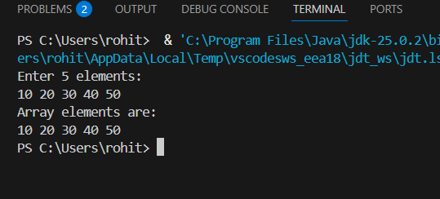

2. Program to Find Sum of Array Elements
Code:
import java.util.Scanner;
public class SumArray {
public static void main(String[] args) {
Scanner sc = new Scanner(System.in);
int[] arr = new int[5];
int sum = 0;
System.out.println("Enter 5 elements:");
for(int i = 0; i < 5; i++)
arr[i] = sc.nextInt();
for(int i = 0; i < 5; i++)
sum += arr[i];
System.out.println("Sum = " + sum);
}
}
OUTPUT:
Input:
5 10 15 20 25
Output:
Sum = 75
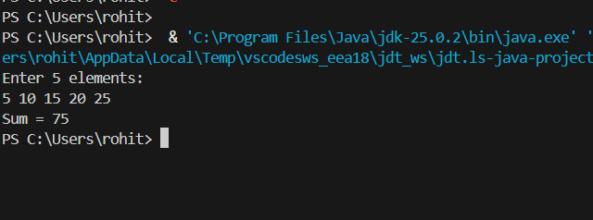

3. Program to Find Largest Element in an Array
Code:
import java.util.Scanner;
public class LargestElement {
public static void main(String[] args) {
Scanner sc = new Scanner(System.in);
int[] arr = new int[5];
System.out.println("Enter 5 elements:");
for(int i = 0; i < 5; i++)
arr[i] = sc.nextInt();
int max = arr[0];
for(int i = 1; i < 5; i++)
if(arr[i] > max)
max = arr[i];
System.out.println("Largest element = " + max);
}
}
OUTPUT:
Input:
12 45 23 9 30
Output:
Largest element = 45
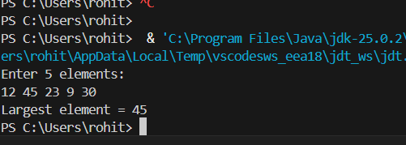

4. Program to Reverse an Array
Code:
import java.util.Scanner;

public class ReverseArray {
public static void main(String[] args) {
Scanner sc = new Scanner(System.in);
int[] arr = new int[5];
System.out.println("Enter 5 elements:");
for(int i = 0; i < 5; i++)
arr[i] = sc.nextInt();
System.out.println("Reversed array:");
for(int i = 4; i >= 0; i--)
System.out.print(arr[i] + " ");
}
}
OUTPUT:
Input:
1 2 3 4 5
Output:
Reversed array:
5 4 3 2 1
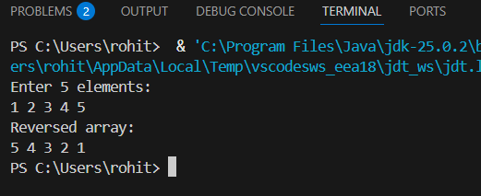

5. Program to Count Even and Odd Numbers
Code:
import java.util.Scanner;
public class EvenOddCount {
public static void main(String[] args) {
Scanner sc = new Scanner(System.in);
int[] arr = new int[5];
int even = 0, odd = 0;
System.out.println("Enter 5 elements:");
for(int i = 0; i < 5; i++)
arr[i] = sc.nextInt();
for(int i = 0; i < 5; i++) {
if(arr[i] % 2 == 0)
even++;
else
odd++;
}

System.out.println("Even = " + even);
System.out.println("Odd = " + odd);
}
}
OUTPUT:
Input:
2 7 4 9 10
Output:
Even = 3
Odd = 2
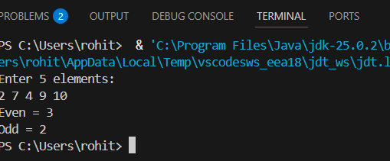

6. Program to Sort Array in Ascending Order
Code:
import java.util.Scanner;
public class SortArray {
public static void main(String[] args) {
Scanner sc = new Scanner(System.in);
int[] arr = new int[5];
int temp;
System.out.println("Enter 5 elements:");
for(int i = 0; i < 5; i++)
arr[i] = sc.nextInt();
for(int i = 0; i < 5; i++) {
for(int j = i + 1; j < 5; j++) {
if(arr[i] > arr[j]) {
temp = arr[i];
arr[i] = arr[j];
arr[j] = temp;
}
}
}
System.out.println("Sorted array:");
for(int i = 0; i < 5; i++)
System.out.print(arr[i] + " ");
}
}
OUTPUT:
Input:
45 12 78 23 9

Output:
Sorted array:
9 12 23 45 78
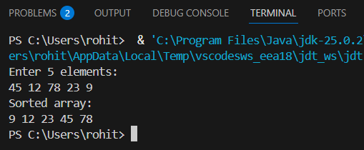

7. Program to Find Second Largest Element
Code:
import java.util.Scanner;
public class SecondLargest {
public static void main(String[] args) {
Scanner sc = new Scanner(System.in);
int[] arr = new int[5];

System.out.println("Enter 5 elements:");
for(int i = 0; i < 5; i++)
arr[i] = sc.nextInt();
int largest = arr[0];
int second = arr[0];
for(int i = 0; i < 5; i++) {
if(arr[i] > largest) {
second = largest;
largest = arr[i];
}
}
System.out.println("Second largest = " + second);
}
}
OUTPUT:
Input:
10 45 23 89 67
Output:
Second largest = 67
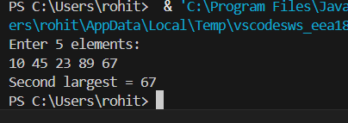

8. Program for Matrix Addition (2D Array)
Code:
import java.util.Scanner;
public class MatrixAddition {
public static void main(String[] args) {
Scanner sc = new Scanner(System.in);
int[][] a = new int[2][2];
int[][] b = new int[2][2];
int[][] sum = new int[2][2];
System.out.println("Enter elements of matrix A:");
for(int i = 0; i < 2; i++)
for(int j = 0; j < 2; j++)
a[i][j] = sc.nextInt();
System.out.println("Enter elements of matrix B:");
for(int i = 0; i < 2; i++)
for(int j = 0; j < 2; j++)
b[i][j] = sc.nextInt();
for(int i = 0; i < 2; i++)
for(int j = 0; j < 2; j++)
sum[i][j] = a[i][j] + b[i][j];
System.out.println("Sum matrix:");
for(int i = 0; i < 2; i++) {
for(int j = 0; j < 2; j++)
System.out.print(sum[i][j] + " ");
System.out.println();
}
}
}
OUTPUT:
Matrix A:
1 2
3 4
Matrix B:
5 6
7 8
Sum matrix:
6 8
10 12
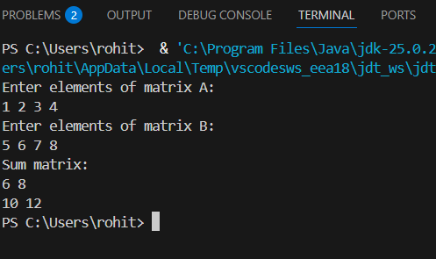

POST LAB EXERCISE
- Why is array indexing usually started from zero instead of one?
Array indexing starts from zero because the index represents the offset from the first memory location.
The first element is at offset 0, so using zero makes memory access faster and more efficient.
- What happens if we try to access an array element outside its declared size?
Accessing an element outside the array size causes a runtime error.
- In Java: ArrayIndexOutOfBoundsException
- In C/C++: It may access garbage values or cause undefined behavior
- How does memory allocation differ for static arrays and dynamic arrays?

Static Array | Dynamic Array
Size is fixed at compile time | Size is decided at runtime
Stored in stack memory | Stored in heap memory
Cannot be resized | Can be resized
Faster access | Slightly slower due to dynamic allocation

- Why is searching faster in arrays compared to linked lists?
Searching is faster in arrays because:
  - Arrays allow direct access using index
  - Elements are stored contiguously in memory
  - Linked lists require sequential traversal from the first node
- What is the difference between contiguous and non-contiguous memory allocation?

Contiguous Memory | Non-Contiguous Memory
Stored in continuous memory locations | Stored in separate memory locations
Faster access | Slower access
Used in arrays | Used in linked lists
Easy indexing | Requires pointers

Result:

Thus the array operations were executed successfully.

ASSESSMENT

Description | Max Marks | Marks Awarded
Pre Lab Exercise | 5
In Lab Exercise | 10
Post Lab Exercise | 5
Viva | 10
Total | 30
Faculty Signature

