Experiment Number : 05 Date: 10.02.2026

INHERITANCE
Aim:
To understand and implement inheritance concepts in Java.
PRE LAB EXERCISE
QUESTIONS
- What is inheritance?
Inheritance is an object-oriented programming concept where one class (child/subclass) acquires the properties and methods of another class (parent/superclass). It helps in organizing code and reducing duplication.
- What is code reusability?
Code reusability means using the same code in different parts of a program or in different programs without rewriting it. It saves time, reduces errors, and makes maintenance easier.
- What is the use of extends keyword?
The extends keyword is used in Java to create a subclass from a superclass. It allows the subclass to inherit variables and methods of the parent class.
IN LAB EXERCISE
Objective:
To implement all types of inheritance.
PROGRAMS:
Student Result System (Single Inheritance)
Question:
A school wants to store student details and calculate marks. Create a base class Student and a derived class Result.
Code:
class Student {
String name;
int rollNo;

void getDetails() {
name = "Anitha";
rollNo = 101;
}
}

class Result extends Student {
int marks = 85;

void display() {
System.out.println("Name: " + name);
System.out.println("Roll No: " + rollNo);
System.out.println("Marks: " + marks);
}
}

public class Main {
public static void main(String[] args) {
Result r = new Result();
r.getDetails();
r.display();
}
}
Output:
Name: RAM
Roll No: 101
Marks: 85
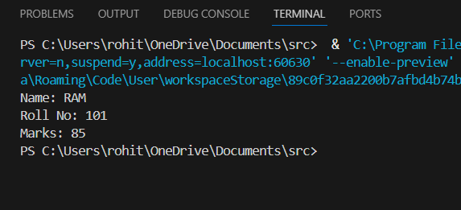

2. Bank Account System (Hierarchical Inheritance)
Question:
A bank has Savings and Current accounts. Both inherit from a common Account class.
Code:
class Account {
void showAccountType() {
System.out.println("Bank Account");
}
}

class SavingsAccount extends Account {
void interest() {
System.out.println("Savings Account gives interest");
}
}

class CurrentAccount extends Account {
void overdraft() {
System.out.println("Current Account supports overdraft");
}
}

public class Main {
public static void main(String[] args) {
SavingsAccount s = new SavingsAccount();
CurrentAccount c = new CurrentAccount();

s.showAccountType();
s.interest();

c.showAccountType();
c.overdraft();
}
}

Output:
Bank Account
Savings Account gives interest
Bank Account
Current Account supports overdraft

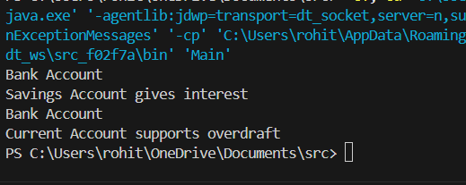

3. Vehicle System (Multilevel Inheritance)
Question:
A company classifi es vehicles as Vehicle → Car → ElectricCar.
Code:
class Vehicle {
void start() {
System.out.println("Vehicle starts");
}
}

class Car extends Vehicle {
void fuelType() {
System.out.println("Car uses petrol");
}
}

class ElectricCar extends Car {
void battery() {
System.out.println("Electric car uses battery");
}
}

public class Main {
public static void main(String[] args) {
ElectricCar e = new ElectricCar();
e.start();
e.fuelType();
e.battery();
}
}
Output:
Vehicle starts
Car uses petrol
Electric car uses battery
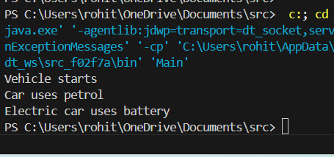

POST LAB EXERCISE
- Why Java does not support multiple inheritance using classes and how it is implemented?
Java does not support multiple inheritance using classes to avoid ambiguity problems like the Diamond Problem, where a child class gets confused about which parent class method to use.
However, Java implements multiple inheritance using interfaces, because interfaces contain only abstract methods (or default methods with clear rules), which avoids ambiguity.

- What is the role of the super keyword? Give examples.
The super keyword is used to refer to the parent class object. It helps in:
- Accessing parent class variables
- Calling parent class methods
- Invoking parent class constructors

- Can a child class access private members of the parent class? Why?
No, a child class cannot access private members of the parent class directly.
This is because private members are accessible only within the same class to ensure data hiding and security.
However, they can be accessed indirectly using public or protected methods of the parent class.
- Explain why hybrid inheritance is not supported in Java.
Hybrid inheritance is a combination of more than one type of inheritance (like multiple + hierarchical).
Java does not support hybrid inheritance using classes because it can lead to ambiguity and complexity similar to multiple inheritance.
Instead, Java supports hybrid inheritance through interfaces, which provides a clear and safe way to implement it.
Result:

Thus the different types of inheritance were implemented and executed successfully.

ASSESSMENT

Description | Max Marks | Marks Awarded
Pre Lab Exercise | 5
In Lab Exercise | 10
Post Lab Exercise | 5
Viva | 10
Total | 30
Faculty Signature

