Experiment Number : 07 Date: 10.02.2026

METHOD OVERLOADING AND METHOD OVERRIDING
Aim:
To understand and implement method overloading and method overriding.
PRE LAB EXERCISE
QUESTIONS
- What is method overloading?
Method overloading is a feature in Java where multiple methods have the same name but different parameter lists (different number, type, or order of parameters) in the same class. It is an example of compile-time polymorphism.

- What is method overriding?
Method overriding occurs when a child class provides a specific implementation of a method already defined in its parent class with the same method name, parameters, and return type. It is an example of runtime polymorphism.
- Difference between overloading and overriding.

Method Overloading | Method Overriding
Same method name, different parameters | Same method name, same parameters
Happens in the same class | Happens in parent–child classes
Compile-time polymorphism | Runtime polymorphism
Return type can be different | Return type must be same or covariant
static, final, private methods can be overloaded | final and private methods cannot be overridden

IN LAB EXERCISE
Objective:
To demonstrate compile-time and runtime polymorphism.
PROGRAMS:
1.Student Result System (Method Overriding)
Description:
- Base class Student has method displayResult().
- Subclasses UGStudent and PGStudent override the method to show different grading systems.

Code :
import java.util.Scanner;

// Base class
class Student {
String name;

void displayResult() {
System.out.println("Student Result");
}
}

// UG Student subclass
class UGStudent extends Student {
int marks;

UGStudent(String n, int m) {
name = n;
marks = m;
}

@Override
void displayResult() {
double percentage = (marks / 100.0) * 100;
System.out.println("UG Student: " + name);
System.out.println("Marks: " + marks);
System.out.println("Percentage: " + percentage + "%");
}
}

// PG Student subclass
class PGStudent extends Student {
double gpa;

PGStudent(String n, double g) {
name = n;
gpa = g;
}

@Override
void displayResult() {
System.out.println("PG Student: " + name);
System.out.println("GPA: " + gpa + " / 10");
}
}

// Main class
public class Main {
public static void main(String[] args) {
Scanner sc = new Scanner(System.in);

// Input for UG student
System.out.print("Enter UG Student Name: ");
String ugName = sc.nextLine();
System.out.print("Enter UG Student Marks (out of 100): ");
int ugMarks = sc.nextInt();
sc.nextLine(); // consume newline

// Input for PG student
System.out.print("Enter PG Student Name: ");
String pgName = sc.nextLine();
System.out.print("Enter PG Student GPA (0-10): ");
double pgGpa = sc.nextDouble();

// Create objects
Student s1 = new UGStudent(ugName, ugMarks);
Student s2 = new PGStudent(pgName, pgGpa);

System.out.println("\n--- Student Results ---");
s1.displayResult();
System.out.println();
s2.displayResult();

sc.close();
}
}
OUTPUT:

Sample Input:
Enter UG Student Name: Ram
Enter UG Student Marks (out of 100): 85
Enter PG Student Name: Ravi
Enter PG Student GPA (0-10): 9.2
Output:
--- Student Results ---
UG Student: Ram
Marks: 85
Percentage: 85.0%
PG Student: Ravi
GPA: 9.2 / 10
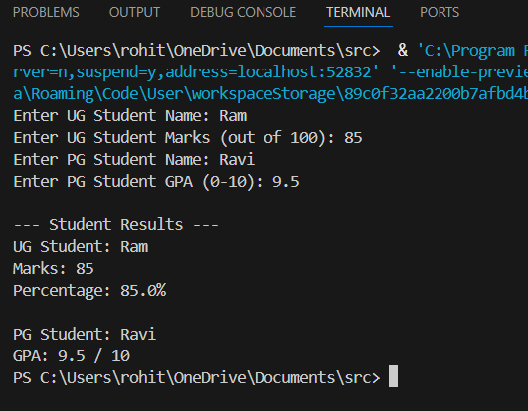

2. Calculator Program (Method Overloading)
Description:
Create a Calculator class with multiple add() methods to calculate:
- Addition of 2 integers
- Addition of 3 integers
- Addition of 2 double numbers
Code:
import java.util.Scanner;
class Calculator {
int add(int a, int b) {
return a + b;
}

int add(int a, int b, int c) {
return a + b + c;
}

double add(double a, double b) {
return a + b;
}
}
public class Main {
public static void main(String[] args) {
Scanner sc = new Scanner(System.in);
Calculator calc = new Calculator();

System.out.print("Enter two integers: ");
int x = sc.nextInt();
int y = sc.nextInt();
System.out.println("Sum of two integers: " + calc.add(x, y));

System.out.print("Enter three integers: ");
int p = sc.nextInt();
int q = sc.nextInt();
int r = sc.nextInt();
System.out.println("Sum of three integers: " + calc.add(p, q, r));

System.out.print("Enter two decimal numbers: ");
double a = sc.nextDouble();
double b = sc.nextDouble();
System.out.println("Sum of two doubles: " + calc.add(a, b));

sc.close();
}
}
Output:
Sample Input:
Enter two integers: 10 20
Enter three integers: 5 10 15
Enter two decimal numbers: 2.5 3.5
Output:
Sum of two integers: 30
Sum of three integers: 30
Sum of two doubles: 6.0
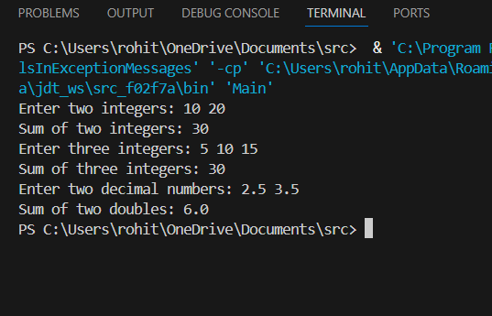

POST LAB EXERCISE
- Is return type important in method overloading and method overriding?
- Method overloading: Return type is not important as long as the parameter list is different.
- Method overriding: Return type is important and must be the same or covariant (subclass type of the return type).

- Can you overload a method by changing only the return type?
No ❌. Changing only the return type is not sufficient for method overloading. The parameter list must be different, otherwise it causes a compilation error.
- Can static methods be overridden? Can they be overloaded?
• Overridden: No ❌. Static methods cannot be overridden because they belong to the class, not the object (this is called method hiding).
• Overloaded: Yes ✅. Static methods can be overloaded by changing the parameter list.

- Can a method be overridden if the parameter list is different?
No ❌. For method overriding, the method name, parameter list, and return type must be the same.
If the parameter list is different, it becomes method overloading, not overriding.
Result:
Thus the method overloading and overriding concepts were implemented and executed successfully.
ASSESSMENT

Description | Max Marks | Marks Awarded
Pre Lab Exercise | 5
In Lab Exercise | 10
Post Lab Exercise | 5
Viva | 10
Total | 30
Faculty Signature

