Experiment Number : 05 Date: 05.02.2026

INHERITANCE
Aim:
To understand and implement inheritance concepts in Java.
PRE LAB EXERCISE
QUESTIONS
- What is inheritance?
Inheritance is a feature of object-oriented programming in which one class (child class) acquires the properties and methods of another class (parent class). It helps in creating a relationship between classes and allows the child class to reuse the existing code of the parent class.
- What is code reusability?
Code reusability means using the same code in multiple places without writing it again. By reusing existing classes, methods, or functions, programs become shorter, easier to maintain, and less error-prone.
- What is the use of extends keyword?
The extends keyword is used in Java to inherit one class from another class. It allows the child class to access the variables and methods of the parent class and supports code reusability.
IN LAB EXERCISE
Objective:
To implement all types of inheritance.
PROGRAMS:
Student Result System (Single Inheritance)
Question:
A school wants to store student details and calculate marks. Create a base class Student and a derived class Result.
Code:
class Student {
String name;
int rollNo;

void getDetails() {
name = "Anitha";
rollNo = 101;
}
}

class Result extends Student {
int marks = 85;

void display() {
System.out.println("Name: " + name);
System.out.println("Roll No: " + rollNo);
System.out.println("Marks: " + marks);
}
}

public class Main {
public static void main(String[] args) {
Result r = new Result();
r.getDetails();
r.display();
}
}
Output:
Name: RAM
Roll No: 101
Marks: 85
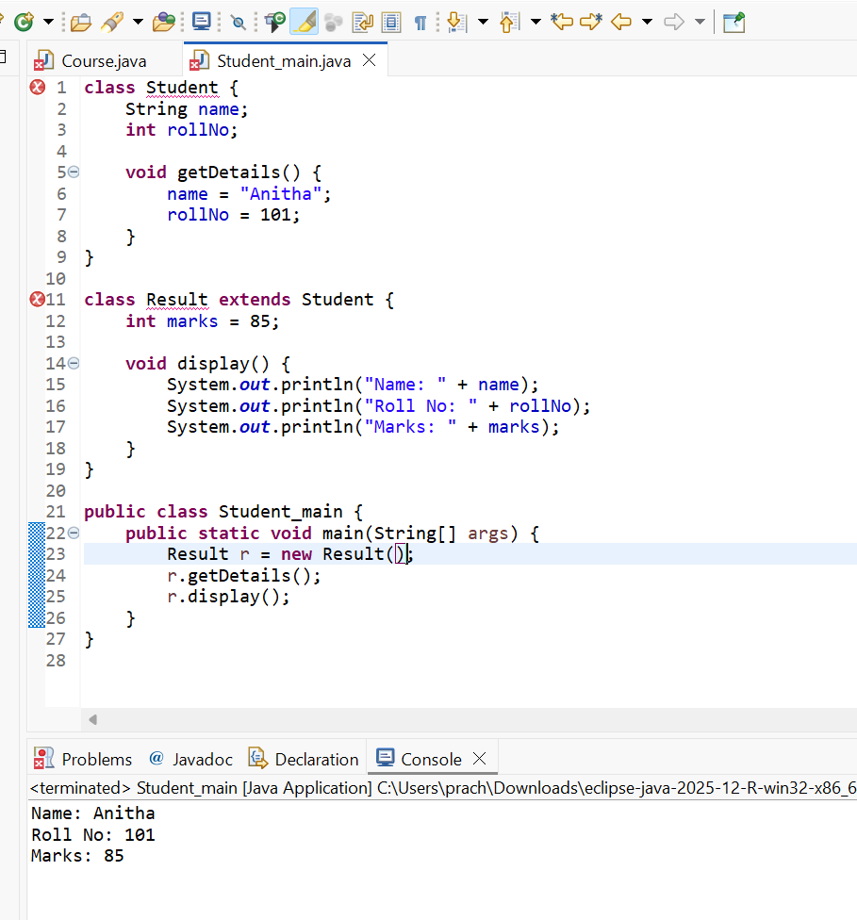

2. Bank Account System (Hierarchical Inheritance)
Question:
A bank has Savings and Current accounts. Both inherit from a common Account class.
Code:
class Account {
void showAccountType() {
System.out.println("Bank Account");
}
}

class SavingsAccount extends Account {
void interest() {
System.out.println("Savings Account gives interest");
}
}

class CurrentAccount extends Account {
void overdraft() {
System.out.println("Current Account supports overdraft");
}
}

public class Main {
public static void main(String[] args) {
SavingsAccount s = new SavingsAccount();
CurrentAccount c = new CurrentAccount();

s.showAccountType();
s.interest();

c.showAccountType();
c.overdraft();
}
}

Output:
Bank Account
Savings Account gives interest
Bank Account
Current Account supports overdraft
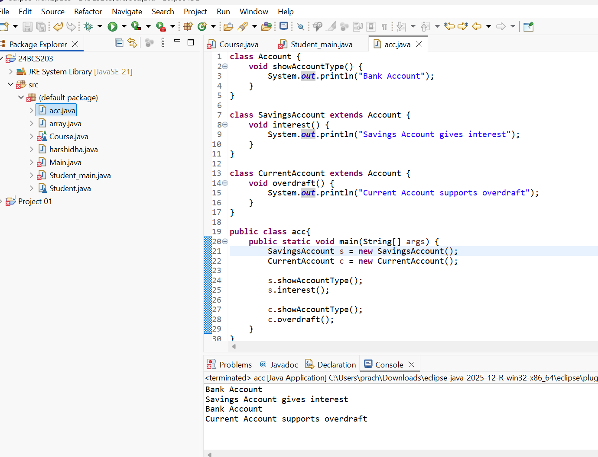

3. Vehicle System (Multilevel Inheritance)
Question:
A company classifies vehicles as Vehicle → Car → ElectricCar.
Code:
class Vehicle {
void start() {
System.out.println("Vehicle starts");
}
}

class Car extends Vehicle {
void fuelType() {
System.out.println("Car uses petrol");
}
}

class ElectricCar extends Car {
void battery() {
System.out.println("Electric car uses battery");
}
}

public class Main {
public static void main(String[] args) {
ElectricCar e = new ElectricCar();
e.start();
e.fuelType();
e.battery();
}
}
Output:
Vehicle starts
Car uses petrol
Electric car uses battery
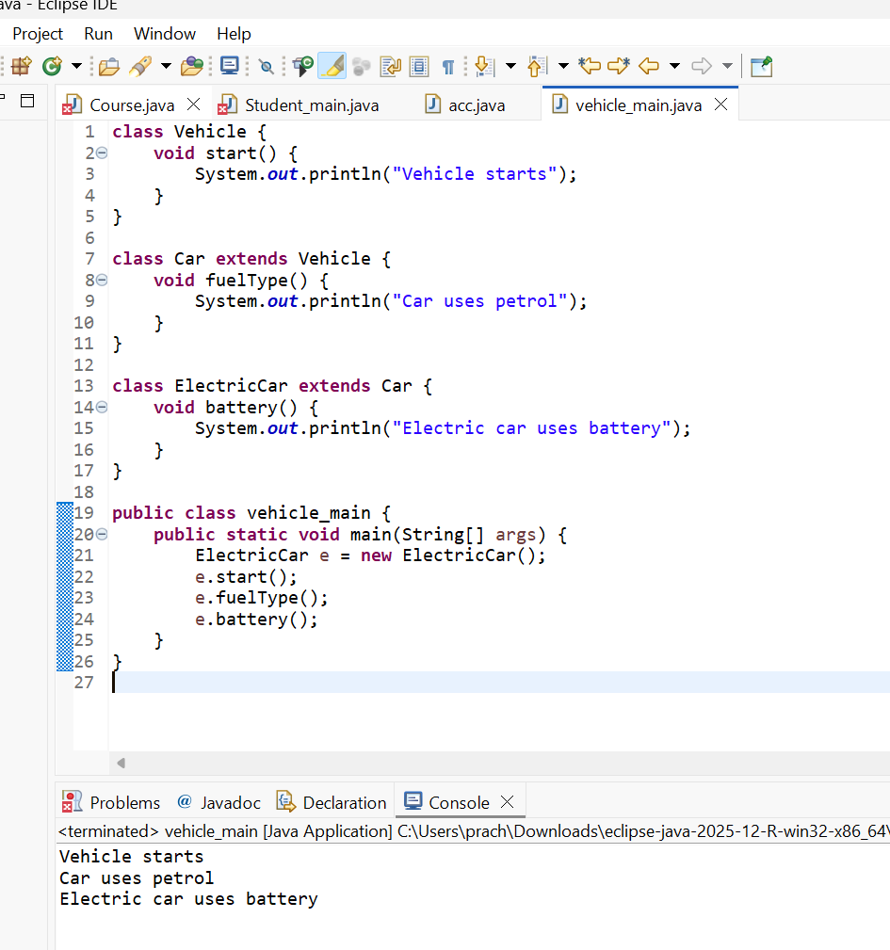
POST LAB EXERCISE
- Why Java does not support multiple inheritance using classes and how it is implemented?
Java does not support multiple inheritance using classes to avoid ambiguity and complexity, especially the diamond problem, where a class may inherit the same method from multiple parent classes and the compiler cannot decide which one to use. To achieve multiple inheritance in a safe way, Java uses interfaces, where a class can implement multiple interfaces without ambiguity.
- What is the role of the super keyword? Give examples.
The super keyword in Java is used to refer to the immediate parent class object. It is used to access parent class variables, methods, and constructors from the child class.
super.show();
super(value);
- Can a child class access private members of the parent class? Why?
No, a child class cannot directly access private members of the parent class because private members are restricted to the class in which they are declared. This ensures data hiding and security. However, private members can be accessed indirectly through public or protected methods of the parent class.
- Explain why hybrid inheritance is not supported in Java.
Hybrid inheritance is a combination of multiple and multilevel inheritance. Java does not support hybrid inheritance using classes because it can cause ambiguity and complexity due to multiple inheritance. However, hybrid inheritance can be achieved using interfaces, which provide a clear and conflict-free way of inheritance.
Result:

Thus the different types of inheritance were implemented and executed successfully.

ASSESSMENT

Description | Max Marks | Marks Awarded
Pre Lab Exercise | 5
In Lab Exercise | 10
Post Lab Exercise | 5
Viva | 10
Total | 30
Faculty Signature

