Experiment Number : 04 Date:

ARRAYS
Aim:
To understand and implement array operations in Java.
PRE LAB EXERCISE
QUESTIONS
- What is an array?
An array is a data structure that stores multiple values of the same data type in contiguous memory locations, all accessed using a single name and an index.
Example:
Instead of storing 5 marks in 5 different variables, you store them in one array.

- Why are arrays used?
Arrays are used because:
- They reduce code duplication
Without arrays, you’d need dozens of variables. That’s stupid and unscalable.
- They make data handling systematic
You can process large data sets using loops instead of repeating code.
- They improve performance
Direct index-based access is fast (O(1)).
- They simplify memory management
Data is stored sequentially, making traversal and computation efficient.
- They are the foundation of advanced structures
Lists, stacks, queues, matrices—all rely on arrays.

- What is the difference between array and variable?
- Aspect | - Variable | - Array
- Storage | - Stores one value | - Stores multiple values
- Data type | - Single value of a type | - Multiple values of the same type
- Memory | - One memory location | - Contiguous memory locations
- Access | - Direct by name | - By index (e.g., a[0])
- Use case | - Simple data | - Bulk data processing

IN LAB EXERCISE
Objective:
To perform array operations using simple programs.
PROGRAMS:
1. Program to Read and Print Array Elements
Code:
import java.util.Scanner;
public class ReadPrintArray {
public static void main(String[] args) {
Scanner sc = new Scanner(System.in);
int[] arr = new int[5];
System.out.println("Enter 5 elements:");
for(int i = 0; i < 5; i++)
arr[i] = sc.nextInt();
System.out.println("Array elements are:");
for(int i = 0; i < 5; i++)
System.out.print(arr[i] + " ");
}
}
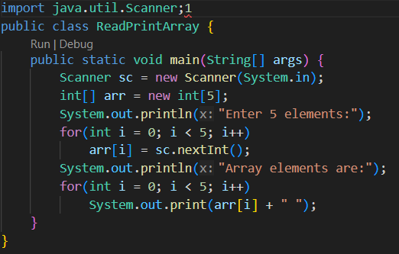
OUTPUT:
Input:
10 20 30 40 50
Output:
Array elements are:
10 20 30 40 50
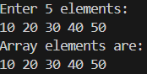

2. Program to Find Sum of Array Elements
Code:
import java.util.Scanner;
public class SumArray {
public static void main(String[] args) {
Scanner sc = new Scanner(System.in);
int[] arr = new int[5];
int sum = 0;
System.out.println("Enter 5 elements:");
for(int i = 0; i < 5; i++)
arr[i] = sc.nextInt();
for(int i = 0; i < 5; i++)
sum += arr[i];
System.out.println("Sum = " + sum);
}
}
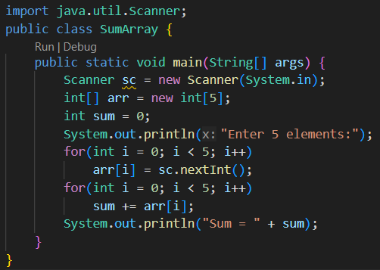
OUTPUT:
Input:
5 10 15 20 25
Output:
Sum = 75

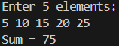

3. Program to Find Largest Element in an Array
Code:
import java.util.Scanner;
public class LargestElement {
public static void main(String[] args) {
Scanner sc = new Scanner(System.in);
int[] arr = new int[5];
System.out.println("Enter 5 elements:");
for(int i = 0; i < 5; i++)
arr[i] = sc.nextInt();
int max = arr[0];
for(int i = 1; i < 5; i++)
if(arr[i] > max)
max = arr[i];
System.out.println("Largest element = " + max);
}
}
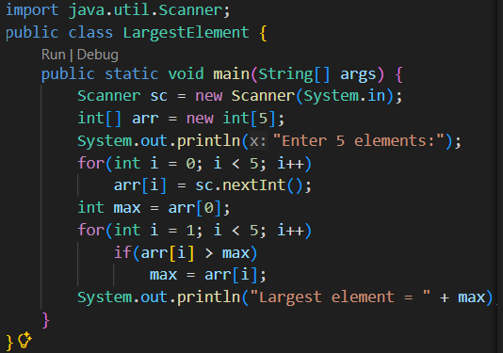
OUTPUT:
Input:
12 45 23 9 30
Output:
Largest element = 45
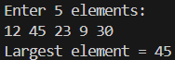

4. Program to Reverse an Array
Code:
import java.util.Scanner;

public class ReverseArray {
public static void main(String[] args) {
Scanner sc = new Scanner(System.in);
int[] arr = new int[5];
System.out.println("Enter 5 elements:");
for(int i = 0; i < 5; i++)
arr[i] = sc.nextInt();
System.out.println("Reversed array:");
for(int i = 4; i >= 0; i--)
System.out.print(arr[i] + " ");
}
}
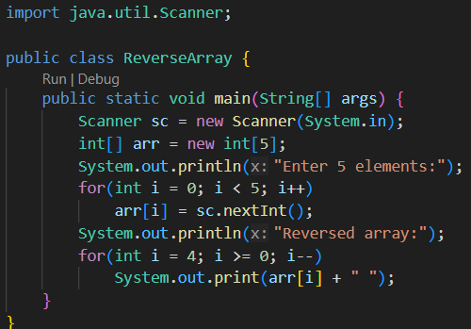
OUTPUT:
Input:
1 2 3 4 5
Output:
Reversed array:
5 4 3 2 1
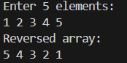

5. Program to Count Even and Odd Numbers
Code:
import java.util.Scanner;
public class EvenOddCount {
public static void main(String[] args) {
Scanner sc = new Scanner(System.in);
int[] arr = new int[5];
int even = 0, odd = 0;
System.out.println("Enter 5 elements:");
for(int i = 0; i < 5; i++)
arr[i] = sc.nextInt();
for(int i = 0; i < 5; i++) {
if(arr[i] % 2 == 0)
even++;
else
odd++;
}

System.out.println("Even = " + even);
System.out.println("Odd = " + odd);
}
}
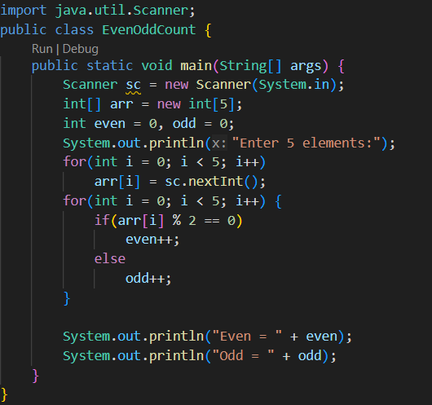
OUTPUT:
Input:
2 7 4 9 10
Output:
Even = 3
Odd = 2
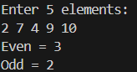

6. Program to Sort Array in Ascending Order
Code:
import java.util.Scanner;
public class SortArray {
public static void main(String[] args) {
Scanner sc = new Scanner(System.in);
int[] arr = new int[5];
int temp;
System.out.println("Enter 5 elements:");
for(int i = 0; i < 5; i++)
arr[i] = sc.nextInt();
for(int i = 0; i < 5; i++) {
for(int j = i + 1; j < 5; j++) {
if(arr[i] > arr[j]) {
temp = arr[i];
arr[i] = arr[j];
arr[j] = temp;
}
}
}
System.out.println("Sorted array:");
for(int i = 0; i < 5; i++)
System.out.print(arr[i] + " ");
}
}
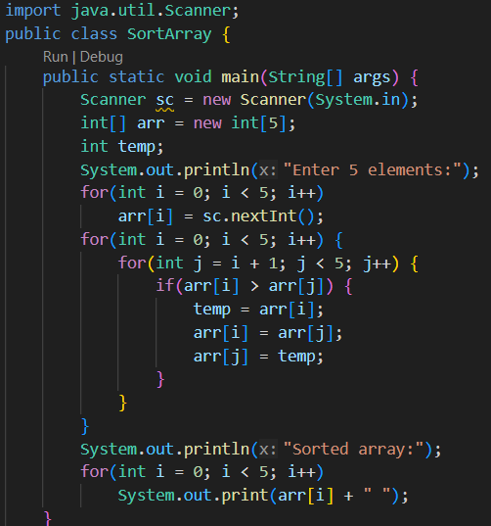

OUTPUT:
Input:
45 12 78 23 9
Output:
Sorted array:
9 12 23 45 78
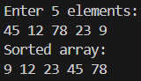

7. Program to Find Second Largest Element
Code:
import java.util.Scanner;
public class SecondLargest {
public static void main(String[] args) {
Scanner sc = new Scanner(System.in);
int[] arr = new int[5];

System.out.println("Enter 5 elements:");
for(int i = 0; i < 5; i++)
arr[i] = sc.nextInt();
int largest = arr[0];
int second = arr[0];
for(int i = 0; i < 5; i++) {
if(arr[i] > largest) {
second = largest;
largest = arr[i];
}
}
System.out.println("Second largest = " + second);
}
} 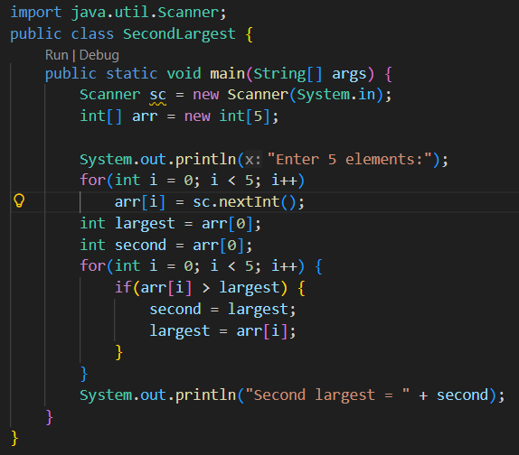
OUTPUT:
Input:
10 45 23 89 67
Output:
Second largest = 67
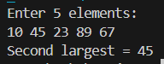

8. Program for Matrix Addition (2D Array)
Code:
import java.util.Scanner;
public class MatrixAddition {
public static void main(String[] args) {
Scanner sc = new Scanner(System.in);
int[][] a = new int[2][2];
int[][] b = new int[2][2];
int[][] sum = new int[2][2];
System.out.println("Enter elements of matrix A:");
for(int i = 0; i < 2; i++)
for(int j = 0; j < 2; j++)
a[i][j] = sc.nextInt();
System.out.println("Enter elements of matrix B:");
for(int i = 0; i < 2; i++)
for(int j = 0; j < 2; j++)
b[i][j] = sc.nextInt();
for(int i = 0; i < 2; i++)
for(int j = 0; j < 2; j++)
sum[i][j] = a[i][j] + b[i][j];
System.out.println("Sum matrix:");
for(int i = 0; i < 2; i++) {
for(int j = 0; j < 2; j++)
System.out.print(sum[i][j] + " ");
System.out.println();
}
}
}

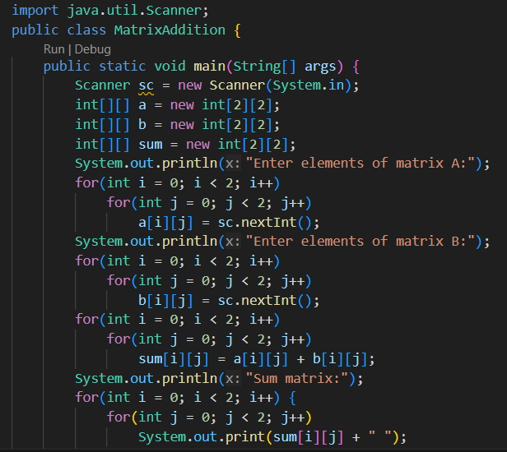

OUTPUT:
Matrix A:
1 2
3 4
Matrix B:
5 6
7 8
Sum matrix:
6 8
10 12
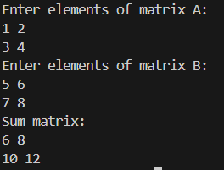

POST LAB EXERCISE
- Why is array indexing usually started from zero instead of one?
Java follows the same memory-offset logic as C/C++.
In Java:
- An array variable stores a reference to the first element
- Index 0 means no offset
- Index i means offset of i × size
Even though Java hides raw memory, the JVM itself is built on zero-based addressing, so zero indexing is faster and simpler internally.
This is not optional or configurable in Java.

- What happens if we try to access an array element outside its declared size?
If you do this:
int[] a = new int[5];
a[5] = 10;
Java throws:
ArrayIndexOutOfBoundsException
Key difference from C/C++:
- Java fails fast
- Prevents memory corruption
- Program stops unless handled
This is one reason Java is safer but slightly slower.

- How does memory allocation differ for static arrays and dynamic arrays?
Java does NOT have true static or dynamic arrays like C/C++.
In Java:
- All arrays are created dynamically at runtime
- Size is fixed after creation
Example:
int[] a = new int[10]; // runtime allocation
Comparison in Java context:
Aspect | Java Array | ArrayList
Size | Fixed | Resizable
Memory | Heap | Heap
Access | Fast (index-based) | Slightly slower
Flexibility | Low | High

- Why is searching faster in arrays compared to linked lists?
Because arrays support random access, linked lists don’t.
In Java:
- Array: a[i] → direct access → O(1)
- LinkedList: traversal needed → O(n)
Also:
- Arrays are cache-friendly
- LinkedList nodes are scattered in heap memory
Even Java’s own documentation admits:
ArrayList is faster than LinkedList for most operations.

- What is the difference between contiguous and non-contiguous memory allocation?
Aspect | Contiguous | Non-contiguous
Memory layout | Sequential | Scattered
Java example | Arrays, ArrayList | LinkedList
Access speed | Faster | Slower
Cache usage | Efficient | Poor
Pointer/reference overhead | None | High

Result:

Thus the array operations were executed successfully.

ASSESSMENT

Description | Max Marks | Marks Awarded
Pre Lab Exercise | 5
In Lab Exercise | 10
Post Lab Exercise | 5
Viva | 10
Total | 30
Faculty Signature

