Experiment Number : 01 Date: 28/12/2026

Installation of Java and Simple Java Programs
Aim:
To install Java Development Kit (JDK), configure the environment, and write simple Java programs including Hello World.
PRE LAB EXERCISE
QUESTIONS
- What is JDK and why is it required?
Answer:
JDK (Java Development Kit) is a software package used to develop Java applications. It includes tools required to write, compile, debug, and run Java programs.
Why it is required:
  - To compile Java source code into bytecode
  - To run Java programs
  - To develop Java applications using tools like:
◦ javac (compiler)
◦ java (interpreter)
◦ debugger and other utilities
- Difference between JDK, JRE, and JVM
Feature | JDK | JRE | JVM
Full form | Java Development Kit | Java Runtime Environment | Java Virtual Machine
Purpose | Develop and run Java programs | Run Java programs | Executes Java bytecode
Contains | JRE + development tools | JVM + libraries | Only execution
Used by | Programmers | Users | engine System
Can compile code? | Yes | No | No
- What is the purpose of the main() method in Java?
Answer:
The main() method is the starting point of execution of any Java program.
Purpose:
  - It tells the JVM where the program starts
  - Without main() method, the program will not execute Syntax:
public static void main(String[] args)
IN LAB EXERCISE
Objective:
To verify Java installation and execute a basic Java program.
INSTALLATION STEPS:
STEP 1: Open Browser
  - Open your browser and go to the official URL Eclipse Downloads page.

STEP 2: Download Eclipse Installer
  - Then, click on the "Download" button to download Eclipse IDE.

STEP 3: Download EXE
  - Now, click on the "Download x86_64" button.
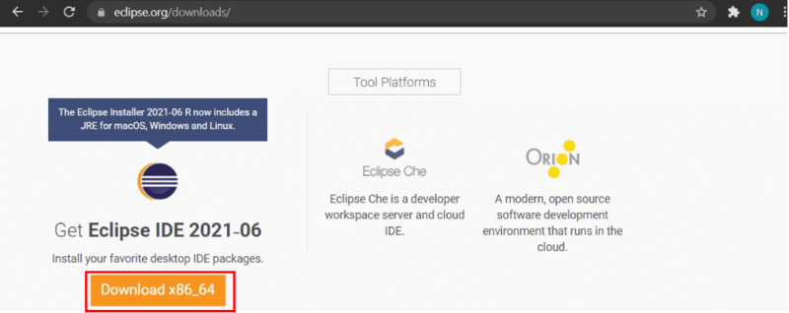
STEP 4: Then click on the "Download" button. After clicking on the download button the .exe file for the eclipse will be downloaded.
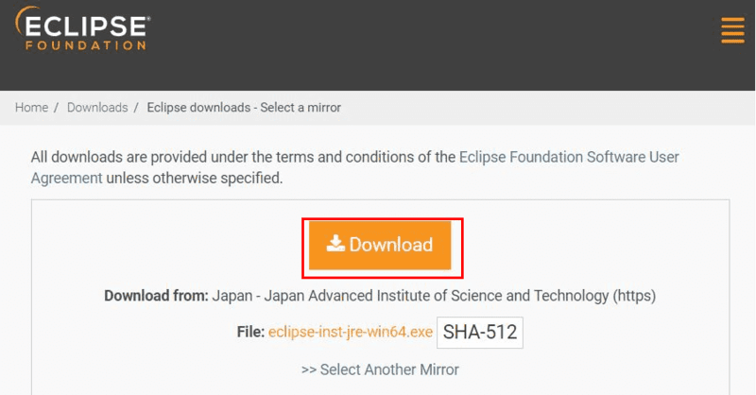
STEP 5: Open Download EXE
  - Now go to File Explorer and click on "Downloads" after that click on the "eclipse-inst-jrewin64.exe" file for installing Eclipse IDE.
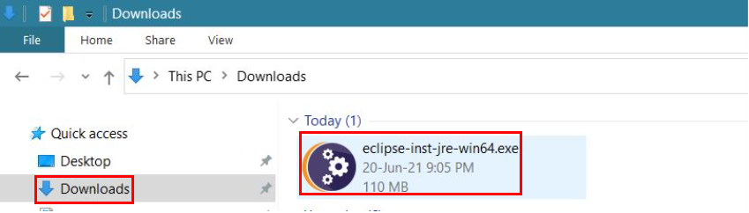
STEP 6: Install Eclipse
  - Then, click on "Eclipse IDE for Java Developers".
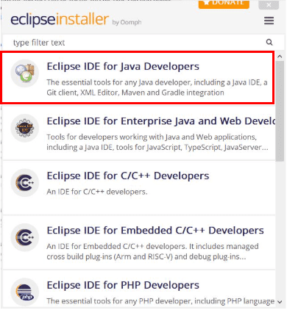
STEP 7: Then, click on the "Install" button.
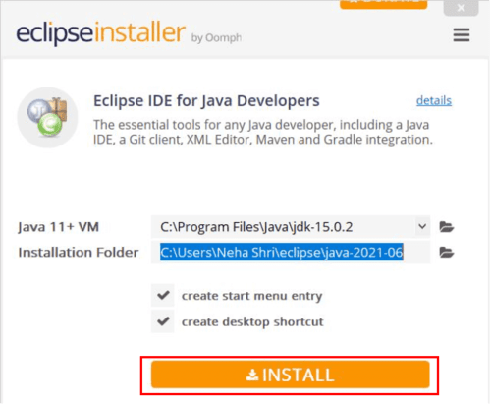
Step 8: Create New Project
Now click on "Create a new Java project".
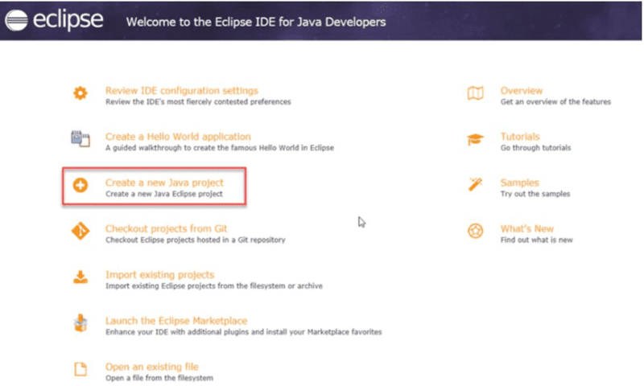
STEP 9:Create a new java project
  - By clicking on the File menu and choosing New → Java Project.
  - By right clicking anywhere in the Project Explorer and selecting New → Java Project.
  - By clicking on the New button ( ) in the Tool bar and selecting Java Project. STEP 10: Enter the Project Name
  - Select the Java Runtime Environment (JRE) or leave it at the default
  - Select the Project Layout which determines whether there would be a separate folder for the source codes and class files. The recommended option is to create separate folders for sources and class files.
  - 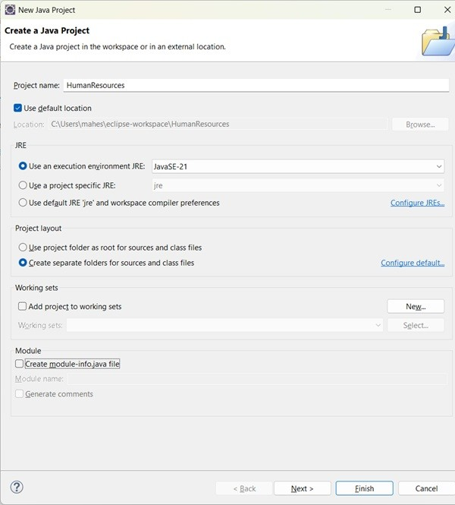
STEP 11: Create a new java package
  - By clicking on the File menu and selecting New → Package.
  - By right click in the package explorer and selecting New → Package.
  - By clicking on the package icon which is in the tool bar( ).
STEP 11:
  - Enter/confirm the source folder name.
  - Enter the package name.
  - Click on the Finish button.
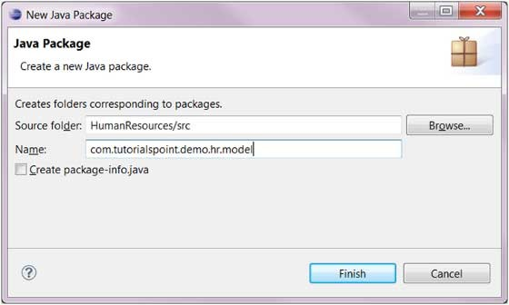
STEP 12:Create a New Java class.
  - By clicking on the File menu and selecting New → Class.
  - By right clicking in the package explorer and selecting New → Class.
  - By clicking on the class drop down button ( ) and selecting class ( ).
STEP 13:
  - Ensure the source folder and package are correct.
  - Enter the class name.
  - Select the appropriate class modifier.
  - Enter the super class name or click on the Browse button to search for an existing class.
  - Click on the Add button to select the interfaces implemented by this class.
  - Examine and modify the check boxes related to method stubs and comments.
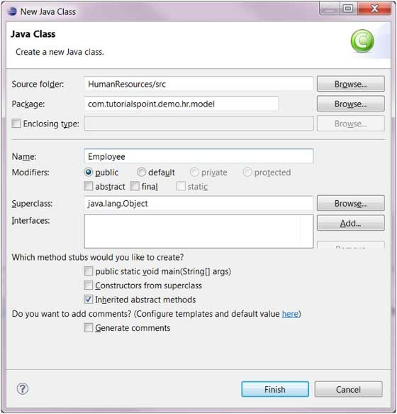
STEP 14: Class created successfully.
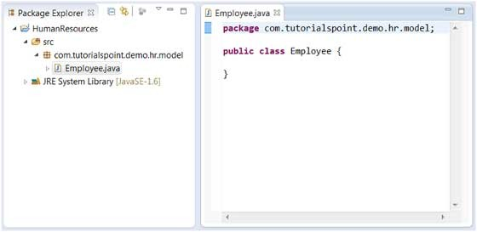
BASIC PROGRAMS:
Program 1: Hello World Program Source Code: class HelloWorld { public static void main(String[] args) {
System.out.println("Hello World");
}
}
Output:
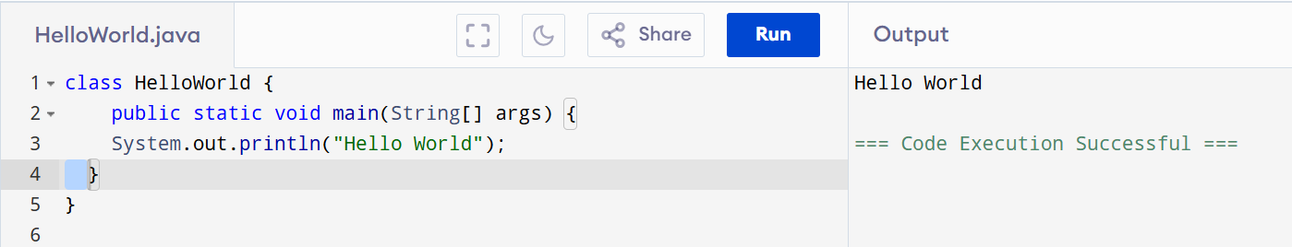
Program 2: Display Personal Details Source Code: class DisplayInfo { public static void main(String[] args) { System.out.println("Name: Pranusree SA");
System.out.println("Age: 20");
}
}
Output:
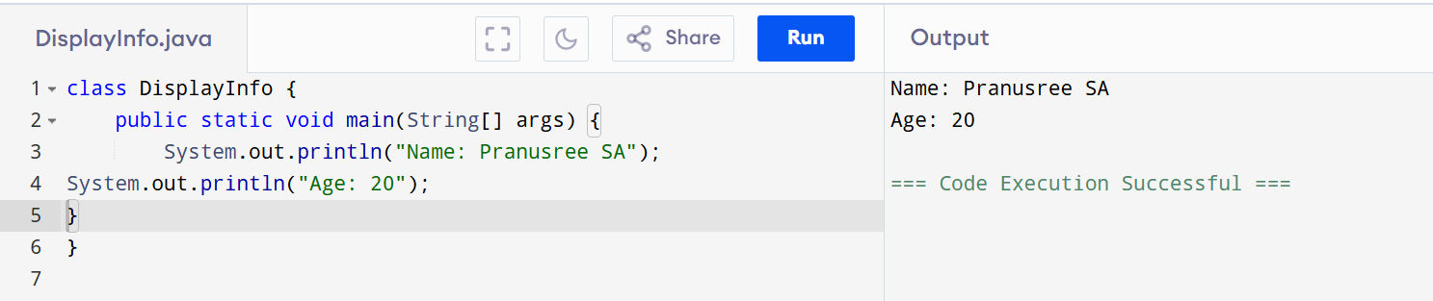
Program 3: Addition of Two Numbers Source Code: class AddTwoNumbers {
public static void main(String[] args) { int a = 17, b = 89;
System.out.println("Sum = " + (a + b));
}
}
Output:
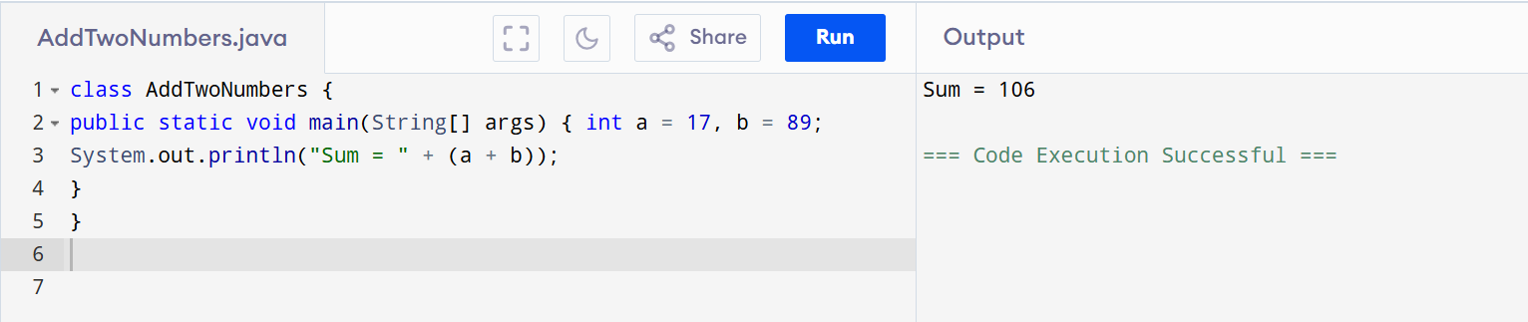
Program 4: Area of a Rectangle Source Code:
class AreaRectangle { public static void main(String[] args) { int length = 56, breadth = 20;
System.out.println("Area = " + (length * breadth));
}
}
Output:
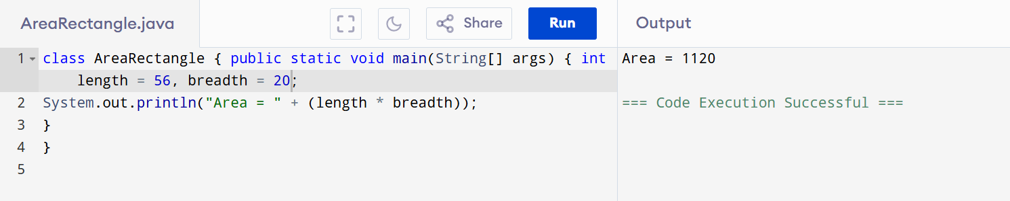
Program 5: Simple Interest Calculation Source Code: class SimpleInterest { public static void main(String[] args) { int p = 2000; int r = 3; int t = 7; int si = (p * r * t) / 100;
System.out.println("Simple Interest = " + si);
}
}
Output:
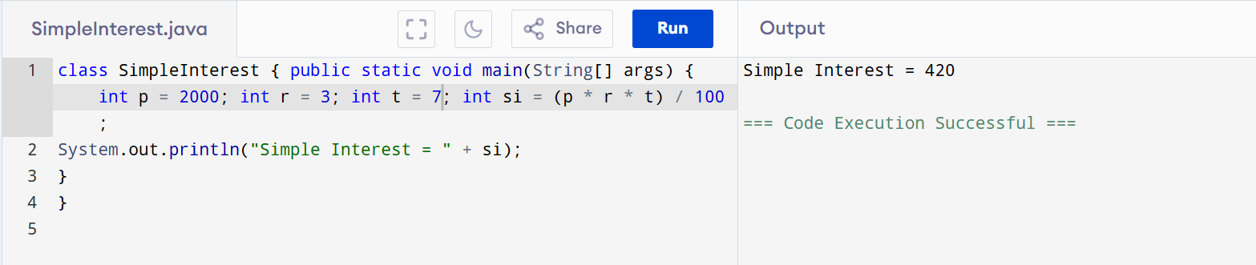
POST LAB EXERCISE
- Write a Java program to display your name and department.
Program:
class DisplayDetails {
public static void main(String[] args) { System.out.println("Name: Pranusree SA");
System.out.println("Department: Computer Science");
} }
Output:
Name: Pranusree SA
Department: Computer Science
- Modify the program to print the output in the same line.
Program:
class DisplayDetailsSameLine { public static void main(String[] args) {
System.out.print("Name: Pranusree SA");
System.out.print("Department: Computer Science");
}
}
Output:
Name: Pranusree SA Department: Computer Science 3. What happens if main() is written without static?
Answer:
If the main() method is written without static, the program will not run.
Reason:
- The JVM calls main() without creating an object.
- A non-static method requires an object.
- Hence, JVM throws an error and execution fails.
- Why is Java called platform independent?
Answer:
Java is called platform independent because Java programs can run on any operating system without modification.
Reason:
  - Java source code is compiled into bytecode.
  - Bytecode runs on JVM, which is available for different platforms (Windows, Linux, macOS).
  - Hence, Java follows the principle: “Write Once, Run Anywhere.”
- Write a program to find the cube of a number.
Program:
class CubeNumber {
public static void main(String[] args) { int num = 5;
int cube = num * num * num; System.out.println("Cube = " + cube);
} }
Output: Cube = 125
Result:
Thus the Java IDE was successfully installed and a simple Java program was executed.
ASSESSMENT
Description |  | Max Marks | Marks Awarded
Pre Lab Exercise |  | 5
In Lab Exercise |  | 10
Post Lab Exercise |  | 5
Viva |  | 10
 | Total | 30
 |  | Faculty Signature

