Experiment Number : 04 Date: 05/02/2026

ARRAYS
Aim:

To understand and implement array operations in Java.

PRE LAB EXERCISE

QUESTIONS

- What is an array?
An array is a collection of elements of the same data type stored in contiguous memory locations. Each element can be accessed using an index value.

- Why are arrays used?
Arrays are used to:
Store multiple values of the same type using a single variable
Reduce code complexity
Allow fast access to elements using index
Improve memory organization and efficiency

- What is the difference between array and variable?
Variable | Array

Stores only one value | Stores multiple values

Uses a single memory location | Uses multiple contiguous memory locations

Accessed by variable name | Accessed using index

Simple data storage | Used for bulk data handling

IN LAB EXERCISE
Objective:
To perform array operations using simple programs.
PROGRAMS:
1. Program to Read and Print Array Elements
Code:
import java.util.Scanner;
public class ReadPrintArray {
public static void main(String[] args) {
Scanner sc = new Scanner(System.in);
int[] arr = new int[5];
System.out.println("Enter 5 elements:");
for(int i = 0; i < 5; i++)
arr[i] = sc.nextInt();
System.out.println("Array elements are:");
for(int i = 0; i < 5; i++)
System.out.print(arr[i] + " ");
}
}
OUTPUT:
Input:
10 20 30 40 50
Output:
Array elements are:
10 20 30 40 50

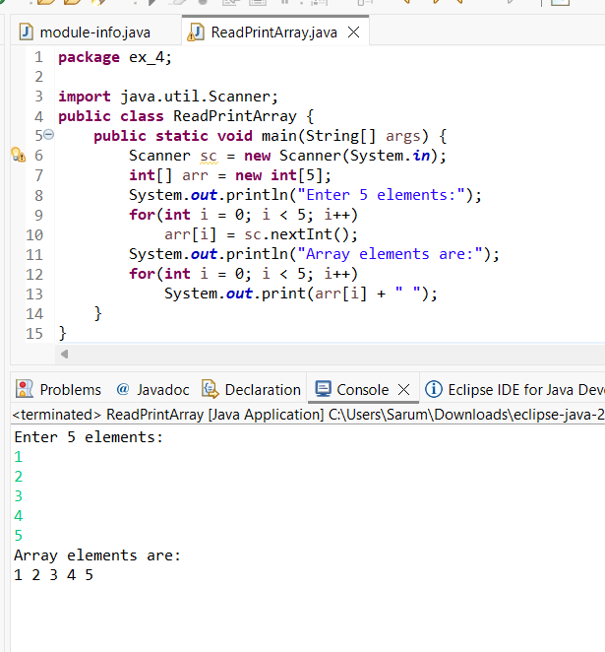

2. Program to Find Sum of Array Elements
Code:
import java.util.Scanner;
public class SumArray {
public static void main(String[] args) {
Scanner sc = new Scanner(System.in);
int[] arr = new int[5];
int sum = 0;
System.out.println("Enter 5 elements:");
for(int i = 0; i < 5; i++)
arr[i] = sc.nextInt();
for(int i = 0; i < 5; i++)
sum += arr[i];
System.out.println("Sum = " + sum);
}
}
OUTPUT:
Input:
5 10 15 20 25
Output:
Sum = 75

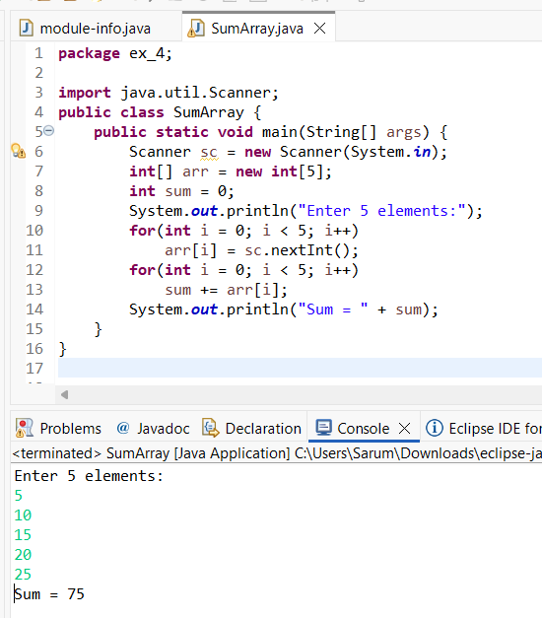

3. Program to Find Largest Element in an Array
Code:
import java.util.Scanner;
public class LargestElement {
public static void main(String[] args) {
Scanner sc = new Scanner(System.in);
int[] arr = new int[5];
System.out.println("Enter 5 elements:");
for(int i = 0; i < 5; i++)
arr[i] = sc.nextInt();
int max = arr[0];
for(int i = 1; i < 5; i++)
if(arr[i] > max)
max = arr[i];
System.out.println("Largest element = " + max);
}
}
OUTPUT:
Input:
12 45 23 9 30
Output:
Largest element = 45
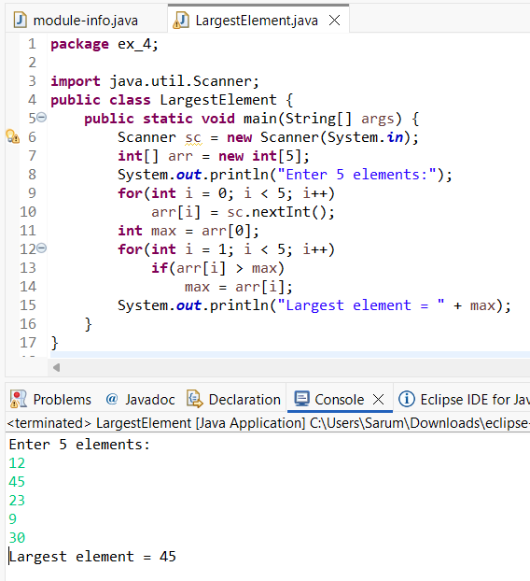

4. Program to Reverse an Array
Code:
import java.util.Scanner;

public class ReverseArray {
public static void main(String[] args) {
Scanner sc = new Scanner(System.in);
int[] arr = new int[5];
System.out.println("Enter 5 elements:");
for(int i = 0; i < 5; i++)
arr[i] = sc.nextInt();
System.out.println("Reversed array:");
for(int i = 4; i >= 0; i--)
System.out.print(arr[i] + " ");
}
}
OUTPUT:
Input:
1 2 3 4 5
Output:
Reversed array:
5 4 3 2 1

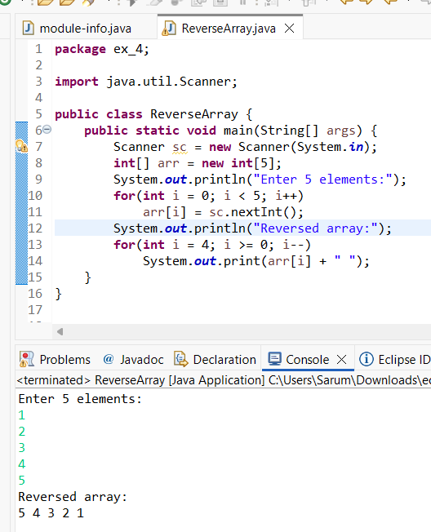

5. Program to Count Even and Odd Numbers
Code:
import java.util.Scanner;
public class EvenOddCount {
public static void main(String[] args) {
Scanner sc = new Scanner(System.in);
int[] arr = new int[5];
int even = 0, odd = 0;
System.out.println("Enter 5 elements:");
for(int i = 0; i < 5; i++)
arr[i] = sc.nextInt();
for(int i = 0; i < 5; i++) {
if(arr[i] % 2 == 0)
even++;
else
odd++;
}

System.out.println("Even = " + even);
System.out.println("Odd = " + odd);
}
}
OUTPUT:
Input:
2 7 4 9 10
Output:
Even = 3
Odd = 2

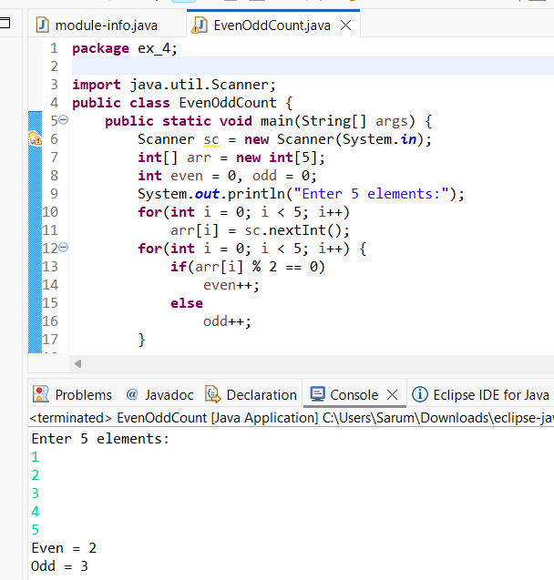

6. Program to Sort Array in Ascending Order
Code:
import java.util.Scanner;
public class SortArray {
public static void main(String[] args) {
Scanner sc = new Scanner(System.in);
int[] arr = new int[5];
int temp;
System.out.println("Enter 5 elements:");
for(int i = 0; i < 5; i++)
arr[i] = sc.nextInt();
for(int i = 0; i < 5; i++) {
for(int j = i + 1; j < 5; j++) {
if(arr[i] > arr[j]) {
temp = arr[i];
arr[i] = arr[j];
arr[j] = temp;
}
}
}
System.out.println("Sorted array:");
for(int i = 0; i < 5; i++)
System.out.print(arr[i] + " ");
}
}
OUTPUT:
Input:
45 12 78 23 9
Output:
Sorted array:
9 12 23 45 78

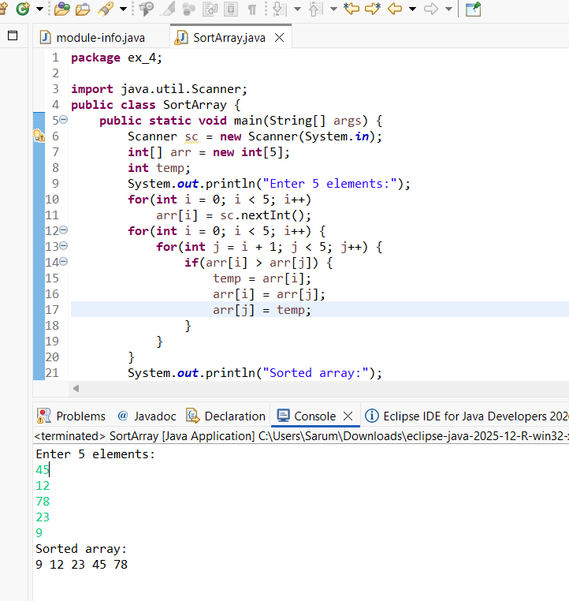

7. Program to Find Second Largest Element
Code:
import java.util.Scanner;
public class SecondLargest {
public static void main(String[] args) {
Scanner sc = new Scanner(System.in);
int[] arr = new int[5];

System.out.println("Enter 5 elements:");
for(int i = 0; i < 5; i++)
arr[i] = sc.nextInt();
int largest = arr[0];
int second = arr[0];
for(int i = 0; i < 5; i++) {
if(arr[i] > largest) {
second = largest;
largest = arr[i];
}
}
System.out.println("Second largest = " + second);
}
}
OUTPUT:
Input:
10 45 23 89 67
Output:
Second largest = 67

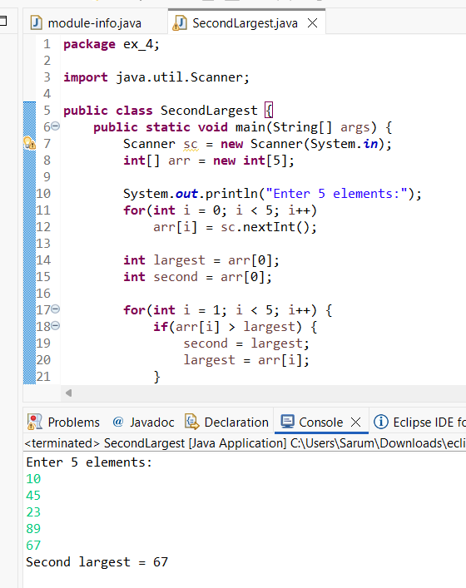

8. Program for Matrix Addition (2D Array)
Code:
import java.util.Scanner;
public class MatrixAddition {
public static void main(String[] args) {
Scanner sc = new Scanner(System.in);
int[][] a = new int[2][2];
int[][] b = new int[2][2];
int[][] sum = new int[2][2];
System.out.println("Enter elements of matrix A:");
for(int i = 0; i < 2; i++)
for(int j = 0; j < 2; j++)
a[i][j] = sc.nextInt();
System.out.println("Enter elements of matrix B:");
for(int i = 0; i < 2; i++)
for(int j = 0; j < 2; j++)
b[i][j] = sc.nextInt();
for(int i = 0; i < 2; i++)
for(int j = 0; j < 2; j++)
sum[i][j] = a[i][j] + b[i][j];
System.out.println("Sum matrix:");
for(int i = 0; i < 2; i++) {
for(int j = 0; j < 2; j++)
System.out.print(sum[i][j] + " ");
System.out.println();
}
}
}
OUTPUT:
Matrix A:
1 2
3 4
Matrix B:
5 6
7 8
Sum matrix:
6 8
10 12

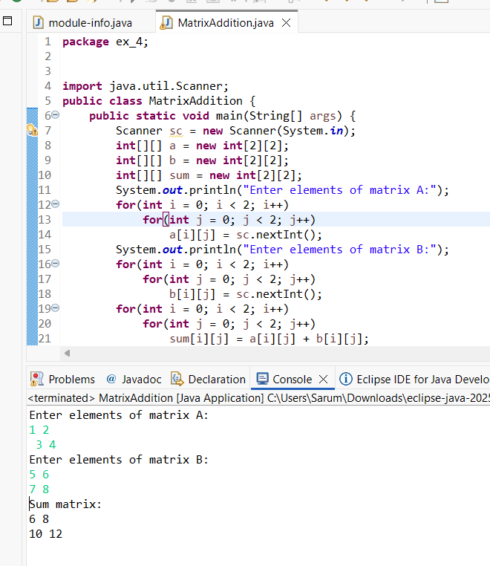

POST LAB EXERCISE
- Why is array indexing usually started from zero instead of one?
Array indexing starts from zero because the index represents the offset from the base memory address. The first element is stored at the base address itself, so its offset is zero.

- What happens if we try to access an array element outside its declared size?
If we access an array element outside its size, Java throws an
ArrayIndexOutOfBoundsException at runtime.

- How does memory allocation differ for static arrays and dynamic arrays?
Static arrays: Size is fixed at compile time and cannot be changed.
Dynamic arrays: Size is decided at runtime and can be changed (e.g., using ArrayList).

- Why is searching faster in arrays compared to linked lists?
Arrays support direct access using index, so elements can be accessed in O(1) time.
Linked lists require sequential traversal, which takes more time.

- What is the difference between contiguous and non-contiguous memory allocation?
Contiguous Memory | Non-Contiguous Memory

Memory blocks are adjacent | Memory blocks are scattered

Used in arrays | Used in linked lists

Faster access | Slower access

Fixed size | Dynamic size

Result:

Thus the array operations were executed successfully.

ASSESSMENT

Description | Max Marks | Marks Awarded
Pre Lab Exercise | 5
In Lab Exercise | 10
Post Lab Exercise | 5
Viva | 10
Total | 30
Faculty Signature

