Experiment Number : 04 Date: 4/2/25

ARRAYS
Aim:
To understand and implement array operations in Java.
PRE LAB EXERCISE
QUESTIONS
- What is an array?
An array is a collection of elements of the same data type stored in continuous memory locations and accessed using an index number.
- Why are arrays used?
Arrays are used to:
- Store multiple values of the same type in one variable
- Reduce the need for many separate variables
- Make data handling and processing easier
- Allow easy access using index positions
- Support looping and bulk operations

- What is the difference between array and variable?
Feature | Variable | Array
Stores | Single value | Multiple values
Data type | One value of a type | Many values of same type
Memory | One memory location | Continuous memory locations
Access | Direct name | Index number
Example | int x = 5; | int arr[5];

IN LAB EXERCISE
Objective:
To perform array operations using simple programs.
PROGRAMS:
1. Program to Read and Print Array Elements
Code:
import java.util.Scanner;
public class ReadPrintArray {
public static void main(String[] args) {
Scanner sc = new Scanner(System.in);
int[] arr = new int[5];
System.out.println("Enter 5 elements:");
for(int i = 0; i < 5; i++)
arr[i] = sc.nextInt();
System.out.println("Array elements are:");
for(int i = 0; i < 5; i++)
System.out.print(arr[i] + " ");
}
}
OUTPUT:
Input:
10 20 30 40 50
Output:
Array elements are:
10 20 30 40 50
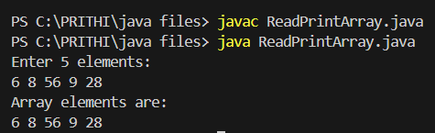

2. Program to Find Sum of Array Elements
Code:
import java.util.Scanner;
public class SumArray {
public static void main(String[] args) {
Scanner sc = new Scanner(System.in);
int[] arr = new int[5];
int sum = 0;
System.out.println("Enter 5 elements:");
for(int i = 0; i < 5; i++)
arr[i] = sc.nextInt();
for(int i = 0; i < 5; i++)
sum += arr[i];
System.out.println("Sum = " + sum);
}
}
OUTPUT:
Input:
5 10 15 20 25
Output:
Sum = 75
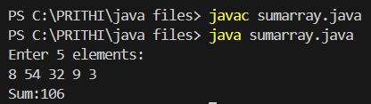
3. Program to Find Largest Element in an Array
Code:
import java.util.Scanner;
public class LargestElement {
public static void main(String[] args) {
Scanner sc = new Scanner(System.in);
int[] arr = new int[5];
System.out.println("Enter 5 elements:");
for(int i = 0; i < 5; i++)
arr[i] = sc.nextInt();
int max = arr[0];
for(int i = 1; i < 5; i++)
if(arr[i] > max)
max = arr[i];
System.out.println("Largest element = " + max);
}
}
OUTPUT:
Input:
12 45 23 9 30
Output:
Largest element = 45
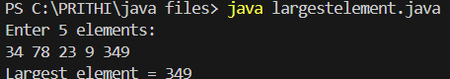
4. Program to Reverse an Array
Code:
import java.util.Scanner;
public class ReverseArray {
public static void main(String[] args) {
Scanner sc = new Scanner(System.in);
int[] arr = new int[5];
System.out.println("Enter 5 elements:");
for(int i = 0; i < 5; i++)
arr[i] = sc.nextInt();
System.out.println("Reversed array:");
for(int i = 4; i >= 0; i--)
System.out.print(arr[i] + " ");
}
}
OUTPUT:
Input:
1 2 3 4 5
Output:
Reversed array:
5 4 3 2 1

5. Program to Count Even and Odd Numbers
Code:
import java.util.Scanner;
public class EvenOddCount {
public static void main(String[] args) {
Scanner sc = new Scanner(System.in);
int[] arr = new int[5];
int even = 0, odd = 0;
System.out.println("Enter 5 elements:");
for(int i = 0; i < 5; i++)
arr[i] = sc.nextInt();
for(int i = 0; i < 5; i++) {
if(arr[i] % 2 == 0)
even++;
else
odd++;
}

System.out.println("Even = " + even);
System.out.println("Odd = " + odd);
}
}
OUTPUT:
Input:
2 7 4 9 10
Output:
Even = 3
Odd = 2

6. Program to Sort Array in Ascending Order
Code:
import java.util.Scanner;
public class SortArray {
public static void main(String[] args) {
Scanner sc = new Scanner(System.in);
int[] arr = new int[5];
int temp;
System.out.println("Enter 5 elements:");
for(int i = 0; i < 5; i++)
arr[i] = sc.nextInt();
for(int i = 0; i < 5; i++) {
for(int j = i + 1; j < 5; j++) {
if(arr[i] > arr[j]) {
temp = arr[i];
arr[i] = arr[j];
arr[j] = temp;
}
}
}
System.out.println("Sorted array:");
for(int i = 0; i < 5; i++)
System.out.print(arr[i] + " ");
}
}
OUTPUT:
Input:
45 12 78 23 9
Output:
Sorted array:
9 12 23 45 78
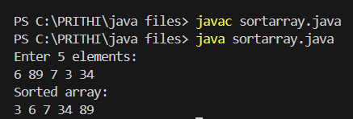
7. Program to Find Second Largest Element
Code:
import java.util.Scanner;
public class SecondLargest {
public static void main(String[] args) {
Scanner sc = new Scanner(System.in);
int[] arr = new int[5];

System.out.println("Enter 5 elements:");
for(int i = 0; i < 5; i++)
arr[i] = sc.nextInt();
int largest = arr[0];
int second = arr[0];
for(int i = 0; i < 5; i++) {
if(arr[i] > largest) {
second = largest;
largest = arr[i];
}
}
System.out.println("Second largest = " + second);
}
}
OUTPUT:
Input:
10 45 23 89 67
Output:
Second largest = 67
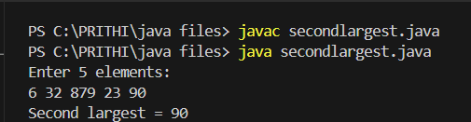
8. Program for Matrix Addition (2D Array)
Code:
import java.util.Scanner;
public class MatrixAddition {
public static void main(String[] args) {
Scanner sc = new Scanner(System.in);
int[][] a = new int[2][2];
int[][] b = new int[2][2];
int[][] sum = new int[2][2];
System.out.println("Enter elements of matrix A:");
for(int i = 0; i < 2; i++)
for(int j = 0; j < 2; j++)
a[i][j] = sc.nextInt();
System.out.println("Enter elements of matrix B:");
for(int i = 0; i < 2; i++)
for(int j = 0; j < 2; j++)
b[i][j] = sc.nextInt();
for(int i = 0; i < 2; i++)
for(int j = 0; j < 2; j++)
sum[i][j] = a[i][j] + b[i][j];
System.out.println("Sum matrix:");
for(int i = 0; i < 2; i++) {
for(int j = 0; j < 2; j++)
System.out.print(sum[i][j] + " ");
System.out.println();
}
}
}
OUTPUT:
Matrix A:
1 2
3 4
Matrix B:
5 6
7 8
Sum matrix:
6 8
10 12
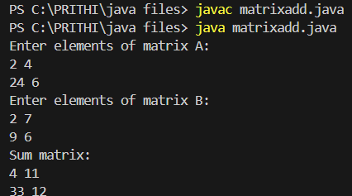

POST LAB EXERCISE
- Why is array indexing usually started from zero instead of one?
Index represents the offset from the first memory location, so the first element has offset 0.This makes address calculation simple and efficient.
- What happens if we try to access an array element outside its declared size?
It causes an out-of-bounds error or exception in most languages.In low-level languages, it may return garbage value or crash the program.
- How does memory allocation differ for static arrays and dynamic arrays?
Static Array | Dynamic Array
Memory allocated at compile time | Memory allocated at runtime
Size is fixed | Size can be changed
Stored usually in stack | Stored in heap
Cannot grow/shrink | Can resize

- Why is searching faster in arrays compared to linked lists?
Arrays allow direct access using index (O(1)) while Linked lists require sequential traversal (O(n)).
- What is the difference between contiguous and non-contiguous memory allocation?
Contiguous Memory | Non-Contiguous Memory
Stored in adjacent memory locations | Stored in scattered locations
Faster access | Slower access
Used by arrays | Used by linked lists
Easy address calculation | Requires pointers/links

Result:

Thus the array operations were executed successfully.

ASSESSMENT

Description | Max Marks | Marks Awarded
Pre Lab Exercise | 5
In Lab Exercise | 10
Post Lab Exercise | 5
Viva | 10
Total | 30
Faculty Signature

