Experiment Number : 02 Date: 28/01/2026

Input and Output Statements in Java Aim:
To understand and use input and output statements in Java using the Scanner class.
PRE LAB EXERCISE
QUESTIONS
- What is input in a program?
Answer:
Input is the data that is given to a program by the user or another source to be processed.
Example:
  - Numbers entered using keyboard
  - Values read from a file
- What is output in a program?
Answer:
Output is the result produced by a program after processing the input.
Example:
  - Result displayed on the screen
  - Data written to a file
- Which class is used to read input from the user in Java?
Answer:
The Scanner class is used to read input from the user in Java.
  - It belongs to the package: java.util
  - It reads input from keyboard using System.in Example:
import java.util.Scanner;
Scanner sc = new Scanner(System.in);
IN LAB EXERCISE
Objective:
To read input from the user and display the output using Java input and output statements.
INPUT STATEMENT:
SCANNER CLASS
  - The Scanner class in Java is used to read input from the user through the keyboard.
It is available in the package java.util.
  - The Scanner object reads different types of input such as integer, float, double, and string and stores them in variables.
  - To use the Scanner class, it must be imported before using it in the program.
SYNTAX:
  - Scanner sc = new Scanner(System.in);
Commonly Used Scanner Methods:
  - nextInt() – reads an integer value
  - nextFloat() – reads a float value
  - nextDouble() – reads a double value
  - next() – reads a single word
  - nextLine() – reads a complete line of text
PROGRAMS:
Program 1: Read and Display Name Source Code:
import java.util.Scanner; class ReadName {
public static void main(String[] args) {
Scanner sc = new Scanner(System.in);
System.out.print("Enter your name: ");
String name = sc.nextLine();
System.out.println("Your name is: " + name);
}
}
Output:

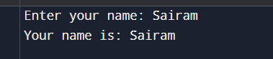
Program 2: Read Two Numbers and Print Sum Source Code:
import java.util.Scanner; class SumInput { public static void main(String[] args) {
Scanner sc = new Scanner(System.in); System.out.print("Enter first number: "); int a = sc.nextInt();
System.out.print("Enter second number: "); int b = sc.nextInt(); int sum = a + b;
System.out.println("Sum = " + sum);
}
}
Output:
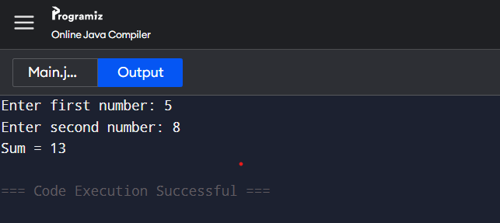
Program 3: Read Length and Breadth and Find Area of Rectangle Source Code: import java.util.Scanner;
class AreaRectangleInput { public static void main(String[] args) {
Scanner sc = new Scanner(System.in); System.out.print("Enter length: "); int length = sc.nextInt(); System.out.print("Enter breadth: "); int breadth = sc.nextInt(); int area = length * breadth;
System.out.println("Area of Rectangle = " + area);
}
}
Output:
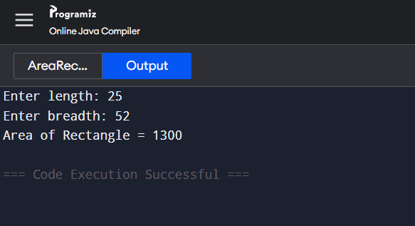

POST LAB EXERCISE
- What is the use of the Scanner class in Java?
Answer:
The Scanner class is used to read input from the user such as numbers, strings, and characters through the keyboard.
- Which package contains the Scanner class?
Answer:
The Scanner class is present in the java.util package.
- What does System.in represent?
Answer:
System.in represents the standard input stream, which is usually the keyboard.
- What does System.out represent?
Answer:
System.out represents the standard output stream, which is usually the monitor (screen).
- Name any two methods used to read input using Scanner.
Answer:
Any two Scanner input methods are:
  - nextInt() → Reads an integer value
  - nextLine() → Reads a full line of text
(Other methods: nextDouble(), next(), nextFloat()) 6. What is the difference between next() and nextLine()?
next() | nextLine()
Reads a single word | Reads a complete line
Stops at space | Reads including spaces
Cannot read full names | Can read full sentences
Result:
Thus the input was successfully read from the user and the corresponding output was displayed using Java input and output statements.
ASSESSMENT
Description |  | Max Marks | Marks Awarded
Pre Lab Exercise |  | 5
In Lab Exercise |  | 10
Post Lab Exercise |  | 5
Viva |  | 10
 | Total | 30
 |  | Faculty Signature

