`Experiment Number : 06 Date: 05-02-26

ABSTRACT CLASSES
Aim:
To understand and implement inheritance concepts in Java.
PRE LAB EXERCISE
QUESTIONS
- What is an abstract class?
- An abstract class is declared using the abstract keyword in Java.
- It cannot be instantiated directly using the new keyword.
- It may contain abstract methods as well as concrete (implemented) methods.
- It is mainly used as a base class to provide common features for subclasses.

- Why are abstract methods used?
• Abstract methods are declared without implementation in the parent class.
• They force the subclasses to provide their own implementation of the method.
• This helps in achieving abstraction by hiding implementation details.
• They ensure that all derived classes follow a common method structure.

- Difference between abstract class and interface.

Abstract Class | Interface
Uses the keyword abstract. | Uses the keyword interface.
Can contain both abstract and concrete (implemented) methods. | Methods are abstract by default (till Java 7).
Can have instance variables. | Variables are public, static, and final by default.
A class can extend only one abstract class. | A class can implement multiple interfaces.
Can have constructors. | Cannot have constructors.
Provides partial abstraction. | Provides complete abstraction.

IN LAB EXERCISE
Objective:
To implement abstract class and demonstrate abstraction.
PROGRAMS:
1.University System
Scenario:
A university has different types of courses: Online, Offline, and Hybrid. Each course has a getDetails() method.
Question:
Create an abstract class Course with abstract method getDetails(). Implement OnlineCourse, OfflineCourse, and HybridCourse classes.
Code:
abstract class Course {
abstract void getDetails();
}

class OnlineCourse extends Course {
void getDetails() {
System.out.println("Online Course: Attend via Internet");
}
}

class OfflineCourse extends Course {
void getDetails() {
System.out.println("Offline Course: Attend in classroom");
}
}

class HybridCourse extends Course {
void getDetails() {
System.out.println("Hybrid Course: Combination of online and offline");
}
}

public class Main {
public static void main(String[] args) {
Course c1 = new OnlineCourse();
Course c2 = new OfflineCourse();
Course c3 = new HybridCourse();

c1.getDetails();
c2.getDetails();
c3.getDetails();
}
}

Output:
Online Course: Attend via Internet
Offline Course: Attend in classroom
Hybrid Course: Combination of online and offline
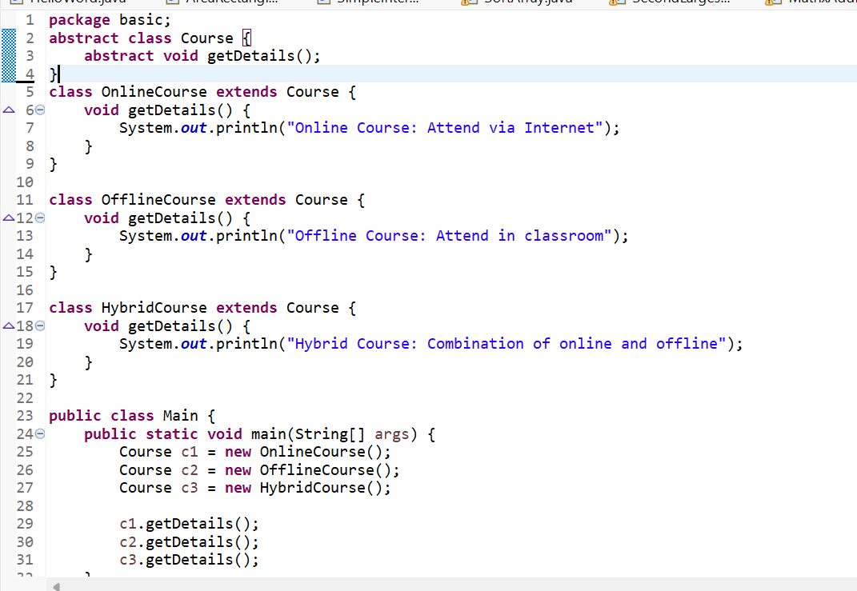
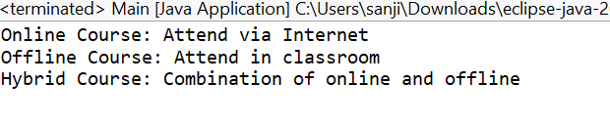
2. Employee Payroll System
Scenario:
A company has different types of employees — Regular and Contract. All employees have a salary, but the calculation differs for each type.
Question:
Design an abstract class Employee with an abstract method calculateSalary(). Implement subclasses RegularEmployee and ContractEmployee to calculate salary differently.
Code:
import java.util.Scanner;
abstract class Employee {
String name;
double baseSalary;

// Abstract method to calculate total salary
abstract void calculateSalary();
}

class RegularEmployee extends Employee {
double bonusRate = 0.1; // 10% bonus

void calculateSalary() {
double totalSalary = baseSalary + (baseSalary * bonusRate);
System.out.println("Regular Employee: " + name);
System.out.println("Base Salary: " + baseSalary);
System.out.println("Total Salary (with 10% bonus): " + totalSalary);
}
}

class ContractEmployee extends Employee {
void calculateSalary() {
System.out.println("Contract Employee: " + name);
System.out.println("Total Salary: " + baseSalary);
}
}

public class Main {
public static void main(String[] args) {
Scanner sc = new Scanner(System.in);

// Input for Regular Employee
System.out.print("Enter Regular Employee Name: ");
String regName = sc.nextLine();
System.out.print("Enter Base Salary: ");
double regSalary = sc.nextDouble();
sc.nextLine(); // Consume newline

// Input for Contract Employee
System.out.print("Enter Contract Employee Name: ");
String conName = sc.nextLine();
System.out.print("Enter Base Salary: ");
double conSalary = sc.nextDouble();

// Create objects
Employee e1 = new RegularEmployee();
e1.name = regName;
e1.baseSalary = regSalary;

Employee e2 = new ContractEmployee();
e2.name = conName;
e2.baseSalary = conSalary;

System.out.println("\n--- Salary Details ---");
e1.calculateSalary();
System.out.println();
e2.calculateSalary();

sc.close();
}
}
Output:
Enter Regular Employee Name: Ram
Enter Base Salary: 30000
Enter Contract Employee Name: Ravi
Enter Base Salary: 20000

--- Salary Details ---
Regular Employee: Anitha
Base Salary: 30000.0
Total Salary (with 10% bonus): 33000.0

Contract Employee: Ravi
Total Salary: 20000.0
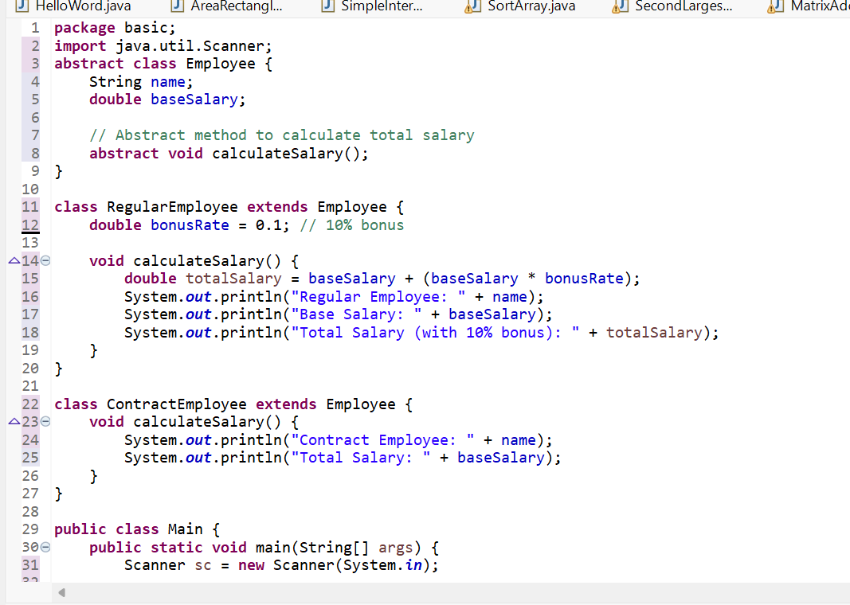
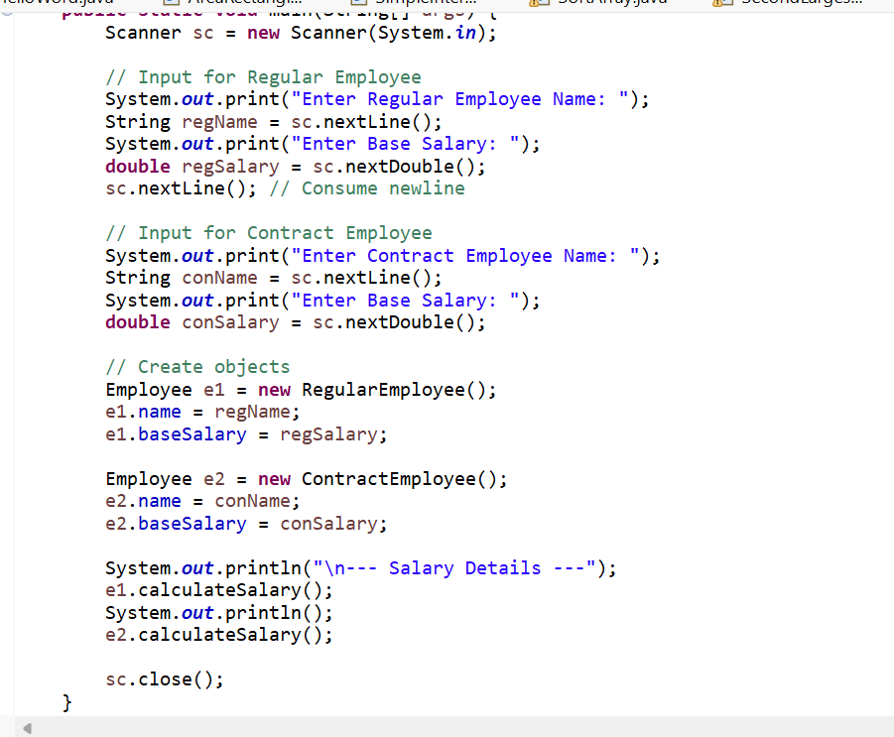
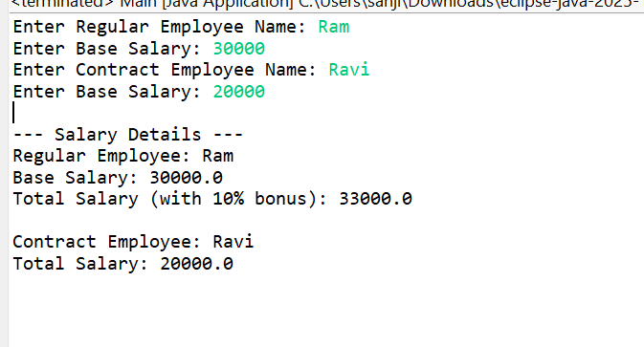
3.Banking System
Scenario:
A bank has different types of accounts: Savings and Current. Both accounts need a method to calculate interest, but the calculation differs for each account type.
Question:
Use an abstract class BankAccount with an abstract method calculateInterest() and implement it in SavingsAccount and CurrentAccount classes.
Code
abstract class BankAccount {
String accountHolder;
double balance;

BankAccount(String name, double bal) {
accountHolder = name;
balance = bal;
}

abstract void calculateInterest(); // Abstract method
}

class SavingsAccount extends BankAccount {
double interestRate = 0.04; // 4% interest

SavingsAccount(String name, double bal) {
super(name, bal);
}

void calculateInterest() {
double interest = balance * interestRate;
System.out.println("Savings Account Interest for " + accountHolder + " = " + interest);
}
}

class CurrentAccount extends BankAccount {
double interestRate = 0.02; // 2% interest

CurrentAccount(String name, double bal) {
super(name, bal);
}

void calculateInterest() {
double interest = balance * interestRate;
System.out.println("Current Account Interest for " + accountHolder + " = " + interest);
}
}

public class Main {
public static void main(String[] args) {
BankAccount acc1 = new SavingsAccount("Ram", 50000);
BankAccount acc2 = new CurrentAccount("Ravi", 80000);

acc1.calculateInterest();
acc2.calculateInterest();
}
}

Output
Savings Account Interest for Ram = 2000.0
Current Account Interest for Ravi = 1600.0
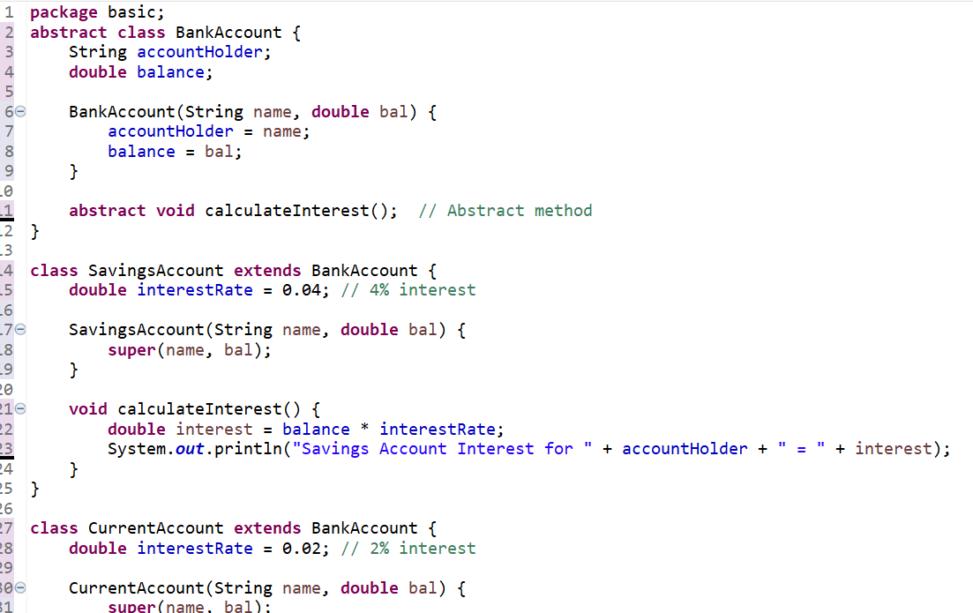
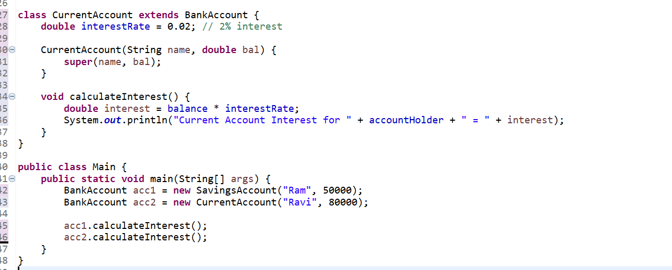

POST LAB EXERCISE
- How is an abstract class different from a regular class?
- An abstract class is declared using the abstract keyword, whereas a regular class is declared normally.
- An abstract class cannot be instantiated, but a regular class can be instantiated.
- An abstract class may contain abstract methods without implementation, while a regular class contains only implemented methods.
- An abstract class is used as a base class for inheritance, whereas a regular class is used to create objects directly.

- Can you create an object of an abstract class? Why or why not?
- No, an object of an abstract class cannot be created.
- An abstract class cannot be instantiated directly.
- It may contain abstract methods (methods without body), so the class is incomplete.
- Abstract classes are meant to be inherited by subclasses, which provide implementations for abstract methods.
- Objects are created only for concrete (non-abstract) classes, not for abstract classes.

- What happens if a subclass does not implement an abstract method?
- If a subclass does not implement all the abstract methods of the parent class, it becomes incomplete.
- Such a subclass must be declared as abstract.
- If it is not declared abstract, the compiler will generate an error.
- This rule ensures that all abstract methods are implemented before creating objects.

- Can an abstract class exist without any abstract methods?
- Yes, an abstract class can exist without any abstract methods.
- It can contain only concrete (implemented) methods.
- Declaring a class as abstract prevents object creation of that class.
- It is mainly used to provide common functionality to derived classes.

- Can an abstract class extend another abstract class?
- Yes, an abstract class can exist without any abstract methods.
- It can contain only concrete (implemented) methods.
- Declaring a class as abstract prevents object creation of that class.
- It is mainly used to provide common functionality to derived classes.

Result:

Thus the abstract classes and methods were implemented and executed successfully.

ASSESSMENT

Description | Max Marks | Marks Awarded
Pre Lab Exercise | 5
In Lab Exercise | 10
Post Lab Exercise | 5
Viva | 10
Total | 30
Faculty Signature

