Experiment Number : 04 Date: 05/02/2026

ARRAYS
Aim:
To understand and implement array operations in Java.
PRE LAB EXERCISE
QUESTIONS
- What is an array?
An array is a data structure used to store multiple values of the same data type in a single variable, using an index.

- Why are arrays used?
Arrays are used to:
- Store multiple related values together
- Reduce the need for many separate variables
- Make data easy to access using index
- Improve code readability and efficiency

- What is the difference between array and variable?
Variable | Array
Stores only one value | Stores multiple values
Needs separate variable for each value | Single name stores many values
Accessed directly | Accessed using index

IN LAB EXERCISE
Objective:
To perform array operations using simple programs.
PROGRAMS:
1. Program to Read and Print Array Elements
Code:
import java.util.Scanner;
public class ReadPrintArray {
public static void main(String[] args) {
Scanner sc = new Scanner(System.in);
int[] arr = new int[5];
System.out.println("Enter 5 elements:");
for(int i = 0; i < 5; i++)
arr[i] = sc.nextInt();
System.out.println("Array elements are:");
for(int i = 0; i < 5; i++)
System.out.print(arr[i] + " ");
}
}
OUTPUT:
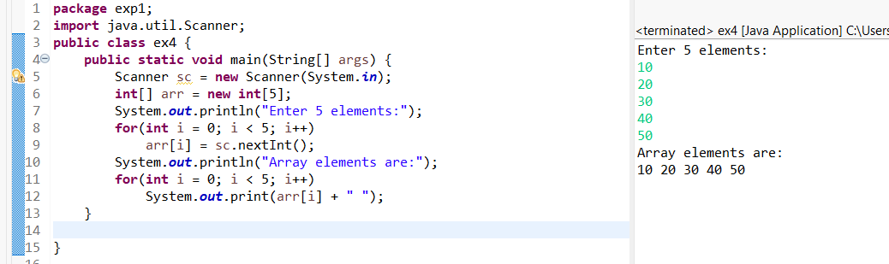

2. Program to Find Sum of Array Elements
Code:
import java.util.Scanner;
public class SumArray {
public static void main(String[] args) {
Scanner sc = new Scanner(System.in);
int[] arr = new int[5];
int sum = 0;
System.out.println("Enter 5 elements:");
for(int i = 0; i < 5; i++)
arr[i] = sc.nextInt();
for(int i = 0; i < 5; i++)
sum += arr[i];
System.out.println("Sum = " + sum);
}
}
OUTPUT:
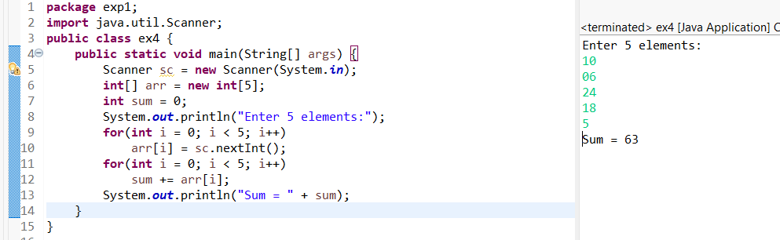
3. Program to Find Largest Element in an Array
Code:
import java.util.Scanner;
public class LargestElement {
public static void main(String[] args) {
Scanner sc = new Scanner(System.in);
int[] arr = new int[5];
System.out.println("Enter 5 elements:");
for(int i = 0; i < 5; i++)
arr[i] = sc.nextInt();
int max = arr[0];
for(int i = 1; i < 5; i++)
if(arr[i] > max)
max = arr[i];
System.out.println("Largest element = " + max);
}
}
OUTPUT:
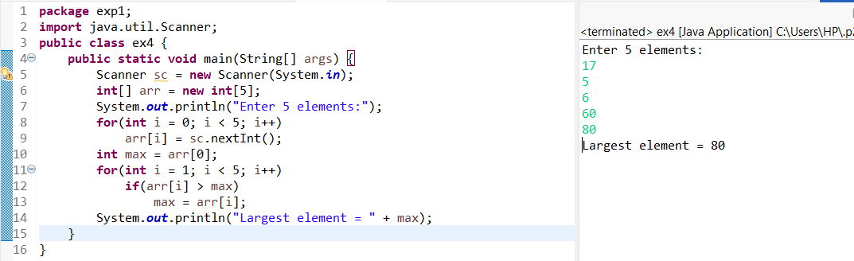

4. Program to Reverse an Array
Code:
import java.util.Scanner;

public class ReverseArray {
public static void main(String[] args) {
Scanner sc = new Scanner(System.in);
int[] arr = new int[5];
System.out.println("Enter 5 elements:");
for(int i = 0; i < 5; i++)
arr[i] = sc.nextInt();
System.out.println("Reversed array:");
for(int i = 4; i >= 0; i--)
System.out.print(arr[i] + " ");
}
}
OUTPUT:
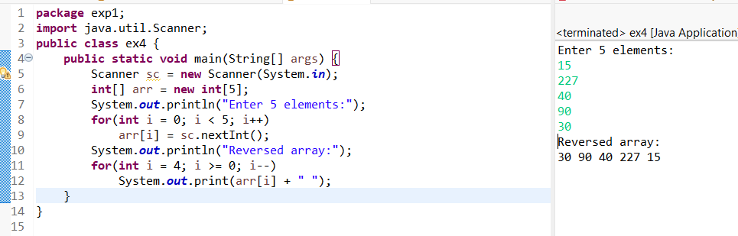
5. Program to Count Even and Odd Numbers
Code:
import java.util.Scanner;
public class EvenOddCount {
public static void main(String[] args) {
Scanner sc = new Scanner(System.in);
int[] arr = new int[5];
int even = 0, odd = 0;
System.out.println("Enter 5 elements:");
for(int i = 0; i < 5; i++)
arr[i] = sc.nextInt();
for(int i = 0; i < 5; i++) {
if(arr[i] % 2 == 0)
even++;
else
odd++;
}

System.out.println("Even = " + even);
System.out.println("Odd = " + odd);
}
}
OUTPUT:
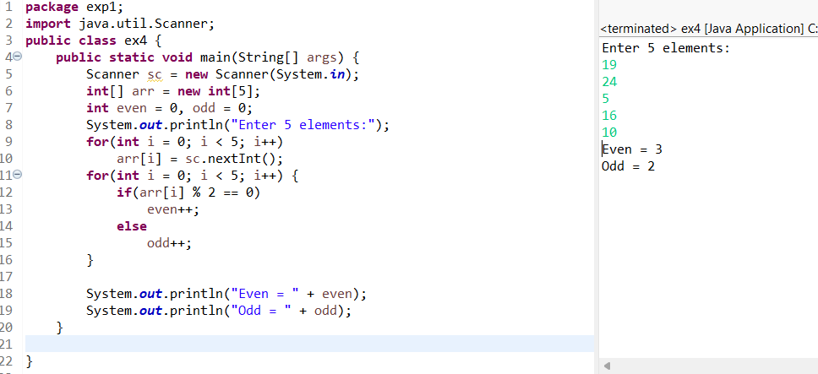
6. Program to Sort Array in Ascending Order
Code:
import java.util.Scanner;
public class SortArray {
public static void main(String[] args) {
Scanner sc = new Scanner(System.in);
int[] arr = new int[5];
int temp;
System.out.println("Enter 5 elements:");
for(int i = 0; i < 5; i++)
arr[i] = sc.nextInt();
for(int i = 0; i < 5; i++) {
for(int j = i + 1; j < 5; j++) {
if(arr[i] > arr[j]) {
temp = arr[i];
arr[i] = arr[j];
arr[j] = temp;
}
}
}
System.out.println("Sorted array:");
for(int i = 0; i < 5; i++)
System.out.print(arr[i] + " ");
}
}
OUTPUT:
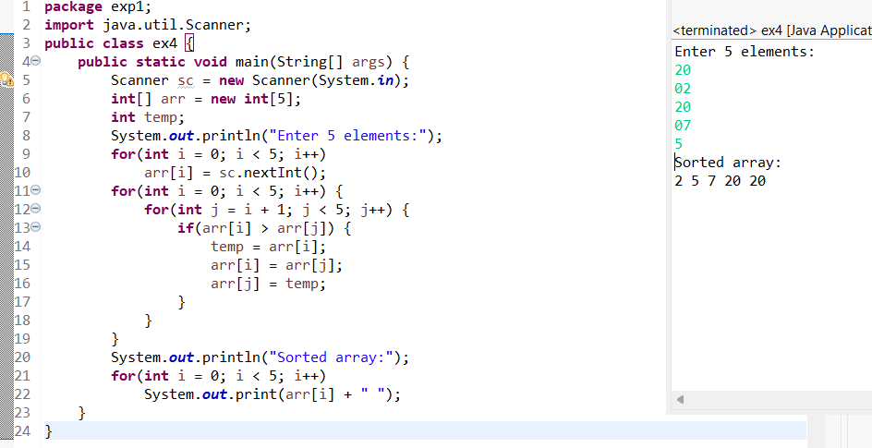
7. Program to Find Second Largest Element
Code:
import java.util.Scanner;
public class SecondLargest {
public static void main(String[] args) {
Scanner sc = new Scanner(System.in);
int[] arr = new int[5];

System.out.println("Enter 5 elements:");
for(int i = 0; i < 5; i++)
arr[i] = sc.nextInt();
int largest = arr[0];
int second = arr[0];
for(int i = 0; i < 5; i++) {
if(arr[i] > largest) {
second = largest;
largest = arr[i];
}
}
System.out.println("Second largest = " + second);
}
}
OUTPUT:
Input:
10 45 23 89 67
Output:
Second largest = 67

8. Program for Matrix Addition (2D Array)
Code:
import java.util.Scanner;
public class MatrixAddition {
public static void main(String[] args) {
Scanner sc = new Scanner(System.in);
int[][] a = new int[2][2];
int[][] b = new int[2][2];
int[][] sum = new int[2][2];
System.out.println("Enter elements of matrix A:");
for(int i = 0; i < 2; i++)
for(int j = 0; j < 2; j++)
a[i][j] = sc.nextInt();
System.out.println("Enter elements of matrix B:");
for(int i = 0; i < 2; i++)
for(int j = 0; j < 2; j++)
b[i][j] = sc.nextInt();
for(int i = 0; i < 2; i++)
for(int j = 0; j < 2; j++)
sum[i][j] = a[i][j] + b[i][j];
System.out.println("Sum matrix:");
for(int i = 0; i < 2; i++) {
for(int j = 0; j < 2; j++)
System.out.print(sum[i][j] + " ");
System.out.println();
}
}
}
OUTPUT:
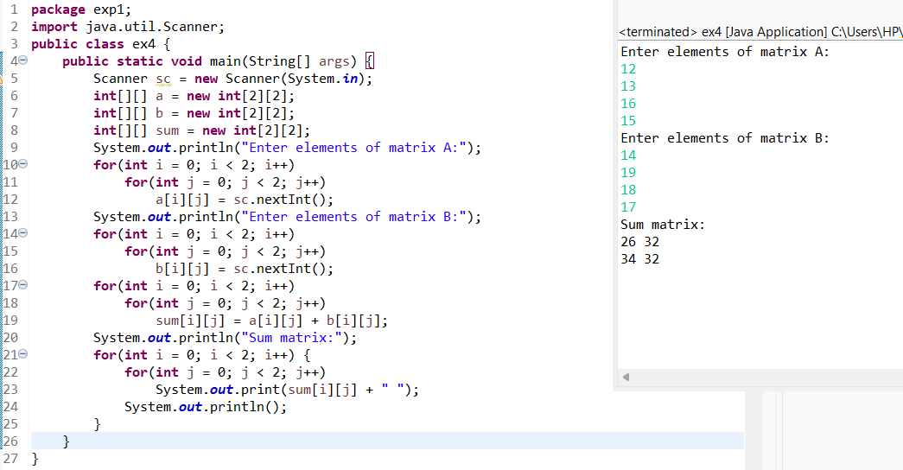
POST LAB EXERCISE
- Why is array indexing usually started from zero instead of one?
Array indexing starts from zero because the index represents the offset from the starting memory address.
So first element ku offset = 0.

- What happens if we try to access an array element outside its declared size?
• It causes a runtime error
• In Java: ArrayIndexOutOfBoundsException
• Program may crash or behave unexpectedly

- How does memory allocation differ for static arrays and dynamic arrays?
Static Array | Dynamic Array
Size fixed at compile time | Size decided at runtime
Memory allocated once | Memory can be resized
Faster access | Flexible but slightly slower

- Why is searching faster in arrays compared to linked lists?
• Arrays store elements in contiguous memory
• Any element can be accessed directly using index (O(1))
• Linked list needs sequential traversal

- What is the difference between contiguous and non-contiguous memory allocation?
Contiguous Memory | Non-Contiguous Memory
Memory blocks are continuous | Memory blocks are scattered
Used in arrays | Used in linked lists
Faster access | Slower access

Result:

Thus the array operations were executed successfully.

ASSESSMENT

Description | Max Marks | Marks Awarded
Pre Lab Exercise | 5
In Lab Exercise | 10
Post Lab Exercise | 5
Viva | 10
Total | 30
Faculty Signature

