Experiment Number : 01 Date:25-01-26

Installation of Java and Simple Java Programs
Aim:
To install Java Development Kit (JDK), configure the environment, and write simple Java programs including Hello World.
PRE LAB EXERCISE
QUESTIONS
- What is JDK and why is it required?
JDK (Java Development Kit) is a software package that provides all the tools needed to develop, compile, and run Java programs.
• It contains the compiler (javac) → converts your Java code into bytecode.
• It includes JRE (Java Runtime Environment) → required to run Java programs.
• It has development tools like debugger, documentation tools, Java libraries, etc.

- Difference between JDK, JRE, and JVM.
Component | Full Form | Purpose | Includes | Used By
JVM | Java Virtual Machine | Executes Java bytecode | — | Runtime engine
JRE | Java Runtime Environment | Provides libraries + JVM to run Java apps | JVM + Core Libraries | End-users who want to run Java programs
JDK | Java Development Kit | Used to develop Java apps | JRE + compiler + dev tools | Developers

- What is the purpose of the main() method in Java?
The main() method is the entry point of a Java program.
public static void main(String[] args)
Purpose
- It tells the JVM where the program should start execution.
- Without it, the JVM doesn't know how to begin running the code.
- It allows you to pass command-line arguments via String[] args.

IN LAB EXERCISE
Objective:
To verify Java installation and execute a basic Java program.
INSTALLATION STEPS:
STEP 1: Open Browser
- Open your browser and go to the official URL Eclipse Downloads page.

STEP 2: Download Eclipse Installer
- Then, click on the "Download" button to download Eclipse IDE.

STEP 3: Download EXE
- Now, click on the "Download x86_64" button.


STEP 4: Then click on the "Download" button. After clicking on the download button the .exe file for the eclipse will be downloaded.



STEP 5: Open Download EXE
- Now go to File Explorer and click on "Downloads" after that click on the "eclipse-inst-jre-win64.exe" file for installing Eclipse IDE.

STEP 6: Install Eclipse
- Then, click on "Eclipse IDE for Java Developers".


STEP 7: Then, click on the "Install" button.


Step 8: Create New Project
Now click on "Create a new Java project".

STEP 9:Create a new java project
- By clicking on the File menu and choosing New → Java Project.
- By right clicking anywhere in the Project Explorer and selecting New → Java Project.
- By clicking on the New button ( ) in the Tool bar and selecting Java Project.
STEP 10: Enter the Project Name
- Select the Java Runtime Environment (JRE) or leave it at the default
- Select the Project Layout which determines whether there would be a separate folder for the source codes and class files. The recommended option is to create separate folders for sources and class files.
- 
STEP 11: Create a new java package
- By clicking on the File menu and selecting New → Package.
- By right click in the package explorer and selecting New → Package.
- By clicking on the package icon which is in the tool bar( ).
STEP 11:
- Enter/confirm the source folder name.
- Enter the package name.
- Click on the Finish button.


STEP 12:Create a New Java class.
- By clicking on the File menu and selecting New → Class.
- By right clicking in the package explorer and selecting New → Class.
- By clicking on the class drop down button ( ) and selecting class ( ).
STEP 13:
- Ensure the source folder and package are correct.
- Enter the class name.
- Select the appropriate class modifier.
- Enter the super class name or click on the Browse button to search for an existing class.
- Click on the Add button to select the interfaces implemented by this class.
- Examine and modify the check boxes related to method stubs and comments.


STEP 14: Class created successfully.

BASIC PROGRAMS:
Program 1: Hello World Program
Source Code:
class HelloWorld {
public static void main(String[] args) {
System.out.println("Hello World");
}
}
Output:
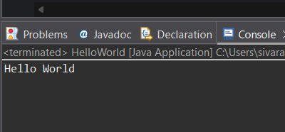
Program 2: Display Personal Details
Source Code:
class DisplayInfo {
public static void main(String[] args) {
System.out.println("Name: Sivaranjani");
System.out.println("Age: 20");
}
}
Output:
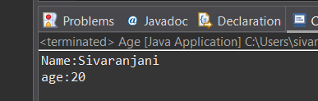
Program 3: Addition of Two Numbers
Source Code:
class Add {
public static void main(String[] args) {
int a = 30, b = 50;
System.out.println("Sum = " + (a + b));
}
}
Output:
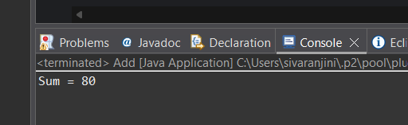Program 4: Area of a Rectangle
Source Code:
class Area {
public static void main(String[] args) {
int length = 90, breadth = 7;
System.out.println("Area = " + (length * breadth));
}
}
Output:
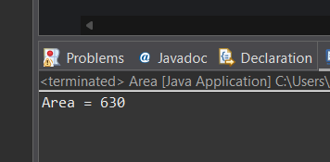Program 5: Simple Interest Calculation
Source Code:
class SI {
public static void main(String[] args) {
int p = 10000;
int r = 8;
int t = 6;
int si = (p * r * t) / 100;
System.out.println("Simple Interest = " + si);
}
}
Output:
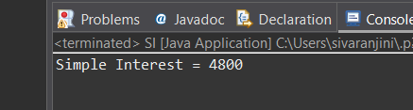

POST LAB EXERCISE
- Write a Java program to display your name and department.
- public class exercise1 {

- public static void main(String[] args) {
- System.out.println("Name: Shivana");
- System.out.println("Department: Computer Science Engineering");
- }

- }
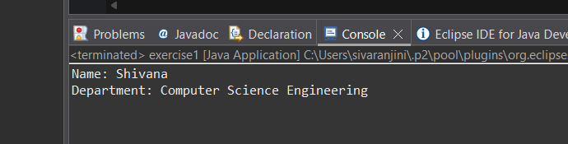
- Modify the program to print the output in same line.
class DisplayInfoSameLine {
public static void main(String[] args) {
System.out.print("Name: Shivana, ");
System.out.print("Department: Computer Science Engineering");
}
}
- What happens if main() is written without static?
JVM cannot call the main method directly.
It expects a static main() to start the program.
Therefore, you get a runtime error like:
Error: Main method not found in class...
👉 Because static methods can be called without creating an object.
- Why is Java called platform independent?
Java is called platform independent because of the JVM.
Explanation:
- Java code is compiled into bytecode, not machine code.
- This bytecode can run on any device that has a JVM.
- JVM acts as a translator for each operating system (Windows, Linux, Mac).
👉 Write Once, Run Anywhere (WORA)
Java program → bytecode → any OS with JVM.

- Write a program to find the cube of a number.
package tutorial;

import java.util.Scanner;

class Cubeofno{
public static void main(String[] args) {
Scanner sc = new Scanner(System.in);

System.out.print("Enter a number: ");
int num = sc.nextInt();

int cube = num * num * num;

System.out.println("Cube of " + num + " is: " + cube);
}
}
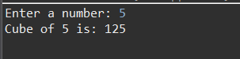

Result:

Thus the Java IDE was successfully installed and a simple Java program was executed.

ASSESSMENT

Description | Max Marks | Marks Awarded
Pre Lab Exercise | 5
In Lab Exercise | 10
Post Lab Exercise | 5
Viva | 10
Total | 30
Faculty Signature

