Experiment Number : 02 Date: 28.01.2026

Input and Output Statements in Java
Aim:
To understand and use input and output statements in Java using the Scanner class.
PRE LAB EXERCISE
QUESTIONS
1.What is input in a program?
- Input is the data entered by the user. o It is used by the program for processing. o Example: numbers or text given to the program.
2.What is output in a program?
- Output is the result produced by the program. o It is shown after processing the input. o Example: result displayed on the screen.
3.Which class is used to read input from the user in Java?
- In Java, the Scanner class is used to read input. o It is available in java.util package. o It reads data like numbers and strings from the user.
IN LAB EXERCISE
Objective:
To read input from the user and display the output using Java input and output statements.
INPUT STATEMENT:
SCANNER CLASS
- The Scanner class in Java is used to read input from the user through the keyboard. It is available in the package java.util.
- The Scanner object reads different types of input such as integer, float, double, and string and stores them in variables.
- To use the Scanner class, it must be imported before using it in the program.
SYNTAX:
- Scanner sc = new Scanner(System.in);
Commonly Used Scanner Methods:
- nextInt() – reads an integer value
- nextFloat() – reads a float value
- nextDouble() – reads a double value
- next() – reads a single word
- nextLine() – reads a complete line of text

PROGRAMS:
Program 1: Read and Display Name
Source Code:
import java.util.Scanner; class ReadName { public static void main(String[] args) { Scanner sc = new Scanner(System.in);
System.out.print("Enter your name: ");
String name = sc.nextLine();
System.out.println("Your name is: " + name);
}
}
Output:
Enter your name: SANTHOSH
Your name is: SANTHOSH
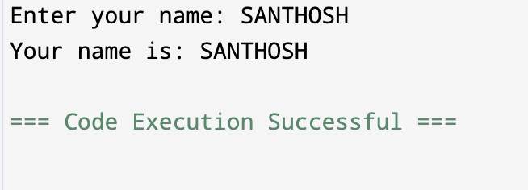

Program 2: Read Two Numbers and Print Sum
Source Code:
import java.util.Scanner; class SumInput { public static void main(String[] args) { Scanner sc = new Scanner(System.in); System.out.print("Enter first number: "); int a = sc.nextInt();
System.out.print("Enter second number: "); int b = sc.nextInt(); int sum = a + b;
System.out.println("Sum = " + sum);
}
}
Output:
Enter first number: 4
Enter second number: 3
Sum = 7

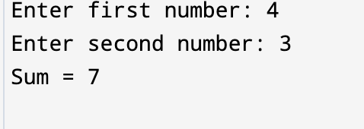

Program 3: Read Length and Breadth and Find Area of Rectangle
Source Code:
import java.util.Scanner;

class AreaRectangleInput { public static void main(String[] args) { Scanner sc = new Scanner(System.in); System.out.print("Enter length: "); int length = sc.nextInt(); System.out.print("Enter breadth: "); int breadth = sc.nextInt(); int area = length * breadth;
System.out.println("Area of Rectangle = " + area);
}
}
Output:
Enter length: 3
Enter breadth: 4
Area of Rectangle = 12

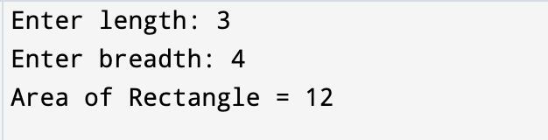

POST LAB EXERCISE
1.What is the use of the Scanner class in Java?
- Scanner class is used to read input from the user.
- It reads data like numbers and strings.

2.Which package contains the Scanner class?
- Scanner class is present in java.util package.

3.What does System.in represent?
- System.in represents standard input. o It is used to take input from keyboard.

4.What does System.out represent?
- System.out represents standard output. o It is used to display output on screen.

5.Name any two methods used to read input using Scanner.
- nextInt() and nextLine() are used to read input.

6.What is the difference between next() and nextLine()?
- next() reads a single word. o nextLine() reads a full line including spaces.

Result:

Thus the input was successfully read from the user and the corresponding output was displayed using Java input and output statements.

ASSESSMENT

Description |  | Max Marks | Marks Awarded
Pre Lab Exercise |  | 5
In Lab Exercise |  | 10
Post Lab Exercise |  | 5
Viva |  | 10
 | Total | 30
 |  | Faculty Signature

