Experiment Number : 07 Date: 05.02.2026

METHOD OVERLOADING AND METHOD OVERRIDING
Aim:
To understand and implement method overloading and method overriding.
PRE LAB EXERCISE
QUESTIONS
- What is method overloading?
Method overloading is a feature in Java where multiple methods have the same name but different parameter lists within the same class. It is an example of compile-time polymorphism.
- What is method overriding?
Method overriding is a feature where a subclass provides its own implementation of a method that is already defined in its parent class. It is an example of runtime polymorphism.
- Difference between overloading and overriding.
Method Overloading | Method Overriding
Same method name, different parameters | Same method name and same parameters
Occurs in same class | Occurs in parent-child classes
Compile-time polymorphism | Runtime polymorphism
Return type can vary | Return type must be same or covariant

IN LAB EXERCISE
Objective:
To demonstrate compile-time and runtime polymorphism.
PROGRAMS:
1.Student Result System (Method Overriding)
Description:
- Base class Student has method displayResult().
- Subclasses UGStudent and PGStudent override the method to show different grading systems.

Code :
import java.util.Scanner;
// Base class
class Student {
String name;
void displayResult() {
System.out.println("Student Result");
}
}
// UG Student subclass
class UGStudent extends Student {
int marks;
UGStudent(String n, int m) {
name = n;
marks = m;
}
@Override
void displayResult() {
double percentage = (marks / 100.0) * 100;
System.out.println("UG Student: " + name);
System.out.println("Marks: " + marks);
System.out.println("Percentage: " + percentage + "%");}}
// PG Student subclass
class PGStudent extends Student {
double gpa;
PGStudent(String n, double g) {
name = n;
gpa = g;}
@Override
void displayResult() {
System.out.println("PG Student: " + name);
System.out.println("GPA: " + gpa + " / 10");}}
// Main class
public class Main {
public static void main(String[] args) {
Scanner sc = new Scanner(System.in);
// Input for UG student
System.out.print("Enter UG Student Name: ");
String ugName = sc.nextLine();
System.out.print("Enter UG Student Marks (out of 100): ");
int ugMarks = sc.nextInt();
sc.nextLine(); // consume newline
// Input for PG student
System.out.print("Enter PG Student Name: ");
String pgName = sc.nextLine();
System.out.print("Enter PG Student GPA (0-10): ");
double pgGpa = sc.nextDouble();
// Create objects
Student s1 = new UGStudent(ugName, ugMarks);
Student s2 = new PGStudent(pgName, pgGpa);
System.out.println("\n--- Student Results ---");
s1.displayResult();
System.out.println();
s2.displayResult();
sc.close();}}

OUTPUT:
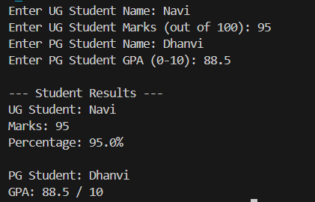

2. Calculator Program (Method Overloading)
Description:
Create a Calculator class with multiple add() methods to calculate:
- Addition of 2 integers
- Addition of 3 integers
- Addition of 2 double numbers
Code:
import java.util.Scanner;
class Calculator {
int add(int a, int b) {
return a + b;
}
int add(int a, int b, int c) {
return a + b + c;
}
double add(double a, double b) {
return a + b;
}}
public class Main {
public static void main(String[] args) {
Scanner sc = new Scanner(System.in);
Calculator calc = new Calculator();
System.out.print("Enter two integers: ");
int x = sc.nextInt();
int y = sc.nextInt();
System.out.println("Sum of two integers: " + calc.add(x, y));
System.out.print("Enter three integers: ");
int p = sc.nextInt();
int q = sc.nextInt();
int r = sc.nextInt();
System.out.println("Sum of three integers: " + calc.add(p, q, r));
System.out.print("Enter two decimal numbers: ");
double a = sc.nextDouble();
double b = sc.nextDouble();
System.out.println("Sum of two doubles: " + calc.add(a, b));
sc.close();}}
Output:
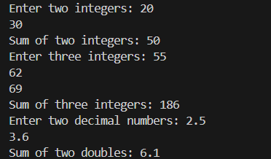

POST LAB EXERCISE
- Is return type important in method overloading and method overriding?
- In method overloading, return type alone is not enough; parameters must differ.
- In method overriding, return type must be the same or covariant.

- Can you overload a method by changing only the return type?
No, a method cannot be overloaded by changing only the return type. The parameter list must be different.
- Can static methods be overridden? Can they be overloaded?
- Static methods cannot be overridden.
- Static methods can be overloaded.

- Can a method be overridden if the parameter list is different?
No, if the parameter list is different, it becomes method overloading, not overriding.
Result:
Thus the method overloading and overriding concepts were implemented and executed successfully.

ASSESSMENT

Description | Max Marks | Marks Awarded
Pre Lab Exercise | 5
In Lab Exercise | 10
Post Lab Exercise | 5
Viva | 10
Total | 30
Faculty Signature

