Experiment Number : 07 Date: 6/2/26

METHOD OVERLOADING AND METHOD OVERRIDING
Aim:
To understand and implement method overloading and method overriding.
PRE LAB EXERCISE
QUESTIONS
- What is method overloading?
Method Overloading means defining multiple methods with the same name but with different parameters in the same class.

Differences in:
Number of parameters
Type of parameters
Order of parameters
EXAMPLE:
class Math {
int add(int a, int b) {
return a + b;
}
int add(int a, int b, int c) {
return a + b + c;
}
}

- What is method overriding?
Method Overriding means redefining a parent class method in the child class with the same method name and same parameters.

Used in:
Inheritance
Runtime polymorphism
EXAMPLE:
class Animal {
void sound() {
System.out.println("Animal makes sound");
}
}
class Dog extends Animal {
void sound() {
System.out.println("Dog barks");
}
}

- Difference between overloading and overriding.

1. Definition
Method Overloading: Same method name with different parameters
Method Overriding: Same method name with same parameters in parent and child class

2. Class
Method Overloading: Occurs in the same class
Method Overriding: Occurs in parent and child classes

3. Inheritance
Method Overloading: Inheritance is not required
Method Overriding: Inheritance is required

4. Polymorphism Type
Method Overloading: Compile-time polymorphism (Static Binding)
Method Overriding: Runtime polymorphism (Dynamic Binding)

5. Return Type
Method Overloading: Return type can be same or different
Method Overriding: Return type must be same or compatible (covariant)

6. Keyword
Method Overloading: No special keyword
Method Overriding: Uses @Override annotation (optional but recommended)

IN LAB EXERCISE
Objective:
To demonstrate compile-time and runtime polymorphism.
PROGRAMS:
1.Student Result System (Method Overriding)
Description:
- Base class Student has method displayResult().
- Subclasses UGStudent and PGStudent override the method to show different grading systems.

Code :
import java.util.Scanner;

// Base class
class Student {
String name;

void displayResult() {
System.out.println("Student Result");
}
}

// UG Student subclass
class UGStudent extends Student {
int marks;

UGStudent(String n, int m) {
name = n;
marks = m;
}

@Override
void displayResult() {
double percentage = (marks / 100.0) * 100;
System.out.println("UG Student: " + name);
System.out.println("Marks: " + marks);
System.out.println("Percentage: " + percentage + "%");
}
}

// PG Student subclass
class PGStudent extends Student {
double gpa;

PGStudent(String n, double g) {
name = n;
gpa = g;
}

@Override
void displayResult() {
System.out.println("PG Student: " + name);
System.out.println("GPA: " + gpa + " / 10");
}
}

// Main class
public class Main {
public static void main(String[] args) {
Scanner sc = new Scanner(System.in);

// Input for UG student
System.out.print("Enter UG Student Name: ");
String ugName = sc.nextLine();
System.out.print("Enter UG Student Marks (out of 100): ");
int ugMarks = sc.nextInt();
sc.nextLine(); // consume newline

// Input for PG student
System.out.print("Enter PG Student Name: ");
String pgName = sc.nextLine();
System.out.print("Enter PG Student GPA (0-10): ");
double pgGpa = sc.nextDouble();

// Create objects
Student s1 = new UGStudent(ugName, ugMarks);
Student s2 = new PGStudent(pgName, pgGpa);

System.out.println("\n--- Student Results ---");
s1.displayResult();
System.out.println();
s2.displayResult();

sc.close();
}
}
OUTPUT:
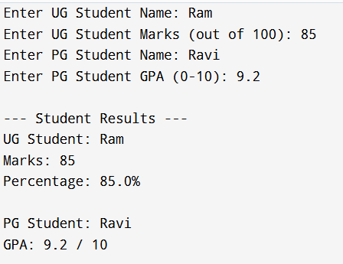
2. Calculator Program (Method Overloading)
Description:
Create a Calculator class with multiple add() methods to calculate:
- Addition of 2 integers
- Addition of 3 integers
- Addition of 2 double numbers
Code:
import java.util.Scanner;
class Calculator {
int add(int a, int b) {
return a + b;
}

int add(int a, int b, int c) {
return a + b + c;
}

double add(double a, double b) {
return a + b;
}
}
public class Main {
public static void main(String[] args) {
Scanner sc = new Scanner(System.in);
Calculator calc = new Calculator();

System.out.print("Enter two integers: ");
int x = sc.nextInt();
int y = sc.nextInt();
System.out.println("Sum of two integers: " + calc.add(x, y));

System.out.print("Enter three integers: ");
int p = sc.nextInt();
int q = sc.nextInt();
int r = sc.nextInt();
System.out.println("Sum of three integers: " + calc.add(p, q, r));

System.out.print("Enter two decimal numbers: ");
double a = sc.nextDouble();
double b = sc.nextDouble();
System.out.println("Sum of two doubles: " + calc.add(a, b));

sc.close();
}
}
Output:
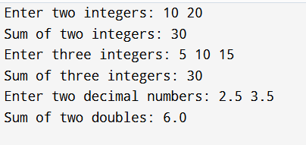
POST LAB EXERCISE
- Is return type important in method overloading and method overriding?

Method Overloading
Return type is not the main criteria
Overloading depends on parameter list (number/type/order)
Return type alone is not enough to overload

Method Overriding
Return type must be same or compatible (covariant)
Parameter list must be exactly same.

- Can you overload a method by changing only the return type?
No, you cannot overload a method by changing only the return type.

Reason:
Compiler decides method call using method name + parameter list, not return type

Example (Invalid)
int show() { return 10; }
double show() { return 10.5; } // ERROR

- Can static methods be overridden? Can they be overloaded?

Static Methods Overriding
Static methods cannot be overridden because they belong to the class, not objects.
They are hidden, not overridden.

Static Methods Overloading
Yes, static methods can be overloaded.

Example:
static void display(int a) {}
static void display(int a, int b) {}

- Can a method be overridden if the parameter list is different?
No, it cannot be overridden.

Explanation:
For overriding, the method name, parameter list, and return type must be same
If parameter list is different → it becomes method overloading, not overriding

Result:
Thus the method overloading and overriding concepts were implemented and executed successfully.
ASSESSMENT

Description | Max Marks | Marks Awarded
Pre Lab Exercise | 5
In Lab Exercise | 10
Post Lab Exercise | 5
Viva | 10
Total | 30
Faculty Signature

