Experiment Number : 04 Date: 24BCS203

ARRAYS
Aim:
To understand and implement array operations in Java.
PRE LAB EXERCISE
QUESTIONS
- What is an array?
An array is a collection of multiple values of the same data type stored in contiguous memory locations under a single name. Each value in an array is accessed using an index number.
- Why are arrays used?
Arrays are used because:
- They store many values using one variable name
- They make programs shorter and cleaner
- Data can be accessed easily using index
- They are useful for handling large amounts of similar data

- What is the difference between array and variable?
A variable is used to store only a single value at a time, whereas an array is used to store multiple values of the same data type under a single name. A variable occupies only one memory location, but an array occupies multiple memory locations to store each element. Variables are suitable when only one piece of data is required, while arrays are useful when handling large amounts of related data efficiently.
IN LAB EXERCISE
Objective:
To perform array operations using simple programs.
PROGRAMS:
1. Program to Read and Print Array Elements
Code:
import java.util.Scanner;
public class ReadPrintArray {
public static void main(String[] args) {
Scanner sc = new Scanner(System.in);
int[] arr = new int[5];
System.out.println("Enter 5 elements:");
for(int i = 0; i < 5; i++)
arr[i] = sc.nextInt();
System.out.println("Array elements are:");
for(int i = 0; i < 5; i++)
System.out.print(arr[i] + " ");
}
}
OUTPUT:
Input:
10 20 30 40 50
Output:
Array elements are:
10 20 30 40 50
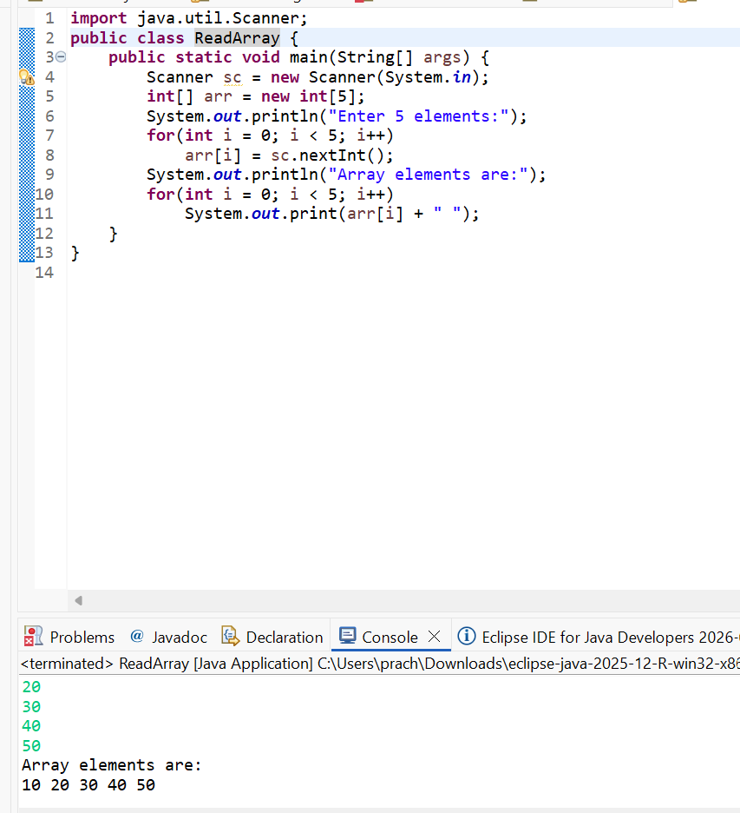

2. Program to Find Sum of Array Elements
Code:
import java.util.Scanner;
public class SumArray {
public static void main(String[] args) {
Scanner sc = new Scanner(System.in);
int[] arr = new int[5];
int sum = 0;
System.out.println("Enter 5 elements:");
for(int i = 0; i < 5; i++)
arr[i] = sc.nextInt();
for(int i = 0; i < 5; i++)
sum += arr[i];
System.out.println("Sum = " + sum);
}
}
OUTPUT:
Input:
5 10 15 20 25
Output:
Sum = 75
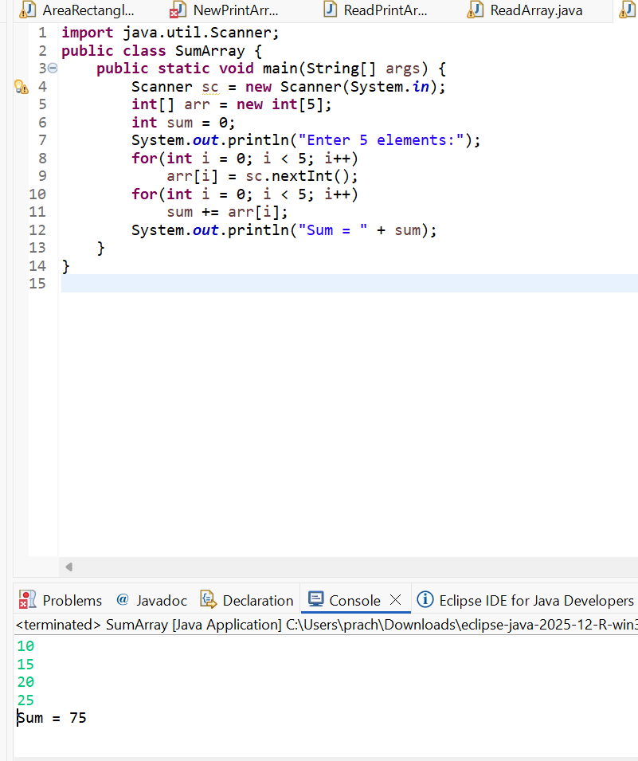

3. Program to Find Largest Element in an Array
Code:
import java.util.Scanner;
public class LargestElement {
public static void main(String[] args) {
Scanner sc = new Scanner(System.in);
int[] arr = new int[5];
System.out.println("Enter 5 elements:");
for(int i = 0; i < 5; i++)
arr[i] = sc.nextInt();
int max = arr[0];
for(int i = 1; i < 5; i++)
if(arr[i] > max)
max = arr[i];
System.out.println("Largest element = " + max);
}
}
OUTPUT:
Input:
12 45 23 9 30
Output:
Largest element = 45
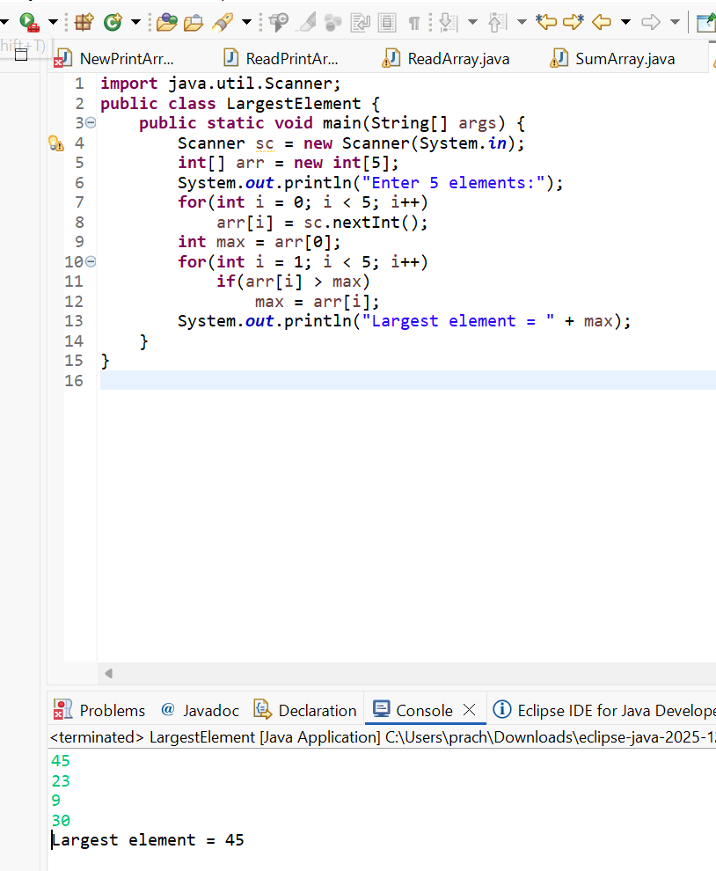

4. Program to Reverse an Array
Code:
import java.util.Scanner;

public class ReverseArray {
public static void main(String[] args) {
Scanner sc = new Scanner(System.in);
int[] arr = new int[5];
System.out.println("Enter 5 elements:");
for(int i = 0; i < 5; i++)
arr[i] = sc.nextInt();
System.out.println("Reversed array:");
for(int i = 4; i >= 0; i--)
System.out.print(arr[i] + " ");
}
}
OUTPUT:
Input:
1 2 3 4 5
Output:
Reversed array:
5 4 3 2 1
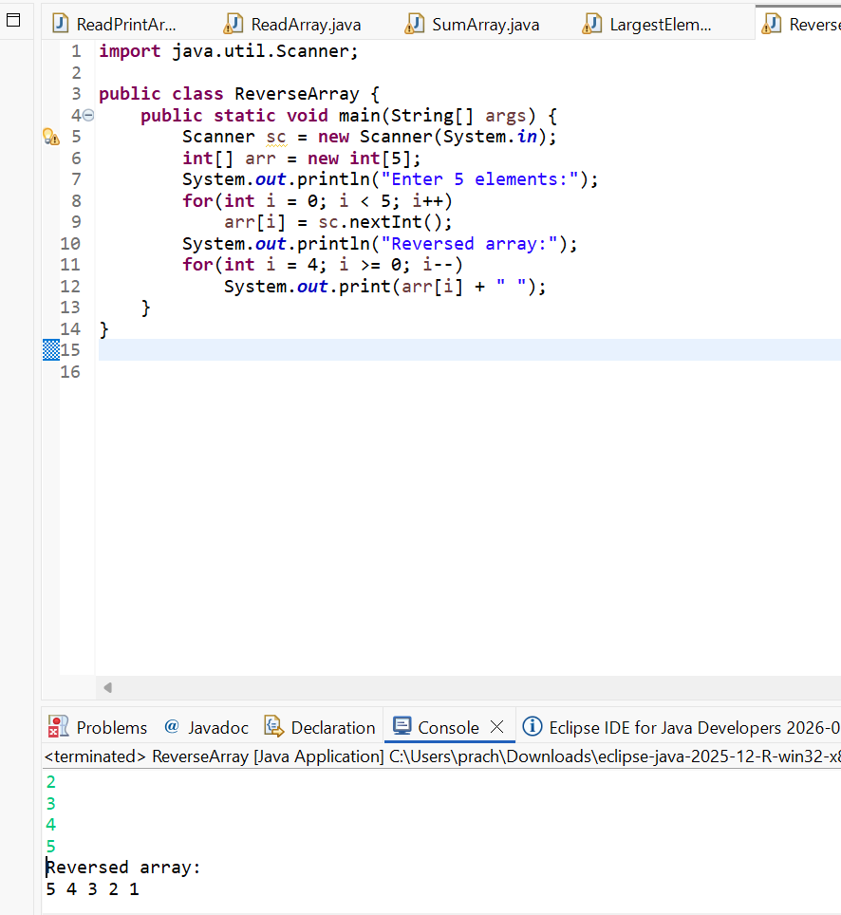

5. Program to Count Even and Odd Numbers
Code:
import java.util.Scanner;
public class EvenOddCount {
public static void main(String[] args) {
Scanner sc = new Scanner(System.in);
int[] arr = new int[5];
int even = 0, odd = 0;
System.out.println("Enter 5 elements:");
for(int i = 0; i < 5; i++)
arr[i] = sc.nextInt();
for(int i = 0; i < 5; i++) {
if(arr[i] % 2 == 0)
even++;
else
odd++;
}

System.out.println("Even = " + even);
System.out.println("Odd = " + odd);
}
}
OUTPUT:
Input:
2 7 4 9 10
Output:
Even = 3
Odd = 2
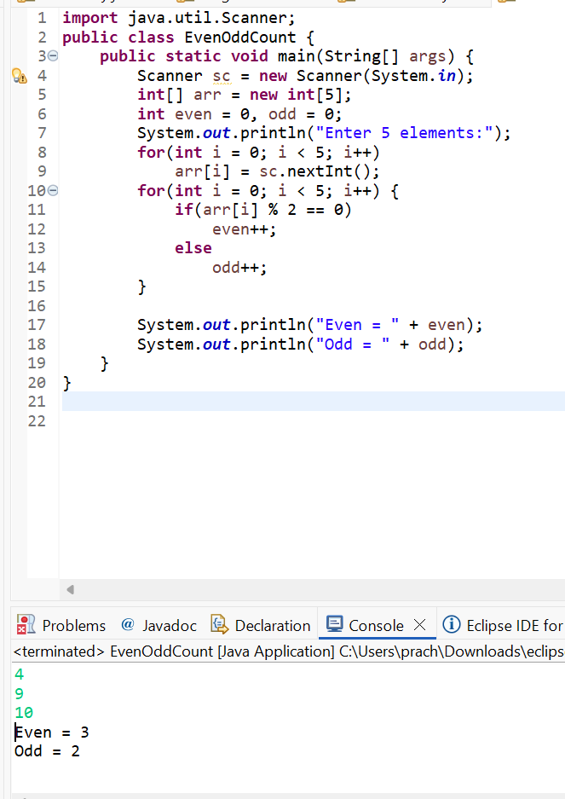

6. Program to Sort Array in Ascending Order
Code:
import java.util.Scanner;
public class SortArray {
public static void main(String[] args) {
Scanner sc = new Scanner(System.in);
int[] arr = new int[5];
int temp;
System.out.println("Enter 5 elements:");
for(int i = 0; i < 5; i++)
arr[i] = sc.nextInt();
for(int i = 0; i < 5; i++) {
for(int j = i + 1; j < 5; j++) {
if(arr[i] > arr[j]) {
temp = arr[i];
arr[i] = arr[j];
arr[j] = temp;
}
}
}
System.out.println("Sorted array:");
for(int i = 0; i < 5; i++)
System.out.print(arr[i] + " ");
}
}
OUTPUT:
Input:
45 12 78 23 9
Output:
Sorted array:
9 12 23 45 78
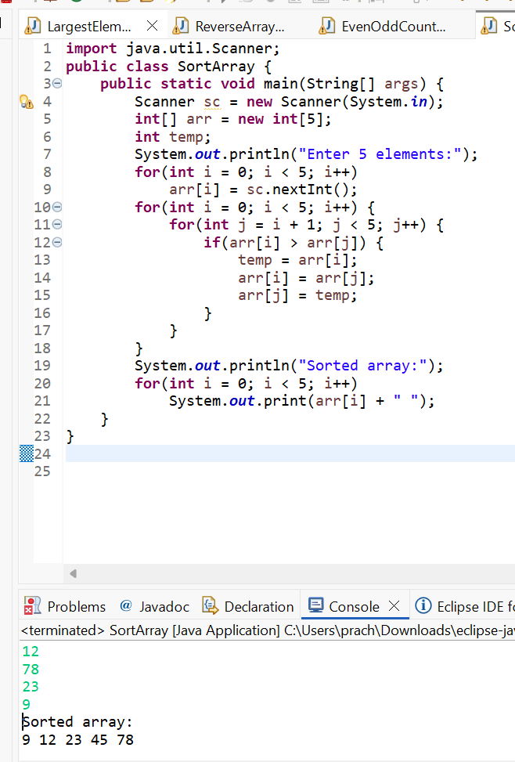

7. Program to Find Second Largest Element
Code:
import java.util.Scanner;
public class SecondLargest {
public static void main(String[] args) {
Scanner sc = new Scanner(System.in);
int[] arr = new int[5];

System.out.println("Enter 5 elements:");
for(int i = 0; i < 5; i++)
arr[i] = sc.nextInt();
int largest = arr[0];
int second = arr[0];
for(int i = 0; i < 5; i++) {
if(arr[i] > largest) {
second = largest;
largest = arr[i];
}
}
System.out.println("Second largest = " + second);
}
}
OUTPUT:
Input:
10 45 23 89 67
Output:
Second largest = 67
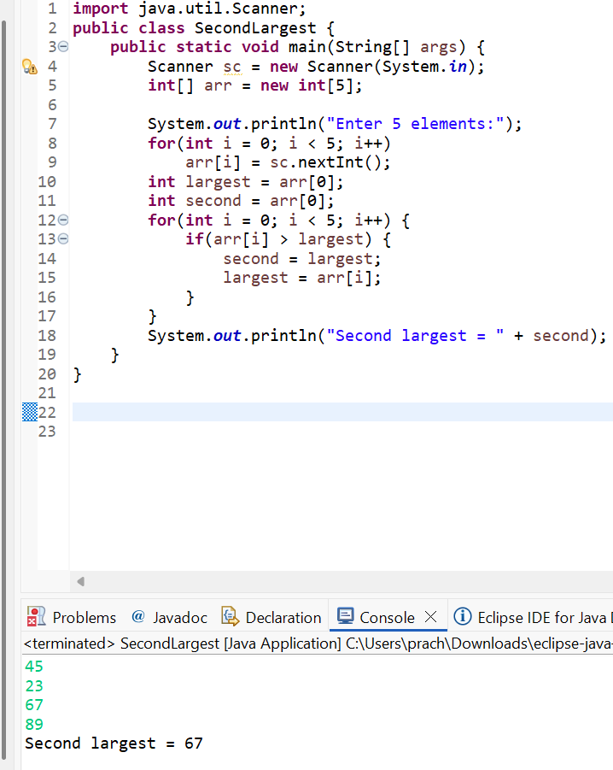

8. Program for Matrix Addition (2D Array)
Code:
import java.util.Scanner;
public class MatrixAddition {
public static void main(String[] args) {
Scanner sc = new Scanner(System.in);
int[][] a = new int[2][2];
int[][] b = new int[2][2];
int[][] sum = new int[2][2];
System.out.println("Enter elements of matrix A:");
for(int i = 0; i < 2; i++)
for(int j = 0; j < 2; j++)
a[i][j] = sc.nextInt();
System.out.println("Enter elements of matrix B:");
for(int i = 0; i < 2; i++)
for(int j = 0; j < 2; j++)
b[i][j] = sc.nextInt();
for(int i = 0; i < 2; i++)
for(int j = 0; j < 2; j++)
sum[i][j] = a[i][j] + b[i][j];
System.out.println("Sum matrix:");
for(int i = 0; i < 2; i++) {
for(int j = 0; j < 2; j++)
System.out.print(sum[i][j] + " ");
System.out.println();
}
}
}
OUTPUT:
Matrix A:
1 2
3 4
Matrix B:
5 6
7 8
Sum matrix:
6 8
10 12
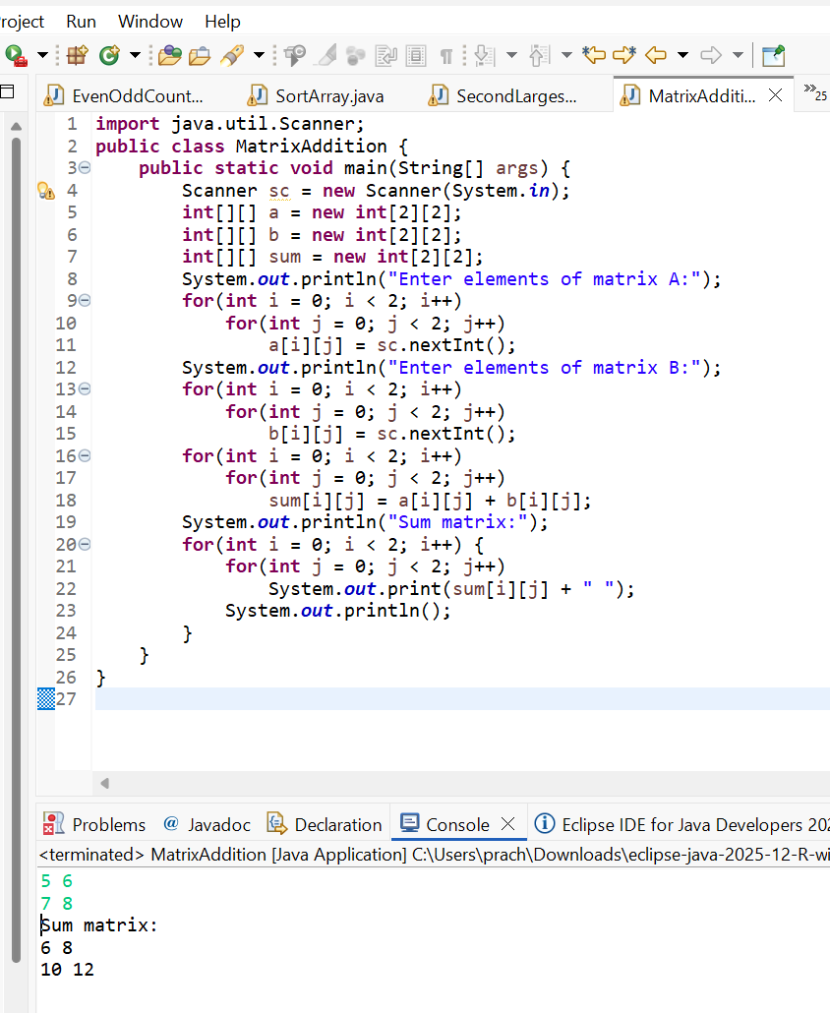

POST LAB EXERCISE
- Why is array indexing usually started from zero instead of one?
Array indexing starts from zero because the index represents the offset from the first memory location. The first element is stored at the base address, so its offset is zero. This makes memory access faster and simpler for the system.
- What happens if we try to access an array element outside its declared size?
If we try to access an array element beyond its declared size, it causes a runtime error. In Java, this results in an ArrayIndexOutOfBoundsException, and the program terminates abnormally.
- How does memory allocation differ for static arrays and dynamic arrays?
In static arrays, memory size is fixed at compile time and cannot be changed during program execution. In dynamic arrays, memory is allocated at runtime, allowing the size to be changed as needed, which provides more flexibility.
- Why is searching faster in arrays compared to linked lists?
Searching is faster in arrays because elements are stored in contiguous memory locations, allowing direct access using index values. In linked lists, elements are stored in non-contiguous locations, so each node must be traversed sequentially.
- What is the difference between contiguous and non-contiguous memory allocation?
In contiguous memory allocation, data elements are stored in adjacent memory locations, which allows faster access. In non-contiguous memory allocation, elements are stored in separate memory locations linked together, which is more flexible but slower to access.

Result:

Thus the array operations were executed successfully.

ASSESSMENT

Description | Max Marks | Marks Awarded
Pre Lab Exercise | 5
In Lab Exercise | 10
Post Lab Exercise | 5
Viva | 10
Total | 30
Faculty Signature

