Experiment Number : 01 Date: 22.01.26

Installation of Java and Simple Java Programs
Aim:
To install Java Development Kit (JDK), configure the environment, and write simple Java programs including Hello World.
PRE LAB EXERCISE
QUESTIONS
- What is JDK and why is it required?
The JDK (Java Development Kit) is a complete software package used for developing Java applications. It contains all the tools required to write, compile, debug, and run Java programs, including the compiler (javac), the Java Runtime Environment (JRE), the Java Virtual Machine (JVM), and other development utilities. The JDK is required because without it, a programmer cannot compile source code into bytecode or develop Java applications. It provides the full environment needed for Java program development.
- Difference between JDK, JRE, and JVM.
The JVM (Java Virtual Machine) is the core component responsible for executing Java bytecode and providing platform independence. The JRE (Java Runtime Environment) consists of the JVM along with core class libraries and supporting files required to run Java programs, but it does not include development tools. The JDK (Java Development Kit) includes the JRE plus development tools such as the compiler and debugger, making it suitable for creating and compiling Java programs. In short, JVM runs the code, JRE provides the environment to run it, and JDK provides the environment to develop it.
- What is the purpose of the main() method in Java?
The main() method is the entry point of a Java application. When a Java program is executed, the JVM first looks for the public static void main(String[] args) method and starts program execution from there. It is defined as static so that it can be called without creating an object, public so that it is accessible to the JVM, and void because it does not return any value. Without the main() method, a normal Java program cannot start execution.

IN LAB EXERCISE
Objective:
To verify Java installation and execute a basic Java program.
INSTALLATION STEPS:
STEP 1: Open Browser
- Open your browser and go to the official URL Eclipse Downloads page.

STEP 2: Download Eclipse Installer
- Then, click on the "Download" button to download Eclipse IDE.

STEP 3: Download EXE
- Now, click on the "Download x86_64" button.


STEP 4: Then click on the "Download" button. After clicking on the download button the .exe file for the eclipse will be downloaded.



STEP 5: Open Download EXE
- Now go to File Explorer and click on "Downloads" after that click on the "eclipse-inst-jre-win64.exe" file for installing Eclipse IDE.

STEP 6: Install Eclipse
- Then, click on "Eclipse IDE for Java Developers".


STEP 7: Then, click on the "Install" button.


Step 8: Create New Project
Now click on "Create a new Java project".

STEP 9:Create a new java project
- By clicking on the File menu and choosing New → Java Project.
- By right clicking anywhere in the Project Explorer and selecting New → Java Project.
- By clicking on the New button ( ) in the Tool bar and selecting Java Project.
STEP 10: Enter the Project Name
- Select the Java Runtime Environment (JRE) or leave it at the default
- Select the Project Layout which determines whether there would be a separate folder for the source codes and class files. The recommended option is to create separate folders for sources and class files.
- 
STEP 11: Create a new java package
- By clicking on the File menu and selecting New → Package.
- By right click in the package explorer and selecting New → Package.
- By clicking on the package icon which is in the tool bar( ).
STEP 11:
- Enter/confirm the source folder name.
- Enter the package name.
- Click on the Finish button.


STEP 12:Create a New Java class.
- By clicking on the File menu and selecting New → Class.
- By right clicking in the package explorer and selecting New → Class.
- By clicking on the class drop down button ( ) and selecting class ( ).
STEP 13:
- Ensure the source folder and package are correct.
- Enter the class name.
- Select the appropriate class modifier.
- Enter the super class name or click on the Browse button to search for an existing class.
- Click on the Add button to select the interfaces implemented by this class.
- Examine and modify the check boxes related to method stubs and comments.


STEP 14: Class created successfully.

BASIC PROGRAMS:
Program 1: Hello World Program
Source Code:
class HelloWorld {
public static void main(String[] args) {
System.out.println("Hello World");
}
}
Output:
Hello World
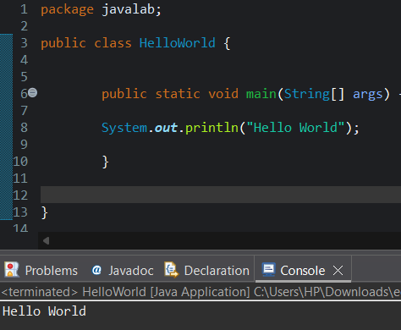
Program 2: Display Personal Details
Source Code:
class DisplayInfo {
public static void main(String[] args) {
System.out.println("Name: Anitha");
System.out.println("Age: 20");
}
}

Output:
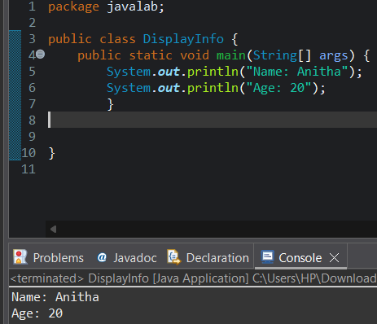
Name: Anitha
Age: 20
Program 3: Addition of Two Numbers
Source Code:
class AddTwoNumbers {
public static void main(String[] args) {
int a = 10, b = 20;
System.out.println("Sum = " + (a + b));
}
}
Output:
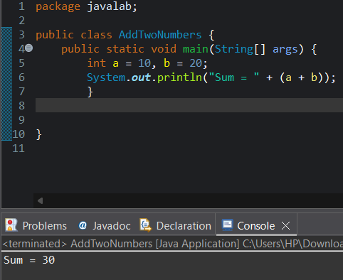
Sum = 30
Program 4: Area of a Rectangle
Source Code:
class AreaRectangle {
public static void main(String[] args) {
int length = 10, breadth = 5;
System.out.println("Area = " + (length * breadth));
}
}

Output:
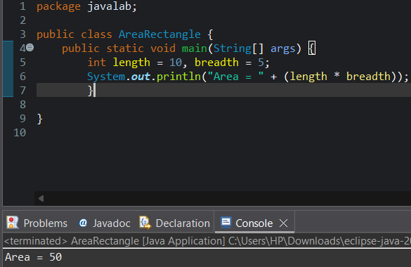
Area = 50
Program 5: Simple Interest Calculation
Source Code:
class SimpleInterest {
public static void main(String[] args) {
int p = 1000;
int r = 5;
int t = 2;
int si = (p * r * t) / 100;
System.out.println("Simple Interest = " + si);
}
}

Output:
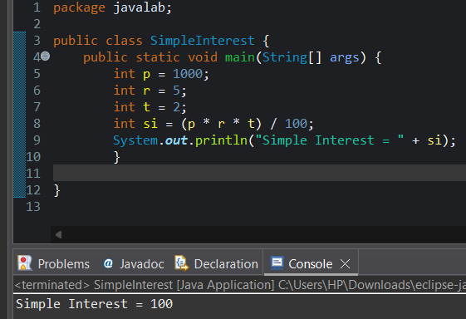
Simple Interest = 100

POST LAB EXERCISE
- Write a Java program to display your name and department.
class DisplayInfo {
public static void main(String[] args) {
System.out.println("Name: Sachita");
System.out.println("Department: Computer Science");
}
}

- Modify the program to print the output in same line.
class DisplayInfo {
public static void main(String[] args) {
System.out.print("Name: Sahana ");
System.out.print("Department: Computer Science");
}

- What happens if main() is written without static?
If the main() method is written without the static keyword, the program will compile successfully, but it will not execute. At runtime, the Java Virtual Machine will generate an error stating that the main method is not static. This is because the JVM invokes the main() method without creating an object of the class, and only static methods can be called directly using the class name. Therefore, the static keyword is mandatory in the main() method signature.
- Why is Java called platform independent?
Java is called platform independent because Java source code is compiled into an intermediate form known as bytecode. This bytecode is not specific to any operating system or hardware architecture. It is executed by the Java Virtual Machine (JVM), which is available for different platforms. As a result, the same Java program can run on any system that has a compatible JVM, supporting the principle “Write Once, Run Anywhere.”
- Write a program to find the cube of a number.
class Cube {
public static void main(String[] args) {
int num = 3;
int cube = num * num * num;
System.out.println("Cube is: " + cube);
}
}

Result:

Thus the Java IDE was successfully installed and a simple Java program was executed.

ASSESSMENT

Description | Max Marks | Marks Awarded
Pre Lab Exercise | 5
In Lab Exercise | 10
Post Lab Exercise | 5
Viva | 10
Total | 30
Faculty Signature

