Experiment Number : 04 Date: 04-02-2026

ARRAYS
Aim:
To understand and implement array operations in Java.
PRE LAB EXERCISE
QUESTIONS
- What is an array?
An array is a collection of elements of the same data type stored in contiguous memory locations and accessed using an index.

- Why are arrays used?
Arrays are used to store multiple values in a single structure, making it easier to manage, process, and access large amounts of related data efficiently.

- What is the difference between array and variable?
A variable stores one value, while an array stores many values under a single name, using index positions to access each element.

IN LAB EXERCISE
Objective:
To perform array operations using simple programs.
PROGRAMS:
1. Program to Read and Print Array Elements
Code:
import java.util.Scanner;
public class ReadPrintArray {
public static void main(String[] args) {
Scanner sc = new Scanner(System.in);
int[] arr = new int[5];
System.out.println("Enter 5 elements:");
for(int i = 0; i < 5; i++)
arr[i] = sc.nextInt();
System.out.println("Array elements are:");
for(int i = 0; i < 5; i++)
System.out.print(arr[i] + " ");
}
}
OUTPUT:
Input:
10 20 30 40 50
Output:
Array elements are:
10 20 30 40 50
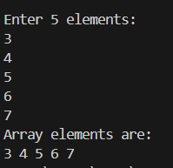

2. Program to Find Sum of Array Elements
Code:
import java.util.Scanner;
public class SumArray {
public static void main(String[] args) {
Scanner sc = new Scanner(System.in);
int[] arr = new int[5];
int sum = 0;
System.out.println("Enter 5 elements:");
for(int i = 0; i < 5; i++)
arr[i] = sc.nextInt();
for(int i = 0; i < 5; i++)
sum += arr[i];
System.out.println("Sum = " + sum);
}
}
OUTPUT:
Input:
5 10 15 20 25
Output:
Sum = 75
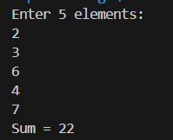

3. Program to Find Largest Element in an Array
Code:
import java.util.Scanner;
public class LargestElement {
public static void main(String[] args) {
Scanner sc = new Scanner(System.in);
int[] arr = new int[5];
System.out.println("Enter 5 elements:");
for(int i = 0; i < 5; i++)
arr[i] = sc.nextInt();
int max = arr[0];
for(int i = 1; i < 5; i++)
if(arr[i] > max)
max = arr[i];
System.out.println("Largest element = " + max);
}
}
OUTPUT:
Input:
12 45 23 9 30
Output:
Largest element = 45
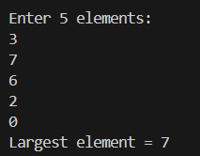

4. Program to Reverse an Array
Code:
import java.util.Scanner;

public class ReverseArray {
public static void main(String[] args) {
Scanner sc = new Scanner(System.in);
int[] arr = new int[5];
System.out.println("Enter 5 elements:");
for(int i = 0; i < 5; i++)
arr[i] = sc.nextInt();
System.out.println("Reversed array:");
for(int i = 4; i >= 0; i--)
System.out.print(arr[i] + " ");
}
}
OUTPUT:
Input:
1 2 3 4 5
Output:
Reversed array:
5 4 3 2 1
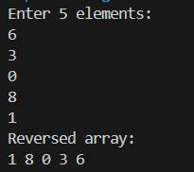

5. Program to Count Even and Odd Numbers
Code:
import java.util.Scanner;
public class EvenOddCount {
public static void main(String[] args) {
Scanner sc = new Scanner(System.in);
int[] arr = new int[5];
int even = 0, odd = 0;
System.out.println("Enter 5 elements:");
for(int i = 0; i < 5; i++)
arr[i] = sc.nextInt();
for(int i = 0; i < 5; i++) {
if(arr[i] % 2 == 0)
even++;
else
odd++;
}

System.out.println("Even = " + even);
System.out.println("Odd = " + odd);
}
}
OUTPUT:
Input:
2 7 4 9 10
Output:
Even = 3
Odd = 2
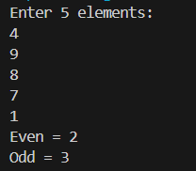

6. Program to Sort Array in Ascending Order
Code:
import java.util.Scanner;
public class SortArray {
public static void main(String[] args) {
Scanner sc = new Scanner(System.in);
int[] arr = new int[5];
int temp;
System.out.println("Enter 5 elements:");
for(int i = 0; i < 5; i++)
arr[i] = sc.nextInt();
for(int i = 0; i < 5; i++) {
for(int j = i + 1; j < 5; j++) {
if(arr[i] > arr[j]) {
temp = arr[i];
arr[i] = arr[j];
arr[j] = temp;
}
}
}
System.out.println("Sorted array:");
for(int i = 0; i < 5; i++)
System.out.print(arr[i] + " ");
}
}
OUTPUT:
Input:
45 12 78 23 9
Output:
Sorted array:
9 12 23 45 78
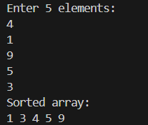

7. Program to Find Second Largest Element
Code:
import java.util.Scanner;
public class SecondLargest {
public static void main(String[] args) {
Scanner sc = new Scanner(System.in);
int[] arr = new int[5];

System.out.println("Enter 5 elements:");
for(int i = 0; i < 5; i++)
arr[i] = sc.nextInt();
int largest = arr[0];
int second = arr[0];
for(int i = 0; i < 5; i++) {
if(arr[i] > largest) {
second = largest;
largest = arr[i];
}
}
System.out.println("Second largest = " + second);
}
}
OUTPUT:
Input:
10 45 23 89 67
Output:
Second largest = 67
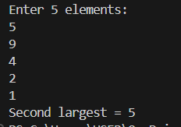

8. Program for Matrix Addition (2D Array)
Code:
import java.util.Scanner;
public class MatrixAddition {
public static void main(String[] args) {
Scanner sc = new Scanner(System.in);
int[][] a = new int[2][2];
int[][] b = new int[2][2];
int[][] sum = new int[2][2];
System.out.println("Enter elements of matrix A:");
for(int i = 0; i < 2; i++)
for(int j = 0; j < 2; j++)
a[i][j] = sc.nextInt();
System.out.println("Enter elements of matrix B:");
for(int i = 0; i < 2; i++)
for(int j = 0; j < 2; j++)
b[i][j] = sc.nextInt();
for(int i = 0; i < 2; i++)
for(int j = 0; j < 2; j++)
sum[i][j] = a[i][j] + b[i][j];
System.out.println("Sum matrix:");
for(int i = 0; i < 2; i++) {
for(int j = 0; j < 2; j++)
System.out.print(sum[i][j] + " ");
System.out.println();
}
}
}
OUTPUT:
Matrix A:
1 2
3 4
Matrix B:
5 6
7 8
Sum matrix:
6 8
10 12
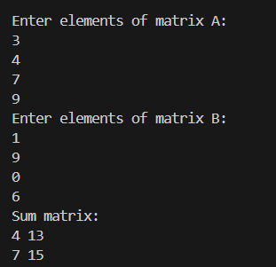

POST LAB EXERCISE
- Why is array indexing usually started from zero instead of one?
Because the index represents an offset from the starting memory address. The first element is stored exactly at the base address, so its offset is 0. Starting from 0 makes address calculation simpler and faster at the hardware level.

- What happens if we try to access an array element outside its declared size?
That’s called out-of-bounds access. It leads to undefined behavior: you might read garbage values, overwrite other memory, crash the program, or create security bugs. Languages like C/C++ don’t stop you; safer languages throw runtime errors.

- How does memory allocation differ for static arrays and dynamic arrays?
Static arrays are allocated at compile time with a fixed size, usually on the stack. Their size cannot change.
Dynamic arrays are allocated at runtime on the heap, and their size can be decided or resized during execution (using malloc/new or similar).

- Why is searching faster in arrays compared to linked lists?
Arrays support direct indexing: you can jump to any element in constant time O(1). Linked lists require sequential traversal, so you must walk node by node, which is slower (O(n)) even to reach the middle.

- What is the difference between contiguous and non-contiguous memory allocation?
Contiguous allocation stores elements next to each other in memory, enabling fast indexing and cache-friendly access (arrays).
Non-contiguous allocation stores elements scattered in memory, connected by pointers (linked lists), which is flexible but slower to traverse.

Result:

Thus the array operations were executed successfully.

ASSESSMENT

Description | Max Marks | Marks Awarded
Pre Lab Exercise | 5
In Lab Exercise | 10
Post Lab Exercise | 5
Viva | 10
Total | 30
Faculty Signature

