Experiment Number : 06 Date: 05-02-2026

ABSTRACT CLASSES
Aim:
To understand and implement inheritance concepts in Java.
PRE LAB EXERCISE
QUESTIONS
- What is an abstract class?
A class that can't be instantiated and may have abstract methods (methods without a body) is called an abstract class. It serves as a foundational class for other classes.
- Why are abstract methods used?
Child classes are forced to provide their own implementation by using abstract methods. They give all subclasses a common structure and aid in achieving polymorphism.
- Difference between abstract class and interface.
While an interface primarily consists of abstract methods (with default/static methods permitted starting with Java 8), an abstract class can have both abstract and concrete methods. Interface variables are always public, static, and final, but variables in abstract classes can have any level of access. Interfaces permit multiple inheritance, while abstract classes only permit one. To put it simply, interfaces define common behaviour, and abstract classes define common structure.
IN LAB EXERCISE
Objective:
To implement abstract class and demonstrate abstraction.
PROGRAMS:
1.University System
Scenario:
A university has different types of courses: Online, Offline, and Hybrid. Each course has a getDetails() method.
Question:
Create an abstract class Course with abstract method getDetails(). Implement OnlineCourse, OfflineCourse, and HybridCourse classes.
Code:
abstract class Course {
abstract void getDetails();
}

class OnlineCourse extends Course {
void getDetails() {
System.out.println("Online Course: Attend via Internet");
}
}

class OfflineCourse extends Course {
void getDetails() {
System.out.println("Offline Course: Attend in classroom");
}
}

class HybridCourse extends Course {
void getDetails() {
System.out.println("Hybrid Course: Combination of online and offline");
}
}

public class Main {
public static void main(String[] args) {
Course c1 = new OnlineCourse();
Course c2 = new OfflineCourse();
Course c3 = new HybridCourse();

c1.getDetails();
c2.getDetails();
c3.getDetails();
}
}
Output:
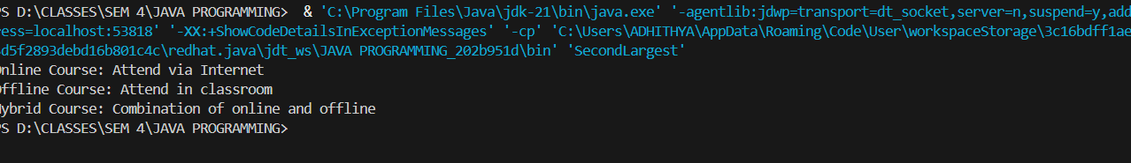2. Employee Payroll System
Scenario:
A company has different types of employees — Regular and Contract. All employees have a salary, but the calculation differs for each type.
Question:
Design an abstract class Employee with an abstract method calculateSalary(). Implement subclasses RegularEmployee and ContractEmployee to calculate salary differently.
Code:
import java.util.Scanner;
abstract class Employee {
String name;
double baseSalary;

// Abstract method to calculate total salary
abstract void calculateSalary();
}

class RegularEmployee extends Employee {
double bonusRate = 0.1; // 10% bonus

void calculateSalary() {
double totalSalary = baseSalary + (baseSalary * bonusRate);
System.out.println("Regular Employee: " + name);
System.out.println("Base Salary: " + baseSalary);
System.out.println("Total Salary (with 10% bonus): " + totalSalary);
}
}

class ContractEmployee extends Employee {
void calculateSalary() {
System.out.println("Contract Employee: " + name);
System.out.println("Total Salary: " + baseSalary);
}
}

public class Main {
public static void main(String[] args) {
Scanner sc = new Scanner(System.in);

// Input for Regular Employee
System.out.print("Enter Regular Employee Name: ");
String regName = sc.nextLine();
System.out.print("Enter Base Salary: ");
double regSalary = sc.nextDouble();
sc.nextLine(); // Consume newline

// Input for Contract Employee
System.out.print("Enter Contract Employee Name: ");
String conName = sc.nextLine();
System.out.print("Enter Base Salary: ");
double conSalary = sc.nextDouble();

// Create objects
Employee e1 = new RegularEmployee();
e1.name = regName;
e1.baseSalary = regSalary;

Employee e2 = new ContractEmployee();
e2.name = conName;
e2.baseSalary = conSalary;

System.out.println("\n--- Salary Details ---");
e1.calculateSalary();
System.out.println();
e2.calculateSalary();

sc.close();
}
}
Output:
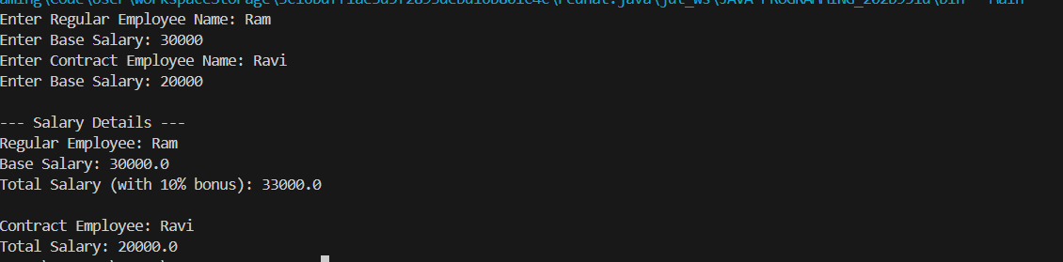3.Banking System
Scenario:
A bank has different types of accounts: Savings and Current. Both accounts need a method to calculate interest, but the calculation differs for each account type.
Question:
Use an abstract class BankAccount with an abstract method calculateInterest() and implement it in SavingsAccount and CurrentAccount classes.
Code
abstract class BankAccount {
String accountHolder;
double balance;

BankAccount(String name, double bal) {
accountHolder = name;
balance = bal;
}

abstract void calculateInterest(); // Abstract method
}

class SavingsAccount extends BankAccount {
double interestRate = 0.04; // 4% interest

SavingsAccount(String name, double bal) {
super(name, bal);
}

void calculateInterest() {
double interest = balance * interestRate;
System.out.println("Savings Account Interest for " + accountHolder + " = " + interest);
}
}

class CurrentAccount extends BankAccount {
double interestRate = 0.02; // 2% interest

CurrentAccount(String name, double bal) {
super(name, bal);
}

void calculateInterest() {
double interest = balance * interestRate;
System.out.println("Current Account Interest for " + accountHolder + " = " + interest);
}
}

public class Main {
public static void main(String[] args) {
BankAccount acc1 = new SavingsAccount("Ram", 50000);
BankAccount acc2 = new CurrentAccount("Ravi", 80000);

acc1.calculateInterest();
acc2.calculateInterest();
}
}

Output
POST LAB EXERCISE
- How is an abstract class different from a regular class?
A regular class can be instantiated and needs to have full method definitions, whereas an abstract class cannot be instantiated and may contain abstract methods.
- Can you create an object of an abstract class? Why or why not?
An abstract class may contain abstract methods without a body, making it incomplete, so you cannot create an object of that class.

- What happens if a subclass does not implement an abstract method?
A compile-time error occurs if a subclass fails to implement all abstract methods; in this case, the subclass must also be declared abstract.
- Can an abstract class exist without any abstract methods?
Yes, it is possible for an abstract class to exist without abstract methods. It serves as a foundation for inheritance and inhibits the creation of objects.

- Can an abstract class extend another abstract class?
It is true that an abstract class can inherit the abstract methods of another abstract class and extend it.

Result:

Thus the abstract classes and methods were implemented and executed successfully.

ASSESSMENT

Description | Max Marks | Marks Awarded
Pre Lab Exercise | 5
In Lab Exercise | 10
Post Lab Exercise | 5
Viva | 10
Total | 30
Faculty Signature

