Experiment Number : 06 Date: 5/2/26

ABSTRACT CLASSES
Aim:
To understand and implement inheritance concepts in Java.
PRE LAB EXERCISE
QUESTIONS
- What is an abstract class?
An abstract class is a class that cannot be instantiated and may contain abstract and non-abstract methods.It is used as a base class to provide common structure for subclasses.
- Why are abstract methods used?
Abstract methods declare a method without implementation.They force child classes to provide their own implementation.
- Difference between abstract class and interface.
Abstract Class | Interface
Can have abstract + concrete methods | Mostly only abstract methods
Supports constructors | No constructors
Uses extends | Uses implements
Supports single inheritance | Supports multiple inheritance

IN LAB EXERCISE
Objective:
To implement abstract class and demonstrate abstraction.
PROGRAMS:
1.University System
Scenario:
A university has different types of courses: Online, Offline, and Hybrid. Each course has a getDetails() method.
Question:
Create an abstract class Course with abstract method getDetails(). Implement OnlineCourse, OfflineCourse, and HybridCourse classes.
Code:
abstract class Course {
abstract void getDetails();
}
class OnlineCourse extends Course {
void getDetails() {
System.out.println("Online Course: Attend via Internet");
}
}
class OfflineCourse extends Course {
void getDetails() {
System.out.println("Offline Course: Attend in classroom");
}
}
class HybridCourse extends Course {
void getDetails() {
System.out.println("Hybrid Course: Combination of online and offline");
}
}
public class university {
public static void main(String[] args) {
Course c1 = new OnlineCourse();
Course c2 = new OfflineCourse();
Course c3 = new HybridCourse();

c1.getDetails();
c2.getDetails();
c3.getDetails();
}
}
Output:
Online Course: Attend via Internet
Offline Course: Attend in classroom
Hybrid Course: Combination of online and offline
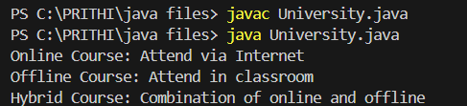
2. Employee Payroll System
Scenario:
A company has different types of employees — Regular and Contract. All employees have a salary, but the calculation differs for each type.
Question:
Design an abstract class Employee with an abstract method calculateSalary(). Implement subclasses RegularEmployee and ContractEmployee to calculate salary differently.
Code:
import java.util.Scanner;
abstract class Employee {
String name;
double baseSalary;
abstract void calculateSalary();
}
class RegularEmployee extends Employee {
double bonusRate = 0.1;

void calculateSalary() {
double totalSalary = baseSalary + (baseSalary * bonusRate);
System.out.println("Regular Employee: " + name);
System.out.println("Base Salary: " + baseSalary);
System.out.println("Total Salary (with 10% bonus): " + totalSalary);
}
}
class ContractEmployee extends Employee {
void calculateSalary() {
System.out.println("Contract Employee: " + name);
System.out.println("Total Salary: " + baseSalary);
}
}
class emp {
public static void main(String[] args) {
Scanner sc = new Scanner(System.in);
System.out.print("Enter Regular Employee Name: ");
String regName = sc.nextLine();
System.out.print("Enter Base Salary: ");
double regSalary = sc.nextDouble();
sc.nextLine();
System.out.print("Enter Contract Employee Name: ");
String conName = sc.nextLine();
System.out.print("Enter Base Salary: ");
double conSalary = sc.nextDouble();
Employee e1 = new RegularEmployee();
e1.name = regName;
e1.baseSalary = regSalary;
Employee e2 = new ContractEmployee();
e2.name = conName;
e2.baseSalary = conSalary;
System.out.println("\n--- Salary Details ---");
e1.calculateSalary();
System.out.println();
e2.calculateSalary();
sc.close();
}
}
Output:

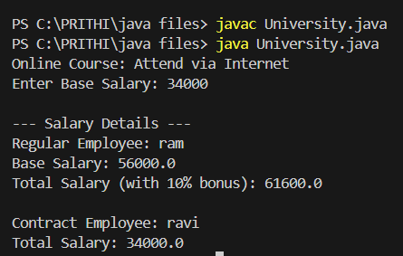
3.Banking System
Scenario:
A bank has different types of accounts: Savings and Current. Both accounts need a method to calculate interest, but the calculation differs for each account type.
Question:
Use an abstract class BankAccount with an abstract method calculateInterest() and implement it in SavingsAccount and CurrentAccount classes.
Code
abstract class BankAccount {
String accountHolder;
double balance;
BankAccount(String name, double bal) {
accountHolder = name;
balance = bal;
}
abstract void calculateInterest();
}
class SavingsAccount extends BankAccount {
double interestRate = 0.04;
SavingsAccount(String name, double bal) {
super(name, bal);
}
void calculateInterest() {
double interest = balance * interestRate;
System.out.println("Savings Account Interest for " + accountHolder + " = " + interest);
}
}
class CurrentAccount extends BankAccount {
double interestRate = 0.02;
CurrentAccount(String name, double bal) {
super(name, bal);
}
void calculateInterest() {
double interest = balance * interestRate;
System.out.println("Current Account Interest for " + accountHolder + " = " + interest);
}
}
class acc {
public static void main(String[] args) {
BankAccount acc1 = new SavingsAccount("Ram", 50000);
BankAccount acc2 = new CurrentAccount("Ravi", 80000);
acc1.calculateInterest();
acc2.calculateInterest();
}
}
Output
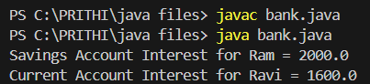
POST LAB EXERCISE
- How is an abstract class different from a regular class?
An abstract class can have abstract (unimplemented) methods, while a regular class has only fully defined methods. An abstract class cannot be instantiated directly but a regular class can.
- Can you create an object of an abstract class? Why or why not?
No, an abstract class cannot be instantiated because it may contain methods without implementation. Objects must be created using a subclass that implements those methods.
- What happens if a subclass does not implement an abstract method?
The subclass will cause a compilation error if it does not implement all abstract methods. It must either implement them or be declared abstract.
- Can an abstract class exist without any abstract methods?
Yes, an abstract class can have only concrete methods. It is declared abstract to prevent direct object creation.
- Can an abstract class extend another abstract class?

Result:

Thus the abstract classes and methods were implemented and executed successfully.

ASSESSMENT

Description | Max Marks | Marks Awarded
Pre Lab Exercise | 5
In Lab Exercise | 10
Post Lab Exercise | 5
Viva | 10
Total | 30
Faculty Signature

