Experiment Number : 07 Date: 5/2/26

METHOD OVERLOADING AND METHOD OVERRIDING
Aim:
To understand and implement method overloading and method overriding.
PRE LAB EXERCISE
QUESTIONS
- What is method overloading?
Method overloading is defining multiple methods in the same class with the same name but different parameters. It is resolved at compile time and improves code readability.
- What is method overriding?
Method overriding is when a subclass provides a new implementation for a method already defined in its parent class. It supports runtime polymorphism.
- Difference between overloading and overriding.
Overloading happens in the same class with different parameters and is decided at compile time. Overriding happens in inheritance with the same method signature and is decided at runtime.
IN LAB EXERCISE
Objective:
To demonstrate compile-time and runtime polymorphism.
PROGRAMS:
1.Student Result System (Method Overriding)
Description:
- Base class Student has method displayResult().
- Subclasses UGStudent and PGStudent override the method to show different grading systems.

Code :
import java.util.Scanner;

// Base class
class Student {
String name;
void displayResult() {
System.out.println("Student Result");
}
}
class UGStudent extends Student {
int marks;
UGStudent(String n, int m) {
name = n;
marks = m;
}
@Override
void displayResult() {
double percentage = (marks / 100.0) * 100;
System.out.println("UG Student: " + name);
System.out.println("Marks: " + marks);
System.out.println("Percentage: " + percentage + "%");
}
}
class PGStudent extends Student {
double gpa;
PGStudent(String n, double g) {
name = n;
gpa = g;
}
@Override
void displayResult() {
System.out.println("PG Student: " + name);
System.out.println("GPA: " + gpa + " / 10");
}
}
public class clg {
public static void main(String[] args) {
Scanner sc = new Scanner(System.in);
System.out.print("Enter UG Student Name: ");
String ugName = sc.nextLine();
System.out.print("Enter UG Student Marks (out of 100): ");
int ugMarks = sc.nextInt();
sc.nextLine();
System.out.print("Enter PG Student Name: ");
String pgName = sc.nextLine();
System.out.print("Enter PG Student GPA (0-10): ");
double pgGpa = sc.nextDouble();
Student s1 = new UGStudent(ugName, ugMarks);
Student s2 = new PGStudent(pgName, pgGpa);
System.out.println("\n--- Student Results ---");
s1.displayResult();
System.out.println();
s2.displayResult();
sc.close();
}
}
OUTPUT:

Sample Input:
Enter UG Student Name: Ram
Enter UG Student Marks (out of 100): 85
Enter PG Student Name: Ravi
Enter PG Student GPA (0-10): 9.2

Output:
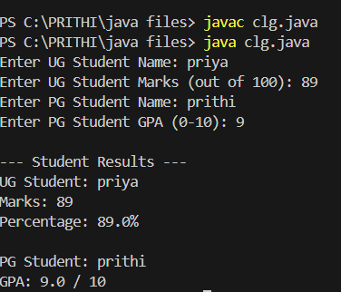
2. Calculator Program (Method Overloading)
Description:
Create a Calculator class with multiple add() methods to calculate:
- Addition of 2 integers
- Addition of 3 integers
- Addition of 2 double numbers
Code:
import java.util.Scanner;
class Calculator {
int add(int a, int b) {
return a + b;
}
int add(int a, int b, int c) {
return a + b + c;
}
double add(double a, double b) {
return a + b;
}
}
public class cal {
public static void main(String[] args) {
Scanner sc = new Scanner(System.in);
Calculator calc = new Calculator();
System.out.print("Enter two integers: ");
int x = sc.nextInt();
int y = sc.nextInt();
System.out.println("Sum of two integers: " + calc.add(x, y));
System.out.print("Enter three integers: ");
int p = sc.nextInt();
int q = sc.nextInt();
int r = sc.nextInt();
System.out.println("Sum of three integers: " + calc.add(p, q, r));
System.out.print("Enter two decimal numbers: ");
double a = sc.nextDouble();
double b = sc.nextDouble();
System.out.println("Sum of two doubles: " + calc.add(a, b));
sc.close();
}
}
Output:
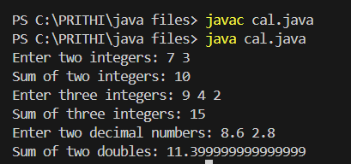

POST LAB EXERCISE
- Is return type important in method overloading and method overriding?
In method overloading, return type is not considered for distinguishing methods, only parameters matter. In method overriding, the return type must be the same or covariant (a subclass type).
- Can you overload a method by changing only the return type?
No, you cannot overload a method by changing only the return type. The parameter list must be different, otherwise it causes a compilation error.
- Can static methods be overridden? Can they be overloaded?
Static methods cannot be overridden because they belong to the class, not the object. However, they can be overloaded with different parameters.
- Can a method be overridden if the parameter list is different?
No, if the parameter list is different, it is method overloading, not overriding. Overriding requires the same method signature.
Result:
Thus the method overloading and overriding concepts were implemented and executed successfully.
ASSESSMENT

Description | Max Marks | Marks Awarded
Pre Lab Exercise | 5
In Lab Exercise | 10
Post Lab Exercise | 5
Viva | 10
Total | 30
Faculty Signature

