Experiment Number : 04 Date:

ARRAYS
Aim:
To understand and implement array operations in Java.
PRE LAB EXERCISE
QUESTIONS
1. What is an array?
An array is a data structure that holds a fixed number of elements of the same type in a continuous block of memory, where each element can be accessed using its position number.
2. Why are arrays used?
Arrays are used to store large amounts of similar data in an organized way so that the data can be easily accessed, updated, and processed using indexes and loops.
3. What is the difference between an array and a variable?
A variable stores a single piece of information, while an array stores many values under one name, allowing easy handling of multiple data items at once.
IN LAB EXERCISE
Objective:
To perform array operations using simple programs.
PROGRAMS:
1. Program to Read and Print Array Elements
Code:
import java.util.Scanner;
public class ReadPrintArray {
public static void main(String[] args) {
Scanner sc = new Scanner(System.in);
int[] arr = new int[5];
System.out.println("Enter 5 elements:");
for(int i = 0; i < 5; i++)
arr[i] = sc.nextInt();
System.out.println("Array elements are:");
for(int i = 0; i < 5; i++)
System.out.print(arr[i] + " ");
}
}
OUTPUT:
Input:
10 20 30 40 50
Output:
Array elements are:
10 20 30 40 50
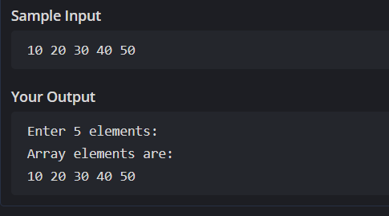

2. Program to Find Sum of Array Elements
Code:
import java.util.Scanner;
public class SumArray {
public static void main(String[] args) {
Scanner sc = new Scanner(System.in);
int[] arr = new int[5];
int sum = 0;
System.out.println("Enter 5 elements:");
for(int i = 0; i < 5; i++)
arr[i] = sc.nextInt();
for(int i = 0; i < 5; i++)
sum += arr[i];
System.out.println("Sum = " + sum);
}
}
OUTPUT:
Input:
5 10 15 20 25
Output:
Sum = 75
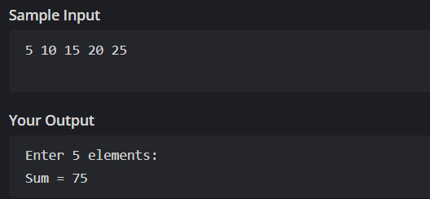
3. Program to Find Largest Element in an Array
Code:
import java.util.Scanner;
public class LargestElement {
public static void main(String[] args) {
Scanner sc = new Scanner(System.in);
int[] arr = new int[5];
System.out.println("Enter 5 elements:");
for(int i = 0; i < 5; i++)
arr[i] = sc.nextInt();
int max = arr[0];
for(int i = 1; i < 5; i++)
if(arr[i] > max)
max = arr[i];
System.out.println("Largest element = " + max);
}
}
OUTPUT:
Input:
12 45 23 9 30
Output:
Largest element = 45
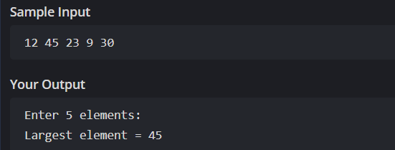

4. Program to Reverse an Array
Code:
import java.util.Scanner;

public class ReverseArray {
public static void main(String[] args) {
Scanner sc = new Scanner(System.in);
int[] arr = new int[5];
System.out.println("Enter 5 elements:");
for(int i = 0; i < 5; i++)
arr[i] = sc.nextInt();
System.out.println("Reversed array:");
for(int i = 4; i >= 0; i--)
System.out.print(arr[i] + " ");
}
}
OUTPUT:
Input:
1 2 3 4 5
Output:
Reversed array:
5 4 3 2 1
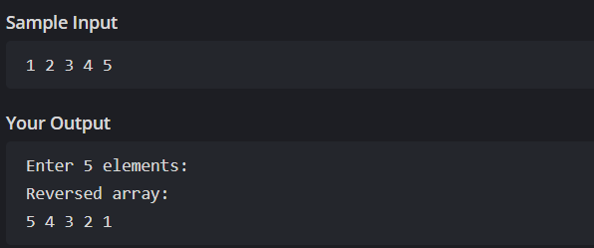

5. Program to Count Even and Odd Numbers
Code:
import java.util.Scanner;
public class EvenOddCount {
public static void main(String[] args) {
Scanner sc = new Scanner(System.in);
int[] arr = new int[5];
int even = 0, odd = 0;
System.out.println("Enter 5 elements:");
for(int i = 0; i < 5; i++)
arr[i] = sc.nextInt();
for(int i = 0; i < 5; i++) {
if(arr[i] % 2 == 0)
even++;
else
odd++;
}

System.out.println("Even = " + even);
System.out.println("Odd = " + odd);
}
}
OUTPUT:
Input:
2 7 4 9 10
Output:
Even = 3
Odd = 2
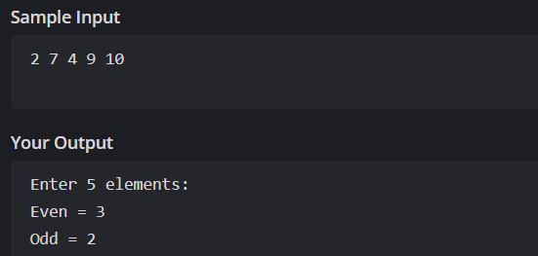
6. Program to Sort Array in Ascending Order
Code:
import java.util.Scanner;
public class SortArray {
public static void main(String[] args) {
Scanner sc = new Scanner(System.in);
int[] arr = new int[5];
int temp;
System.out.println("Enter 5 elements:");
for(int i = 0; i < 5; i++)
arr[i] = sc.nextInt();
for(int i = 0; i < 5; i++) {
for(int j = i + 1; j < 5; j++) {
if(arr[i] > arr[j]) {
temp = arr[i];
arr[i] = arr[j];
arr[j] = temp;
}
}
}
System.out.println("Sorted array:");
for(int i = 0; i < 5; i++)
System.out.print(arr[i] + " ");
}
}
OUTPUT:
Input:
45 12 78 23 9
Output:
Sorted array:
9 12 23 45 78
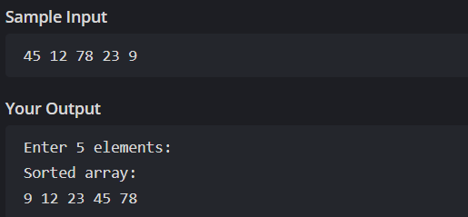

7. Program to Find Second Largest Element
Code:
import java.util.Scanner;
public class SecondLargest {
public static void main(String[] args) {
Scanner sc = new Scanner(System.in);
int[] arr = new int[5];

System.out.println("Enter 5 elements:");
for(int i = 0; i < 5; i++)
arr[i] = sc.nextInt();
int largest = arr[0];
int second = arr[0];
for(int i = 0; i < 5; i++) {
if(arr[i] > largest) {
second = largest;
largest = arr[i];
}
}
System.out.println("Second largest = " + second);
}
}
OUTPUT:
Input:
10 45 23 89 67
Output:
Second largest = 45
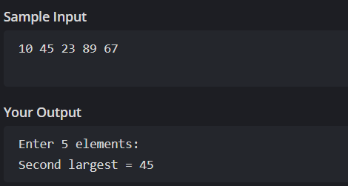

8. Program for Matrix Addition (2D Array)
Code:
import java.util.Scanner;
public class MatrixAddition {
public static void main(String[] args) {
Scanner sc = new Scanner(System.in);
int[][] a = new int[2][2];
int[][] b = new int[2][2];
int[][] sum = new int[2][2];
System.out.println("Enter elements of matrix A:");
for(int i = 0; i < 2; i++)
for(int j = 0; j < 2; j++)
a[i][j] = sc.nextInt();
System.out.println("Enter elements of matrix B:");
for(int i = 0; i < 2; i++)
for(int j = 0; j < 2; j++)
b[i][j] = sc.nextInt();
for(int i = 0; i < 2; i++)
for(int j = 0; j < 2; j++)
sum[i][j] = a[i][j] + b[i][j];
System.out.println("Sum matrix:");
for(int i = 0; i < 2; i++) {
for(int j = 0; j < 2; j++)
System.out.print(sum[i][j] + " ");
System.out.println();
}
}
}
OUTPUT:
Matrix A:
1 2
3 4
Matrix B:
5 6
7 8
Sum matrix:
6 8
10 12
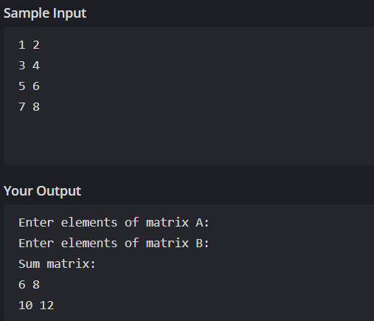

POST LAB EXERCISE
1. Why is array indexing usually started from zero instead of one?
Array indexing begins from zero because it makes address calculation easier, as the index directly maps to how far an element is from the first position in memory.

2. What happens if we try to access an array element outside its declared size?
Trying to access an invalid index leads to unpredictable behavior; in many programming languages, it causes an error or program crash to protect memory from being misused.
3. How does memory allocation differ for static arrays and dynamic arrays?
Static arrays are created with a fixed size that cannot change, while dynamic arrays can grow or shrink during program execution as needed.
4. Why is searching faster in arrays compared to linked lists?
Arrays allow instant access to any element using its position number, but linked lists require checking each node one by one, which takes more time.
5. What is the difference between contiguous and non-contiguous memory allocation?
Contiguous memory keeps data in one continuous block, making it faster to reach, while non-contiguous memory stores data in scattered locations connected through pointers.

Result:

Thus the array operations were executed successfully.

ASSESSMENT

Description | Max Marks | Marks Awarded
Pre Lab Exercise | 5
In Lab Exercise | 10
Post Lab Exercise | 5
Viva | 10
Total | 30
Faculty Signature

