Experiment Number : 04 Date: 05.02.2026

ARRAYS
Aim:
To understand and implement array operations in Java.
PRE LAB EXERCISE
QUESTIONS
1) What is an array?
An array is a collection of elements of the same data type stored in continuous memory locations.
Each element in an array is accessed using an index number, which starts from 0.
Example:
int[] marks = {80, 75, 90, 85};

2) Why are arrays used?
Arrays are used because:
- They allow storing multiple values in a single variable
- They make programs simple and organized
- They reduce the need for writing multiple variables
- They allow easy access to data using index
- They are useful when working with large amounts of data

3) Difference between array and variable
Variable | Array
Stores only one value | Stores multiple values
Can hold a single data item | Can hold many data items of same type
Needs many variables to store many values | One array is enough
Example: int a = 10; | Example: int[] a = {10, 20, 30};
IN LAB EXERCISE
Objective:
To perform array operations using simple programs.
PROGRAMS:
1. Program to Read and Print Array Elements
Code:
import java.util.Scanner;
public class ReadPrintArray {
public static void main(String[] args) {
Scanner sc = new Scanner(System.in);
int[] arr = new int[5];
System.out.println("Enter 5 elements:");
for(int i = 0; i < 5; i++)
arr[i] = sc.nextInt();
System.out.println("Array elements are:");
for(int i = 0; i < 5; i++)
System.out.print(arr[i] + " ");
}
}
OUTPUT:
Input:
10 20 30 40 50
Array elements are:
10 20 30 40 50
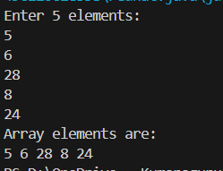

2. Program to Find Sum of Array Elements
Code:
import java.util.Scanner;
public class SumArray {
public static void main(String[] args) {
Scanner sc = new Scanner(System.in);
int[] arr = new int[5];
int sum = 0;
System.out.println("Enter 5 elements:");
for(int i = 0; i < 5; i++)
arr[i] = sc.nextInt();
for(int i = 0; i < 5; i++)
sum += arr[i];
System.out.println("Sum = " + sum);
}
}
OUTPUT:
Input:
5 10 15 20 25
Output:
Sum = 75
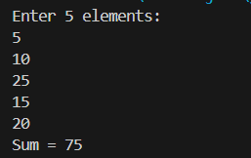

3. Program to Find Largest Element in an Array
Code:
import java.util.Scanner;
public class LargestElement {
public static void main(String[] args) {
Scanner sc = new Scanner(System.in);
int[] arr = new int[5];
System.out.println("Enter 5 elements:");
for(int i = 0; i < 5; i++)
arr[i] = sc.nextInt();
int max = arr[0];
for(int i = 1; i < 5; i++)
if(arr[i] > max)
max = arr[i];
System.out.println("Largest element = " + max);
}
}
OUTPUT:
Input:
12 45 23 9 30
Output:
Largest element = 45
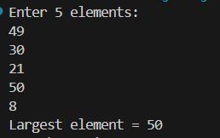

4. Program to Reverse an Array
Code:
import java.util.Scanner;

public class ReverseArray {
public static void main(String[] args) {
Scanner sc = new Scanner(System.in);
int[] arr = new int[5];
System.out.println("Enter 5 elements:");
for(int i = 0; i < 5; i++)
arr[i] = sc.nextInt();
System.out.println("Reversed array:");
for(int i = 4; i >= 0; i--)
System.out.print(arr[i] + " ");
}
}
OUTPUT:
Input:
1 2 3 4 5
Output:
Reversed array:
5 4 3 2 1
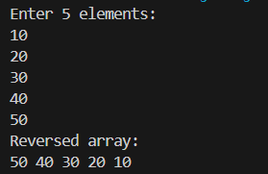

5. Program to Count Even and Odd Numbers
Code:
import java.util.Scanner;
public class EvenOddCount {
public static void main(String[] args) {
Scanner sc = new Scanner(System.in);
int[] arr = new int[5];
int even = 0, odd = 0;
System.out.println("Enter 5 elements:");
for(int i = 0; i < 5; i++)
arr[i] = sc.nextInt();
for(int i = 0; i < 5; i++) {
if(arr[i] % 2 == 0)
even++;
else
odd++;
}
System.out.println("Even = " + even);
System.out.println("Odd = " + odd);
}
}
OUTPUT:
Input:
2 7 4 9 10
Output:
Even = 3
Odd = 2
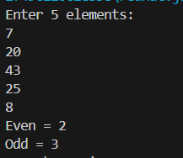

6. Program to Sort Array in Ascending Order
Code:
import java.util.Scanner;
public class SortArray {
public static void main(String[] args) {
Scanner sc = new Scanner(System.in);
int[] arr = new int[5];
int temp;
System.out.println("Enter 5 elements:");
for(int i = 0; i < 5; i++)
arr[i] = sc.nextInt();
for(int i = 0; i < 5; i++) {
for(int j = i + 1; j < 5; j++) {
if(arr[i] > arr[j]) {
temp = arr[i];
arr[i] = arr[j];
arr[j] = temp;
}
}
}
System.out.println("Sorted array:");
for(int i = 0; i < 5; i++)
System.out.print(arr[i] + " ");
}
}
OUTPUT:
Input:
45 12 78 23 9
Output:
Sorted array:
9 12 23 45 78
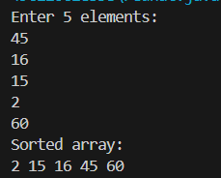

7. Program to Find Second Largest Element
Code:
import java.util.Scanner;
public class SecondLargest {
public static void main(String[] args) {
Scanner sc = new Scanner(System.in);
int[] arr = new int[5];

System.out.println("Enter 5 elements:");
for(int i = 0; i < 5; i++)
arr[i] = sc.nextInt();
int largest = arr[0];
int second = arr[0];
for(int i = 0; i < 5; i++) {
if(arr[i] > largest) {
second = largest;
largest = arr[i];
}
}
System.out.println("Second largest = " + second);
}
}
OUTPUT:
Input:
10 45 23 89 67
Output:
Second largest = 67
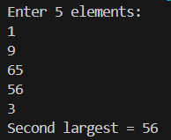

8. Program for Matrix Addition (2D Array)
Code:
import java.util.Scanner;
public class MatrixAddition {
public static void main(String[] args) {
Scanner sc = new Scanner(System.in);
int[][] a = new int[2][2];
int[][] b = new int[2][2];
int[][] sum = new int[2][2];
System.out.println("Enter elements of matrix A:");
for(int i = 0; i < 2; i++)
for(int j = 0; j < 2; j++)
a[i][j] = sc.nextInt();
System.out.println("Enter elements of matrix B:");
for(int i = 0; i < 2; i++)
for(int j = 0; j < 2; j++)
b[i][j] = sc.nextInt();
for(int i = 0; i < 2; i++)
for(int j = 0; j < 2; j++)
sum[i][j] = a[i][j] + b[i][j];
System.out.println("Sum matrix:");
for(int i = 0; i < 2; i++) {
for(int j = 0; j < 2; j++)
System.out.print(sum[i][j] + " ");
System.out.println();
}
}
}
OUTPUT:
Matrix A:
1 2
3 4
Matrix B:
5 6
7 8
Sum matrix:
6 8
10 12
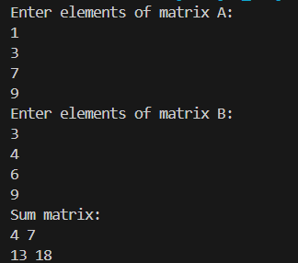

POST LAB EXERCISE
1) Why is array indexing usually started from zero instead of one?
Array indexing starts from zero because the index represents the offset from the starting memory location.
The first element is at offset 0, the second at offset 1, and so on.
This makes memory access faster and more efficient for the system.

2) What happens if we try to access an array element outside its declared size?
Accessing an array element outside its size causes an error or undefined behavior.
- In Java: ArrayIndexOutOfBoundsException
- In C/C++: May give garbage value or cause a runtime error
This happens because the program tries to access memory that does not belong to the array.

3) How does memory allocation differ for static arrays and dynamic arrays?
Static Array | Dynamic Array
Size is fixed at compile time | Size is decided at runtime
Memory allocated in stack | Memory allocated in heap
Cannot change size | Size can be increased or decreased
Faster access | Slightly slower than static arrays

4) Why is searching faster in arrays compared to linked lists?
Searching is faster in arrays because:
- Arrays support direct access using index
- Memory is contiguous
- No need to traverse element by element
In linked lists, elements must be accessed sequentially, which takes more time.

5) What is the difference between contiguous and non-contiguous memory allocation?
Contiguous Memory Allocation | Non-Contiguous Memory Allocation
Memory blocks are stored continuously | Memory blocks are stored at different locations
Faster access | Slower access
Used in arrays | Used in linked lists
Easy index-based access | Access through pointers
-

Result:

Thus the array operations were executed successfully.

ASSESSMENT

Description | Max Marks | Marks Awarded
Pre Lab Exercise | 5
In Lab Exercise | 10
Post Lab Exercise | 5
Viva | 10
Total | 30
Faculty Signature

