Experiment Number : 04 Date: 05/02/2026

ARRAYS
Aim:
To understand and implement array operations in Java.
PRE LAB EXERCISE
QUESTIONS
What is an array?
An array is a collection of similar data types stored in contiguous memory locations under one name.
Why are arrays used?
Arrays are used to store multiple values efficiently and access them easily using an index.
Difference between array and variable?
A variable stores one value, while an array stores multiple values of the same data type.
IN LAB EXERCISE
Objective:
To perform array operations using simple programs.
PROGRAMS:
1. Program to Read and Print Array Elements
Code:
import java.util.Scanner;
public class ReadPrintArray {
public static void main(String[] args) {
Scanner sc = new Scanner(System.in);
int[] arr = new int[5];
System.out.println("Enter 5 elements:");
for(int i = 0; i < 5; i++)
arr[i] = sc.nextInt();
System.out.println("Array elements are:");
for(int i = 0; i < 5; i++)
System.out.print(arr[i] + " ");
}
}
OUTPUT:
Input:
10 20 30 40 50
Output:
Array elements are:
10 20 30 40 50
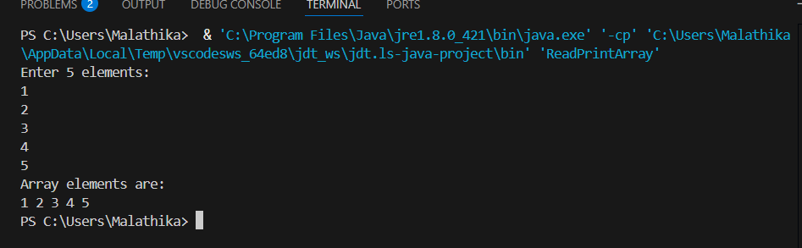

2. Program to Find Sum of Array Elements
Code:
import java.util.Scanner;
public class SumArray {
public static void main(String[] args) {
Scanner sc = new Scanner(System.in);
int[] arr = new int[5];
int sum = 0;
System.out.println("Enter 5 elements:");
for(int i = 0; i < 5; i++)
arr[i] = sc.nextInt();
for(int i = 0; i < 5; i++)
sum += arr[i];
System.out.println("Sum = " + sum);
}
}

Input:
5 10 15 20 25
Output:
Sum = 75
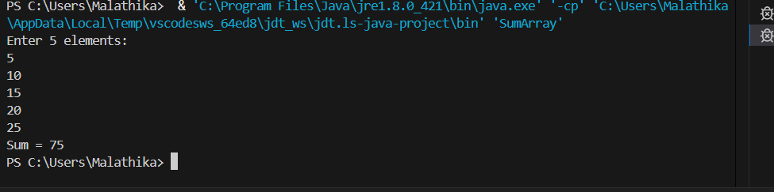
3. Program to Find Largest Element in an Array
Code:
import java.util.Scanner;
public class LargestElement {
public static void main(String[] args) {
Scanner sc = new Scanner(System.in);
int[] arr = new int[5];
System.out.println("Enter 5 elements:");
for(int i = 0; i < 5; i++)
arr[i] = sc.nextInt();
int max = arr[0];
for(int i = 1; i < 5; i++)
if(arr[i] > max)
max = arr[i];
System.out.println("Largest element = " + max);
}
}
OUTPUT:
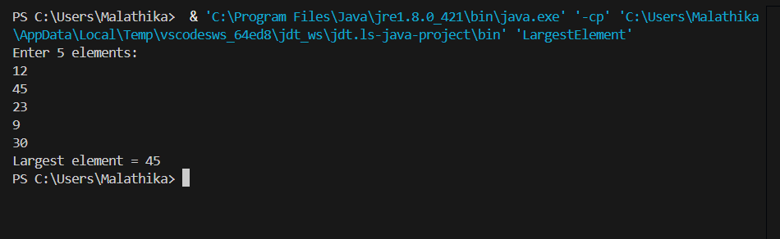
Input:
12 45 23 9 30
Output:
Largest element = 45

4. Program to Reverse an Array
Code:
import java.util.Scanner;

public class ReverseArray {
public static void main(String[] args) {
Scanner sc = new Scanner(System.in);
int[] arr = new int[5];
System.out.println("Enter 5 elements:");
for(int i = 0; i < 5; i++)
arr[i] = sc.nextInt();
System.out.println("Reversed array:");
for(int i = 4; i >= 0; i--)
System.out.print(arr[i] + " ");
}
}
OUTPUT:
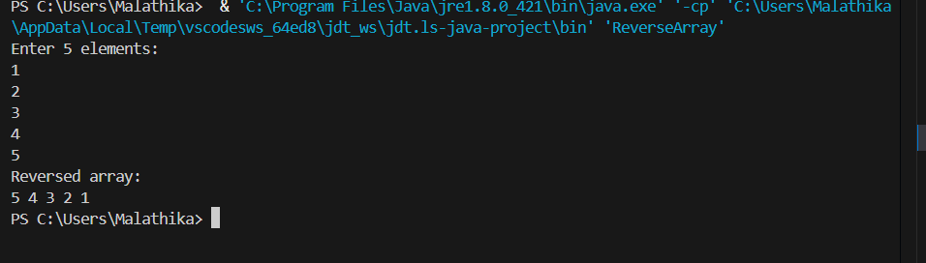
Input:
1 2 3 4 5
Output:
Reversed array:
5 4 3 2 1

5. Program to Count Even and Odd Numbers
Code:
import java.util.Scanner;
public class EvenOddCount {
public static void main(String[] args) {
Scanner sc = new Scanner(System.in);
int[] arr = new int[5];
int even = 0, odd = 0;
System.out.println("Enter 5 elements:");
for(int i = 0; i < 5; i++)
arr[i] = sc.nextInt();
for(int i = 0; i < 5; i++) {
if(arr[i] % 2 == 0)
even++;
else
odd++;
}

System.out.println("Even = " + even);
System.out.println("Odd = " + odd);
}
}
OUTPUT:
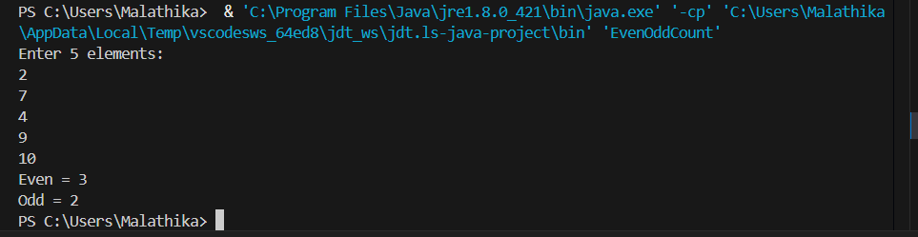
Input:
2 7 4 9 10
Output:
Even = 3
Odd = 2

6. Program to Sort Array in Ascending Order
Code:
import java.util.Scanner;
public class SortArray {
public static void main(String[] args) {
Scanner sc = new Scanner(System.in);
int[] arr = new int[5];
int temp;
System.out.println("Enter 5 elements:");
for(int i = 0; i < 5; i++)
arr[i] = sc.nextInt();
for(int i = 0; i < 5; i++) {
for(int j = i + 1; j < 5; j++) {
if(arr[i] > arr[j]) {
temp = arr[i];
arr[i] = arr[j];
arr[j] = temp;
}
}
}
System.out.println("Sorted array:");
for(int i = 0; i < 5; i++)
System.out.print(arr[i] + " ");
}
}
OUTPUT:
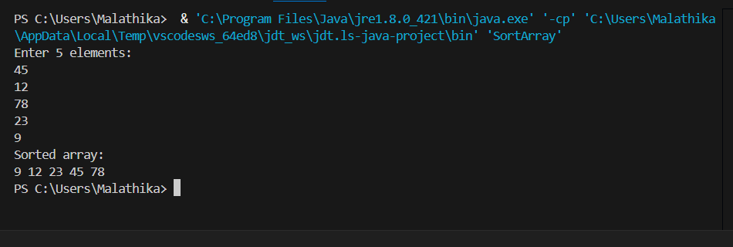
Input:
45 12 78 23 9
Output:
Sorted array:
9 12 23 45 78

7. Program to Find Second Largest Element
Code:
import java.util.Scanner;
public class SecondLargest {
public static void main(String[] args) {
Scanner sc = new Scanner(System.in);
int[] arr = new int[5];

System.out.println("Enter 5 elements:");
for(int i = 0; i < 5; i++)
arr[i] = sc.nextInt();
int largest = arr[0];
int second = arr[0];
for(int i = 0; i < 5; i++) {
if(arr[i] > largest) {
second = largest;
largest = arr[i];
}
}
System.out.println("Second largest = " + second);
}
}
OUTPUT:
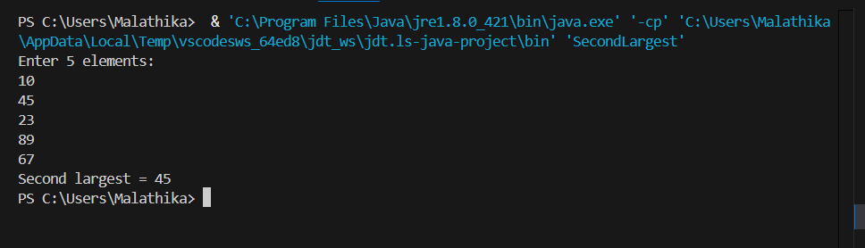
Input:
10 45 23 89 67
Output:
Second largest = 67

8. Program for Matrix Addition (2D Array)
Code:
import java.util.Scanner;
public class MatrixAddition {
public static void main(String[] args) {
Scanner sc = new Scanner(System.in);
int[][] a = new int[2][2];
int[][] b = new int[2][2];
int[][] sum = new int[2][2];
System.out.println("Enter elements of matrix A:");
for(int i = 0; i < 2; i++)
for(int j = 0; j < 2; j++)
a[i][j] = sc.nextInt();
System.out.println("Enter elements of matrix B:");
for(int i = 0; i < 2; i++)
for(int j = 0; j < 2; j++)
b[i][j] = sc.nextInt();
for(int i = 0; i < 2; i++)
for(int j = 0; j < 2; j++)
sum[i][j] = a[i][j] + b[i][j];
System.out.println("Sum matrix:");
for(int i = 0; i < 2; i++) {
for(int j = 0; j < 2; j++)
System.out.print(sum[i][j] + " ");
System.out.println();
}
}
}
OUTPUT:
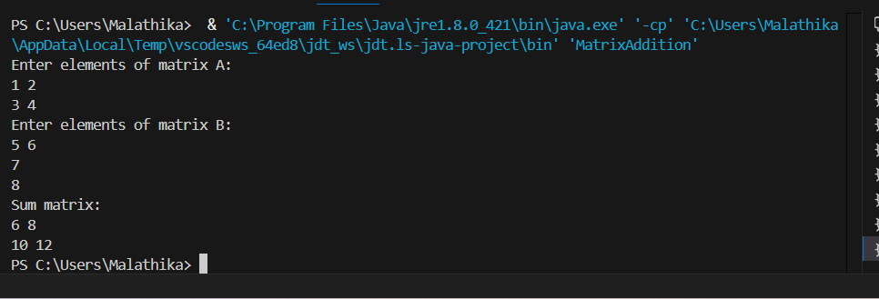
Matrix A:
1 2
3 4
Matrix B:
5 6
7 8
Sum matrix:
6 8
10 12

POST LAB EXERCISE
Why is array indexing usually started from zero instead of one?
Because index represents offset from base address; 0 means no offset, making memory access faster and simpler.
What happens if we try to access an array element outside its declared size?
It causes a runtime error or undefined behavior (like ArrayIndexOutOfBoundsException in Java).
How does memory allocation differ for static arrays and dynamic arrays?
Static arrays use fixed memory at compile time; dynamic arrays allocate memory at runtime and can resize.
Why is searching faster in arrays compared to linked lists?
Arrays allow direct access using index; linked lists require sequential traversal.
What is the difference between contiguous and non-contiguous memory allocation?
Contiguous allocation stores elements in adjacent memory; non-contiguous stores elements at different locations linked by pointers.

Result:

Thus the array operations were executed successfully.

ASSESSMENT

Description | Max Marks | Marks Awarded
Pre Lab Exercise | 5
In Lab Exercise | 10
Post Lab Exercise | 5
Viva | 10
Total | 30
Faculty Signature

