Experiment Number : 8 Date: 12.02.2026

Implementation of Packages in Java

Aim:
Write a Java program to implement built-in, user-defined packages and accessing all classes in a package.

PRE LAB EXERCISE
QUESTIONS
- What is java.util package and what collection framework does it contain?

The java.util package is a built-in package in Java that provides a wide range of utility classes and interfaces used for everyday programming tasks. It includes classes for data structures, date and time handling, random number generation, string manipulation, and more. One of its most important components is the Java Collection Framework, which provides a standardized architecture for storing and managing groups of objects. The Collection Framework includes core interfaces such as List, Set, Queue, and Map, along with their implementation classes like ArrayList, LinkedList, HashSet, TreeSet, PriorityQueue, and HashMap. These classes help developers efficiently store, retrieve, and manipulate data in different ways depending on the requirement.

- What are the two types of packages in Java?
In Java, packages are categorized into two types: built-in packages and user-defined packages. Built-in packages are those that are provided by Java by default, such as java.lang, java.util, and java.io. These packages contain predefined classes and interfaces that programmers can directly use in their applications. User-defined packages, on the other hand, are created by programmers using the package keyword to organize their own classes and interfaces. They help in grouping related classes together, avoiding naming conflicts, and improving code organization and reusability.

IN LAB EXERCISE
Objective
To understand and implement the concepts of built-in, user-defined packages and accessing all classes in a package in Java.
Built-in Packages comprise a large number of classes that are part of the Java API. Some of the commonly used built-in packages are:
- java.lang: Contains language support classes(e.g, classes that define primitive data types, math operations). This package is automatically imported.
- java.io: Contains classes for supporting input/output operations.
- java.util: Contains utility classes that implement data structures such as Linked Lists and Dictionaries, as well as support for date and time operations.
- java.applet: Contains classes for creating Applets.
- java.awt: Contains classes for implementing the components for graphical user interfaces (like buttons, menus, etc).
Source Code
import java.util.Random; // built-in package
public class Sample{
public static void main(String[] args) {
// using Random class
Random rand = new Random();
// generates a number between 0–99
int number = rand.nextInt(100);
System.out.println("Random number: " + number);
}
}
Output
Random number: 49
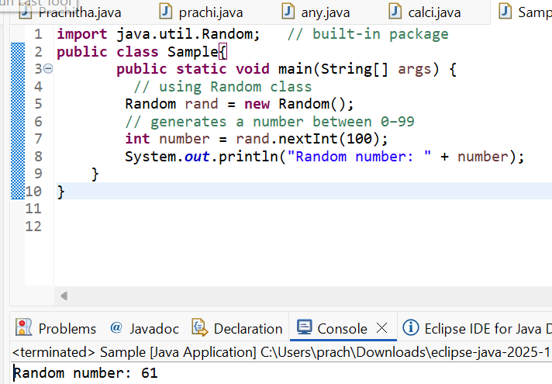

User-defined Packages are the packages that are defined by the user.
Source code
package com.myapp;
public class Helper {
public static void show() {
System.out.println("Hello from Helper!");
}
}
==To use this in another class==
import com.myapp.Helper;
public class Test {
public static void main(String[] args) {
Helper.show();
}
}

Output:
Hello from Helper!
//Importing all classes from a package.
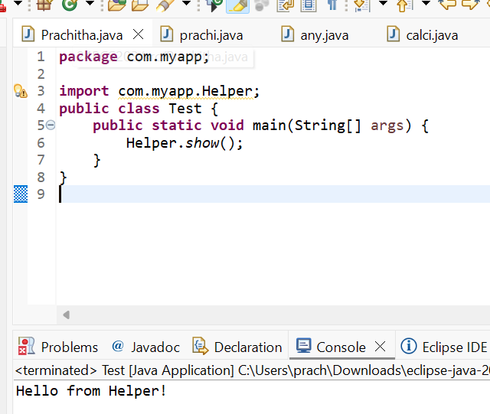
Source code
import java.util.Vector;
public class Coders {
public Coders() {
// java.util.Vector is imported, We are able to access it directly in our code.
Vector v = new Vector();
java.util.ArrayList l = new java.util.ArrayList();
l.add(3);
l.add(5);
l.add(7);
System.out.println(l);
}
public static void main(String[] args) {
new Coders();
}
}
Output
[3,5,7]
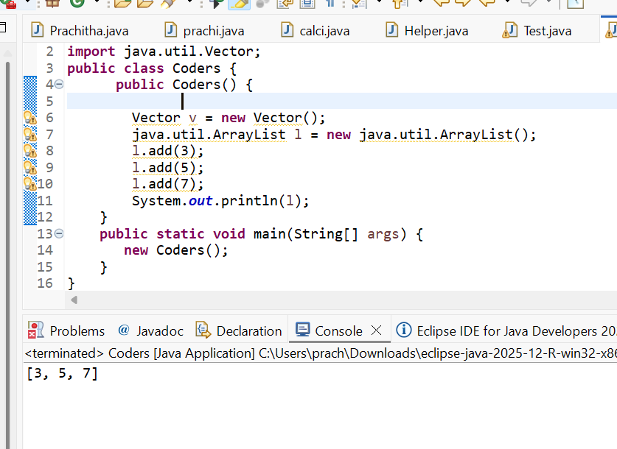
POST LAB EXERCISE
- What will happen if two classes in different packages have the same name and are imported in a Java file?
If two classes with the same name are imported from different packages into the same Java file, the compiler will produce a compile-time ambiguity error. This happens because Java cannot determine which class to use when the class name is referenced in the code. For example, both java.util.Date and java.sql.Date have the same class name Date. If both are imported and the program simply uses Date, the compiler becomes confused. To resolve this issue, the programmer must use the fully qualified class name (including the package name) for at least one of the classes. This removes ambiguity and clearly specifies which class is being used.

- What is the purpose of using packages in Java?
Packages in Java are used to group related classes and interfaces together in an organized manner. They help in structuring large applications by dividing them into manageable sections. One of the main purposes of packages is to avoid naming conflicts when multiple classes have the same name. Packages also provide access protection by controlling the visibility of classes and members using access modifiers. Additionally, they promote code reusability and make maintenance easier. Overall, packages improve readability, organization, and security of Java programs.

- Which built-in Java package would you use if you want to create a GUI window and display a message?
- java.util
- java.sql
- java.awt
- java.net
c. java.awt
The java.awt (Abstract Window Toolkit) package is used to create graphical user interface (GUI) components in Java. It provides classes for creating windows, buttons, labels, text fields, and other graphical elements. If you want to create a GUI window and display a message, this package contains the necessary components to design and manage the interface.

ASSESSMENT

Description | Max Marks | Marks Awarded
Pre Lab Exercise | 5
In Lab Exercise | 10
Post Lab Exercise | 5
Viva | 10
Total | 30
Faculty Signature

