Experiment Number : 8 Date: 12.02.2026

Implementation of Packages in Java

Aim:
Write a Java program to implement built-in, user-defined packages and accessing all classes in a package.

PRE LAB EXERCISE
QUESTIONS
- What is java.util package and what collection framework does it contain?
java.util is a built-in Java package that provides utility classes and interfaces for data structures, date & time, random numbers, and other helper functions.
It contains the Java Collection Framework, which includes:
List (ArrayList, LinkedList)
Set (HashSet, TreeSet)
Map (HashMap, TreeMap)
Queue (PriorityQueue)
- What are the two types of packages in Java?
There are two types of packages in Java:
Built-in Packages – Predefined packages provided by Java, such as java.lang, java.util, and java.io.
User-defined Packages – Packages created by programmers to organize their own classes.

IN LAB EXERCISE
Objective
To understand and implement the concepts of built-in, user-defined packages and accessing all classes in a package in Java.
Built-in Packages comprise a large number of classes that are part of the Java API. Some of the commonly used built-in packages are:
- java.lang: Contains language support classes(e.g, classes that define primitive data types, math operations). This package is automatically imported.
- java.io: Contains classes for supporting input/output operations.
- java.util: Contains utility classes that implement data structures such as Linked Lists and Dictionaries, as well as support for date and time operations.
- java.applet: Contains classes for creating Applets.
- java.awt: Contains classes for implementing the components for graphical user interfaces (like buttons, menus, etc).
Source Code
import java.util.Random; // built-in package
public class Sample{
public static void main(String[] args) {
// using Random class
Random rand = new Random();
// generates a number between 0–99
int number = rand.nextInt(100);
System.out.println("Random number: " + number);
}
}
Output
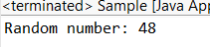
User-defined Packages are the packages that are defined by the user.
Source code
package com.myapp;
public class Helper {
public static void show() {
System.out.println("Hello from Helper!");
}
}
==To use this in another class==
import com.myapp.Helper;
public class Test {
public static void main(String[] args) {
Helper.show();
}
}

Output:
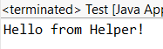
//Importing all classes from a package.
Source code
import java.util.Vector;
public class Coders {
public Coders() {
// java.util.Vector is imported, We are able to access it directly in our code.
Vector v = new Vector();
java.util.ArrayList l = new java.util.ArrayList();
l.add(3);
l.add(5);
l.add(7);
System.out.println(l);
}
public static void main(String[] args) {
new Coders();
}
}
Output
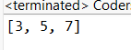
POST LAB EXERCISE
- What will happen if two classes in different packages have the same name and are imported in a Java file?
If two classes with the same name are imported from different packages, a compile-time error (ambiguity error) will occur.
The compiler cannot identify which class to use.
To solve this, we must use the fully qualified class name (package name + class name).
Example:
java.util.Date
java.sql.Date

- What is the purpose of using packages in Java?
The purpose of using packages in Java is to:
Organize related classes and interfaces
Avoid name conflicts
Provide access protection (security)
Improve code maintainability and reusability
- Which built-in Java package would you use if you want to create a GUI window and display a message?
- java.util
- java.sql
- java.awt
- java.net
Correct Answer:
C. java.awt
The java.awt package (Abstract Window Toolkit) is used to create GUI components like windows, buttons, labels, and message dialogs.

ASSESSMENT

Description | Max Marks | Marks Awarded
Pre Lab Exercise | 5
In Lab Exercise | 10
Post Lab Exercise | 5
Viva | 10
Total | 30
Faculty Signature

Experiment Number : 9 Date: 12.02.2026

Implementation of a Java Program to import packages using different methods

Aim:
Write a Java program to import packages using different methods for different use cases.

PRE LAB EXERCISE
QUESTIONS
- How to import a single class and multiple classes from a package in Java?
Importing a single class:
import java.util.Scanner;
This imports only the Scanner class from the java.util package.
Importing multiple classes (all classes in a package):
import java.util.*;
This imports all classes available in the java.util package.

- Which package is always imported by default in every Java class?
The package that is automatically imported in every Java program is:
java.lang
This package contains fundamental classes like:
- String
- System
- Math
- Object
- Exception
- Thread
Example:
System.out.println("Hello");
You can use System without writing:
import java.lang.System;
Because java.lang is automatically imported.

IN LAB EXERCISE
Objective
To understand and implement the Java packages using different methods and import them.
Problem
Define a package named ‘useFul’ with a class names ‘UseMe’ having following methods:
1) area()- To calculate the area of given shape.
2) salary()- To calculate the salary given basic Salary,da,hRA.
3) percentage()-To calculate the percentage given total marks and marks obtained.
4) Develop a program named ‘Package Use’ to import the above package ‘useFul’ and use the method area().
5) Develop a program named ‘manager’
Source Code
//Package Creation:
package useFull;
import java.util.*;
public class UseMe
{
Scanner obj=new Scanner(System.in);
public static void area()
{
class method{
void aos(int a)
{
System.out.print("\nArea of square with length "+a+" is "+(a*a));
}
void aor(int a,int b)
{
System.out.print("\nArea of reactangle with dimensions "+a+" & "+b+" is "+(a*b));
}
void aoc(int r)
{
double a=3.14*r*r;
}
System.out.print("\nArea of circle with radius "+r+" is "+a);
}
void aot(int a,int b)
{
float ar=(a*b)/2;
System.out.print("\nArea of triangle with dimensions "+a+" &"+b+" is "+ar);
} }
Scanner obj=new Scanner(System.in);
method m=new method();
System.out.print("\n1.Square\n2.Rectangle\n3.Circle\n4.Triangle\nSelect the shape\n");
int ch=obj.nextInt();
UseMe u=new UseMe();
switch(ch)
{
case 1:System.out.print("\nEnter the length of side of square : ");
int s=obj.nextInt();m.aos(s);
break;
case 2:System.out.print("\nEnter the dimensions of rectangle : ");
int l=obj.nextInt();
int b=obj.nextInt();
m.aor(l,b);
break;
case 3:System.out.print("\nEnter the radius of circle : ");
int r=obj.nextInt();
m.aoc(r);
break;
case 4:System.out.print("\nEnter the dimensions of triangle : ");
int ba=obj.nextInt();
int w=obj.nextInt();
m.aot(ba,w);
break; } }
public void salary()
{
int ba,da,hra;
System.out.print("\nEnter the basic salary : ");
ba=obj.nextInt();
System.out.print("\nEnter the dearness allowance :");
da=obj.nextInt();
System.out.print("\nEnter the house rent allowance : ");
hra=obj.nextInt();
System.out.print("\nThe total Gross salary of employee is : "+(ba+da+hra));
}
public void percentage()
{
int n,sum=0;
float p;
System.out.print("\nEnter the total number of subjects : ");
n=obj.nextInt();
int m[]=new int[n];
System.out.print("\nEnter the marks of "+n+" subjects : ");
for(int i=0;i<n;i++)
{
m[n]=obj.nextInt();
}
for(int i=0;i<n;i++)
{
sum=sum+m[i];
}
p=sum/n;
{
System.out.print("\nPercentahe of student : "+p);
}
}
}
//Package Implementation-1:
import useFull.UseMe;
class packageUse
{
public static void main(String args[])
{
UseMe o=new UseMe();o.area();
}
}

Output

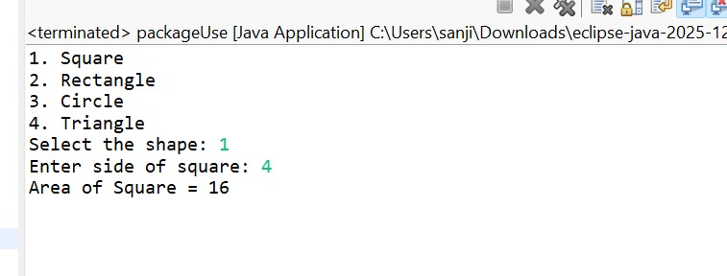
//Package Implementation-2:
import useFull.UseMe;
class manager
{
public static void main(String args[])
{
UseMe obj=new UseMe();obj.salary();
}
}

Output

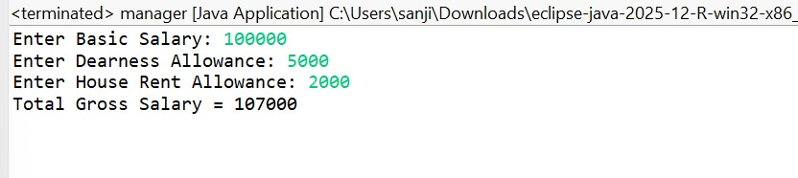
POST LAB EXERCISE
- Find the key differences between java.util and java.lang packages.
· Import Requirement
java.lang is automatically imported in every Java program.
java.util must be imported explicitly using import java.util.*;.
· Purpose
java.lang contains core classes like String, Math, System, and wrapper classes.
java.util contains utility and collection classes like ArrayList, HashMap, Scanner, and Random.
· Data Structures
java.lang does not provide collection framework classes.
java.util provides data structures such as List, Set, and Map.

- List some of the subpackages of java.util
Some important subpackages are:
- java.util.concurrent
→ Used for multithreading utilities (Executor, Locks, etc.)
- java.util.concurrent.atomic
→ Supports atomic operations in multithreading
- java.util.concurrent.locks
→ Locking mechanisms like ReentrantLock
- java.util.function
→ Functional interfaces for lambda expressions
- java.util.stream
→ Stream API for processing collections
- java.util.regex
→ Regular expression handling

ASSESSMENT

Description | Max Marks | Marks Awarded
Pre Lab Exercise | 5
In Lab Exercise | 10
Post Lab Exercise | 5
Viva | 10
Total | 30
Faculty Signature

Experiment Number : 10 Date: 12.02.2026

Implementation of Access Modifiers in Java

Aim:
Write a Java program to implement different access modifiers.

PRE LAB EXERCISE
QUESTIONS
- What are the 4 access modifiers available in Java?

Java provides four access modifiers to control visibility:
- public
→ Accessible from anywhere (inside class, package, outside package).
- protected
→ Accessible within the same package and also by subclasses (even in different packages).
- default (package-private)
→ No keyword is used.
→ Accessible only within the same package.
- private
→ Accessible only within the same class.

- Which access modifiers can be used in Java to control access to class members?
Java provides four access modifiers to control access to class members (variables, methods, constructors):
Private (private)
Accessible only within the same class.
Default (no modifier)
Accessible only within the same package.
Protected (protected)
Accessible within the same package and by subclasses (even in different packages).
Public (public)
Accessible from anywhere in the program.

IN LAB EXERCISE
Objective
To demonstrate different access modifiers such as Default, Private, Protected and Public using Java programs.
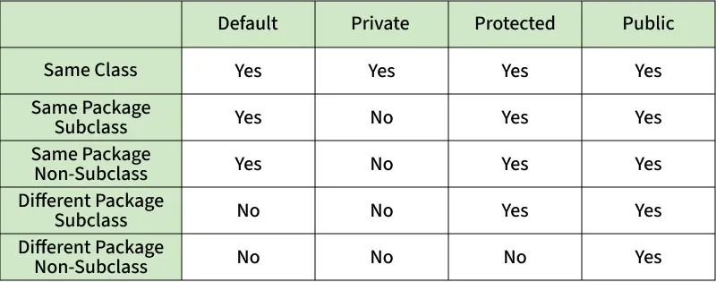
Fig: Comparison table of Access Modifiers in Java
Source Code
// Default Access modifier
class Car {
String model; // default access
}
public class Main {
public static void main(String[] args){
Car c = new Car();
c.model = "Tesla"; // accessible within the same package
System.out.println(c.model);
}
}
Output:
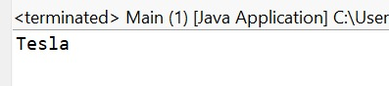
//Private Access Modifier
class Person {
// private variable
private String name;
public void setName(String name) {
this.name = name; // accessible within class
}
public String getName() {
return name;
}
}
public class Geeks {
public static void main(String[] args)
{
Person p = new Person();
p.setName("Alice");

// System.out.println(p.name);
// Error: 'name'
// has private access
System.out.println(p.getName());
}
}
Output
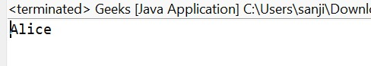
//Protected Access Modifier
class Vehicle {
protected int speed; // protected member
}
class Bike extends Vehicle {
void setSpeed(int s)
{
speed = s; // accessible in subclass
}
int getSpeed()
{
return speed; // accessible in subclass
}
}
public class Main {
public static void main(String[] args){
Bike b = new Bike();
b.setSpeed(100);
System.out.println("Access via subclass method: "+ b.getSpeed());
Vehicle v = new Vehicle();
System.out.println(v.speed);
}
}
Output
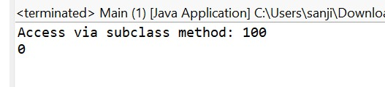

//Public Access Modifier
class MathUtils {
public static int add(int a, int b) {
return a + b;
}
}
public class Main {
public static void main(String[] args) {
System.out.println(MathUtils.add(5, 10)); // accessible anywhere
}
}
Output
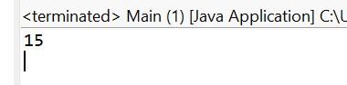
POST LAB EXERCISE
  - Write a Java program to implement Default access modifier which has a default class within the same package and a default class from a different package.
Default access (package-private) means:
- Accessible only within the same package
- Not accessible from a different package

Step 1: Same Package Example (Works)
Package: pack1
File 1: Car.java
package pack1;
class Car { // default class
String model = "Tesla"; // default variable
void display() { // default method
System.out.println("Car model: " + model);
}
}
File 2: TestSamePackage.java
package pack1;
public class TestSamePackage {
public static void main(String[] args) {
Car c = new Car(); // Accessible (same package)
c.display(); // Accessible
}
}
Output:
Car model: Tesla
Works because both classes are inside same package (pack1)

  - Which access modifier provides the highest level of access?
Accessible from:
  - Same class
  - Same package
  - Subclass (different package)
  - Any other class anywhere

Access Level Order (From Lowest to Highest)
private < default < protected < public

ASSESSMENT

Description | Max Marks | Marks Awarded
Pre Lab Exercise | 5
In Lab Exercise | 10
Post Lab Exercise | 5
Viva | 10
Total | 30
Faculty Signature

Experiment Number :11 Date: 12.02.2026

Implementation of multiple inheritance in Java using Interface

Aim:
Write a Java program to implement multiple inheritance using Interface.

PRE LAB EXERCISE
QUESTIONS
- Why Java does not support multiple inheritance using classes like that of C?
Java does not support multiple inheritance using classes to avoid the Diamond Problem (ambiguity problem).
If two parent classes have the same method and a child class inherits both, the compiler gets confused about which method to use.
To avoid this complexity and ambiguity, Java does not allow multiple inheritance with classes.
Instead, Java supports multiple inheritance using interfaces.

- What is the primary purpose of an interface in Java?
- To store data using instance variables
- To define a contract of methods a class must implement
- To allow creation of objects
- To improve runtime performance
Correct Answer:
B. To define a contract of methods a class must implement
An interface defines method declarations that a class must implement, ensuring standard behavior without providing full implementation.

IN LAB EXERCISE
Objective
To demonstrate how an interface in Java defines constants and abstract methods, which are implemented by a class.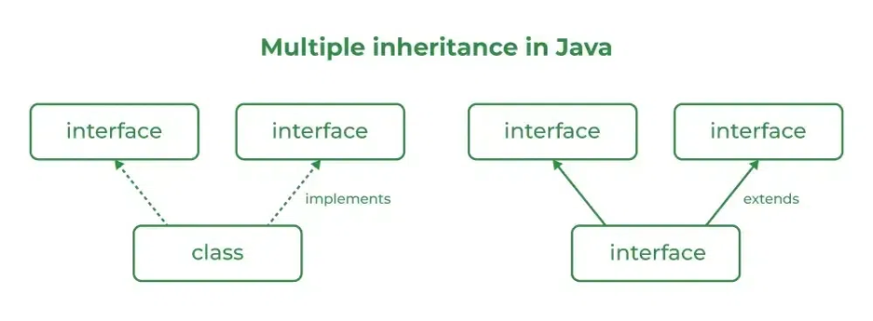

Source Code
import java.io.*;
// Add interface
interface Add{
int add(int a,int b);
}
// Sub interface
interface Sub{
int sub(int a,int b);
}
// Calculator class implementing Add and Sub
class Cal implements Add , Sub
{
// Method to add two numbers
public int add(int a,int b){
return a+b;
}
// Method to sub two numbers
public int sub(int a,int b){
return a-b;
}
}
class Example{
// Main Method
public static void main (String[] args){

// instance of Cal class
Cal x = new Cal();
System.out.println("Addition : " + x.add(2,1));
System.out.println("Substraction : " + x.sub(2,1));
}
}

Outputs
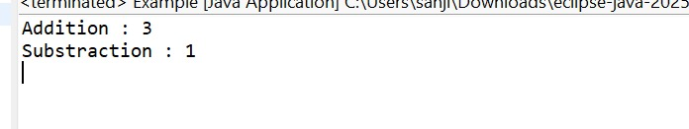
POST LAB EXERCISE
  - Can a functional interface extend another interface?
Yes, a functional interface can extend another interface only if it still has exactly one abstract method after inheritance.
If extending another interface results in more than one abstract method, then it is no longer a functional interface.

  - Which feature was introduced in interfaces starting from Java 8?
- Constructors
- Private methods
- Default and static methods
- Final classes
Correct Answer:
C. Default and static methods
Starting from Java 8, interfaces can have:
- Default methods (with implementation)
- Static methods (with implementation)
This was introduced to support backward compatibility and lambda expressions.

ASSESSMENT

Description | Max Marks | Marks Awarded
Pre Lab Exercise | 5
In Lab Exercise | 10
Post Lab Exercise | 5
Viva | 10
Total | 30
Faculty Signature

Experiment Number : 12 Date: 25.02.2026

Implementation of exception handling in Java
Aim:
Write a java program to implement exception handling.

PRE LAB EXERCISE
QUESTIONS
- What is exception handling in Java?

Exception handling in Java is a mechanism to handle runtime errors so that the program can continue executing normally without crashing.
It is done using keywords like:
- try
- catch
- finally
- throw
- throws

- What is the purpose of using try-catch blocks in exception handling?
The try block contains code that may cause an exception.
The catch block handles the exception if it occurs.
Purpose:
- To prevent program termination
- To handle errors gracefully
- To maintain normal program flow

IN LAB EXERCISE
Objective
To understand and implement exception handling through try-catch and finally blocks.
Source Code
import java.util.InputMismatchException;
import java.util.Scanner;
public class ExceptionHandlingExample {
public static void main(String[] args) {
Scanner scanner = new Scanner(System.in);
try {
System.out.print("Enter an integer: ");
int num = scanner.nextInt();
int result = 10 / num;
System.out.println("Result: " + result);
} catch (InputMismatchException e) {
System.out.println("Invalid input! Please enter an integer.");
} catch (ArithmeticException e) {
System.out.println("Cannot divide by zero!");
} finally {
scanner.close();
System.out.println("Program execution completed.");
} }
}
Outputs
Output 1 (Valid Input - Non-zero Integer):
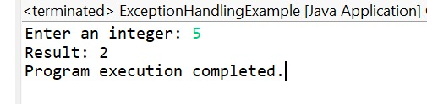
Output 2 (Valid Input - Zero):
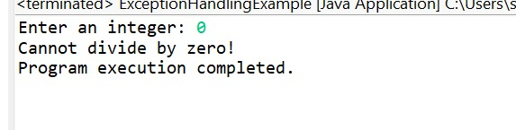
Output 3 (Invalid Input - Non-integer):
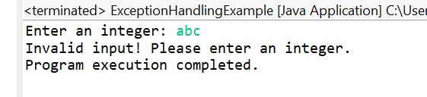

POST LAB EXERCISE
- What is the purpose of the Scanner object in the Java program?

The Scanner class (from java.util package) is used to read input from the user at runtime.
It can read:
- Integers → nextInt()
- Float → nextFloat()
- String → nextLine()
- Double → nextDouble()
Main purpose: To take input from keyboard (System.in).

- What exceptions are expected to be thrown in the code within the try block? Why?
- InputMismatchException
  - Occurs if the user enters input of the wrong type.
  - Example: Entering a string when nextInt() is expected.
- ArithmeticException
  - Occurs during mathematical errors.
  - Example: Division by zero.
- NumberFormatException
  - Occurs when converting invalid string to number.
These exceptions occur because of invalid input or illegal operations inside the try block

ASSESSMENT

Description | Max Marks | Marks Awarded
Pre Lab Exercise | 5
In Lab Exercise | 10
Post Lab Exercise | 5
Viva | 10
Total | 30
Faculty Signature

Experiment Number : 13 Date: 25.02.2026

Implementation of User-defined Exception in Java

Aim:
Write a java program to implement User-defined Exception.

PRE LAB EXERCISE
QUESTIONS
1.What is Java custom exception?
A custom exception is a user-defined exception created to handle specific errors in a program.
2.What are the two types of custom exceptions in Java?

IN LAB EXERCISE
Objective
To understand and implement Checked and Unchecked custom exceptions.
Source Code
Ex 1: // Custom Checked Exception
class InvalidAgeException extends Exception {
public InvalidAgeException(String m) {
super(m);
}
}
// Using the Custom Exception
public class AgeCheck{
public static void validate(int age)
throws InvalidAgeException {
if (age < 18) {
throw new InvalidAgeException("Age must be 18 or above.");
}
System.out.println("Valid age: " + age);
}
public static void main(String[] args) {
try {
validate(12);
} catch (InvalidAgeException e) {
System.out.println("Caught Exception: " + e.getMessage());
}
}
}

Output 1

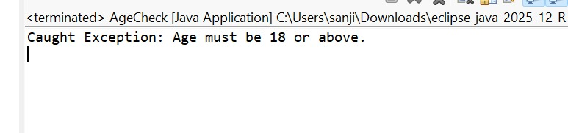
Ex 2: // Custom Unchecked Exception
class DivideByZeroException extends RuntimeException {
public DivideByZeroException(String m) {
super(m);
}
}
// Using the Custom Exception
public class TestSample {
public static void divide(int a, int b) {
if (b == 0) {
throw new DivideByZeroException("Division by zero is not allowed.");
}
System.out.println("Result: " + (a / b));
}
public static void main(String[] args) {
try {
divide(10, 0);
} catch (DivideByZeroException e) {
System.out.println("Caught Exception: " + e.getMessage());
}
}
}

Output 2

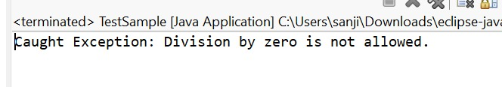
POST LAB EXERCISE
- What is required to create a custom exception in Java?
- Extend the Object class
- Extend the Throwable class
- Extend Exception or RuntimeException
- Implement the Serializable interface

- List some use cases for the checked and unchecked exceptions.

ASSESSMENT

Description | Max Marks | Marks Awarded
Pre Lab Exercise | 5
In Lab Exercise | 10
Post Lab Exercise | 5
Viva | 10
Total | 30
Faculty Signature

