THREADING

Public Transport Ticket Booking and Fare Processing System
Aim:
To develop a Java application for managing ticket booking and fare calculation using object-oriented principles such as encapsulation, constructors, reference assignment, object creation, and rule-based fare calculation without conditional statements.
QUESTIONS
1. How does accepting ticket details at runtime allow the same program to handle different passengers without changing the source code?
Accepting ticket details at runtime allows users to enter different passenger information during program execution. This makes the program flexible and reusable, as the same code can process data for any passenger without modifying the source code.

2. In what way does creating a ticket with limited details restrict or delay certain operations compared to a fully initialized ticket?
A ticket created with limited information does not contain complete travel data such as distance and class. Therefore, operations like fare calculation or travel confirmation cannot be performed until the missing details are added later.

3. If two different modules update the same ticket through shared references, what risks or benefits arise in maintaining ticket data?
The benefit is that changes made through one reference are reflected everywhere, ensuring consistent data. However, the risk is that uncontrolled updates by multiple modules may lead to unintended modifications or data inconsistencies.

4. Why is creating a separate ticket object safer than reusing the same object when testing changes such as travel class upgrades?
Creating a separate object ensures that the original ticket data remains unchanged. This allows safe testing of modifications such as class upgrades or fare changes without affecting the original booking information.

5. What kind of incorrect behavior would occur if the program failed to distinguish between method parameters and class data members?
If the program does not distinguish between parameters and class variables, the method might update only the local parameters instead of the actual object data members, resulting in no change in the stored ticket information.

6. How does using a rule-based calculation instead of conditional statements improve or limit future changes in fare policy?
Using rule-based calculations such as maps or lookup tables allows easy updates to fare multipliers without modifying complex conditional logic. However, it may limit flexibility if very complex fare conditions or exceptions need to be implemented.

7. If ticket data members were publicly accessible, how could this affect fare accuracy and system reliability?
Public data members could be modified directly by any part of the program. This could lead to incorrect values, accidental changes, or inconsistent data, which would reduce system reliability and fare accuracy.

8. Why is it important to restrict the lifetime of ticket objects that are created only for comparison or testing?
Temporary objects used for testing or comparison should exist only for a short duration. This prevents unnecessary memory usage, confusion in program logic, and accidental use of temporary data in the main application flow.

IN LAB EXERCISE
Objective
• To store ticket details using private data members.
• To access and modify ticket details using public methods only.
• To demonstrate constructor overloading using limited and complete ticket information.
• To understand reference assignment and object sharing.
• To create independent objects from existing object data.
• To update data members using methods with identical parameter names.
• To perform fare calculation without conditional statements.
• To demonstrate temporary object creation during processing.
Source Code
import java.util.Scanner;
import java.util.HashMap;

class Ticket {

// Step 7: Private data members
private int ticketNumber;
private String passengerName;
private int passengerAge;
private int travelDistance;
private String travelClass;

// Constructor with limited data
public Ticket(int ticketNumber, String passengerName, int passengerAge) {
this.ticketNumber = ticketNumber;
this.passengerName = passengerName;
this.passengerAge = passengerAge;
}

// Constructor with complete data
public Ticket(int ticketNumber, String passengerName, int passengerAge,
int travelDistance, String travelClass) {
this.ticketNumber = ticketNumber;
this.passengerName = passengerName;
this.passengerAge = passengerAge;
this.travelDistance = travelDistance;
this.travelClass = travelClass;
}

// Step 5: Update method with identical parameter names
public void updateTicket(int ticketNumber, String passengerName, int passengerAge,
int travelDistance, String travelClass) {
this.ticketNumber = ticketNumber;
this.passengerName = passengerName;
this.passengerAge = passengerAge;
this.travelDistance = travelDistance;
this.travelClass = travelClass;
}

// Public setter methods
public void setTravelDistance(int travelDistance) {
this.travelDistance = travelDistance;
}

public void setTravelClass(String travelClass) {
this.travelClass = travelClass;
}

// Getter methods
public int getTravelDistance() {
return travelDistance;
}

public String getTravelClass() {
return travelClass;
}

public int getTicketNumber() {
return ticketNumber;
}

public String getPassengerName() {
return passengerName;
}

public int getPassengerAge() {
return passengerAge;
}

// Display method
public void displayTicket() {
System.out.println("Ticket Number: " + ticketNumber);
System.out.println("Passenger Name: " + passengerName);
System.out.println("Passenger Age: " + passengerAge);
System.out.println("Travel Distance: " + travelDistance);
System.out.println("Travel Class: " + travelClass);
System.out.println("-----------------------------");
}

// Step 6 & Step 8: Fare calculation without condition
public static void calculateFare(Ticket t) {

int baseFare = 10;

HashMap<String, Integer> multiplier = new HashMap<>();
multiplier.put("General", 1);
multiplier.put("Sleeper", 2);
multiplier.put("AC", 3);

int m = multiplier.getOrDefault(t.travelClass, 1);

int fare = t.travelDistance * baseFare * m;

// Step 8: Temporary object for comparison
Ticket tempTicket = new Ticket(0, "Temp", 0, 50, "General");
int tempFare = tempTicket.travelDistance * baseFare * multiplier.get("General");

System.out.println("Calculated Fare: " + fare);
}
}

public class TicketSystem {

public static void main(String[] args) {

Scanner sc = new Scanner(System.in);

// Step 1: Runtime Input
System.out.println("Enter Ticket Number:");
int tNo = sc.nextInt();
sc.nextLine();

System.out.println("Enter Passenger Name:");
String name = sc.nextLine();

System.out.println("Enter Passenger Age:");
int age = sc.nextInt();

System.out.println("Enter Travel Distance:");
int distance = sc.nextInt();
sc.nextLine();

System.out.println("Enter Travel Class (General/Sleeper/AC):");
String tClass = sc.nextLine();

Ticket runtimeTicket = new Ticket(tNo, name, age, distance, tClass);

System.out.println("\nRuntime Ticket Details");
runtimeTicket.displayTicket();

// Step 2: Object Creation
Ticket ticket1 = new Ticket(101, "Arun", 25);
Ticket ticket2 = new Ticket(102, "Meena", 30, 120, "Sleeper");

System.out.println("Ticket 1 (Limited Data)");
ticket1.displayTicket();

System.out.println("Ticket 2 (Complete Data)");
ticket2.displayTicket();

// Step 3: Reference Assignment
Ticket refTicket = ticket1;
refTicket.setTravelDistance(200);

System.out.println("After Updating using second reference");
ticket1.displayTicket();
refTicket.displayTicket();

// Step 4: Independent Object Creation
Ticket ticket3 = new Ticket(ticket2.getTicketNumber(),
ticket2.getPassengerName(),
ticket2.getPassengerAge(),
ticket2.getTravelDistance(),
ticket2.getTravelClass());

ticket3.setTravelClass("AC");

System.out.println("Original Ticket");
ticket2.displayTicket();

System.out.println("New Ticket with Updated Class");
ticket3.displayTicket();

// Step 5: Update method
ticket2.updateTicket(102, "Meena", 30, 150, "AC");

System.out.println("Updated Ticket Details");
ticket2.displayTicket();

// Step 6: Fare Calculation
Ticket.calculateFare(ticket2);

sc.close();
}
}
Output
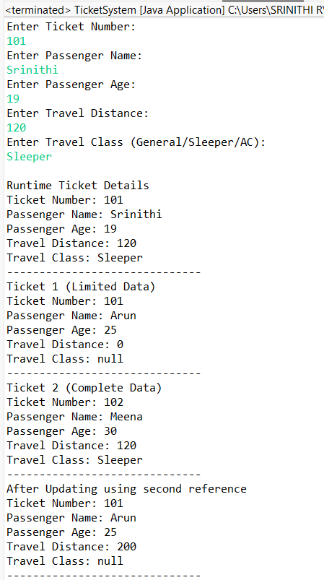
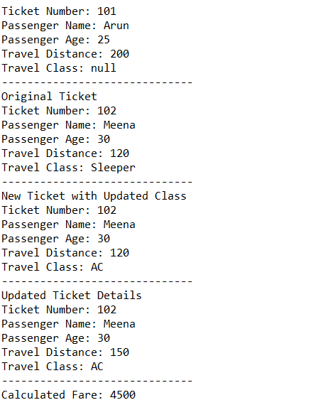
Result
The Java application for ticket booking and fare calculation was successfully implemented using encapsulation, constructors, reference assignment, object copying, and rule-based fare calculation without conditional statements.

ASSESSMENT

Description | Max Marks | Marks Awarded
Pre Lab Exercise | 5
In Lab Exercise | 10
Post Lab Exercise | 5
Viva | 10
Total | 30
Faculty Signature

