Experiment Number : 8 Date: 12/02/2026

Implementation of Packages in Java

Aim:

Write a Java program to implement built-in, user-defined packages and accessing all classes in a package.

PRE LAB EXERCISE
QUESTIONS
- What is java.util package and what collection framework does it contain?
java.util package
java.util is a built-in Java package that provides utility classes used for:
- Data structures
- Date & time handling
- Random number generation
- String manipulation
- Event handling
It is one of the most commonly used packages in Java.
Collection Framework in java.util
The Java Collection Framework (JCF) is part of java.util.
It provides ready-made classes and interfaces to store and manipulate groups of objects.
Core Interfaces
- List → ordered collection
- Set → unique elements
- Queue → elements processed in order
- Map → key–value pairs (not technically a Collection but part of framework)

- What are the two types of packages in Java?
Java packages are classified into:
1. Built-in Packages (Predefined Packages)
Packages provided by Java API.
Examples:
- java.lang → core classes (String, Math)
- java.util → utilities & collections
- java.io → input/output
- java.sql → database connectivity
- java.awt → GUI components

2. User-Defined Packages
Packages created by programmers to organize their own classes.
Example:
package mypackage;
public class MyClass {
public void display() {
System.out.println("User-defined package");
}
}

IN LAB EXERCISE
Objective
To understand and implement the concepts of built-in, user-defined packages and accessing all classes in a package in Java.
Built-in Packages comprise a large number of classes that are part of the Java API. Some of the commonly used built-in packages are:
- java.lang: Contains language support classes(e.g, classes that define primitive data types, math operations). This package is automatically imported.
- java.io: Contains classes for supporting input/output operations.
- java.util: Contains utility classes that implement data structures such as Linked Lists and Dictionaries, as well as support for date and time operations.
- java.applet: Contains classes for creating Applets.
- java.awt: Contains classes for implementing the components for graphical user interfaces (like buttons, menus, etc).
Source Code
import java.util.Random; // built-in package
public class Sample{
public static void main(String[] args) {
// using Random class
Random rand = new Random();
// generates a number between 0–99
int number = rand.nextInt(100);
System.out.println("Random number: " + number);
}
}
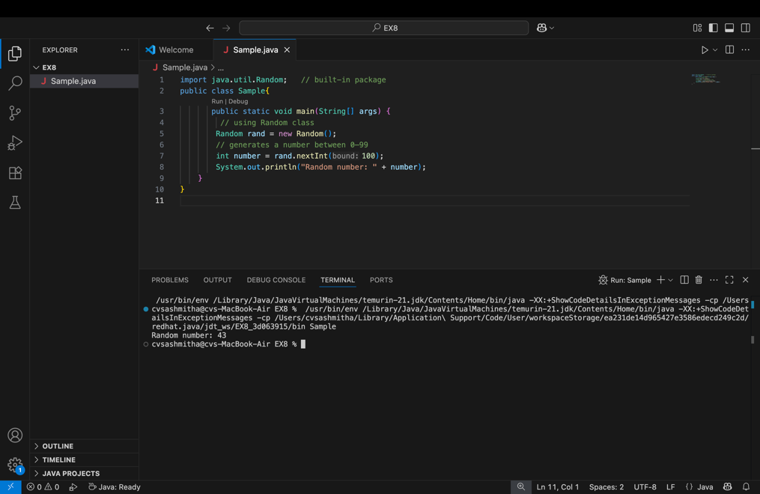a
Output
Random number: 49

User-defined Packages are the packages that are defined by the user.
Source code
package com.myapp;
public class Helper {
public static void show() {
System.out.println("Hello from Helper!");
}
}
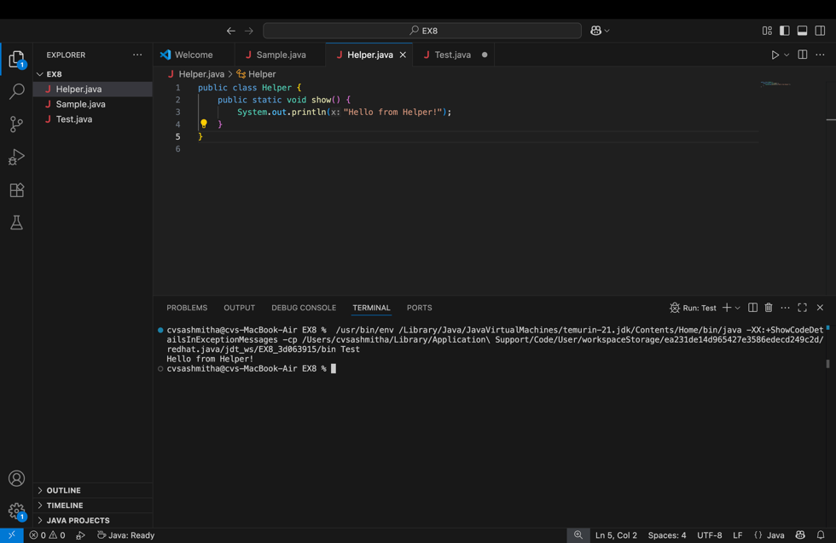
==To use this in another class==
import com.myapp.Helper;
public class Test {
public static void main(String[] args) {
Helper.show();
}
}
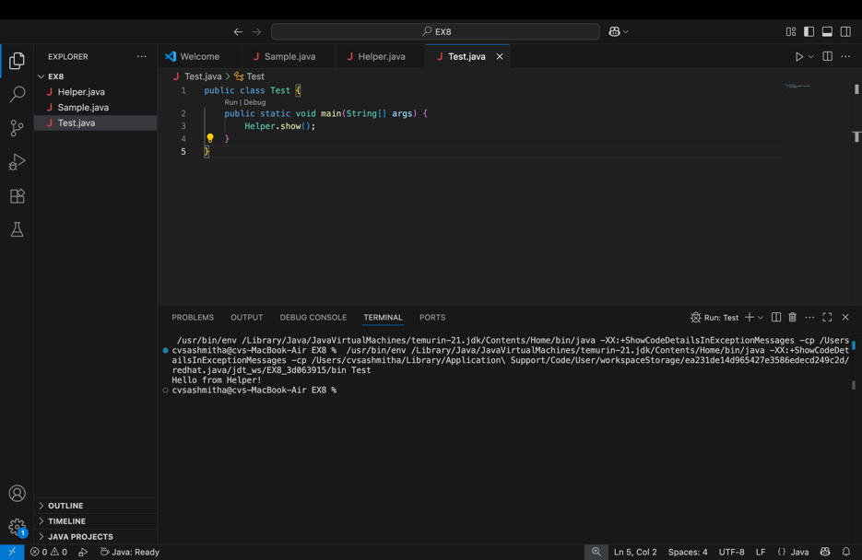

Output:
Hello from Helper!
//Importing all classes from a package.
Source code
import java.util.Vector;
public class Coders {
public Coders() {
// java.util.Vector is imported, We are able to access it directly in our code.
Vector v = new Vector();
java.util.ArrayList l = new java.util.ArrayList();
l.add(3);
l.add(5);
l.add(7);
System.out.println(l);
}
public static void main(String[] args) {
new Coders();
}
}
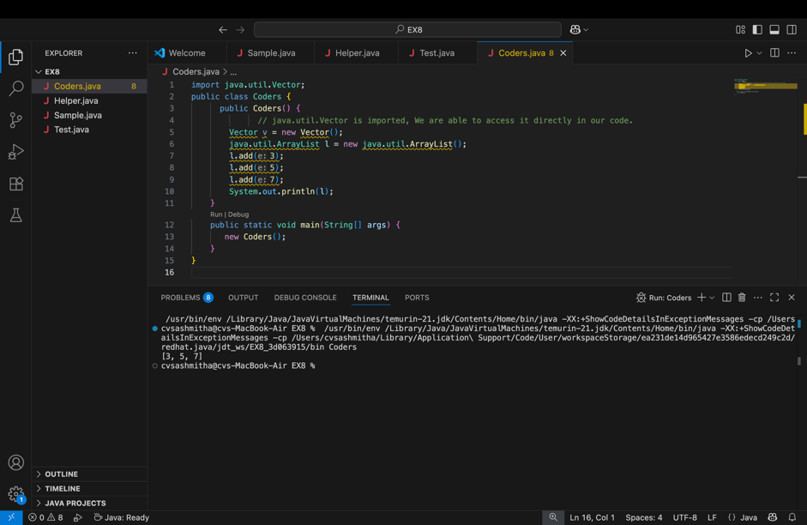
Output
[3,5,7]
POST LAB EXERCISE
- What will happen if two classes in different packages have the same name and are imported in a Java file?

If two classes with the same name are imported, Java creates ambiguity and the compiler throws an error.
To resolve it, use the fully qualified name:
package1.ClassName obj1;
package2.ClassName obj2;

- What is the purpose of using packages in Java?

Packages are used to:
- organize classes into groups
- avoid name conflicts
- improve code reuse
- control access using access modifiers

- Which built-in Java package would you use if you want to create a GUI window and display a message?
- java.util
- java.sql
- java.awt
- java.net

C. java.awt
java.awt provides classes for creating GUI components like windows, buttons, and labels.

ASSESSMENT

Description | Max Marks | Marks Awarded
Pre Lab Exercise | 5
In Lab Exercise | 10
Post Lab Exercise | 5
Viva | 10
Total | 30
Faculty Signature

Experiment Number : 9 Date: 12/02/2026

Implementation of a Java Program to import packages using different methods

Aim:
Write a Java program to import packages using different methods for different use cases.

PRE LAB EXERCISE
QUESTIONS
- How to import a single class and multiple classes from a package in Java?

Import a single class:
import packageName.ClassName;
Example:
import java.util.Scanner;
Import multiple classes (entire package):
import packageName.*;
Example:
import java.util.*;

- Which package is always imported by default in every Java class?
java.lang
It includes core classes like:
- String
- Math
- System
- Object
No need to import it explicitly.

IN LAB EXERCISE
Objective
To understand and implement the Java packages using different methods and import them.
Problem
Define a package named ‘useFul’ with a class names ‘UseMe’ having following methods:
1) area()- To calculate the area of given shape.
2) salary()- To calculate the salary given basic Salary,da,hRA.
3) percentage()-To calculate the percentage given total marks and marks obtained.
4) Develop a program named ‘Package Use’ to import the above package ‘useFul’ and use the method area().
5) Develop a program named ‘manager’
Source Code
//Package Creation:
package useFull;
import java.util.*;
public class UseMe
{
Scanner obj=new Scanner(System.in);
public static void area()
{
class method{
void aos(int a)
{
System.out.print("\nArea of square with length "+a+" is "+(a*a));
}
void aor(int a,int b)
{
System.out.print("\nArea of reactangle with dimensions "+a+" & "+b+" is "+(a*b));
}
void aoc(int r)
{
double a=3.14*r*r;
}
System.out.print("\nArea of circle with radius "+r+" is "+a);
}
void aot(int a,int b)
{
float ar=(a*b)/2;
System.out.print("\nArea of triangle with dimensions "+a+" &"+b+" is "+ar);
} }
Scanner obj=new Scanner(System.in);
method m=new method();
System.out.print("\n1.Square\n2.Rectangle\n3.Circle\n4.Triangle\nSelect the shape\n");
int ch=obj.nextInt();
UseMe u=new UseMe();
switch(ch)
{
case 1:System.out.print("\nEnter the length of side of square : ");
int s=obj.nextInt();m.aos(s);
break;
case 2:System.out.print("\nEnter the dimensions of rectangle : ");
int l=obj.nextInt();
int b=obj.nextInt();
m.aor(l,b);
break;
case 3:System.out.print("\nEnter the radius of circle : ");
int r=obj.nextInt();
m.aoc(r);
break;
case 4:System.out.print("\nEnter the dimensions of triangle : ");
int ba=obj.nextInt();
int w=obj.nextInt();
m.aot(ba,w);
break; } }
public void salary()
{
int ba,da,hra;
System.out.print("\nEnter the basic salary : ");
ba=obj.nextInt();
System.out.print("\nEnter the dearness allowance :");
da=obj.nextInt();
System.out.print("\nEnter the house rent allowance : ");
hra=obj.nextInt();
System.out.print("\nThe total Gross salary of employee is : "+(ba+da+hra));
}
public void percentage()
{
int n,sum=0;
float p;
System.out.print("\nEnter the total number of subjects : ");
n=obj.nextInt();
int m[]=new int[n];
System.out.print("\nEnter the marks of "+n+" subjects : ");
for(int i=0;i<n;i++)
{
m[n]=obj.nextInt();
}
for(int i=0;i<n;i++)
{
sum=sum+m[i];
}
p=sum/n;
{
System.out.print("\nPercentahe of student : "+p);
}
}
}
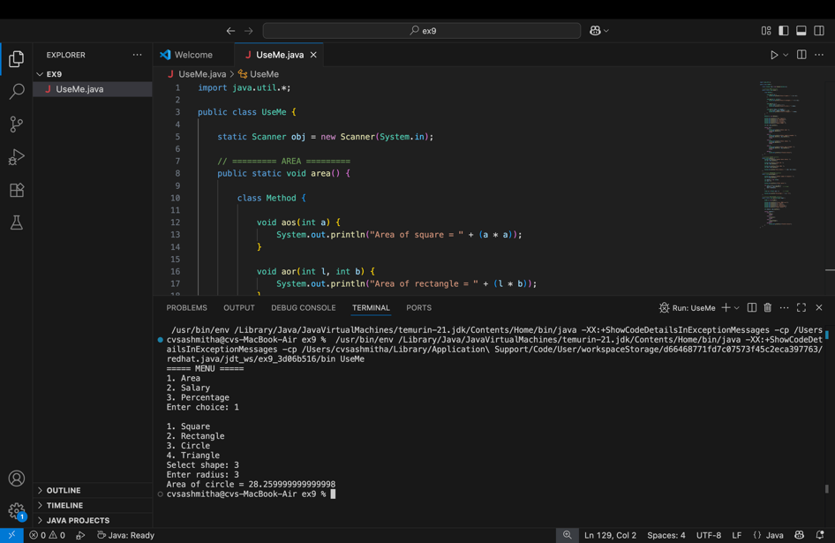
//Package Implementation-1:
import useFull.UseMe;
class packageUse
{
public static void main(String args[])
{
UseMe o=new UseMe();o.area();
}
}
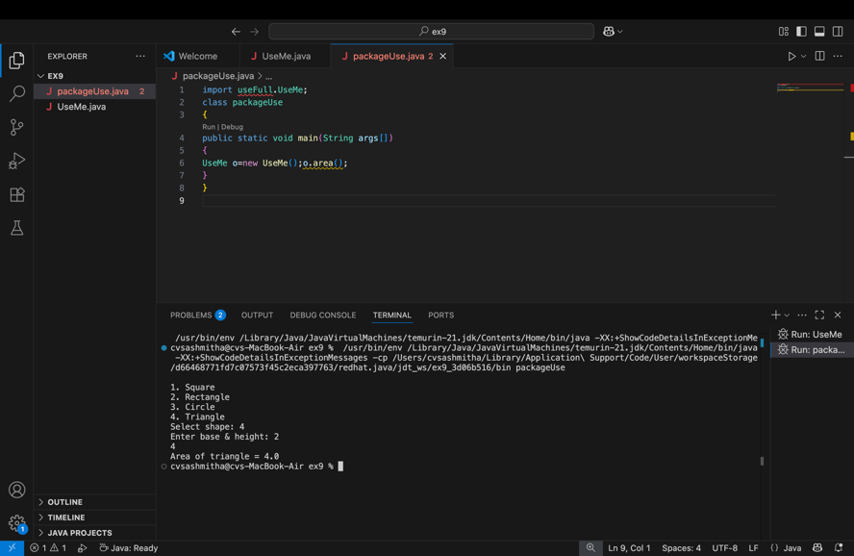
Output
javac packageUse.java
java packageUse
- Square
- Rectangle
- Circle
- Triangle
Select the shape
2

Enter the dimensions of the rectangle: 10 15
Area of the rectangle with dimensions 10&15 is 150
//Package Implementation-2:
import useFull.UseMe;
class manager
{
public static void main(String args[])
{
UseMe obj=new UseMe();obj.salary();
}
}
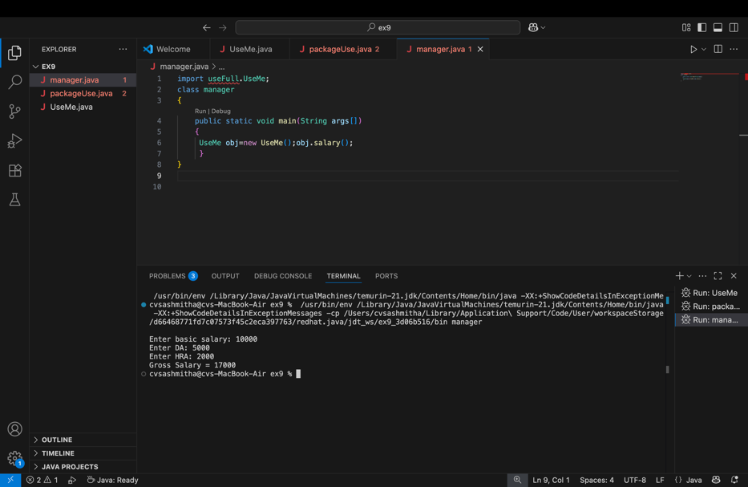
Output
javac manager.java
java manager

Enter the basic salary: 100000
Enter the dearness allowance: 5000
Enter the house rent allowance: 2000
The total Gross salary of employee is: 107000

POST LAB EXERCISE
- Find the key differences between java.util and java.lang packages.

Feature | java.lang | java.util
Purpose | Core language support | Utility classes & data structures
Imported by  default | Yes (automatic) | No (must import manually)
Used for | Basic operations & fundamental classes | Collections, date/time, utilities
Contains | Wrapper classes, String handling, math, threads | Collections framework, Scanner, Random, Date
Need import statement? | No | Yes → import java.util.*;
Examples of classes | String, System, Math, Integer, Thread | Scanner, ArrayList, HashMap, Collections, Random

- List some of the subpackages of java.util

java.util includes several important subpackages that provide additional utilities:
Common subpackages
- java.util.concurrent → Supports multithreading and concurrent programming (Executor, Locks, Thread pools)
- java.util.function → Contains functional interfaces used with lambda expressions
- java.util.logging → Provides logging framework for applications
- java.util.regex → Supports regular expression pattern matching
- java.util.stream → Enables stream processing of data (filter, map, reduce)
- java.util.zip → Provides compression and decompression utilities
- java.util.jar → Supports handling of JAR files
- java.util.spi → Service provider interfaces for extending utilities

ASSESSMENT

Description | Max Marks | Marks Awarded
Pre Lab Exercise | 5
In Lab Exercise | 10
Post Lab Exercise | 5
Viva | 10
Total | 30
Faculty Signature

Experiment Number : 10 Date: 12/02/2026

Implementation of Access Modifiers in Java

Aim:
Write a Java program to implement different access modifiers.

PRE LAB EXERCISE
QUESTIONS
- What are the 4 access modifiers available in Java?

Java provides four access modifiers to control visibility:
- public
  - Accessible from anywhere (same class, same package, other packages).
- protected
  - Accessible within the same package and by subclasses in other packages.
- default (no modifier)
  - Accessible only within the same package.
  - Also called package-private.
- private
  - Accessible only within the same class.

- Which access modifiers can be used in Java to control access to class members?

Class members include variables, methods, and constructors.
All four access modifiers can be used:
- public → accessible everywhere
- protected → same package + subclasses
- default → same package only
- private → same class only
Example
class Example {
public int a; // accessible everywhere
protected int b; // package + subclass
int c; // default (package only)
private int d; // class only
}

IN LAB EXERCISE
Objective
To demonstrate different access modifiers such as Default, Private, Protected and Public using Java programs.
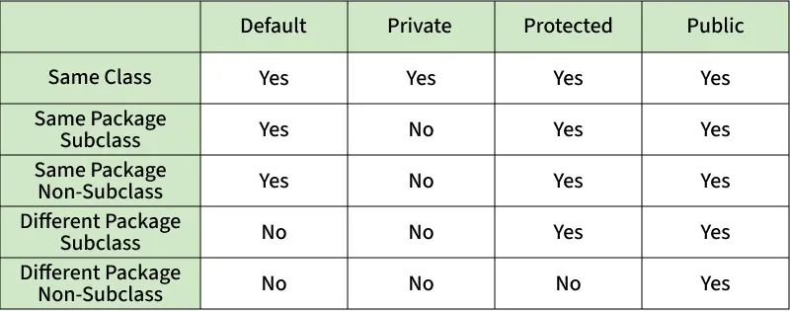
Fig: Comparison table of Access Modifiers in Java
Source Code
// Default Access modifier
class Car {
String model; // default access
}
public class Main {
public static void main(String[] args){
Car c = new Car();
c.model = "Tesla"; // accessible within the same package
System.out.println(c.model);
}
}
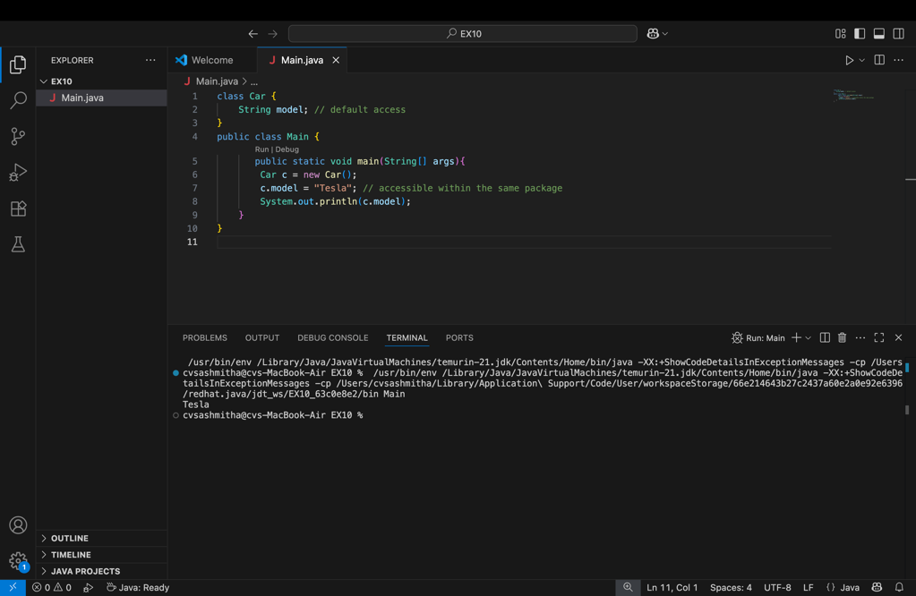
Output:
Tesla

//Private Access Modifier
class Person {
// private variable
private String name;
public void setName(String name) {
this.name = name; // accessible within class
}
public String getName() {
return name;
}
}
public class Geeks {
public static void main(String[] args)
{
Person p = new Person();
p.setName("Alice");

// System.out.println(p.name);
// Error: 'name'
// has private access
System.out.println(p.getName());
}
}
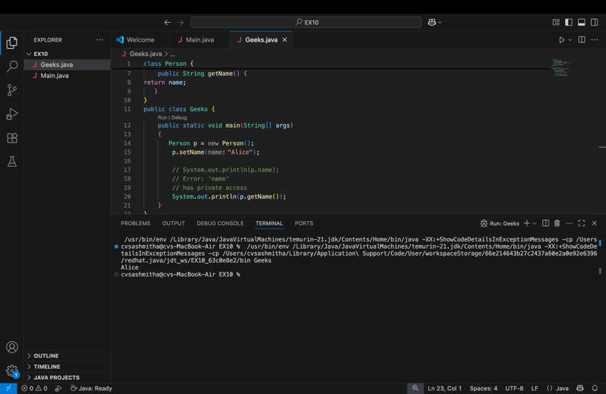
Output
Alice

//Protected Access Modifier
class Vehicle {
protected int speed; // protected member
}
class Bike extends Vehicle {
void setSpeed(int s)
{
speed = s; // accessible in subclass
}
int getSpeed()
{
return speed; // accessible in subclass
}
}
public class Main {
public static void main(String[] args){
Bike b = new Bike();
b.setSpeed(100);
System.out.println("Access via subclass method: "+ b.getSpeed());
Vehicle v = new Vehicle();
System.out.println(v.speed);
}
}
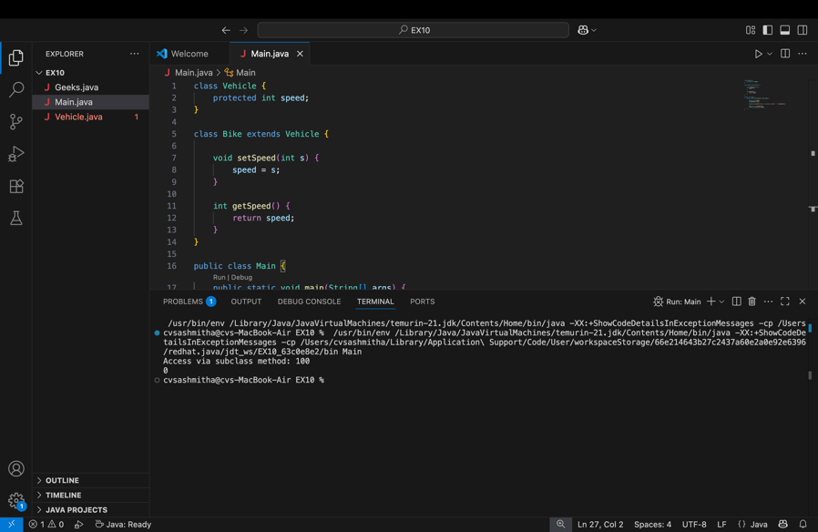
Output
Access via subclass method: 100
0

//Public Access Modifier
class MathUtils {
public static int add(int a, int b) {
return a + b;
}
}
public class Main {
public static void main(String[] args) {
System.out.println(MathUtils.add(5, 10)); // accessible anywhere
}
}
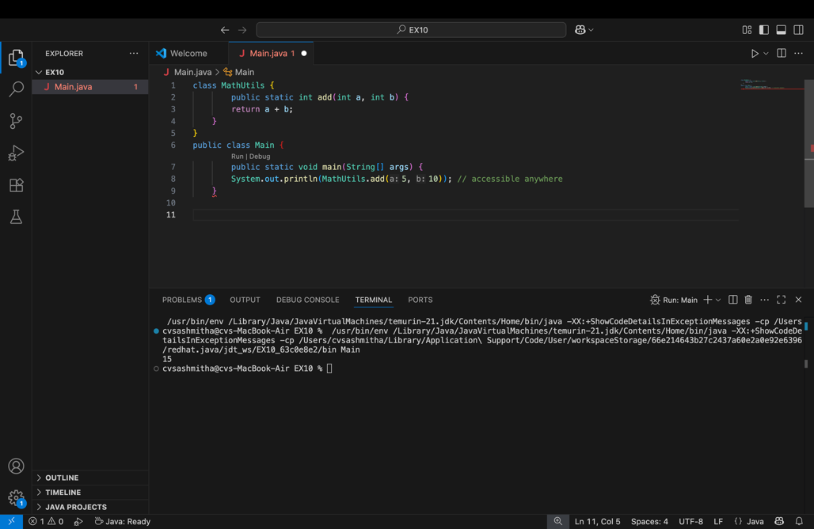
Output
15

POST LAB EXERCISE
  - Write a Java program to implement Default access modifier which has a default class within the same package and a default class from a different package.

Package pack1
// pack1/DefaultClass.java
package pack1;
class DefaultClass {
void show() {
System.out.println("Accessible within same package");
}
}
// pack1/SamePackage.java
package pack1;
public class SamePackage {
public static void main(String[] args) {
DefaultClass obj = new DefaultClass(); // allowed
obj.show();
}
}

Package pack2
// pack2/DifferentPackage.java
package pack2;
import pack1.DefaultClass; // not accessible
public class DifferentPackage {
public static void main(String[] args) {
DefaultClass obj = new DefaultClass(); // compilation error
}
}
Conclusion: Default classes are accessible only within the same package.

  - Which access modifier provides the highest level of access?
The public access modifier provides the highest level of accessibility in Java.
A public class, method, or variable can be accessed:
- within the same class
- within the same package
- from different packages
- from any other class in the program
Because of this unrestricted visibility, public members are typically used when functionality needs to be shared across multiple classes or packages.
Accessibility order (highest to lowest):
public → protected → default → private

ASSESSMENT

Description | Max Marks | Marks Awarded
Pre Lab Exercise | 5
In Lab Exercise | 10
Post Lab Exercise | 5
Viva | 10
Total | 30
Faculty Signature

Experiment Number :11 Date: 12/02/2026

Implementation of multiple inheritance in Java using Interface

Aim:
Write a Java program to implement multiple inheritance using Interface.

PRE LAB EXERCISE
QUESTIONS
- Why Java does not support multiple inheritance using classes like that of C?

Java does not support multiple inheritance with classes to avoid ambiguity and complexity, especially the Diamond Problem.
If a class inherits from two parent classes that contain the same method, the compiler cannot determine which method to use. This creates confusion and maintenance issues.
To prevent such conflicts and keep the language simpler and more reliable, Java allows multiple inheritance only through interfaces, not classes.

- What is the primary purpose of an interface in Java?
- To store data using instance variables
- To define a contract of methods a class must implement
- To allow creation of objects
- To improve runtime performance

Correct Answer:
B. To define a contract of methods a class must implement
Explanation:
An interface specifies a set of methods that a class must implement. It defines what a class should do, not how it should do it. Interfaces help achieve abstraction and support multiple inheritance.
Incorrect options:
- A: Interfaces do not store instance variables.
- C: Interfaces cannot be used to create objects.
- D: They are not primarily meant to improve runtime performance.

IN LAB EXERCISE
Objective
To demonstrate how an interface in Java defines constants and abstract methods, which are implemented by a class.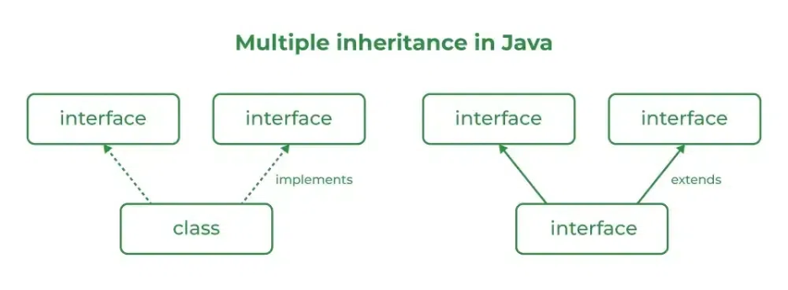

Source Code
import java.io.*;
// Add interface
interface Add{
int add(int a,int b);
}
// Sub interface
interface Sub{
int sub(int a,int b);
}
// Calculator class implementing Add and Sub
class Cal implements Add , Sub
{
// Method to add two numbers
public int add(int a,int b){
return a+b;
}
// Method to sub two numbers
public int sub(int a,int b){
return a-b;
}
}
class Example{
// Main Method
public static void main (String[] args){

// instance of Cal class
Cal x = new Cal();
System.out.println("Addition : " + x.add(2,1));
System.out.println("Substraction : " + x.sub(2,1));
}
}
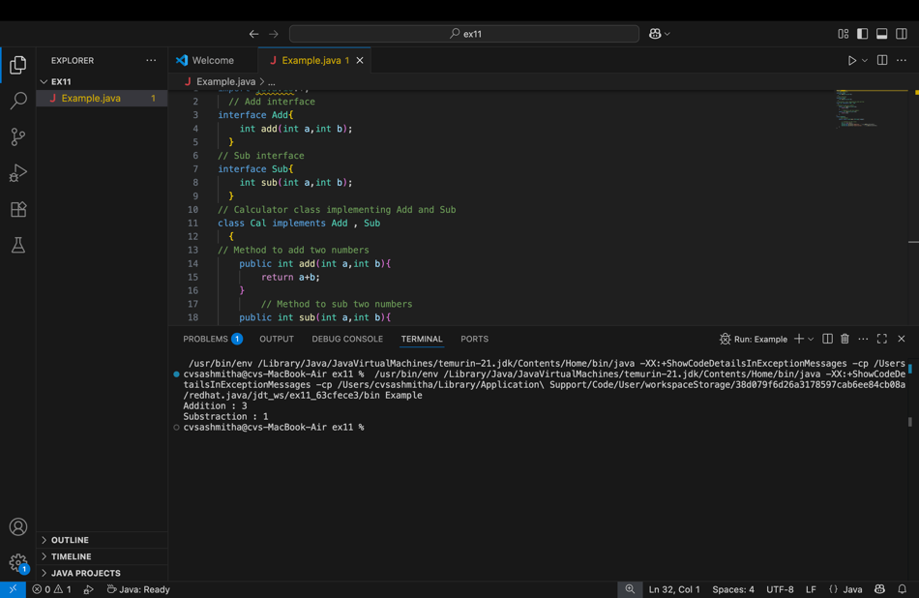

Outputs
Addition : 3
Subtraction : 1

POST LAB EXERCISE
  - Can a functional interface extend another interface?
Yes, a functional interface can extend another interface only if it still has exactly one abstract method.
- If the parent interface has an abstract method, the child must not introduce additional abstract methods.
- It may include default or static methods without affecting its functional nature.
Example:
interface Parent {
void show();
}
@FunctionalInterface
interface Child extends Parent {
// still one abstract method → valid
}

  - Which feature was introduced in interfaces starting from Java 8?
- Constructors
- Private methods
- Default and static methods
- Final classes
Correct Answer:
C. Default and static methods
Explanation:
Java 8 introduced default and static methods in interfaces to allow method implementation within interfaces and to maintain backward compatibility when new methods are added.
Incorrect options:
- A: Interfaces do not have constructors.
- B: Private methods were introduced later (Java 9).
- D: Final classes are unrelated to interfaces.

ASSESSMENT

Description | Max Marks | Marks Awarded
Pre Lab Exercise | 5
In Lab Exercise | 10
Post Lab Exercise | 5
Viva | 10
Total | 30
Faculty Signature

Experiment Number : 12 Date: 12/02/2026

Implementation of exception handling in Java
Aim:
Write a java program to implement exception handling.

PRE LAB EXERCISE
QUESTIONS
- What is exception handling in Java?

Exception handling in Java is a mechanism used to handle runtime errors so that the normal flow of the program is not interrupted. It allows a program to detect errors, handle them properly, and continue execution instead of terminating abruptly.
Examples of exceptions include division by zero, file not found, and invalid input.

- What is the purpose of using try-catch blocks in exception handling?

The try-catch block is used to handle exceptions that may occur during program execution.
- The try block contains code that might cause an exception.
- The catch block handles the exception and prevents the program from crashing.
This ensures the program continues running smoothly and allows the developer to display error messages or take corrective action.

IN LAB EXERCISE
Objective
To understand and implement exception handling through try-catch and finally blocks.
Source Code
import java.util.InputMismatchException;
import java.util.Scanner;
public class ExceptionHandlingExample {
public static void main(String[] args) {
Scanner scanner = new Scanner(System.in);
try {
System.out.print("Enter an integer: ");
int num = scanner.nextInt();
int result = 10 / num;
System.out.println("Result: " + result);
} catch (InputMismatchException e) {
System.out.println("Invalid input! Please enter an integer.");
} catch (ArithmeticException e) {
System.out.println("Cannot divide by zero!");
} finally {
scanner.close();
System.out.println("Program execution completed.");
} }
}
Outputs
Output 1 (Valid Input - Non-zero Integer):
Enter an integer: 5
Result: 2
Program execution completed.

Output 2 (Valid Input - Zero):
Enter an integer: 0
Cannot divide by zero!
Program execution completed.

Output 3 (Invalid Input - Non-integer):
Enter an integer: abc
Invalid input! Please enter an integer.
Program execution completed.
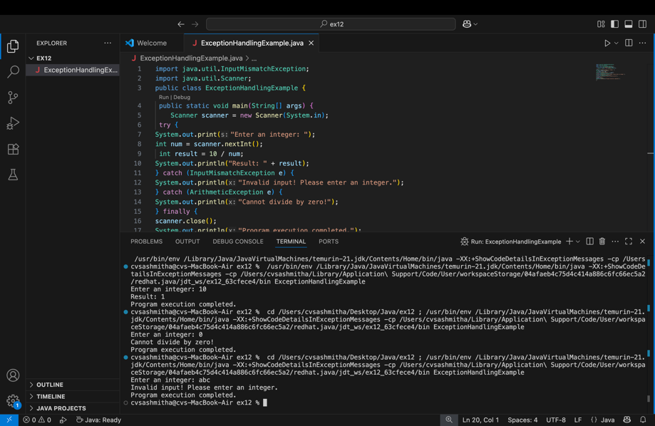

POST LAB EXERCISE
- What is the purpose of the Scanner object in the Java program?

The Scanner object is used to read input from the user at runtime.
It allows a program to accept data such as integers, strings, and floats from sources like the keyboard.
Example:
Scanner sc = new Scanner(System.in);
int num = sc.nextInt();
This reads an integer entered by the user.

- What exceptions are expected to be thrown in the code within the try block? Why?

The exceptions depend on the operations inside the try block. Common expected exceptions include:
- ArithmeticException – occurs when an illegal arithmetic operation is performed (e.g., division by zero).
- InputMismatchException – occurs when the user enters data of the wrong type (e.g., entering text when an integer is expected).
- ArrayIndexOutOfBoundsException – occurs when accessing an invalid array index.
- NullPointerException – occurs when trying to use an object reference that is null.
These exceptions occur due to invalid input, illegal operations, or improper memory access during program execution.

ASSESSMENT

Description | Max Marks | Marks Awarded
Pre Lab Exercise | 5
In Lab Exercise | 10
Post Lab Exercise | 5
Viva | 10
Total | 30
Faculty Signature

Experiment Number : 13 Date: 12/02/2026

Implementation of User-defined Exception in Java

Aim:
Write a java program to implement User-defined Exception.

PRE LAB EXERCISE
QUESTIONS
- What is Java custom exception?

A custom exception is a user-defined exception created by extending the Exception or RuntimeException class.
It is used to handle application-specific errors that are not covered by Java’s built-in exceptions.
Example: creating an exception for invalid age or insufficient balance.

- What are the two types of custom exceptions in Java?

There are two types:
1. Checked custom exceptions
- Extend the Exception class.
- Must be handled using try-catch or declared with throws.
- Checked at compile time.
Example:
class MyException extends Exception { }
2. Unchecked custom exceptions
- Extend the RuntimeException class.
- Handling is optional.
- Occur at runtime.
Example:
class MyException extends RuntimeException { }

IN LAB EXERCISE
Objective
To understand and implement Checked and Unchecked custom exceptions.
Source Code
Ex 1: // Custom Checked Exception
class InvalidAgeException extends Exception {
public InvalidAgeException(String m) {
super(m);
}
}
// Using the Custom Exception
public class AgeCheck{
public static void validate(int age)
throws InvalidAgeException {
if (age < 18) {
throw new InvalidAgeException("Age must be 18 or above.");
}
System.out.println("Valid age: " + age);
}
public static void main(String[] args) {
try {
validate(12);
} catch (InvalidAgeException e) {
System.out.println("Caught Exception: " + e.getMessage());
}
}
}
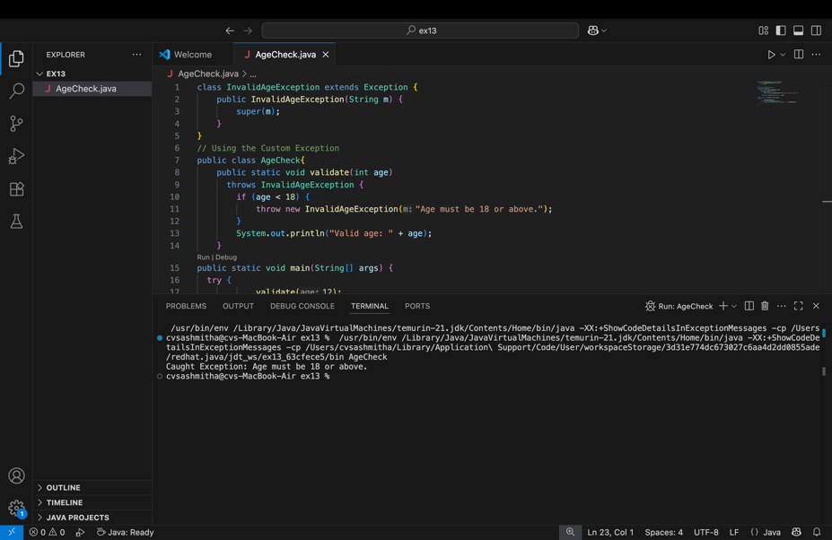
Output 1
Caught Exception: Age must be 18 or above.

Ex 2: // Custom Unchecked Exception
class DivideByZeroException extends RuntimeException {
public DivideByZeroException(String m) {
super(m);
}
}
// Using the Custom Exception
public class TestSample {
public static void divide(int a, int b) {
if (b == 0) {
throw new DivideByZeroException("Division by zero is not allowed.");
}
System.out.println("Result: " + (a / b));
}
public static void main(String[] args) {
try {
divide(10, 0);
} catch (DivideByZeroException e) {
System.out.println("Caught Exception: " + e.getMessage());
}
}
}
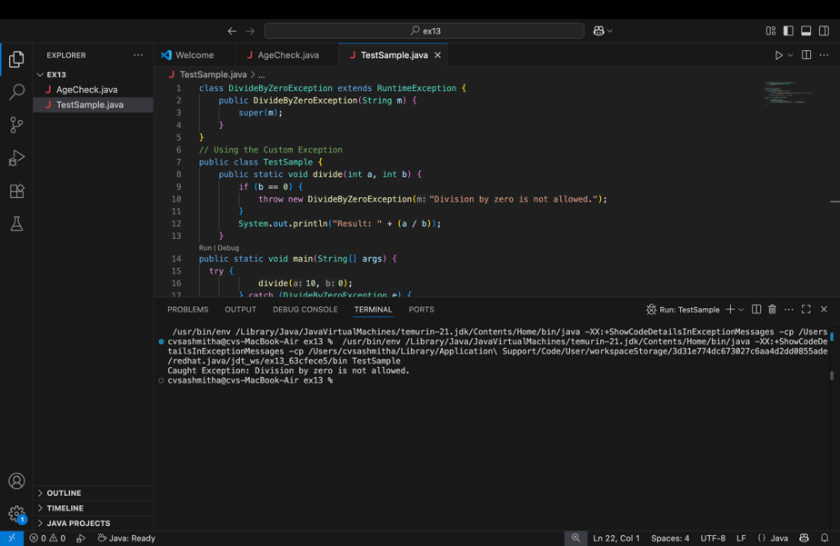
Output 2
Caught Exception: Division by zero is not allowed.

POST LAB EXERCISE
- What is required to create a custom exception in Java?
- Extend the Object class
- Extend the Throwable class
- Extend Exception or RuntimeException
- Implement the Serializable interface

Correct Answer:
C. Extend Exception or RuntimeException
Explanation:
A custom exception is created by extending:
- Exception → to create a checked exception
- RuntimeException → to create an unchecked exception
Other options are incorrect because extending Throwable directly is uncommon and not recommended, and implementing Serializable is not required.

- List some use cases for the checked and unchecked exceptions.

logic. Checked Exceptions (handled at compile time)
Used when the program can recover from the error.
Use cases:
- File handling errors (file not found)
- Database connection failures
- Network communication issues
- Invalid user input that must be corrected

Unchecked Exceptions (runtime exceptions)
Used for programming errors that should be prevented through proper coding.
Use cases:
- Division by zero (ArithmeticException)
- Accessing invalid array index
- Null object access (NullPointerException)
- Logical programming mistakes
Checked exceptions help enforce error handling, while unchecked exceptions indicate bugs in the program

ASSESSMENT

Description | Max Marks | Marks Awarded
Pre Lab Exercise | 5
In Lab Exercise | 10
Post Lab Exercise | 5
Viva | 10
Total | 30
Faculty Signature

