Experiment Number : 8 Date: 23/02/2026

Implementation of Packages in Java

Aim:
Write a Java program to implement built-in, user-defined packages and accessing all classes in a package.

PRE LAB EXERCISE
QUESTIONS
- What is java.util package and what collection framework does it contain?

The java.util package is a built-in Java package that provides utility classes and data structures.
It contains the Java Collection Framework, which includes interfaces and classes like List, Set, Queue, Map, ArrayList, LinkedList, HashSet, and HashMap used to store and manage groups of objects.

- What are the two types of packages in Java?
The two types of packages in Java are:
- Built-in packages – Already provided by Java (e.g., java.util, java.lang).
- User-defined packages – Created by programmers.

IN LAB EXERCISE
Objective
To understand and implement the concepts of built-in, user-defined packages and accessing all classes in a package in Java.
Built-in Packages comprise a large number of classes that are part of the Java API. Some of the commonly used built-in packages are:
- java.lang: Contains language support classes(e.g, classes that define primitive data types, math operations). This package is automatically imported.
- java.io: Contains classes for supporting input/output operations.
- java.util: Contains utility classes that implement data structures such as Linked Lists and Dictionaries, as well as support for date and time operations.
- java.applet: Contains classes for creating Applets.
- java.awt: Contains classes for implementing the components for graphical user interfaces (like buttons, menus, etc).
Source Code
import java.util.Random; // built-in package
public class Sample{
public static void main(String[] args) {
// using Random class
Random rand = new Random();
// generates a number between 0–99
int number = rand.nextInt(100);
System.out.println("Random number: " + number);
}
}
Output
Random number: 49
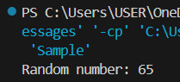

User-defined Packages are the packages that are defined by the user.
Source code
package com.myapp;
public class Helper {
public static void show() {
System.out.println("Hello from Helper!");
}
}
==To use this in another class==
import com.myapp.Helper;
public class Test {
public static void main(String[] args) {
Helper.show();
}
}

Output:
Hello from Helper!
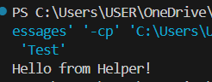

//Importing all classes from a package.
Source code
import java.util.Vector;
public class Coders {
public Coders() {
// java.util.Vector is imported, We are able to access it directly in our code.
Vector v = new Vector();
java.util.ArrayList l = new java.util.ArrayList();
l.add(3);
l.add(5);
l.add(7);
System.out.println(l);
}
public static void main(String[] args) {
new Coders();
}
}
Output
[3,5,7]
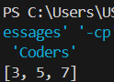

POST LAB EXERCISE

- What will happen if two classes in different packages have the same name and are imported in a Java file?

A name conflict occurs.
Java will show an ambiguity error because it cannot identify which class to use.
To solve this, use the fully qualified class name, for example:

Syntax:

package1.ClassName obj1;
package2.ClassName obj2;

- What is the purpose of using packages in Java?

Packages are used to:
- Organize related classes
- Avoid name conflicts
- Improve code management and reusability
- Provide access protection

- Which built-in Java package would you use if you want to create a GUI window and display a message?
- java.util
- java.sql
- java.awt
- java.net

Correct Answer: C. java.awt

ASSESSMENT

Description | Max Marks | Marks Awarded
Pre Lab Exercise | 5
In Lab Exercise | 10
Post Lab Exercise | 5
Viva | 10
Total | 30
Faculty Signature

Experiment Number : 9 Date: 23/02/2026

Implementation of a Java Program to import packages using different methods

Aim:
Write a Java program to import packages using different methods for different use cases.

PRE LAB EXERCISE
QUESTIONS
- How to import a single class and multiple classes from a package in Java?

- Single class:
import package_name.ClassName;
- Multiple classes:
import package_name.*;

- Which package is always imported by default in every Java class?

java.lang package.

IN LAB EXERCISE
Objective
To understand and implement the Java packages using different methods and import them.
Problem
Define a package named ‘useFul’ with a class names ‘UseMe’ having following methods:
1) area()- To calculate the area of given shape.
2) salary()- To calculate the salary given basic Salary,da,hRA.
3) percentage()-To calculate the percentage given total marks and marks obtained.
4) Develop a program named ‘Package Use’ to import the above package ‘useFul’ and use the method area().
5) Develop a program named ‘manager’
Source Code
//Package Creation:
package useFull;
import java.util.*;
public class UseMe
{
Scanner obj=new Scanner(System.in);
public static void area()
{
class method{
void aos(int a)
{
System.out.print("\nArea of square with length "+a+" is "+(a*a));
}
void aor(int a,int b)
{
System.out.print("\nArea of reactangle with dimensions "+a+" & "+b+" is "+(a*b));
}
void aoc(int r)
{
double a=3.14*r*r;
}
System.out.print("\nArea of circle with radius "+r+" is "+a);
}
void aot(int a,int b)
{
float ar=(a*b)/2;
System.out.print("\nArea of triangle with dimensions "+a+" &"+b+" is "+ar);
} }
Scanner obj=new Scanner(System.in);
method m=new method();
System.out.print("\n1.Square\n2.Rectangle\n3.Circle\n4.Triangle\nSelect the shape\n");
int ch=obj.nextInt();
UseMe u=new UseMe();
switch(ch)
{
case 1:System.out.print("\nEnter the length of side of square : ");
int s=obj.nextInt();m.aos(s);
break;
case 2:System.out.print("\nEnter the dimensions of rectangle : ");
int l=obj.nextInt();
int b=obj.nextInt();
m.aor(l,b);
break;
case 3:System.out.print("\nEnter the radius of circle : ");
int r=obj.nextInt();
m.aoc(r);
break;
case 4:System.out.print("\nEnter the dimensions of triangle : ");
int ba=obj.nextInt();
int w=obj.nextInt();
m.aot(ba,w);
break; } }
public void salary()
{
int ba,da,hra;
System.out.print("\nEnter the basic salary : ");
ba=obj.nextInt();
System.out.print("\nEnter the dearness allowance :");
da=obj.nextInt();
System.out.print("\nEnter the house rent allowance : ");
hra=obj.nextInt();
System.out.print("\nThe total Gross salary of employee is : "+(ba+da+hra));
}
public void percentage()
{
int n,sum=0;
float p;
System.out.print("\nEnter the total number of subjects : ");
n=obj.nextInt();
int m[]=new int[n];
System.out.print("\nEnter the marks of "+n+" subjects : ");
for(int i=0;i<n;i++)
{
m[n]=obj.nextInt();
}
for(int i=0;i<n;i++)
{
sum=sum+m[i];
}
p=sum/n;
{
System.out.print("\nPercentahe of student : "+p);
}
}
}
//Package Implementation-1:
import useFull.UseMe;
class packageUse
{
public static void main(String args[])
{
UseMe o=new UseMe();o.area();
}
}

Output
javac packageUse.java
java packageUse
- Square
- Rectangle
- Circle
- Triangle
Select the shape
2

Enter the dimensions of the rectangle: 10 15
Area of the rectangle with dimensions 10&15 is 150
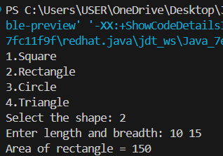

//Package Implementation-2:
import useFull.UseMe;
class manager
{
public static void main(String args[])
{
UseMe obj=new UseMe();obj.salary();
}
}

Output
javac manager.java
java manager

Enter the basic salary: 100000
Enter the dearness allowance: 5000
Enter the house rent allowance: 2000
The total Gross salary of employee is: 107000
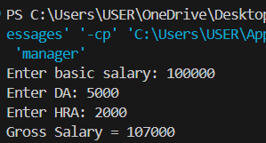

POST LAB EXERCISE
- Find the key differences between java.util and java.lang packages.

Feature | java.lang | java.util
Import | Automatically imported | Must be imported manually
Purpose | Basic language support | Utility classes & data structures
Examples | String, System, Math, Integer | Scanner, ArrayList, HashMap, Date

In short:

- java.lang → Core language classes
- java.util → Utility tools and collections

- List some of the subpackages of java.util

- java.util.concurrent
- java.util.function
- java.util.logging
- java.util.regex
- java.util.stream

ASSESSMENT

Description | Max Marks | Marks Awarded
Pre Lab Exercise | 5
In Lab Exercise | 10
Post Lab Exercise | 5
Viva | 10
Total | 30
Faculty Signature

Experiment Number : 10 Date: 26/02/2026

Implementation of Access Modifiers in Java

Aim:
Write a Java program to implement different access modifiers.

PRE LAB EXERCISE
QUESTIONS
- What are the 4 access modifiers available in Java?
- public – accessible from anywhere
- protected – accessible within the same package and by subclasses
- default (no modifier) – accessible only within the same package
- private – accessible only within the same class

- Which access modifiers can be used in Java to control access to class members?
- public
- protected
- private
- default (package-private)

IN LAB EXERCISE
Objective
To demonstrate different access modifiers such as Default, Private, Protected and Public using Java programs.
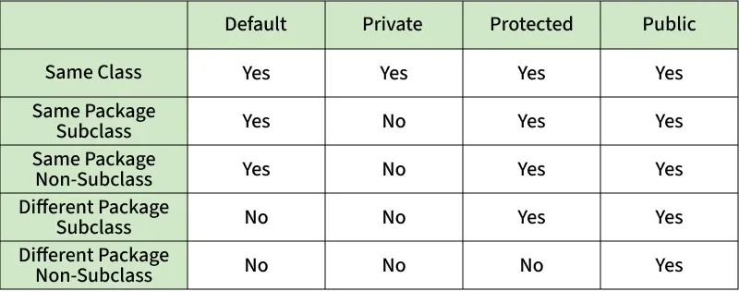
Fig: Comparison table of Access Modifiers in Java
Source Code
// Default Access modifier
class Car {
String model; // default access
}
public class Main {
public static void main(String[] args){
Car c = new Car();
c.model = "Tesla"; // accessible within the same package
System.out.println(c.model);
}
}
Output:
Tesla
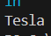
//Private Access Modifier
class Person {
// private variable
private String name;
public void setName(String name) {
this.name = name; // accessible within class
}
public String getName() {
return name;
}
}
public class Geeks {
public static void main(String[] args)
{
Person p = new Person();
p.setName("Alice");

// System.out.println(p.name);
// Error: 'name'
// has private access
System.out.println(p.getName());
}
}
Output
Alice
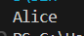
//Protected Access Modifier
class Vehicle {
protected int speed; // protected member
}
class Bike extends Vehicle {
void setSpeed(int s)
{
speed = s; // accessible in subclass
}
int getSpeed()
{
return speed; // accessible in subclass
}
}
public class Main {
public static void main(String[] args){
Bike b = new Bike();
b.setSpeed(100);
System.out.println("Access via subclass method: "+ b.getSpeed());
Vehicle v = new Vehicle();
System.out.println(v.speed);
}
}
Output
Access via subclass method: 100
0
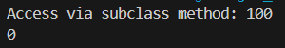
//Public Access Modifier
class MathUtils {
public static int add(int a, int b) {
return a + b;
}
}
public class Main {
public static void main(String[] args) {
System.out.println(MathUtils.add(5, 10)); // accessible anywhere
}
}
Output
15

POST LAB EXERCISE
  - Write a Java program to implement Default access modifier which has a default class within the same package and a default class from a different package.

package Package1;

class DefaultClass { // default access (no modifier)
void display() {
System.out.println("Default class accessed within same package");
}
}

package Package1;

public class TestDefault {
public static void main(String[] args) {
DefaultClass obj = new DefaultClass();
obj.display();
System.out.println("Rupakkrishna P M (24BCS231)");
}
}

package Package2;

import Package1.DefaultClass; // This will cause an error

public class TestOutside {
public static void main(String[] args) {
DefaultClass obj = new DefaultClass(); // Not accessible
obj.display();
System.out.println("Rupakkrishna P M (24BCS231)");
}
}

Explanation:
Default access members/classes can be accessed only within the same package, not from different packages.

  - Which access modifier provides the highest level of access?

public
- It allows access from any class, any package.

ASSESSMENT

Description | Max Marks | Marks Awarded
Pre Lab Exercise | 5
In Lab Exercise | 10
Post Lab Exercise | 5
Viva | 10
Total | 30
Faculty Signature

Experiment Number :11 Date: 26/02/2026

Implementation of multiple inheritance in Java using Interface

Aim:
Write a Java program to implement multiple inheritance using Interface.

PRE LAB EXERCISE
QUESTIONS
- Why Java does not support multiple inheritance using classes like that of C?

Java avoids multiple inheritance with classes to prevent ambiguity problems (Diamond Problem) where a class may inherit the same method from multiple parent classes and the compiler cannot decide which one to use.

- What is the primary purpose of an interface in Java?
- To store data using instance variables
- To define a contract of methods a class must implement
- To allow creation of objects
- To improve runtime performance
Correct Answer: B. To define a contract of methods a class must implement. An interface specifies methods that a class must implement, ensuring a standard structure.

IN LAB EXERCISE
Objective
To demonstrate how an interface in Java defines constants and abstract methods, which are implemented by a class.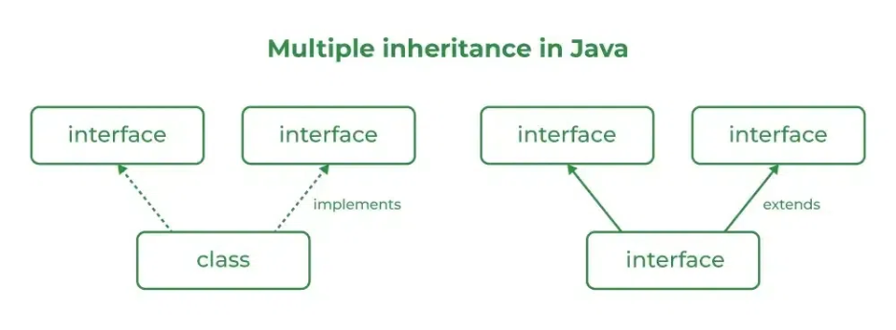

Source Code
import java.io.*;
// Add interface
interface Add{
int add(int a,int b);
}
// Sub interface
interface Sub{
int sub(int a,int b);
}
// Calculator class implementing Add and Sub
class Cal implements Add , Sub
{
// Method to add two numbers
public int add(int a,int b){
return a+b;
}
// Method to sub two numbers
public int sub(int a,int b){
return a-b;
}
}
class Example{
// Main Method
public static void main (String[] args){

// instance of Cal class
Cal x = new Cal();
System.out.println("Addition : " + x.add(2,1));
System.out.println("Substraction : " + x.sub(2,1));
}
}

Outputs
Addition : 3
Subtraction : 1
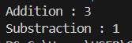
POST LAB EXERCISE
  - Can a functional interface extend another interface?

Yes. A functional interface can extend another interface, but it must still contain only one abstract method in total.

  - Which feature was introduced in interfaces starting from Java 8?
- Constructors
- Private methods
- Default and static methods
- Final classes

Correct Answer: C. Default and static methods
Java 8 introduced default methods and static methods inside interfaces.

ASSESSMENT

Description | Max Marks | Marks Awarded
Pre Lab Exercise | 5
In Lab Exercise | 10
Post Lab Exercise | 5
Viva | 10
Total | 30
Faculty Signature

Experiment Number : 12 Date: 26/02/2026

Implementation of exception handling in Java
Aim:
Write a java program to implement exception handling.

PRE LAB EXERCISE
QUESTIONS
- What is exception handling in Java?

Exception handling is a mechanism used to handle runtime errors so the program does not crash and can continue execution normally.

- What is the purpose of using try-catch blocks in exception handling?

try is used to write code that may cause an exception, and catch is used to handle the error if the exception occurs.

IN LAB EXERCISE
Objective
To understand and implement exception handling through try-catch and finally blocks.
Source Code
import java.util.InputMismatchException;
import java.util.Scanner;
public class ExceptionHandlingExample {
public static void main(String[] args) {
Scanner scanner = new Scanner(System.in);
try {
System.out.print("Enter an integer: ");
int num = scanner.nextInt();
int result = 10 / num;
System.out.println("Result: " + result);
} catch (InputMismatchException e) {
System.out.println("Invalid input! Please enter an integer.");
} catch (ArithmeticException e) {
System.out.println("Cannot divide by zero!");
} finally {
scanner.close();
System.out.println("Program execution completed.");
} }
}

Outputs
Output 1 (Valid Input - Non-zero Integer):
Enter an integer: 5
Result: 2
Program execution completed.
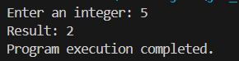

Output 2 (Valid Input - Zero):
Enter an integer: 0
Cannot divide by zero!
Program execution completed.
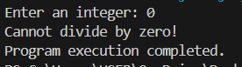

Output 3 (Invalid Input - Non-integer):
Enter an integer: abc
Invalid input! Please enter an integer.
Program execution completed.
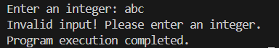

POST LAB EXERCISE
- What is the purpose of the Scanner object in the Java program?

The Scanner object is used to take input from the user, usually from the keyboard (System.in).

- What exceptions are expected to be thrown in the code within the try block? Why?

Common exceptions include:

- InputMismatchException – when the user enters the wrong data type.
- ArithmeticException – when an illegal arithmetic operation occurs (like division by zero).

They occur when the program receives invalid input or performs an invalid operation inside the try block.

ASSESSMENT

Description | Max Marks | Marks Awarded
Pre Lab Exercise | 5
In Lab Exercise | 10
Post Lab Exercise | 5
Viva | 10
Total | 30
Faculty Signature

Experiment Number : 13 Date: 26/02/2026

Implementation of User-defined Exception in Java

Aim:
Write a java program to implement User-defined Exception.

PRE LAB EXERCISE
QUESTIONS
- What is Java custom exception?

A custom exception is a user-defined exception created by a programmer to handle specific error conditions in a program.

- What are the two types of custom exceptions in Java?

- Checked exceptions
- Unchecked exceptions

IN LAB EXERCISE
Objective
To understand and implement Checked and Unchecked custom exceptions.
Source Code
Ex 1: // Custom Checked Exception
class InvalidAgeException extends Exception {
public InvalidAgeException(String m) {
super(m);
}
}
// Using the Custom Exception
public class AgeCheck{
public static void validate(int age)
throws InvalidAgeException {
if (age < 18) {
throw new InvalidAgeException("Age must be 18 or above.");
}
System.out.println("Valid age: " + age);
}
public static void main(String[] args) {
try {
validate(12);
} catch (InvalidAgeException e) {
System.out.println("Caught Exception: " + e.getMessage());
}
}
}

Output 1
Caught Exception: Age must be 18 or above.

Ex 2: // Custom Unchecked Exception
class DivideByZeroException extends RuntimeException {
public DivideByZeroException(String m) {
super(m);
}
}
// Using the Custom Exception
public class TestSample {
public static void divide(int a, int b) {
if (b == 0) {
throw new DivideByZeroException("Division by zero is not allowed.");
}
System.out.println("Result: " + (a / b));
}
public static void main(String[] args) {
try {
divide(10, 0);
} catch (DivideByZeroException e) {
System.out.println("Caught Exception: " + e.getMessage());
}
}
}

Output 2
Caught Exception: Division by zero is not allowed.

POST LAB EXERCISE
- What is required to create a custom exception in Java?
- Extend the Object class
- Extend the Throwable class
- Extend Exception or RuntimeException
- Implement the Serializable interface

Correct Answer: C. Extend Exception or RuntimeException
- Extend Exception → for checked exceptions
- Extend RuntimeException → for unchecked exceptions

- List some use cases for the checked and unchecked exceptions.

Checked Exceptions (handled at compile time):

- File handling errors (file not found)
- Database connection errors
- Network communication errors

Unchecked Exceptions (runtime errors):

- Division by zero
- Invalid array index
- Null object access (NullPointerException)

ASSESSMENT

Description | Max Marks | Marks Awarded
Pre Lab Exercise | 5
In Lab Exercise | 10
Post Lab Exercise | 5
Viva | 10
Total | 30
Faculty Signature

