Experiment Number : 8 Date: 26/02/2026

Implementation of Packages in Java

Aim:
Write a Java program to implement built-in, user-defined packages and accessing all classes in a package.

PRE LAB EXERCISE
QUESTIONS
- What is java.util package and what collection framework does it contain?

java.util is a built-in Java package that provides utility classes and the Collection Framework for storing and manipulating data.
It contains:
- List → ArrayList, LinkedList
- Set → HashSet, TreeSet
- Queue → PriorityQueue
- Map → HashMap, TreeMap

- What are the two types of packages in Java?

The two types of packages in Java are:
- Built-in Packages
- User-defined Packages

IN LAB EXERCISE
Objective
To understand and implement the concepts of built-in, user-defined packages and accessing all classes in a package in Java.
Built-in Packages comprise a large number of classes that are part of the Java API. Some of the commonly used built-in packages are:
- java.lang: Contains language support classes(e.g, classes that define primitive data types, math operations). This package is automatically imported.
- java.io: Contains classes for supporting input/output operations.
- java.util: Contains utility classes that implement data structures such as Linked Lists and Dictionaries, as well as support for date and time operations.
- java.applet: Contains classes for creating Applets.
- java.awt: Contains classes for implementing the components for graphical user interfaces (like buttons, menus, etc).
Source Code
import java.util.Random; // built-in package
public class Sample{
public static void main(String[] args) {
// using Random class
Random rand = new Random();
// generates a number between 0–99
int number = rand.nextInt(100);
System.out.println("Random number: " + number);
}
}

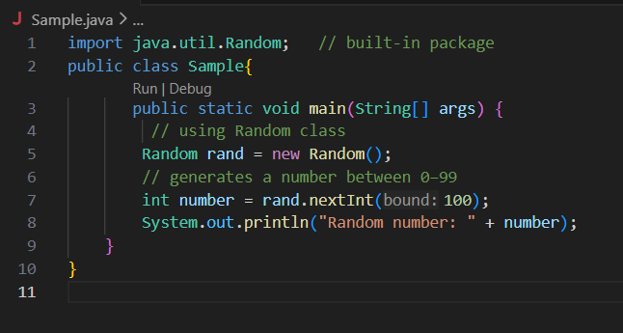
Output
Random number: 49


User-defined Packages are the packages that are defined by the user.
Source code
package com.myapp;
public class Helper {
public static void show() {
System.out.println("Hello from Helper!");
}
}
==To use this in another class==
import com.myapp.Helper;
public class Test {
public static void main(String[] args) {
Helper.show();
}
}
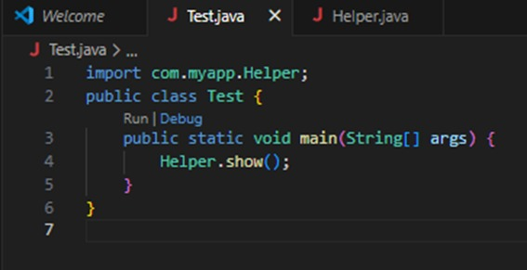
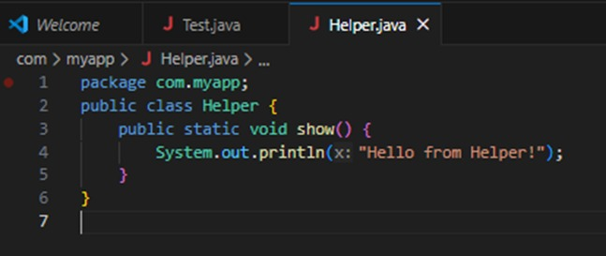

Output:
Hello from Helper!

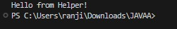

//Importing all classes from a package.
Source code
import java.util.Vector;
public class Coders {
public Coders() {
// java.util.Vector is imported, We are able to access it directly in our code.
Vector v = new Vector();
java.util.ArrayList l = new java.util.ArrayList();
l.add(3);
l.add(5);
l.add(7);
System.out.println(l);
}
public static void main(String[] args) {
new Coders();
}
}
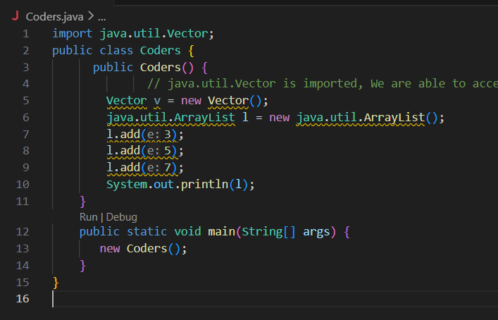
Output
[3,5,7]
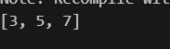
POST LAB EXERCISE
- What will happen if two classes in different packages have the same name and are imported in a Java file?

If two classes with the same name from different packages are imported, Java will show a compile-time ambiguity error because it cannot decide which class to use.
Solution:
Use the fully qualified class name (complete package path).

- What is the purpose of using packages in Java?

Packages are used to:
- Organize large programs properly
- Avoid class name conflicts
- Improve code reusability
- Provide security (access control)
- Make maintenance easier

- Which built-in Java package would you use if you want to create a GUI window and display a message?
- java.util
- java.sql
- java.awt
- java.net

C. java.awt
Reason (brief):
java.awt provides classes to create GUI components like windows, buttons, labels, and dialogs.

ASSESSMENT

Description | Max Marks | Marks Awarded
Pre Lab Exercise | 5
In Lab Exercise | 10
Post Lab Exercise | 5
Viva | 10
Total | 30
Faculty Signature

Experiment Number : 9 Date: 25/02/2026

Implementation of a Java Program to import packages using different methods

Aim:
Write a Java program to import packages using different methods for different use cases.

PRE LAB EXERCISE
QUESTIONS
- How to import a single class and multiple classes from a package in Java?

In Java, a single class can be imported using the import packageName.ClassName; statement, and multiple classes can be imported using the import packageName.*; statement, which imports all classes of that package.

- Which package is always imported by default in every Java class?

The java.lang package is automatically imported by default in every Java program. It contains essential classes like System, String, and Math.

IN LAB EXERCISE
Objective
To understand and implement the Java packages using different methods and import them.
Problem
Define a package named ‘useFul’ with a class names ‘UseMe’ having following methods:
1) area()- To calculate the area of given shape.
2) salary()- To calculate the salary given basic Salary,da,hRA.
3) percentage()-To calculate the percentage given total marks and marks obtained.
4) Develop a program named ‘Package Use’ to import the above package ‘useFul’ and use the method area().
5) Develop a program named ‘manager’
Source Code
//Package Creation:
package useFull;
import java.util.*;
public class UseMe
{
Scanner obj=new Scanner(System.in);
public static void area()
{
class method{
void aos(int a)
{
System.out.print("\nArea of square with length "+a+" is "+(a*a));
}
void aor(int a,int b)
{
System.out.print("\nArea of reactangle with dimensions "+a+" & "+b+" is "+(a*b));
}
void aoc(int r)
{
double a=3.14*r*r;
}
System.out.print("\nArea of circle with radius "+r+" is "+a);
}
void aot(int a,int b)
{
float ar=(a*b)/2;
System.out.print("\nArea of triangle with dimensions "+a+" &"+b+" is "+ar);
} }
Scanner obj=new Scanner(System.in);
method m=new method();
System.out.print("\n1.Square\n2.Rectangle\n3.Circle\n4.Triangle\nSelect the shape\n");
int ch=obj.nextInt();
UseMe u=new UseMe();
switch(ch)
{
case 1:System.out.print("\nEnter the length of side of square : ");
int s=obj.nextInt();m.aos(s);
break;
case 2:System.out.print("\nEnter the dimensions of rectangle : ");
int l=obj.nextInt();
int b=obj.nextInt();
m.aor(l,b);
break;
case 3:System.out.print("\nEnter the radius of circle : ");
int r=obj.nextInt();
m.aoc(r);
break;
case 4:System.out.print("\nEnter the dimensions of triangle : ");
int ba=obj.nextInt();
int w=obj.nextInt();
m.aot(ba,w);
break; } }
public void salary()
{
int ba,da,hra;
System.out.print("\nEnter the basic salary : ");
ba=obj.nextInt();
System.out.print("\nEnter the dearness allowance :");
da=obj.nextInt();
System.out.print("\nEnter the house rent allowance : ");
hra=obj.nextInt();
System.out.print("\nThe total Gross salary of employee is : "+(ba+da+hra));
}
public void percentage()
{
int n,sum=0;
float p;
System.out.print("\nEnter the total number of subjects : ");
n=obj.nextInt();
int m[]=new int[n];
System.out.print("\nEnter the marks of "+n+" subjects : ");
for(int i=0;i<n;i++)
{
m[n]=obj.nextInt();
}
for(int i=0;i<n;i++)
{
sum=sum+m[i];
}
p=sum/n;
{
System.out.print("\nPercentahe of student : "+p);
}
}
}
//Package Implementation-1:
import useFull.UseMe;
class packageUse
{
public static void main(String args[])
{
UseMe o=new UseMe();o.area();
}
}

Output
javac packageUse.java
java packageUse
- Square
- Rectangle
- Circle
- Triangle
Select the shape
2

Enter the dimensions of the rectangle: 10 15
Area of the rectangle with dimensions 10&15 is 150

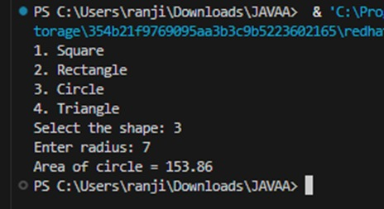
//Package Implementation-2:
import useFull.UseMe;
class manager
{
public static void main(String args[])
{
UseMe obj=new UseMe();obj.salary();
}
}

Output
javac manager.java
java manager

Enter the basic salary: 100000
Enter the dearness allowance: 5000
Enter the house rent allowance: 2000
The total Gross salary of employee is: 107000

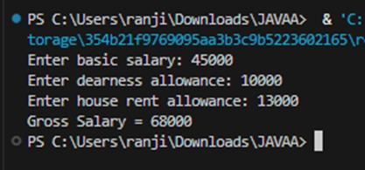

POST LAB EXERCISE
- Find the key differences between java.util and java.lang packages.
java.lang | java.util
Automatically imported by default | Must be imported explicitly
Contains core language classes | Contains utility and collection classes
Examples: String, System, Math, Object | Examples: Scanner, ArrayList, HashMap, Date

- List some of the subpackages of java.util

Some important subpackages of java.util are:
- java.util.concurrent
- java.util.function
- java.util.regex
- java.util.stream
- java.util.logging

ASSESSMENT

Description | Max Marks | Marks Awarded
Pre Lab Exercise | 5
In Lab Exercise | 10
Post Lab Exercise | 5
Viva | 10
Total | 30
Faculty Signature

Experiment Number : 10 Date: 25/02/26

Implementation of Access Modifiers in Java

Aim:
Write a Java program to implement different access modifiers.

PRE LAB EXERCISE
QUESTIONS
- What are the 4 access modifiers available in Java?
• Default
• Private
• Protected
• Public

- Which access modifiers can be used in Java to control access to class members?
• Private
• Protected
• Public
• Default

IN LAB EXERCISE
Objective
To demonstrate different access modifiers such as Default, Private, Protected and Public using Java programs.
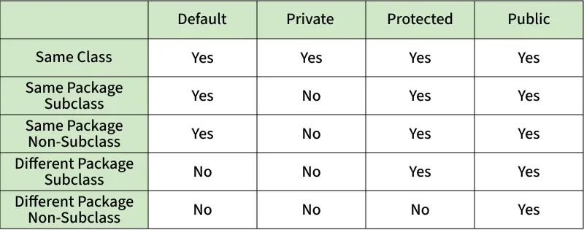
Fig: Comparison table of Access Modifiers in Java
Source Code
// Default Access modifier
class Car {
String model; // default access
}
public class Main {
public static void main(String[] args){
Car c = new Car();
c.model = "Tesla"; // accessible within the same package
System.out.println(c.model);
}
}
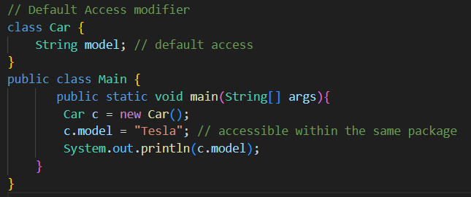
Output:
Tesla

//Private Access Modifier
class Person {
// private variable
private String name;
public void setName(String name) {
this.name = name; // accessible within class
}
public String getName() {
return name;
}
}
public class Geeks {
public static void main(String[] args)
{
Person p = new Person();
p.setName("Alice");

// System.out.println(p.name);
// Error: 'name'
// has private access
System.out.println(p.getName());
}
}
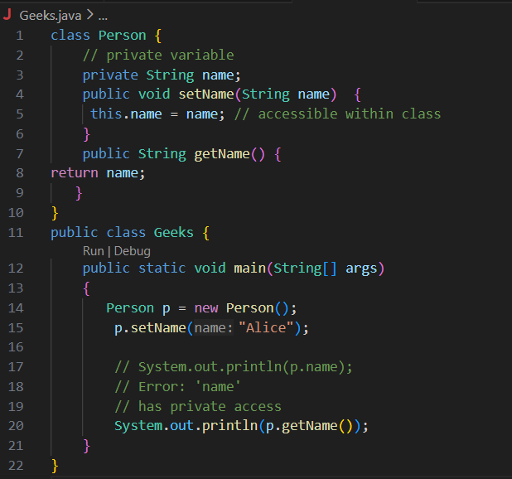
Output
Alice

//Protected Access Modifier
class Vehicle {
protected int speed; // protected member
}
class Bike extends Vehicle {
void setSpeed(int s)
{
speed = s; // accessible in subclass
}
int getSpeed()
{
return speed; // accessible in subclass
}
}
public class Main {
public static void main(String[] args){
Bike b = new Bike();
b.setSpeed(100);
System.out.println("Access via subclass method: "+ b.getSpeed());
Vehicle v = new Vehicle();
System.out.println(v.speed);
}
}
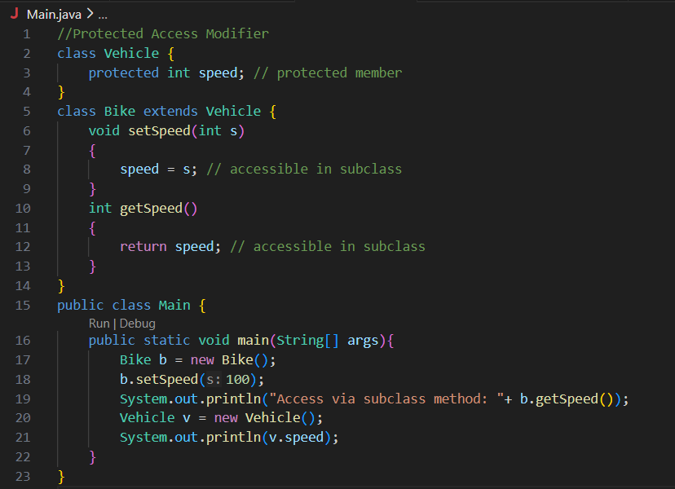
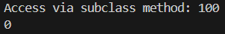
Output
Access via subclass method: 100
0

//Public Access Modifier
class MathUtils {
public static int add(int a, int b) {
return a + b;
}
}
public class Main {
public static void main(String[] args) {
System.out.println(MathUtils.add(5, 10)); // accessible anywhere
}
}
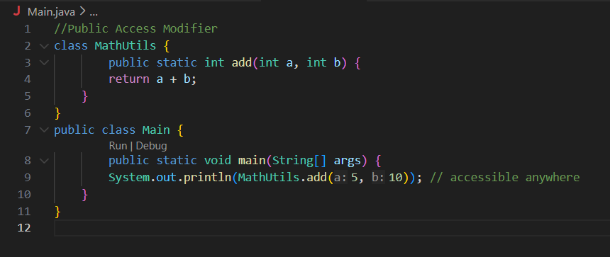
Output
15

POST LAB EXERCISE
  - Write a Java program to implement Default access modifier which has a default class within the same package and a default class from a different package.
• Default members are accessible only within same package.
• Not accessible from different package.

  - Which access modifier provides the highest level of access?

  - ✅ Public

ASSESSMENT

Description | Max Marks | Marks Awarded
Pre Lab Exercise | 5
In Lab Exercise | 10
Post Lab Exercise | 5
Viva | 10
Total | 30
Faculty Signature

Experiment Number :11 Date: 25/02/26

Implementation of multiple inheritance in Java using Interface

Aim:
Write a Java program to implement multiple inheritance using Interface.

PRE LAB EXERCISE
QUESTIONS
- Why Java does not support multiple inheritance using classes like that of C?
Because of the Diamond Problem (ambiguity problem).
- What is the primary purpose of an interface in Java?
- To store data using instance variables
- To define a contract of methods a class must implement
- To allow creation of objects
- To improve runtime performance
✅ B. To define a contract of methods a class must implement

IN LAB EXERCISE
Objective
To demonstrate how an interface in Java defines constants and abstract methods, which are implemented by a class.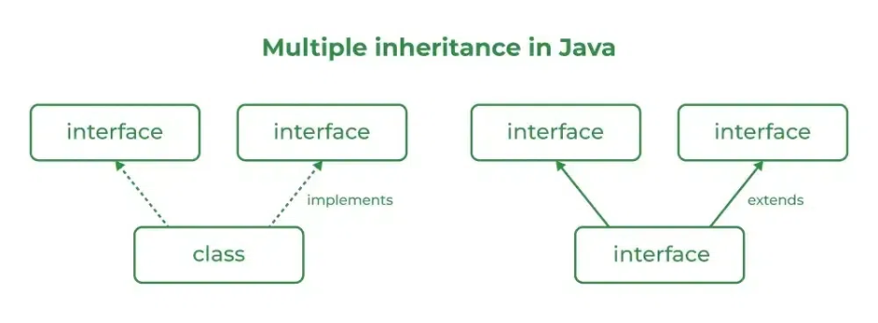

Source Code
import java.io.*;
// Add interface
interface Add{
int add(int a,int b);
}
// Sub interface
interface Sub{
int sub(int a,int b);
}
// Calculator class implementing Add and Sub
class Cal implements Add , Sub
{
// Method to add two numbers
public int add(int a,int b){
return a+b;
}
// Method to sub two numbers
public int sub(int a,int b){
return a-b;
}
}
class Example{
// Main Method
public static void main (String[] args){

// instance of Cal class
Cal x = new Cal();
System.out.println("Addition : " + x.add(2,1));
System.out.println("Substraction : " + x.sub(2,1));
}
}
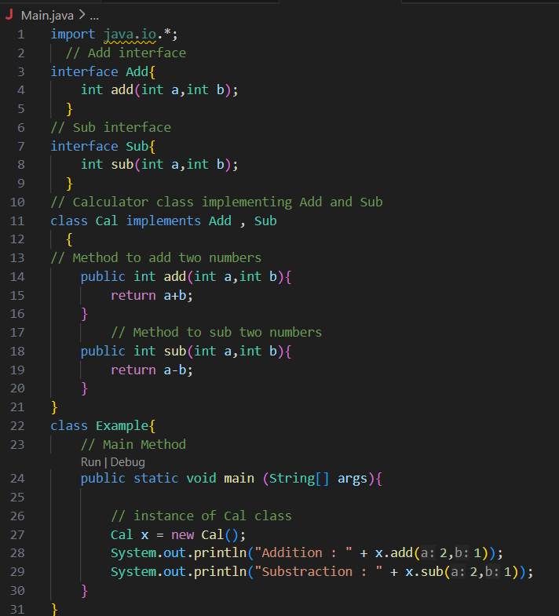
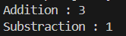
Outputs
Addition : 3
Subtraction : 1

POST LAB EXERCISE
  - Can a functional interface extend another interface?
Yes, but it must still contain only one abstract method.
  - Which feature was introduced in interfaces starting from Java 8?
- Constructors
- Private methods
- Default and static methods
- Final classes
✅ C. Default and static methods

ASSESSMENT

Description | Max Marks | Marks Awarded
Pre Lab Exercise | 5
In Lab Exercise | 10
Post Lab Exercise | 5
Viva | 10
Total | 30
Faculty Signature

Experiment Number : 12 Date: 25/02/26

Implementation of exception handling in Java
Aim:
Write a java program to implement exception handling.

PRE LAB EXERCISE
QUESTIONS
- What is exception handling in Java?
• It is a mechanism to handle runtime errors so that program execution does not stop abruptly.
- What is the purpose of using try-catch blocks in exception handling?
  - try → contains risky code
  - catch → handles the exception

IN LAB EXERCISE
Objective
To understand and implement exception handling through try-catch and finally blocks.
Source Code
import java.util.InputMismatchException;
import java.util.Scanner;
public class ExceptionHandlingExample {
public static void main(String[] args) {
Scanner scanner = new Scanner(System.in);
try {
System.out.print("Enter an integer: ");
int num = scanner.nextInt();
int result = 10 / num;
System.out.println("Result: " + result);
} catch (InputMismatchException e) {
System.out.println("Invalid input! Please enter an integer.");
} catch (ArithmeticException e) {
System.out.println("Cannot divide by zero!");
} finally {
scanner.close();
System.out.println("Program execution completed.");
} }
}
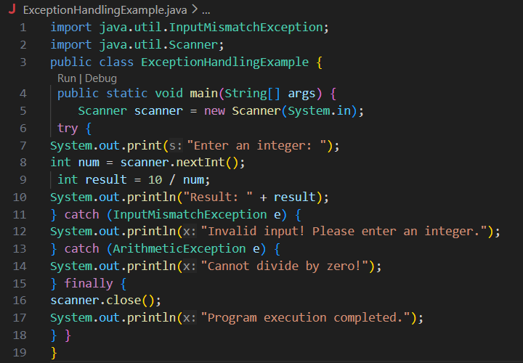
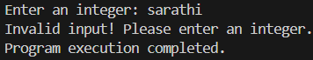
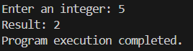
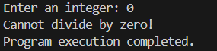
Outputs
Output 1 (Valid Input - Non-zero Integer):
Enter an integer: 5
Result: 2
Program execution completed.

Output 2 (Valid Input - Zero):
Enter an integer: 0
Cannot divide by zero!
Program execution completed.

Output 3 (Invalid Input - Non-integer):
Enter an integer: abc
Invalid input! Please enter an integer.
Program execution completed.

POST LAB EXERCISE
- What is the purpose of the Scanner object in the Java program?
To take input from the user.
- What exceptions are expected to be thrown in the code within the try block? Why?
  - InputMismatchException → if user enters non-integer
  - ArithmeticException → if divided by zero

ASSESSMENT

Description | Max Marks | Marks Awarded
Pre Lab Exercise | 5
In Lab Exercise | 10
Post Lab Exercise | 5
Viva | 10
Total | 30
Faculty Signature

Experiment Number : 13 Date: 25/02/26

Implementation of User-defined Exception in Java

Aim:
Write a java program to implement User-defined Exception.

PRE LAB EXERCISE
QUESTIONS
- What is Java custom exception?
A user-created exception class to handle specific application errors.
- What are the two types of custom exceptions in Java?
  - Checked Exception (extends Exception)
  - Unchecked Exception (extends RuntimeException)

IN LAB EXERCISE
Objective
To understand and implement Checked and Unchecked custom exceptions.
Source Code
Ex 1: // Custom Checked Exception
class InvalidAgeException extends Exception {
public InvalidAgeException(String m) {
super(m);
}
}
// Using the Custom Exception
public class AgeCheck{
public static void validate(int age)
throws InvalidAgeException {
if (age < 18) {
throw new InvalidAgeException("Age must be 18 or above.");
}
System.out.println("Valid age: " + age);
}
public static void main(String[] args) {
try {
validate(12);
} catch (InvalidAgeException e) {
System.out.println("Caught Exception: " + e.getMessage());
}
}
}

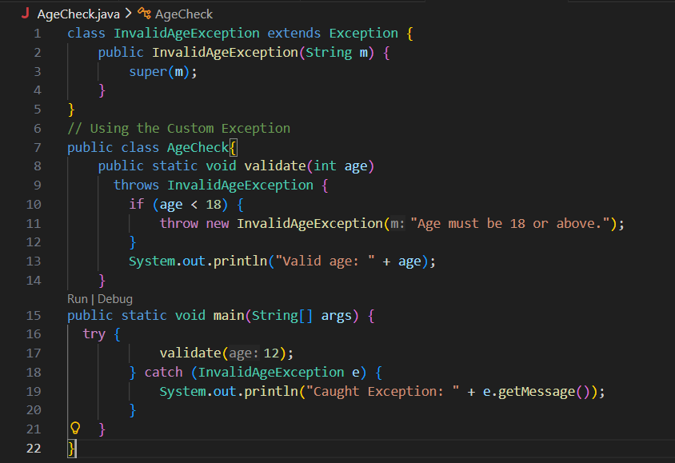

Output 1
Caught Exception: Age must be 18 or above.

Ex 2: // Custom Unchecked Exception
class DivideByZeroException extends RuntimeException {
public DivideByZeroException(String m) {
super(m);
}
}
// Using the Custom Exception
public class TestSample {
public static void divide(int a, int b) {
if (b == 0) {
throw new DivideByZeroException("Division by zero is not allowed.");
}
System.out.println("Result: " + (a / b));
}
public static void main(String[] args) {
try {
divide(10, 0);
} catch (DivideByZeroException e) {
System.out.println("Caught Exception: " + e.getMessage());
}
}
}
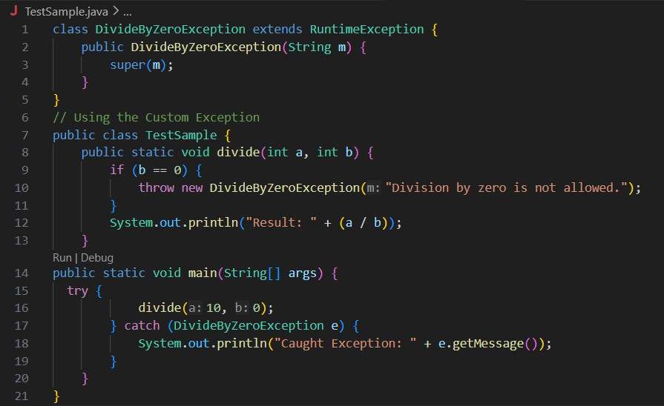

Output 2
Caught Exception: Division by zero is not allowed.

POST LAB EXERCISE
- What is required to create a custom exception in Java?
- Extend the Object class
- Extend the Throwable class
- Extend Exception or RuntimeException
- Implement the Serializable interface
✅ C. Extend Exception or RuntimeException

- List some use cases for the checked and unchecked exceptions.

Checked Exception:
- File handling
- Database operations
- Network errors
Unchecked Exception:
- Invalid input
- Arithmetic errors
- Business rule violations

ASSESSMENT

Description | Max Marks | Marks Awarded
Pre Lab Exercise | 5
In Lab Exercise | 10
Post Lab Exercise | 5
Viva | 10
Total | 30
Faculty Signature

