Experiment Number : 8 Date: 11/02/2026

Implementation of Packages in Java

Aim:
Write a Java program to implement built-in, user-defined packages and accessing all classes in a package.

PRE LAB EXERCISE QUESTIONS
- What is java.util package and what collection framework does it contain?

java.util is a built-in Java package that contains utility classes such as collections, date and time utilities, and random number generation.
It contains the Collection Framework, including classes like ArrayList, LinkedList, HashSet, HashMap, Vector, and Stack.
- What are the two types of packages in Java?
- Built-in Packages
- User-defined Packages

IN LAB EXERCISE
Objective
To understand and implement the concepts of built-in, user-defined packages and accessing all classes in a package in Java.
Built-in Packages comprise a large number of classes that are part of the Java API. Some of the commonly used built-in packages are:
- java.lang: Contains language support classes(e.g, classes that define primitive data types, math operations). This package is automatically imported.
- java.io: Contains classes for supporting input/output operations.
- java.util: Contains utility classes that implement data structures such as Linked Lists and Dictionaries, as well as support for date and time operations.
- java.applet: Contains classes for creating Applets.
- java.awt: Contains classes for implementing the components for graphical user interfaces (like buttons, menus, etc).
Source Code
import java.util.Random; // built-in package
public class Sample{
public static void main(String[] args) {
// using Random class
Random rand = new Random();
// generates a number between 0–99
int number = rand.nextInt(100);
System.out.println("Random number: " + number);
}
}
Output
Random number: 49
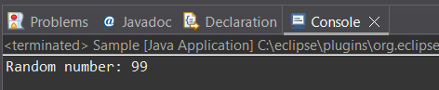

User-defined Packages are the packages that are defined by the user.
Source code
package com.myapp;
public class Helper {
public static void show() {
System.out.println("Hello from Helper!");
}
}
==To use this in another class==
import com.myapp.Helper;
public class Test {
public static void main(String[] args) {
Helper.show();
}
}

Output:
Hello from Helper!
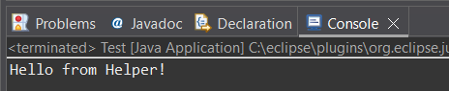

//Importing all classes from a package.
Source code
import java.util.Vector;
public class Coders {
public Coders() {
// java.util.Vector is imported, We are able to access it directly in our code.
Vector v = new Vector();
java.util.ArrayList l = new java.util.ArrayList();
l.add(3);
l.add(5);
l.add(7);
System.out.println(l);
}
public static void main(String[] args) {
new Coders();
}
}
Output
[3,5,7]
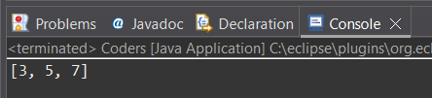

POST LAB EXERCISE
- What will happen if two classes in different packages have the same name and are imported in a Java file?

It will cause a name conflict (ambiguity error).
To resolve this, we must use the fully qualified class name (package name + class name).

- What is the purpose of using packages in Java?

- To organize related classes and interfaces
- To avoid name conflicts
- To provide access protection
- To improve code reusability and maintainability

- Which built-in Java package would you use if you want to create a GUI window and display a message?
- java.util
- java.sql
- java.awt
- java.net

java.awt is a built-in Java package would you use if you want to create a GUI window and display a message

ASSESSMENT

Description | Max Marks | Marks Awarded
Pre Lab Exercise | 5
In Lab Exercise | 10
Post Lab Exercise | 5
Viva | 10
Total | 30
Faculty Signature

Experiment Number : 9 Date: 11/02/2026

Implementation of a Java Program to import packages using different methods

Aim:
Write a Java program to import packages using different methods for different use cases.

PRE LAB EXERCISE QUESTIONS
- How to import a single class and multiple classes from a package in Java?

- Import single class:
import java.util.Scanner;
- Import multiple classes (all classes):
import java.util.*;

- Which package is always imported by default in every Java class?
java.lang package is always imported by default in every Java class.

IN LAB EXERCISE
Objective
To understand and implement the Java packages using different methods and import them.
Problem
Define a package named ‘useFul’ with a class names ‘UseMe’ having following methods:
1) area()- To calculate the area of given shape.
2) salary()- To calculate the salary given basic Salary,da,hRA.
3) percentage()-To calculate the percentage given total marks and marks obtained.
4) Develop a program named ‘Package Use’ to import the above package ‘useFul’ and use the method area().
5) Develop a program named ‘manager’
Source Code
//Package Creation:
package useFull;
import java.util.*;
public class UseMe
{
Scanner obj=new Scanner(System.in);
public static void area()
{
class method{
void aos(int a)
{
System.out.print("\nArea of square with length "+a+" is "+(a*a));
}
void aor(int a,int b)
{
System.out.print("\nArea of reactangle with dimensions "+a+" & "+b+" is "+(a*b));
}
void aoc(int r)
{
double a=3.14*r*r;
}
System.out.print("\nArea of circle with radius "+r+" is "+a);
}
void aot(int a,int b)
{
float ar=(a*b)/2;
System.out.print("\nArea of triangle with dimensions "+a+" &"+b+" is "+ar);
} }
Scanner obj=new Scanner(System.in);
method m=new method();
System.out.print("\n1.Square\n2.Rectangle\n3.Circle\n4.Triangle\nSelect the shape\n");
int ch=obj.nextInt();
UseMe u=new UseMe();
switch(ch)
{
case 1:System.out.print("\nEnter the length of side of square : ");
int s=obj.nextInt();m.aos(s);
break;
case 2:System.out.print("\nEnter the dimensions of rectangle : ");
int l=obj.nextInt();
int b=obj.nextInt();
m.aor(l,b);
break;
case 3:System.out.print("\nEnter the radius of circle : ");
int r=obj.nextInt();
m.aoc(r);
break;
case 4:System.out.print("\nEnter the dimensions of triangle : ");
int ba=obj.nextInt();
int w=obj.nextInt();
m.aot(ba,w);
break; } }
public void salary()
{
int ba,da,hra;
System.out.print("\nEnter the basic salary : ");
ba=obj.nextInt();
System.out.print("\nEnter the dearness allowance :");
da=obj.nextInt();
System.out.print("\nEnter the house rent allowance : ");
hra=obj.nextInt();
System.out.print("\nThe total Gross salary of employee is : "+(ba+da+hra));
}
public void percentage()
{
int n,sum=0;
float p;
System.out.print("\nEnter the total number of subjects : ");
n=obj.nextInt();
int m[]=new int[n];
System.out.print("\nEnter the marks of "+n+" subjects : ");
for(int i=0;i<n;i++)
{
m[n]=obj.nextInt();
}
for(int i=0;i<n;i++)
{
sum=sum+m[i];
}
p=sum/n;
{
System.out.print("\nPercentahe of student : "+p);
}
}
}
//Package Implementation-1:
import useFull.UseMe;
class packageUse
{
public static void main(String args[])
{
UseMe o=new UseMe();o.area();
}
}

Output
javac packageUse.java
java packageUse
- Square
- Rectangle
- Circle
- Triangle
Select the shape
2

Enter the dimensions of the rectangle: 10 15
Area of the rectangle with dimensions 10&15 is 150
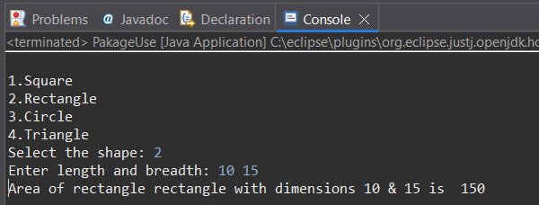
//Package Implementation-2:
import useFull.UseMe;
class manager
{
public static void main(String args[])
{
UseMe obj=new UseMe();obj.salary();
}
}

Output
javac manager.java
java manager

Enter the basic salary: 100000
Enter the dearness allowance: 5000
Enter the house rent allowance: 2000
The total Gross salary of employee is: 107000
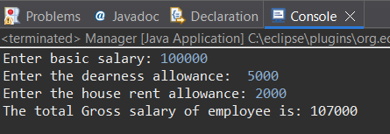

POST LAB EXERCISE
- Find the key differences between java.util and java.lang packages.

java.lang:
- Automatically imported
- Contains core classes like String, Math, System
- Basic language support

java.util:
- Must be imported manually
- Contains utility classes like Scanner, Random, ArrayList
- Collection framework and utility tools

- List some of the subpackages of java.util

- java.util.concurrent
- java.util.function
- java.util.logging
- java.util.regex
- java.util.stream

ASSESSMENT

Description | Max Marks | Marks Awarded
Pre Lab Exercise | 5
In Lab Exercise | 10
Post Lab Exercise | 5
Viva | 10
Total | 30
Faculty Signature

Experiment Number : 10 Date: 11/02/2026

Implementation of Access Modifiers in Java

Aim:
Write a Java program to implement different access modifiers.

PRE LAB EXERCISE QUESTIONS
- What are the 4 access modifiers available in Java?
- Default
- Private
- Protected
- Public

- Which access modifiers can be used in Java to control access to class members?
- Private
- Protected
- Public
- Default

IN LAB EXERCISE
Objective
To demonstrate different access modifiers such as Default, Private, Protected and Public using Java programs.
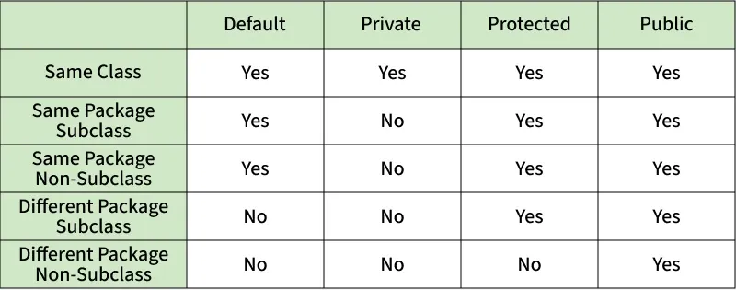
Fig: Comparison table of Access Modifiers in Java
Source Code
// Default Access modifier
class Car {
String model; // default access
}
public class Main {
public static void main(String[] args){
Car c = new Car();
c.model = "Tesla"; // accessible within the same package
System.out.println(c.model);
}
}
Output:
Tesla
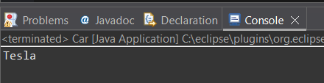

//Private Access Modifier
class Person {
// private variable
private String name;
public void setName(String name) {
this.name = name; // accessible within class
}
public String getName() {
return name;
}
}
public class Geeks {
public static void main(String[] args)
{
Person p = new Person();
p.setName("Alice");

// System.out.println(p.name);
// Error: 'name'
// has private access
System.out.println(p.getName());
}
}
Output
Alice
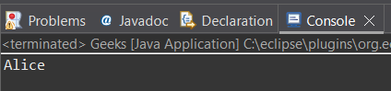
//Protected Access Modifier
class Vehicle {
protected int speed; // protected member
}
class Bike extends Vehicle {
void setSpeed(int s)
{
speed = s; // accessible in subclass
}
int getSpeed()
{
return speed; // accessible in subclass
}
}
public class Main {
public static void main(String[] args){
Bike b = new Bike();
b.setSpeed(100);
System.out.println("Access via subclass method: "+ b.getSpeed());
Vehicle v = new Vehicle();
System.out.println(v.speed);
}
}
Output
Access via subclass method: 100
0
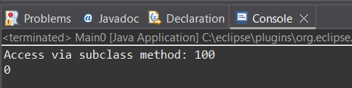
//Public Access Modifier
class MathUtils {
public static int add(int a, int b) {
return a + b;
}
}
public class Main {
public static void main(String[] args) {
System.out.println(MathUtils.add(5, 10)); // accessible anywhere
}
}
Output
15
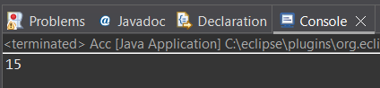

POST LAB EXERCISE
  - Write a Java program to implement Default access modifier which has a default class within the same package and a default class from a different package.

class DefaultClass {
void display() {
System.out.println("Default access within same package");
}
}

public class TestDefault {
public static void main(String[] args) {
DefaultClass obj = new DefaultClass();
obj.display();
}
}

  - Which access modifier provides the highest level of access?

Public access modifier provides the highest level of access.

ASSESSMENT

Description | Max Marks | Marks Awarded
Pre Lab Exercise | 5
In Lab Exercise | 10
Post Lab Exercise | 5
Viva | 10
Total | 30
Faculty Signature

Experiment Number :11 Date: 12/02/2026

Implementation of multiple inheritance in Java using Interface

Aim:
Write a Java program to implement multiple inheritance using Interface.

PRE LAB EXERCISE
QUESTIONS
- Why Java does not support multiple inheritance using classes like that of C?
Because it can cause ambiguity problem (Diamond problem) and complexity.
- What is the primary purpose of an interface in Java?
- To store data using instance variables
- To define a contract of methods a class must implement
- To allow creation of objects
- To improve runtime performance
To define a contract of methods a class must implement
IN LAB EXERCISE
Objective
To demonstrate how an interface in Java defines constants and abstract methods, which are implemented by a class.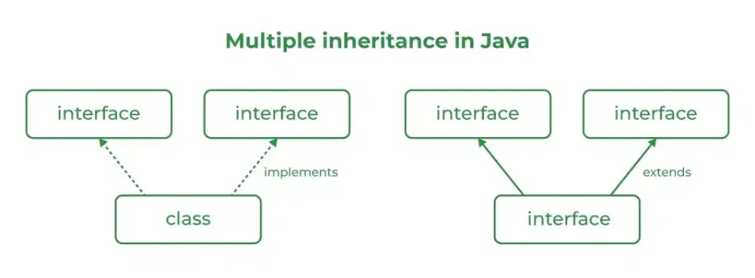

Source Code
import java.io.*;
// Add interface
interface Add{
int add(int a,int b);
}
// Sub interface
interface Sub{
int sub(int a,int b);
}
// Calculator class implementing Add and Sub
class Cal implements Add , Sub
{
// Method to add two numbers
public int add(int a,int b){
return a+b;
}
// Method to sub two numbers
public int sub(int a,int b){
return a-b;
}
}
class Example{
// Main Method
public static void main (String[] args){

// instance of Cal class
Cal x = new Cal();
System.out.println("Addition : " + x.add(2,1));
System.out.println("Substraction : " + x.sub(2,1));
}
}

Outputs
Addition : 3
Subtraction : 1
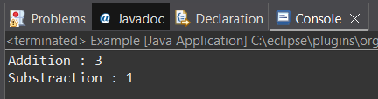
POST LAB EXERCISE
  - Can a functional interface extend another interface?

Yes, but only if it still has one abstract method.

  - Which feature was introduced in interfaces starting from Java 8?
- Constructors
- Private methods
- Default and static methods
- Final classes

Default and static methods feature was introduced in interfaces starting from Java 8.

ASSESSMENT

Description | Max Marks | Marks Awarded
Pre Lab Exercise | 5
In Lab Exercise | 10
Post Lab Exercise | 5
Viva | 10
Total | 30
Faculty Signature

Experiment Number : 12 Date: 12/02/2026

Implementation of exception handling in Java
Aim:
Write a java program to implement exception handling.

PRE LAB EXERCISE QUESTIONS
- What is exception handling in Java?
Exception handling is a mechanism to handle runtime errors so that the program does not terminate abnormally.

- What is the purpose of using try-catch blocks in exception handling?
To catch and handle exceptions that occur inside the try block and prevent program crash.

IN LAB EXERCISE
Objective
To understand and implement exception handling through try-catch and finally blocks.
Source Code
import java.util.InputMismatchException;
import java.util.Scanner;
public class ExceptionHandlingExample {
public static void main(String[] args) {
Scanner scanner = new Scanner(System.in);
try {
System.out.print("Enter an integer: ");
int num = scanner.nextInt();
int result = 10 / num;
System.out.println("Result: " + result);
} catch (InputMismatchException e) {
System.out.println("Invalid input! Please enter an integer.");
} catch (ArithmeticException e) {
System.out.println("Cannot divide by zero!");
} finally {
scanner.close();
System.out.println("Program execution completed.");
} }
}
Outputs
Output 1 (Valid Input - Non-zero Integer):
Enter an integer: 5
Result: 2
Program execution completed.
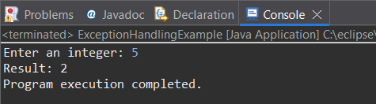
Output 2 (Valid Input - Zero):
Enter an integer: 0
Cannot divide by zero!
Program execution completed.
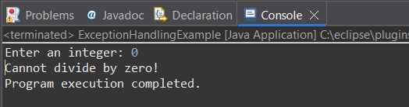

Output 3 (Invalid Input - Non-integer):
Enter an integer: abc
Invalid input! Please enter an integer.
Program execution completed.
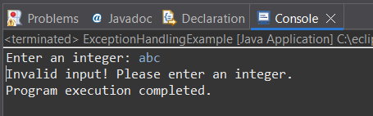

POST LAB EXERCISE
- What is the purpose of the Scanner object in the Java program?

It is used to take input from the user.

- What exceptions are expected to be thrown in the code within the try block? Why?

- InputMismatchException – if user enters non-integer value
- ArithmeticException – if user enters zero (division by zero)

ASSESSMENT

Description | Max Marks | Marks Awarded
Pre Lab Exercise | 5
In Lab Exercise | 10
Post Lab Exercise | 5
Viva | 10
Total | 30
Faculty Signature

Experiment Number : 13 Date: 12/02/2026

Implementation of User-defined Exception in Java

Aim:
Write a java program to implement User-defined Exception.

PRE LAB EXERCISE QUESTIONS
- What is Java custom exception?

A custom exception is a user-defined exception created by extending Exception or RuntimeException classes.

- What are the two types of custom exceptions in Java?

- Checked Exception
- Unchecked Exception
IN LAB EXERCISE
Objective
To understand and implement Checked and Unchecked custom exceptions.
Source Code
Ex 1: // Custom Checked Exception
class InvalidAgeException extends Exception {
public InvalidAgeException(String m) {
super(m);
}
}
// Using the Custom Exception
public class AgeCheck{
public static void validate(int age)
throws InvalidAgeException {
if (age < 18) {
throw new InvalidAgeException("Age must be 18 or above.");
}
System.out.println("Valid age: " + age);
}
public static void main(String[] args) {
try {
validate(12);
} catch (InvalidAgeException e) {
System.out.println("Caught Exception: " + e.getMessage());
}
}
}

Output 1
Caught Exception: Age must be 18 or above.
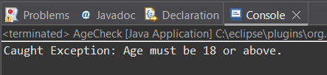
Ex 2: // Custom Unchecked Exception
class DivideByZeroException extends RuntimeException {
public DivideByZeroException(String m) {
super(m);
}
}
// Using the Custom Exception
public class TestSample {
public static void divide(int a, int b) {
if (b == 0) {
throw new DivideByZeroException("Division by zero is not allowed.");
}
System.out.println("Result: " + (a / b));
}
public static void main(String[] args) {
try {
divide(10, 0);
} catch (DivideByZeroException e) {
System.out.println("Caught Exception: " + e.getMessage());
}
}
}

Output 2
Caught Exception: Division by zero is not allowed.
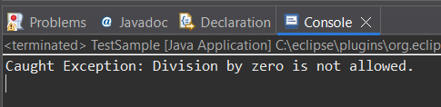

POST LAB EXERCISE
- What is required to create a custom exception in Java?
- Extend the Object class
- Extend the Throwable class
- Extend Exception or RuntimeException
- Implement the Serializable interface
Extend Exception or RuntimeException is required to create a custom exception in Java.

- List some use cases for the checked and unchecked exceptions.
Checked Exceptions
- File handling errors
- Database connection errors
- Validation errors

Unchecked Exceptions
- Arithmetic errors
- Null pointer errors
- Logical programming errors

ASSESSMENT

Description | Max Marks | Marks Awarded
Pre Lab Exercise | 5
In Lab Exercise | 10
Post Lab Exercise | 5
Viva | 10
Total | 30
Faculty Signature

