Experiment Number : 8 Date: 12/02/2026

Implementation of Packages in Java

Aim:
Write a Java program to implement built-in, user-defined packages and accessing all classes in a package.

PRE LAB EXERCISE
QUESTIONS
- What is java.util package and what collection framework does it contain?

- The java.util package is a built-in package in Java that provides utility classes and interfaces for data structures, date and time handling, random numbers, string tokenizing, and more.
- It contains the Java Collection Framework (JCF).
- The Collection Framework provides ready-made classes and interfaces to store and manipulate groups of objects dynamically.
Main Interfaces in Collection Framework:
  - List
  - Set
  - Queue
  - Map (separate hierarchy, not a subtype of Collection)

- What are the two types of packages in Java?
  - Built-in Packages (Predefined Packages)
Examples:
  - java.lang
  - java.util
  - java.io
  - java.sql
  - java.net
  - User-defined Packages
These are packages created by the programmer to organize their own classes.
Example:
package mypackage;

IN LAB EXERCISE
Objective
To understand and implement the concepts of built-in, user-defined packages and accessing all classes in a package in Java.
Built-in Packages comprise a large number of classes that are part of the Java API. Some of the commonly used built-in packages are:
- java.lang: Contains language support classes(e.g, classes that define primitive data types, math operations). This package is automatically imported.
- java.io: Contains classes for supporting input/output operations.
- java.util: Contains utility classes that implement data structures such as Linked Lists and Dictionaries, as well as support for date and time operations.
- java.applet: Contains classes for creating Applets.
- java.awt: Contains classes for implementing the components for graphical user interfaces (like buttons, menus, etc).
Source Code
import java.util.Random; // built-in package
public class Sample{
public static void main(String[] args) {
// using Random class
Random rand = new Random();
// generates a number between 0–99
int number = rand.nextInt(100);
System.out.println("Random number: " + number);
}
}

Output
Random number: 49

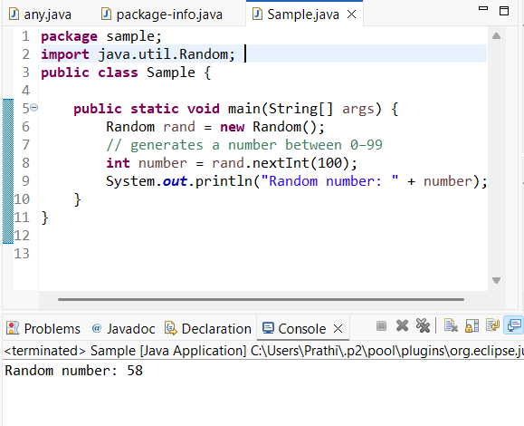

User-defined Packages are the packages that are defined by the user.
Source code
package com.myapp;
public class Helper {
public static void show() {
System.out.println("Hello from Helper!");
}
}
==To use this in another class==
import com.myapp.Helper;
public class Test {
public static void main(String[] args) {
Helper.show();
}
}

Output:
Hello from Helper!
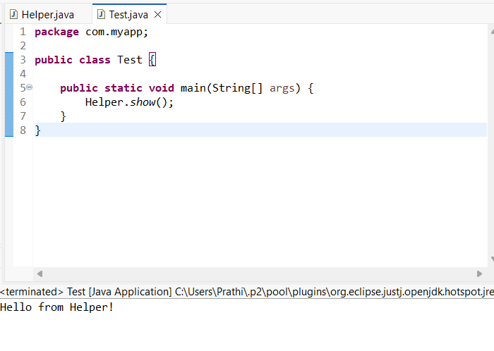
//Importing all classes from a package.
Source code
import java.util.Vector;
public class Coders {
public Coders() {
// java.util.Vector is imported, We are able to access it directly in our code.
Vector v = new Vector();
java.util.ArrayList l = new java.util.ArrayList();
l.add(3);
l.add(5);
l.add(7);
System.out.println(l);
}
public static void main(String[] args) {
new Coders();
}
}
Output
[3,5,7]
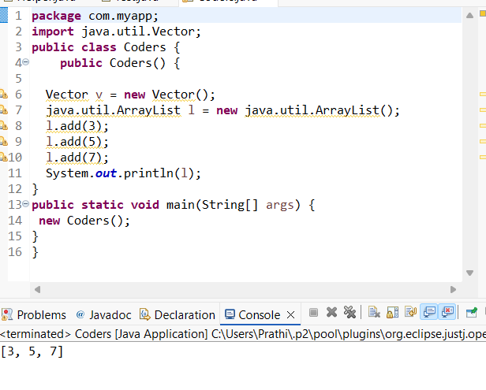

POST LAB EXERCISE
- What will happen if two classes in different packages have the same name and are imported in a Java file?

- If two classes with the same name from different packages are imported, the compiler will create an ambiguity error.
Example:
import package1.MyClass;
import package2.MyClass;
Java will not know which MyClass to use.

- Solution: Use the fully qualified class name:
package1.MyClass obj1 = new package1.MyClass();
package2.MyClass obj2 = new package2.MyClass();

- What is the purpose of using packages in Java?

Packages are used to:
- Organize related classes and interfaces together
- Avoid name conflicts
- Provide access protection (using access modifiers)
- Improve code maintainability and reusability
- Packages help in managing large projects efficiently.

- Which built-in Java package would you use if you want to create a GUI window and display a message?
- java.util
- java.sql
- java.awt
- java.net
Ans : java.awt
java.awt (Abstract Window Toolkit) is used for creating GUI components like windows, buttons, labels, etc.

ASSESSMENT

Description | Max Marks | Marks Awarded
Pre Lab Exercise | 5
In Lab Exercise | 10
Post Lab Exercise | 5
Viva | 10
Total | 30
Faculty Signature

