Experiment Number : 9 Date: 12/02/2026

Implementation of a Java Program to import packages using different methods

Aim:
Write a Java program to import packages using different methods for different use cases.

PRE LAB EXERCISE
QUESTIONS
- How to import a single class and multiple classes from a package in Java?

In Java, the import keyword is used to access classes from another package.

  - Importing a Single Class
A single class can be imported by specifying its fully qualified name (package name + class name).
Syntax:
import package_name.class_name;
Example:
import java.util.Scanner;
This allows the program to use the Scanner class without writing its full package name.

  - Importing Multiple Classes
Multiple classes from a package can be imported using the wildcard (*) symbol.
Syntax:
import package_name.*;
Example:
import java.util.*;
This imports all classes available in the java.util package.

- Which package is always imported by default in every Java class?
The java.lang package is automatically imported by default in every Java program.
It contains fundamental classes such as:
- String
- System
- Math
- Object
- Integer
- Thread
Because java.lang is imported automatically, there is no need to explicitly import it in a program.
Example:
System.out.println("Hello World");
In the above statement, the System class belongs to the java.lang package, yet it works without an import statement.

IN LAB EXERCISE
Objective
To understand and implement the Java packages using different methods and import them.
Problem
Define a package named ‘useFul’ with a class names ‘UseMe’ having following methods:
1) area()- To calculate the area of given shape.
2) salary()- To calculate the salary given basic Salary,da,hRA.
3) percentage()-To calculate the percentage given total marks and marks obtained.
4) Develop a program named ‘Package Use’ to import the above package ‘useFul’ and use the method area().
5) Develop a program named ‘manager’
Source Code
//Package Creation:
package useFull;
import java.util.*;
public class UseMe
{
Scanner obj=new Scanner(System.in);
public static void area()
{
class method{
void aos(int a)
{
System.out.print("\nArea of square with length "+a+" is "+(a*a));
}
void aor(int a,int b)
{
System.out.print("\nArea of reactangle with dimensions "+a+" & "+b+" is "+(a*b));
}
void aoc(int r)
{
double a=3.14*r*r;
}
System.out.print("\nArea of circle with radius "+r+" is "+a);
}
void aot(int a,int b)
{
float ar=(a*b)/2;
System.out.print("\nArea of triangle with dimensions "+a+" &"+b+" is "+ar);
} }
Scanner obj=new Scanner(System.in);
method m=new method();
System.out.print("\n1.Square\n2.Rectangle\n3.Circle\n4.Triangle\nSelect the shape\n");
int ch=obj.nextInt();
UseMe u=new UseMe();
switch(ch)
{
case 1:System.out.print("\nEnter the length of side of square : ");
int s=obj.nextInt();m.aos(s);
break;
case 2:System.out.print("\nEnter the dimensions of rectangle : ");
int l=obj.nextInt();
int b=obj.nextInt();
m.aor(l,b);
break;
case 3:System.out.print("\nEnter the radius of circle : ");
int r=obj.nextInt();
m.aoc(r);
break;
case 4:System.out.print("\nEnter the dimensions of triangle : ");
int ba=obj.nextInt();
int w=obj.nextInt();
m.aot(ba,w);
break; } }
public void salary()
{
int ba,da,hra;
System.out.print("\nEnter the basic salary : ");
ba=obj.nextInt();
System.out.print("\nEnter the dearness allowance :");
da=obj.nextInt();
System.out.print("\nEnter the house rent allowance : ");
hra=obj.nextInt();
System.out.print("\nThe total Gross salary of employee is : "+(ba+da+hra));
}
public void percentage()
{
int n,sum=0;
float p;
System.out.print("\nEnter the total number of subjects : ");
n=obj.nextInt();
int m[]=new int[n];
System.out.print("\nEnter the marks of "+n+" subjects : ");
for(int i=0;i<n;i++)
{
m[n]=obj.nextInt();
}
for(int i=0;i<n;i++)
{
sum=sum+m[i];
}
p=sum/n;
{
System.out.print("\nPercentahe of student : "+p);
}
}
}
//Package Implementation-1:
import useFull.UseMe;
class packageUse
{
public static void main(String args[])
{
UseMe o=new UseMe();o.area();
}
}

Output
javac packageUse.java
java packageUse
- Square
- Rectangle
- Circle
- Triangle
Select the shape

2

Enter the dimensions of the rectangle: 10 15
Area of the rectangle with dimensions 10&15 is 150

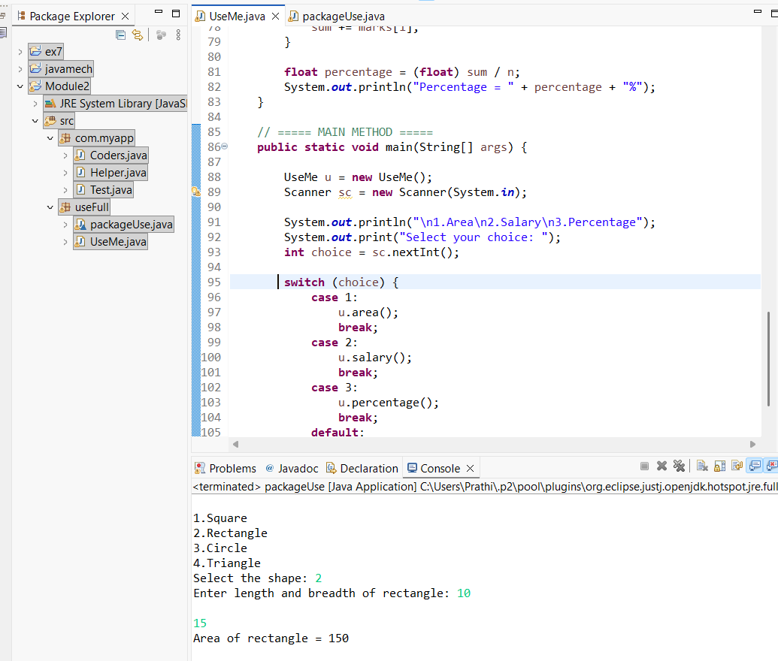
//Package Implementation-2:
import useFull.UseMe;
class manager
{
public static void main(String args[])
{
UseMe obj=new UseMe();obj.salary();
}
}

Output
javac manager.java
java manager

Enter the basic salary: 100000
Enter the dearness allowance: 5000
Enter the house rent allowance: 2000
The total Gross salary of employee is: 107000
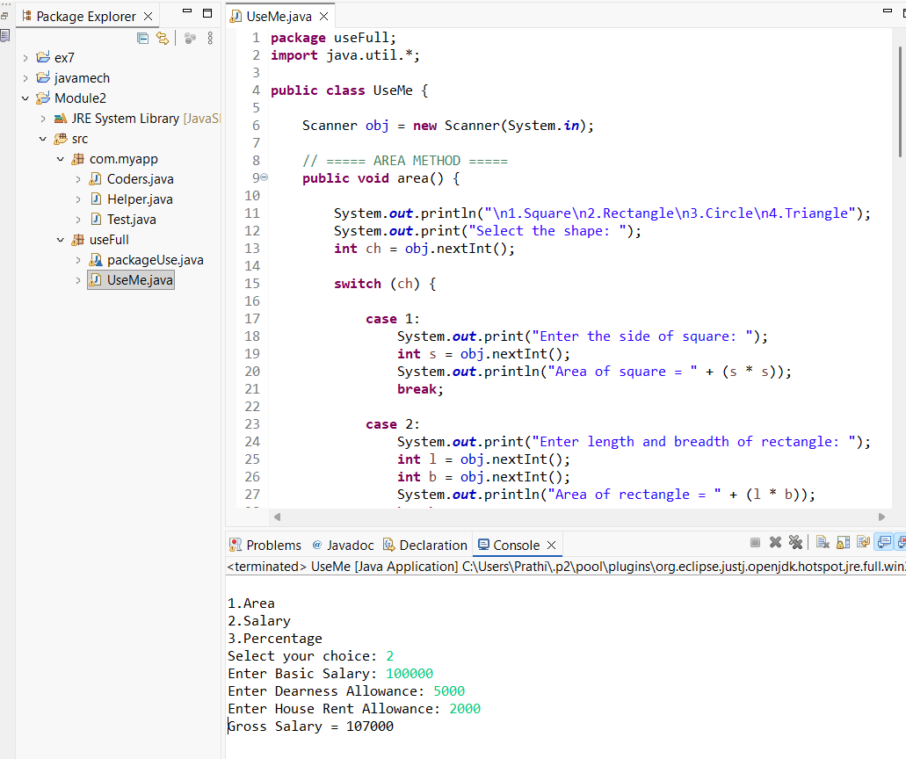

POST LAB EXERCISE
- Find the key differences between java.util and java.lang packages.

Basis of Difference | java.lang | java.util
Purpose | Provides fundamental classes required for basic Java programming | Provides utility classes and data structures
Import Requirement | Automatically imported by default | Must be imported explicitly
Main Use | Core language support | Collections,utilities and helper classes
Examples of classes | String, System, Math, Object, Integer, Thread | ArrayList, Scanner, HashMap, Date, Random, Collections
Types of Features | Basic language features and wrapper classes | Collection framework and utility tools

- List some of the subpackages of java.util

The java.util package contains several subpackages that provide additional functionalities. Some of them are:
- java.util.concurrent – Supports multithreading and concurrent programming.
- java.util.function – Contains functional interfaces used in lambda expressions.
- java.util.logging – Provides logging framework.
- java.util.regex – Supports regular expression operations.
- java.util.stream – Supports stream API for functional-style operations.
These subpackages extend the functionality of java.util and help in advanced programming tasks.

ASSESSMENT

Description | Max Marks | Marks Awarded
Pre Lab Exercise | 5
In Lab Exercise | 10
Post Lab Exercise | 5
Viva | 10
Total | 30
Faculty Signature

