Experiment Number : 8 Date: 03.03.26

Implementation of Packages in Java

Aim:
Write a Java program to implement built-in, user-defined packages and accessing all classes in a package.

PRE LAB EXERCISE
QUESTIONS
- What is java.util package and what collection framework does it contain?

java.util is a built-in Java package that provides utility classes and the Java Collections Framework, which includes interfaces and classes like List, Set, Map, ArrayList, HashMap, etc.
- What are the two types of packages in Java?
- Built-in (Predefined) packages
- User-defined packages

IN LAB EXERCISE
Objective
To understand and implement the concepts of built-in, user-defined packages and accessing all classes in a package in Java.
Built-in Packages comprise a large number of classes that are part of the Java API. Some of the commonly used built-in packages are:
- java.lang: Contains language support classes(e.g, classes that define primitive data types, math operations). This package is automatically imported.
- java.io: Contains classes for supporting input/output operations.
- java.util: Contains utility classes that implement data structures such as Linked Lists and Dictionaries, as well as support for date and time operations.
- java.applet: Contains classes for creating Applets.
- java.awt: Contains classes for implementing the components for graphical user interfaces (like buttons, menus, etc).
Source Code
import java.util.Random; // built-in package
public class Sample{
public static void main(String[] args) {
// using Random class
Random rand = new Random();
// generates a number between 0–99
int number = rand.nextInt(100);
System.out.println("Random number: " + number);
}
}
Output
User-defined Packages are the packages that are defined by the user.
Source code
package com.myapp;
public class Helper {
public static void show() {
System.out.println("Hello from Helper!");
}
}
==To use this in another class==
import com.myapp.Helper;
public class Test {
public static void main(String[] args) {
Helper.show();
}
}

Output:
//Importing all classes from a package.
Source code
import java.util.Vector;
public class Coders {
public Coders() {
// java.util.Vector is imported, We are able to access it directly in our code.
Vector v = new Vector();
java.util.ArrayList l = new java.util.ArrayList();
l.add(3);
l.add(5);
l.add(7);
System.out.println(l);
}
public static void main(String[] args) {
new Coders();
}
}
Output
POST LAB EXERCISE
- What will happen if two classes in different packages have the same name and are imported in a Java file?

If two classes with the same name are imported, Java will cause a compile-time error (ambiguity error).
To fix it, you must use the fully qualified class name (package name + class name).

- What is the purpose of using packages in Java?

• To organize classes properly
• To avoid name conflicts
• To provide access control and security

- Which built-in Java package would you use if you want to create a GUI window and display a message?
- java.util
- java.sql
- java.awt
- java.net

C. java.awt

ASSESSMENT

Description | Max Marks | Marks Awarded
Pre Lab Exercise | 5
In Lab Exercise | 10
Post Lab Exercise | 5
Viva | 10
Total | 30
Faculty Signature

Experiment Number : 9 Date: 03.03.26

Implementation of a Java Program to import packages using different methods

Aim:
Write a Java program to import packages using different methods for different use cases.

PRE LAB EXERCISE
QUESTIONS
- How to import a single class and multiple classes from a package in Java?

Single class import:

import packageName.ClassName;

Multiple classes (entire package):

import packageName.*;

- Which package is always imported by default in every Java class?

import packageName.*;

IN LAB EXERCISE
Objective
To understand and implement the Java packages using different methods and import them.
Problem
Define a package named ‘useFul’ with a class names ‘UseMe’ having following methods:
1) area()- To calculate the area of given shape.
2) salary()- To calculate the salary given basic Salary,da,hRA.
3) percentage()-To calculate the percentage given total marks and marks obtained.
4) Develop a program named ‘Package Use’ to import the above package ‘useFul’ and use the method area().
5) Develop a program named ‘manager’
Source Code
//Package Creation:
package useFull;
import java.util.*;
public class UseMe
{
Scanner obj=new Scanner(System.in);
public static void area()
{
class method{
void aos(int a)
{
System.out.print("\nArea of square with length "+a+" is "+(a*a));
}
void aor(int a,int b)
{
System.out.print("\nArea of reactangle with dimensions "+a+" & "+b+" is "+(a*b));
}
void aoc(int r)
{
double a=3.14*r*r;
}
System.out.print("\nArea of circle with radius "+r+" is "+a);
}
void aot(int a,int b)
{
float ar=(a*b)/2;
System.out.print("\nArea of triangle with dimensions "+a+" &"+b+" is "+ar);
} }
Scanner obj=new Scanner(System.in);
method m=new method();
System.out.print("\n1.Square\n2.Rectangle\n3.Circle\n4.Triangle\nSelect the shape\n");
int ch=obj.nextInt();
UseMe u=new UseMe();
switch(ch)
{
case 1:System.out.print("\nEnter the length of side of square : ");
int s=obj.nextInt();m.aos(s);
break;
case 2:System.out.print("\nEnter the dimensions of rectangle : ");
int l=obj.nextInt();
int b=obj.nextInt();
m.aor(l,b);
break;
case 3:System.out.print("\nEnter the radius of circle : ");
int r=obj.nextInt();
m.aoc(r);
break;
case 4:System.out.print("\nEnter the dimensions of triangle : ");
int ba=obj.nextInt();
int w=obj.nextInt();
m.aot(ba,w);
break; } }
public void salary()
{
int ba,da,hra;
System.out.print("\nEnter the basic salary : ");
ba=obj.nextInt();
System.out.print("\nEnter the dearness allowance :");
da=obj.nextInt();
System.out.print("\nEnter the house rent allowance : ");
hra=obj.nextInt();
System.out.print("\nThe total Gross salary of employee is : "+(ba+da+hra));
}
public void percentage()
{
int n,sum=0;
float p;
System.out.print("\nEnter the total number of subjects : ");
n=obj.nextInt();
int m[]=new int[n];
System.out.print("\nEnter the marks of "+n+" subjects : ");
for(int i=0;i<n;i++)
{
m[n]=obj.nextInt();
}
for(int i=0;i<n;i++)
{
sum=sum+m[i];
}
p=sum/n;
{
System.out.print("\nPercentahe of student : "+p);
}
}
}
//Package Implementation-1:
import useFull.UseMe;
class packageUse
{
public static void main(String args[])
{
UseMe o=new UseMe();o.area();
}
}

Output
javac packageUse.java
java packageUse
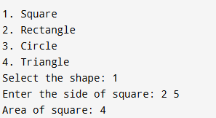
//Package Implementation-2:
import useFull.UseMe;
class manager
{
public static void main(String args[])
{
UseMe obj=new UseMe();obj.salary();
}
}

Output
javac manager.java
java manager

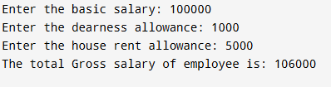
POST LAB EXERCISE
- Find the key differences between java.util and java.lang packages.

Aspect | java.lang | java.util
Purpose | Core language support classes (fundamental classes) | Utility classes for collections, date/time, and more
Automatically Imported? | Yes, always imported by default | No, must be explicitly imported
Examples of Classes | String, Math, System, Thread, Object | ArrayList, HashMap, Scanner, Date
Functionality | Basic building blocks of Java programs | Data structures, algorithms, utilities

- List some of the subpackages of java.util

• java.util.concurrent — concurrency utilities like thread pools, locks
• java.util.regex — regular expression processing
• java.util.zip — classes for ZIP and GZIP compression
• java.util.logging — logging framework classes
• java.util.function — functional programming interfaces (lambdas)

ASSESSMENT

Description | Max Marks | Marks Awarded
Pre Lab Exercise | 5
In Lab Exercise | 10
Post Lab Exercise | 5
Viva | 10
Total | 30
Faculty Signature

Experiment Number : 10 Date: 03.03.26 03.03.26

Implementation of Access Modifiers in Java

Aim:
Write a Java program to implement different access modifiers.

PRE LAB EXERCISE
QUESTIONS
- What are the 4 access modifiers available in Java?

• public — accessible from anywhere
• protected — accessible within the same package and subclasses
• default (no modifier) — accessible only within the same package
• private — accessible only within the same class

- Which access modifiers can be used in Java to control access to class members?

• public
• protected
• default (no modifier)
• private

IN LAB EXERCISE
Objective
To demonstrate different access modifiers such as Default, Private, Protected and Public using Java programs.
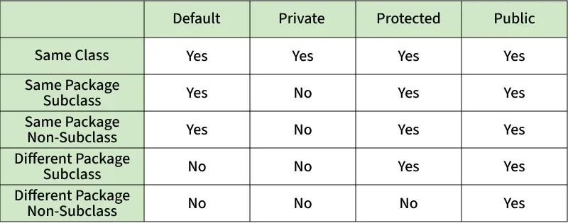
Fig: Comparison table of Access Modifiers in Java
Source Code
// Default Access modifier
class Car {
String model; // default access
}
public class Main {
public static void main(String[] args){
Car c = new Car();
c.model = "Tesla"; // accessible within the same package
System.out.println(c.model);
}
}
Output:

//Private Access Modifier
class Person {
// private variable
private String name;
public void setName(String name) {
this.name = name; // accessible within class
}
public String getName() {
return name;
}
}
public class Geeks {
public static void main(String[] args)
{
Person p = new Person();
p.setName("Alice");

// System.out.println(p.name);
// Error: 'name'
// has private access
System.out.println(p.getName());
}
}
Output
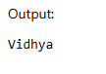

//Protected Access Modifier
class Vehicle {
protected int speed; // protected member
}
class Bike extends Vehicle {
void setSpeed(int s)
{
speed = s; // accessible in subclass
}
int getSpeed()
{
return speed; // accessible in subclass
}
}
public class Main {
public static void main(String[] args){
Bike b = new Bike();
b.setSpeed(100);
System.out.println("Access via subclass method: "+ b.getSpeed());
Vehicle v = new Vehicle();
System.out.println(v.speed);
}
}
Output
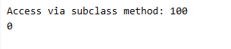

//Public Access Modifier
class MathUtils {
public static int add(int a, int b) {
return a + b;
}
}
public class Main {
public static void main(String[] args) {
System.out.println(MathUtils.add(5, 10)); // accessible anywhere
}
}
Output
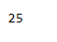

POST LAB EXERCISE
  - Write a Java program to implement Default access modifier which has a default class within the same package and a default class from a different package.

Step 1: Create package packageA with a default class (no access modifier)
File: packageA/DefaultClassA.java
package packageA;

// Default access class (no public/private/protected)
class DefaultClassA {
void display() {
System.out.println("Inside DefaultClassA (packageA)");
}
}

Step 2: Create another class in the same package accessing DefaultClassA
File: packageA/SamePackageTest.java
package packageA;

public class SamePackageTest {
public static void main(String[] args) {
DefaultClassA obj = new DefaultClassA(); // Allowed: same package
obj.display();
}
}

Step 3: Create a class in a different package trying to access DefaultClassA
File: packageB/DifferentPackageTest.java
package packageB;

import packageA.DefaultClassA;

public class DifferentPackageTest {
public static void main(String[] args) {
// DefaultClassA is not visible here; this will cause a compile error
// Uncommenting below lines will cause error
// DefaultClassA obj = new DefaultClassA();
// obj.display();

System.out.println("Cannot access DefaultClassA from different package due to default access modifier");
}
}

  - Which access modifier provides the highest level of access?

public — it allows access from anywhere (same class, same package, different package, subclasses, everywhere).

ASSESSMENT

Description | Max Marks | Marks Awarded
Pre Lab Exercise | 5
In Lab Exercise | 10
Post Lab Exercise | 5
Viva | 10
Total | 30
Faculty Signature

Experiment Number :11 Date: 03.03.26 03.03.26

Implementation of multiple inheritance in Java using Interface

Aim:
Write a Java program to implement multiple inheritance using Interface.

PRE LAB EXERCISE
QUESTIONS
- Why Java does not support multiple inheritance using classes like that of C?

Because multiple inheritance with classes can lead to the "Diamond Problem", where a class inherits the same method or variable from multiple parent classes, causing ambiguity and complexity. Java avoids this by allowing multiple inheritance only through interfaces, which contain method declarations without implementation, thus preventing such conflicts

- What is the primary purpose of an interface in Java?
- To store data using instance variables
- To define a contract of methods a class must implement
- To allow creation of objects
- To improve runtime performance
B. To define a contract of methods a class must implement

IN LAB EXERCISE
Objective
To demonstrate how an interface in Java defines constants and abstract methods, which are implemented by a class.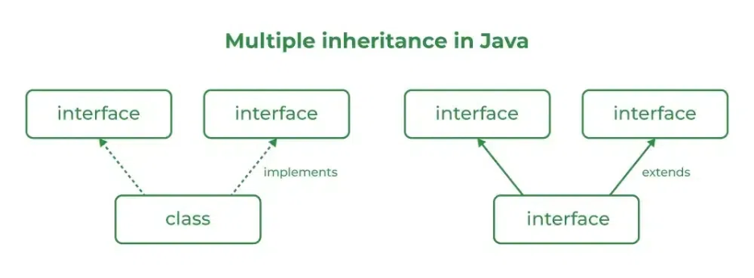

Source Code
import java.io.*;
// Add interface
interface Add{
int add(int a,int b);
}
// Sub interface
interface Sub{
int sub(int a,int b);
}
// Calculator class implementing Add and Sub
class Cal implements Add , Sub
{
// Method to add two numbers
public int add(int a,int b){
return a+b;
}
// Method to sub two numbers
public int sub(int a,int b){
return a-b;
}
}
class Example{
// Main Method
public static void main (String[] args){

// instance of Cal class
Cal x = new Cal();
System.out.println("Addition : " + x.add(2,1));
System.out.println("Substraction : " + x.sub(2,1));
}
}

Outputs
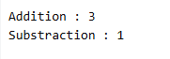
POST LAB EXERCISE
  - Can a functional interface extend another interface?

Yes, a functional interface can extend another interface. As long as it still contains exactly one abstract method (either declared or inherited), it remains a functional interface

  - Which feature was introduced in interfaces starting from Java 8?
- Constructors
- Private methods
- Default and static methods
- Final classes
C. Default and static methods

ASSESSMENT

Description | Max Marks | Marks Awarded
Pre Lab Exercise | 5
In Lab Exercise | 10
Post Lab Exercise | 5
Viva | 10
Total | 30
Faculty Signature

Experiment Number : 12 Date: 03.03.26 03.03.26

Implementation of exception handling in Java
Aim:
Write a java program to implement exception handling.

PRE LAB EXERCISE
QUESTIONS
- What is exception handling in Java?

Exception handling in Java is a mechanism to handle runtime errors or unexpected conditions (called exceptions) in a controlled way, preventing the program from crashing and allowing it to recover or terminate gracefully.

- What is the purpose of using try-catch blocks in exception handling?

The purpose of try-catch blocks is to:
- try: Enclose the code that might throw an exception.
- catch: Handle the exception if it occurs, allowing the program to continue running or respond appropriately instead of terminating abruptly.
This helps maintain program stability and manage errors effectively.

IN LAB EXERCISE
Objective
To understand and implement exception handling through try-catch and finally blocks.
Source Code
import java.util.InputMismatchException;
import java.util.Scanner;
public class ExceptionHandlingExample {
public static void main(String[] args) {
Scanner scanner = new Scanner(System.in);
try {
System.out.print("Enter an integer: ");
int num = scanner.nextInt();
int result = 10 / num;
System.out.println("Result: " + result);
} catch (InputMismatchException e) {
System.out.println("Invalid input! Please enter an integer.");
} catch (ArithmeticException e) {
System.out.println("Cannot divide by zero!");
} finally {
scanner.close();
System.out.println("Program execution completed.");
} }
}
Outputs
Output 1 (Valid Input - Non-zero Integer):
Output 2 (Valid Input - Zero):
Output 3 (Invalid Input - Non-integer):

POST LAB EXERCISE
- What is the purpose of the Scanner object in the Java program?

The Scanner object is used to read user input from the keyboard (using System.in).

- What exceptions are expected to be thrown in the code within the try block? Why?

- InputMismatchException – Thrown if the user enters something that is not an integer.
- ArithmeticException – Thrown if the user enters 0, causing division by zero (10 / num).

ASSESSMENT

Description | Max Marks | Marks Awarded
Pre Lab Exercise | 5
In Lab Exercise | 10
Post Lab Exercise | 5
Viva | 10
Total | 30
Faculty Signature

Experiment Number : 13 Date: 03.03.26

Implementation of User-defined Exception in Java

Aim:
Write a java program to implement User-defined Exception.

PRE LAB EXERCISE
QUESTIONS
- What is Java custom exception?

A custom exception is a user-defined exception created by extending the Exception or RuntimeException class to handle specific application errors

- What are the two types of custom exceptions in Java?

    - Checked Custom Exception
    - Extends Exception
    - Must be handled using try-catch or declared with throws
    - Unchecked Custom Exception
    - Extends RuntimeException
    - Not required to be handled explicitly

IN LAB EXERCISE
Objective
To understand and implement Checked and Unchecked custom exceptions.
Source Code
Ex 1: // Custom Checked Exception
class InvalidAgeException extends Exception {
public InvalidAgeException(String m) {
super(m);
}
}
// Using the Custom Exception
public class AgeCheck{
public static void validate(int age)
throws InvalidAgeException {
if (age < 18) {
throw new InvalidAgeException("Age must be 18 or above.");
}
System.out.println("Valid age: " + age);
}
public static void main(String[] args) {
try {
validate(12);
} catch (InvalidAgeException e) {
System.out.println("Caught Exception: " + e.getMessage());
}
}
}

Output 1
Ex 2: // Custom Unchecked Exception
class DivideByZeroException extends RuntimeException {
public DivideByZeroException(String m) {
super(m);
}
}
// Using the Custom Exception
public class TestSample {
public static void divide(int a, int b) {
if (b == 0) {
throw new DivideByZeroException("Division by zero is not allowed.");
}
System.out.println("Result: " + (a / b));
}
public static void main(String[] args) {
try {
divide(10, 0);
} catch (DivideByZeroException e) {
System.out.println("Caught Exception: " + e.getMessage());
}
}
}

Output 2
POST LAB EXERCISE
- What is required to create a custom exception in Java?
- Extend the Object class
- Extend the Throwable class
- Extend Exception or RuntimeException
- Implement the Serializable interface

Extend Exception or RuntimeException

- List some use cases for the checked and unchecked exceptions.
- Checked exceptions: File errors, database errors, invalid input (recoverable problems)
- Unchecked exceptions: Divide by zero, null pointer, array index error (programming mistakes)

ASSESSMENT

Description | Max Marks | Marks Awarded
Pre Lab Exercise | 5
In Lab Exercise | 10
Post Lab Exercise | 5
Viva | 10
Total | 30
Faculty Signature

