Experiment Number : 8 Date: 12/02/2026

Implementation of Packages in Java

Aim:
Write a Java program to implement built-in, user-defined packages and accessing all classes in a package.

PRE LAB EXERCISE
QUESTIONS
- What is java.util package and what collection framework does it contain?

- The java.util package is a built-in package in Java that provides utility classes and interfaces for data structures, date and time handling, random numbers, string tokenizing, and more.
- It contains the Java Collection Framework (JCF).
- The Collection Framework provides ready-made classes and interfaces to store and manipulate groups of objects dynamically.
Main Interfaces in Collection Framework:
  - List
  - Set
  - Queue
  - Map (separate hierarchy, not a subtype of Collection)

- What are the two types of packages in Java?
  - Built-in Packages (Predefined Packages)
Examples:
  - java.lang
  - java.util
  - java.io
  - java.sql
  - java.net
  - User-defined Packages
These are packages created by the programmer to organize their own classes.
Example:
package mypackage;

IN LAB EXERCISE
Objective
To understand and implement the concepts of built-in, user-defined packages and accessing all classes in a package in Java.
Built-in Packages comprise a large number of classes that are part of the Java API. Some of the commonly used built-in packages are:
- java.lang: Contains language support classes(e.g, classes that define primitive data types, math operations). This package is automatically imported.
- java.io: Contains classes for supporting input/output operations.
- java.util: Contains utility classes that implement data structures such as Linked Lists and Dictionaries, as well as support for date and time operations.
- java.applet: Contains classes for creating Applets.
- java.awt: Contains classes for implementing the components for graphical user interfaces (like buttons, menus, etc).
Source Code
import java.util.Random; // built-in package
public class Sample{
public static void main(String[] args) {
// using Random class
Random rand = new Random();
// generates a number between 0–99
int number = rand.nextInt(100);
System.out.println("Random number: " + number);
}
}

Output
Random number: 49
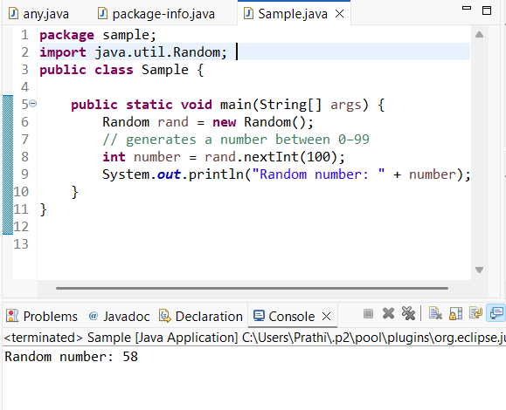

User-defined Packages are the packages that are defined by the user.
Source code
package com.myapp;
public class Helper {
public static void show() {
System.out.println("Hello from Helper!");
}
}
==To use this in another class==
import com.myapp.Helper;
public class Test {
public static void main(String[] args) {
Helper.show();
}
}

Output:
Hello from Helper!
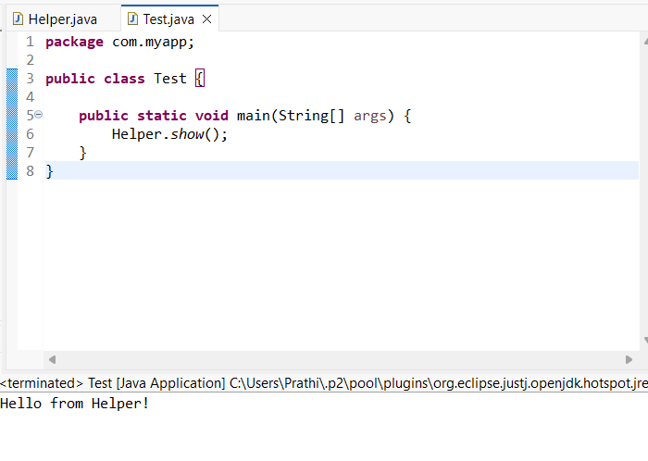
//Importing all classes from a package.
Source code
import java.util.Vector;
public class Coders {
public Coders() {
// java.util.Vector is imported, We are able to access it directly in our code.
Vector v = new Vector();
java.util.ArrayList l = new java.util.ArrayList();
l.add(3);
l.add(5);
l.add(7);
System.out.println(l);
}
public static void main(String[] args) {
new Coders();
}
}
Output
[3,5,7]
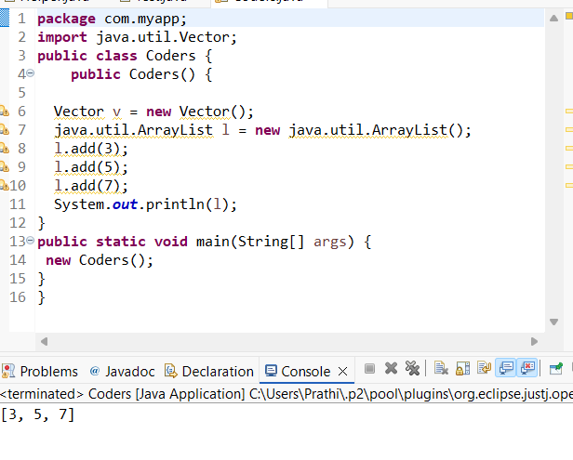

POST LAB EXERCISE
- What will happen if two classes in different packages have the same name and are imported in a Java file?

- If two classes with the same name from different packages are imported, the compiler will create an ambiguity error.
Example:
import package1.MyClass;
import package2.MyClass;
Java will not know which MyClass to use.

- Solution: Use the fully qualified class name:
package1.MyClass obj1 = new package1.MyClass();
package2.MyClass obj2 = new package2.MyClass();

- What is the purpose of using packages in Java?

Packages are used to:
- Organize related classes and interfaces together
- Avoid name conflicts
- Provide access protection (using access modifiers)
- Improve code maintainability and reusability
- Packages help in managing large projects efficiently.

- Which built-in Java package would you use if you want to create a GUI window and display a message?
- java.util
- java.sql
- java.awt
- java.net
Ans : java.awt
java.awt (Abstract Window Toolkit) is used for creating GUI components like windows, buttons, labels, etc.

ASSESSMENT

Description | Max Marks | Marks Awarded
Pre Lab Exercise | 5
In Lab Exercise | 10
Post Lab Exercise | 5
Viva | 10
Total | 30
Faculty Signature

Experiment Number : 9 Date: 12/02/2026

Implementation of a Java Program to import packages using different methods

Aim:
Write a Java program to import packages using different methods for different use cases.

PRE LAB EXERCISE
QUESTIONS
- How to import a single class and multiple classes from a package in Java?

In Java, the import keyword is used to access classes from another package.

  - Importing a Single Class
A single class can be imported by specifying its fully qualified name (package name + class name).
Syntax:
import package_name.class_name;
Example:
import java.util.Scanner;
This allows the program to use the Scanner class without writing its full package name.

  - Importing Multiple Classes
Multiple classes from a package can be imported using the wildcard (*) symbol.
Syntax:
import package_name.*;
Example:
import java.util.*;
This imports all classes available in the java.util package.

- Which package is always imported by default in every Java class?
The java.lang package is automatically imported by default in every Java program.
It contains fundamental classes such as:
- String
- System
- Math
- Object
- Integer
- Thread
Because java.lang is imported automatically, there is no need to explicitly import it in a program.
Example:
System.out.println("Hello World");
In the above statement, the System class belongs to the java.lang package, yet it works without an import statement.

IN LAB EXERCISE
Objective
To understand and implement the Java packages using different methods and import them.
Problem
Define a package named ‘useFul’ with a class names ‘UseMe’ having following methods:
1) area()- To calculate the area of given shape.
2) salary()- To calculate the salary given basic Salary,da,hRA.
3) percentage()-To calculate the percentage given total marks and marks obtained.
4) Develop a program named ‘Package Use’ to import the above package ‘useFul’ and use the method area().
5) Develop a program named ‘manager’
Source Code
//Package Creation:
package useFull;
import java.util.*;
public class UseMe
{
Scanner obj=new Scanner(System.in);
public static void area()
{
class method{
void aos(int a)
{
System.out.print("\nArea of square with length "+a+" is "+(a*a));
}
void aor(int a,int b)
{
System.out.print("\nArea of reactangle with dimensions "+a+" & "+b+" is "+(a*b));
}
void aoc(int r)
{
double a=3.14*r*r;
}
System.out.print("\nArea of circle with radius "+r+" is "+a);
}
void aot(int a,int b)
{
float ar=(a*b)/2;
System.out.print("\nArea of triangle with dimensions "+a+" &"+b+" is "+ar);
} }
Scanner obj=new Scanner(System.in);
method m=new method();
System.out.print("\n1.Square\n2.Rectangle\n3.Circle\n4.Triangle\nSelect the shape\n");
int ch=obj.nextInt();
UseMe u=new UseMe();
switch(ch)
{
case 1:System.out.print("\nEnter the length of side of square : ");
int s=obj.nextInt();m.aos(s);
break;
case 2:System.out.print("\nEnter the dimensions of rectangle : ");
int l=obj.nextInt();
int b=obj.nextInt();
m.aor(l,b);
break;
case 3:System.out.print("\nEnter the radius of circle : ");
int r=obj.nextInt();
m.aoc(r);
break;
case 4:System.out.print("\nEnter the dimensions of triangle : ");
int ba=obj.nextInt();
int w=obj.nextInt();
m.aot(ba,w);
break; } }
public void salary()
{
int ba,da,hra;
System.out.print("\nEnter the basic salary : ");
ba=obj.nextInt();
System.out.print("\nEnter the dearness allowance :");
da=obj.nextInt();
System.out.print("\nEnter the house rent allowance : ");
hra=obj.nextInt();
System.out.print("\nThe total Gross salary of employee is : "+(ba+da+hra));
}
public void percentage()
{
int n,sum=0;
float p;
System.out.print("\nEnter the total number of subjects : ");
n=obj.nextInt();
int m[]=new int[n];
System.out.print("\nEnter the marks of "+n+" subjects : ");
for(int i=0;i<n;i++)
{
m[n]=obj.nextInt();
}
for(int i=0;i<n;i++)
{
sum=sum+m[i];
}
p=sum/n;
{
System.out.print("\nPercentahe of student : "+p);
}
}
}
//Package Implementation-1:
import useFull.UseMe;
class packageUse
{
public static void main(String args[])
{
UseMe o=new UseMe();o.area();
}
}

Output
javac packageUse.java
java packageUse
- Square
- Rectangle
- Circle
- Triangle
Select the shape

2

Enter the dimensions of the rectangle: 10 15
Area of the rectangle with dimensions 10&15 is 150

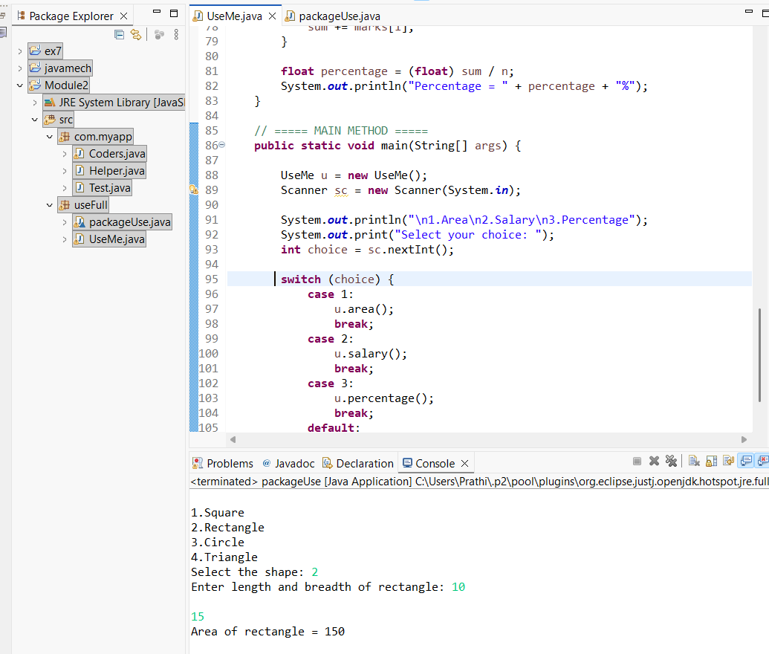
//Package Implementation-2:
import useFull.UseMe;
class manager
{
public static void main(String args[])
{
UseMe obj=new UseMe();obj.salary();
}
}

Output
javac manager.java
java manager

Enter the basic salary: 100000
Enter the dearness allowance: 5000
Enter the house rent allowance: 2000
The total Gross salary of employee is: 107000
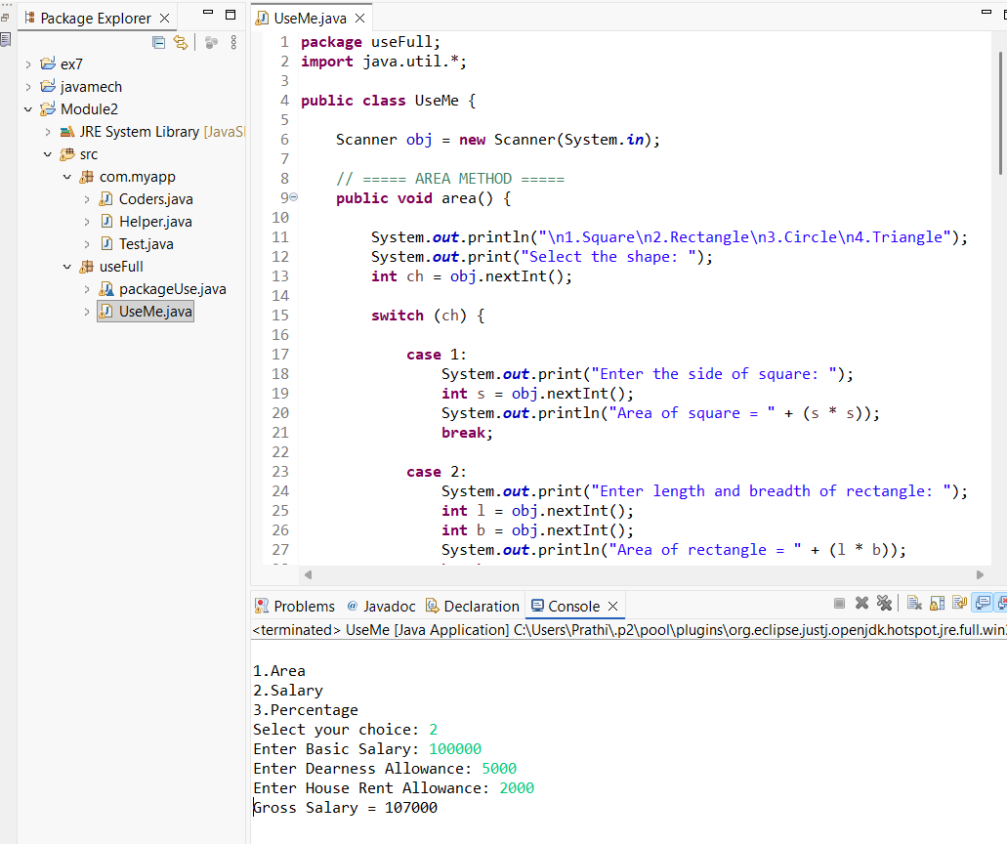
POST LAB EXERCISE
- Find the key differences between java.util and java.lang packages.

Basis of Difference | java.lang | java.util
Purpose | Provides fundamental classes required for basic Java programming | Provides utility classes and data structures
Import Requirement | Automatically imported by default | Must be imported explicitly
Main Use | Core language support | Collections,utilities and helper classes
Examples of classes | String, System, Math, Object, Integer, Thread | ArrayList, Scanner, HashMap, Date, Random, Collections
Types of Features | Basic language features and wrapper classes | Collection framework and utility tools

- List some of the subpackages of java.util

The java.util package contains several subpackages that provide additional functionalities. Some of them are:
- java.util.concurrent – Supports multithreading and concurrent programming.
- java.util.function – Contains functional interfaces used in lambda expressions.
- java.util.logging – Provides logging framework.
- java.util.regex – Supports regular expression operations.
- java.util.stream – Supports stream API for functional-style operations.
These subpackages extend the functionality of java.util and help in advanced programming tasks.

ASSESSMENT

Description | Max Marks | Marks Awarded
Pre Lab Exercise | 5
In Lab Exercise | 10
Post Lab Exercise | 5
Viva | 10
Total | 30
Faculty Signature

Experiment Number : 10 Date: 26/02/2026

Implementation of Access Modifiers in Java

Aim:
Write a Java program to implement different access modifiers.

PRE LAB EXERCISE
QUESTIONS
- What are the 4 access modifiers available in Java?

In Java, access modifiers are keywords used to control the visibility of classes, variables, methods, and constructors. The four access modifiers are:
- private – The member is accessible only within the same class. It provides the highest level of restriction and is mainly used for data hiding.
- default (package-private) – When no access modifier is specified, it is considered default. The member is accessible only within the same package.
- protected – The member is accessible within the same package and also accessible in subclasses (even if they are in different packages).
- public – The member is accessible from anywhere in the program. It provides the least restriction.

- Which access modifiers can be used in Java to control access to class members?

All four access modifiers — private, default, protected, and public — can be used to control access to class members such as variables, methods, and constructors.

- private ensures strict encapsulation by restricting access within the class only.
- default allows access within the same package.
- protected allows access within the package and through inheritance.
- public allows global access from any class.

Thus, access modifiers help in implementing encapsulation and data security in Java programs.

IN LAB EXERCISE
Objective
To demonstrate different access modifiers such as Default, Private, Protected and Public using Java programs.
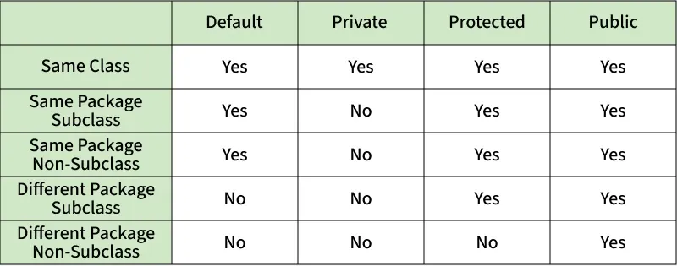
Fig: Comparison table of Access Modifiers in Java
Source Code
// Default Access modifier
class Car {
String model; // default access
}
public class Main {
public static void main(String[] args){
Car c = new Car();
c.model = "Tesla"; // accessible within the same package
System.out.println(c.model);
}
}

Output:
Tesla
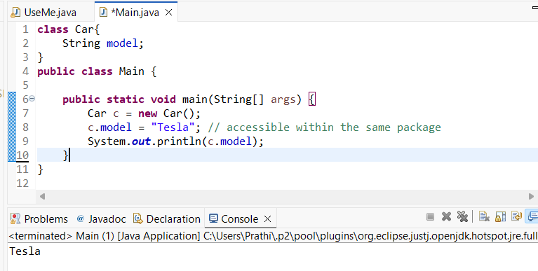

//Private Access Modifier
class Person {
// private variable
private String name;
public void setName(String name) {
this.name = name; // accessible within class
}
public String getName() {
return name;
}
}
public class Geeks {
public static void main(String[] args)
{
Person p = new Person();
p.setName("Alice");

// System.out.println(p.name);
// Error: 'name'
// has private access
System.out.println(p.getName());
}
}
Output
Alice
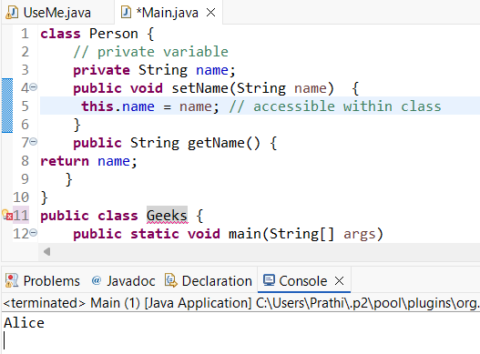

//Protected Access Modifier
class Vehicle {
protected int speed; // protected member
}
class Bike extends Vehicle {
void setSpeed(int s)
{
speed = s; // accessible in subclass
}
int getSpeed()
{
return speed; // accessible in subclass
}
}
public class Main {
public static void main(String[] args){
Bike b = new Bike();
b.setSpeed(100);
System.out.println("Access via subclass method: "+ b.getSpeed());
Vehicle v = new Vehicle();
System.out.println(v.speed);
}
}
Output
Access via subclass method: 100
0
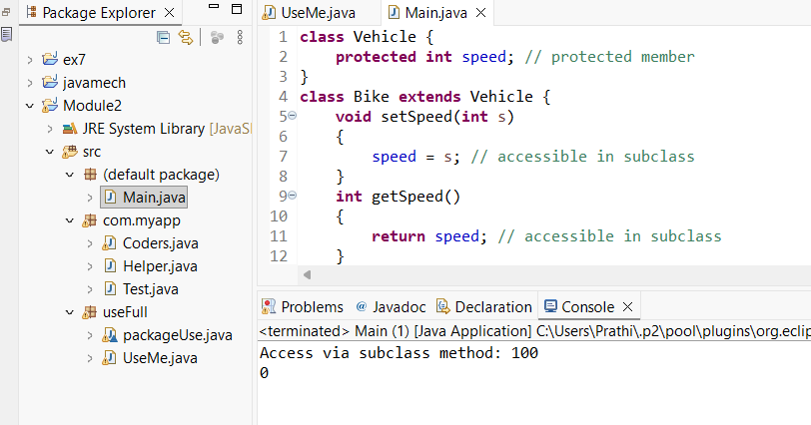

//Public Access Modifier
class MathUtils {
public static int add(int a, int b) {
return a + b;
}
}
public class Main {
public static void main(String[] args) {
System.out.println(MathUtils.add(5, 10)); // accessible anywhere
}
}
Output
15
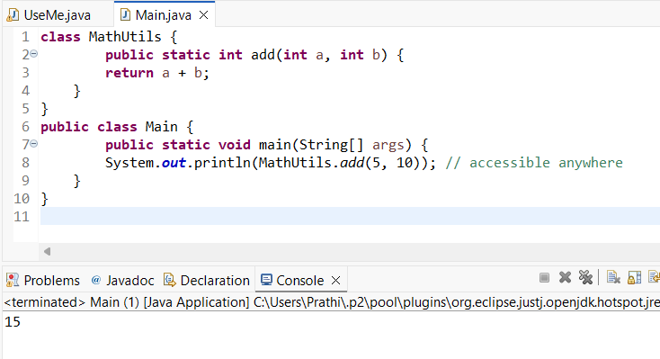

POST LAB EXERCISE
  - Write a Java program to implement Default access modifier which has a default class within the same package and a default class from a different package.

Accessing Default Class Within the Same Package:

package pack1;
class DefaultClass { // default access (no public keyword)
void show() {
System.out.println("Default class accessed within same package.");
}
}
public class TestSamePackage {
public static void main(String[] args) {
DefaultClass obj = new DefaultClass();
obj.show();
}
}

Accessing Default Class From Different Package:

package pack2;

import pack1.DefaultClass; // This will cause error

public class TestDifferentPackage {
public static void main(String[] args) {
DefaultClass obj = new DefaultClass(); // Not accessible
obj.show();
}
}

Result:
Compile-time error
(DefaultClass is not public and cannot be accessed from outside package)
The default access modifier allows access only within the same package and restricts access from different packages.

  - Which access modifier provides the highest level of access?

The public access modifier provides the highest level of access.
A public class or member can be accessed from any package and any class in the program.

ASSESSMENT

Description | Max Marks | Marks Awarded
Pre Lab Exercise | 5
In Lab Exercise | 10
Post Lab Exercise | 5
Viva | 10
Total | 30
Faculty Signature

Experiment Number :11 Date: 26/02/2026

Implementation of multiple inheritance in Java using Interface

Aim:
Write a Java program to implement multiple inheritance using Interface.

PRE LAB EXERCISE
QUESTIONS
  - Why Java does not support multiple inheritance using classes like that of C?

In Java, multiple inheritance using classes is not supported to avoid ambiguity problems, especially the Diamond Problem.

If a class inherits from two parent classes that have the same method, the compiler becomes confused about which method to execute.
This creates:
- Ambiguity
- Complexity
- Maintenance issues
To keep the language simple and secure, Java does not allow multiple inheritance through classes.

  - What is the primary purpose of an interface in Java?
- To store data using instance variables
- To define a contract of methods a class must implement
- To allow creation of objects
- To improve runtime performance

Ans : To define a contract of methods a class must implement
Explanation:
An interface defines a set of abstract methods that a class must implement. It acts as a blueprint and ensures that the implementing class provides method definitions.

IN LAB EXERCISE
Objective
To demonstrate how an interface in Java defines constants and abstract methods, which are implemented by a class.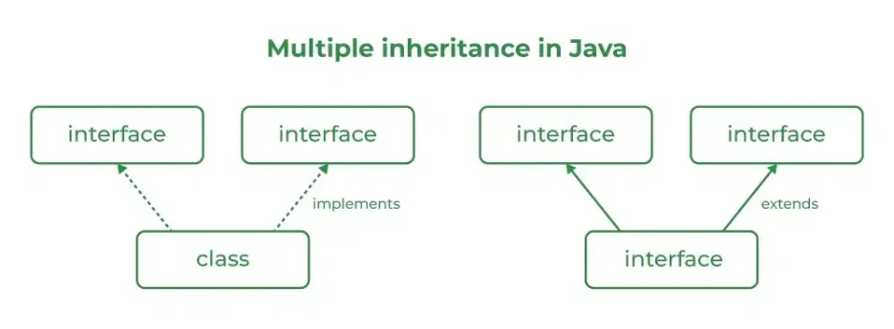

Source Code
import java.io.*;
// Add interface
interface Add{
int add(int a,int b);
}
// Sub interface
interface Sub{
int sub(int a,int b);
}
// Calculator class implementing Add and Sub
class Cal implements Add , Sub
{
// Method to add two numbers
public int add(int a,int b){
return a+b;
}
// Method to sub two numbers
public int sub(int a,int b){
return a-b;
}
}
class Example{
// Main Method
public static void main (String[] args){

// instance of Cal class
Cal x = new Cal();
System.out.println("Addition : " + x.add(2,1));
System.out.println("Substraction : " + x.sub(2,1));
}
}

Outputs
Addition : 3
Subtraction : 1
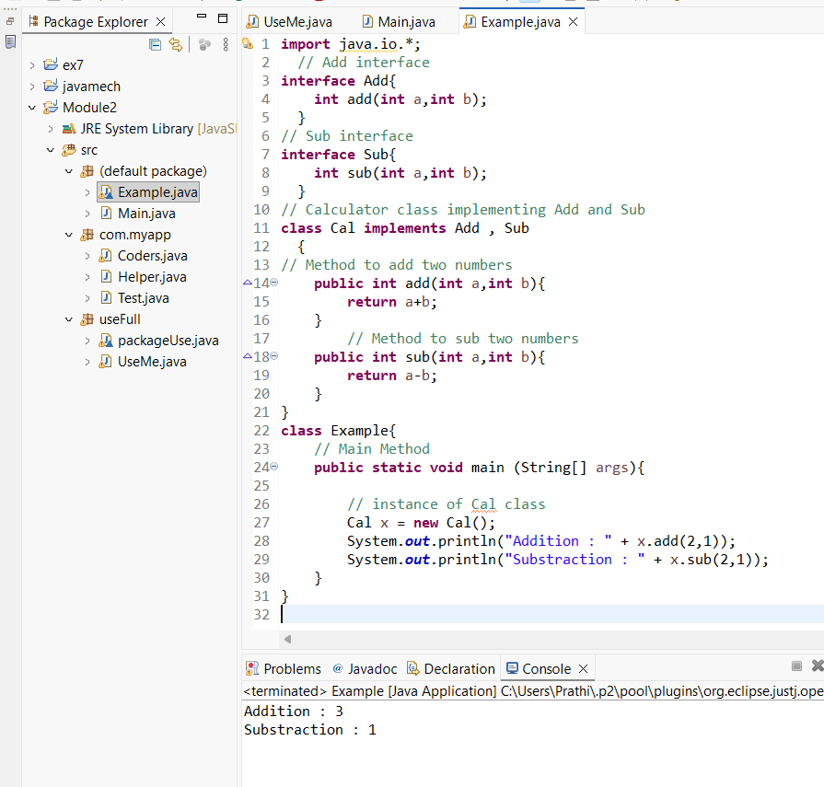

POST LAB EXERCISE
  - Can a functional interface extend another interface?

- Yes, a functional interface in Java can extend another interface but it must still have only one abstract method in total.
- If the parent interface already has one abstract method, the child functional interface must not add any new abstract methods. Otherwise, it will no longer remain a functional interface.
- So, it can extend another interface only if the total number of abstract methods remains one.

  - Which feature was introduced in interfaces starting from Java 8?
- Constructors
- Private methods
- Default and static methods
- Final classes
Ans : Default and static methods
Explanation:
Starting from Java 8, interfaces can contain:
- Default methods → Methods with a body using default keyword.
- Static methods → Methods with a body using static keyword.
This was introduced to support backward compatibility and lambda expressions.

ASSESSMENT

Description | Max Marks | Marks Awarded
Pre Lab Exercise | 5
In Lab Exercise | 10
Post Lab Exercise | 5
Viva | 10
Total | 30
Faculty Signature

Experiment Number : 12 Date: 26/02/2026

Implementation of exception handling in Java
Aim:
Write a java program to implement exception handling.

PRE LAB EXERCISE
QUESTIONS
- What is exception handling in Java?

- In Java, exception handling is a mechanism used to handle runtime errors so that the normal execution of the program is not disturbed.
- An exception is an unexpected event that occurs during program execution, such as division by zero, invalid input, or accessing an invalid array index.
- Java provides try, catch, finally, throw, and throws keywords to handle exceptions effectively.

- What is the purpose of using try-catch blocks in exception handling?

The try-catch block is used to handle exceptions safely.
- The try block contains code that may cause an exception.
- The catch block handles the exception if it occurs.
- It prevents the program from terminating abnormally.
- It allows the program to continue execution after handling the error.
Thus, try-catch ensures smooth program flow even when errors occur.

IN LAB EXERCISE
Objective
To understand and implement exception handling through try-catch and finally blocks.
Source Code
import java.util.InputMismatchException;
import java.util.Scanner;
public class ExceptionHandlingExample {
public static void main(String[] args) {
Scanner = new Scanner(System.in);
try {
System.out.print("Enter an integer: ");
int num = scanner.nextInt();
int result = 10 / num;
System.out.println("Result: " + result);
} catch (InputMismatchException e) {
System.out.println("Invalid input! Please enter an integer.");
} catch (ArithmeticException e) {
System.out.println("Cannot divide by zero!");
} finally {
scanner.close();
System.out.println("Program execution completed.");
} }
}
Outputs
Output 1 (Valid Input - Non-zero Integer):
Enter an integer: 5
Result: 2
Program execution completed.
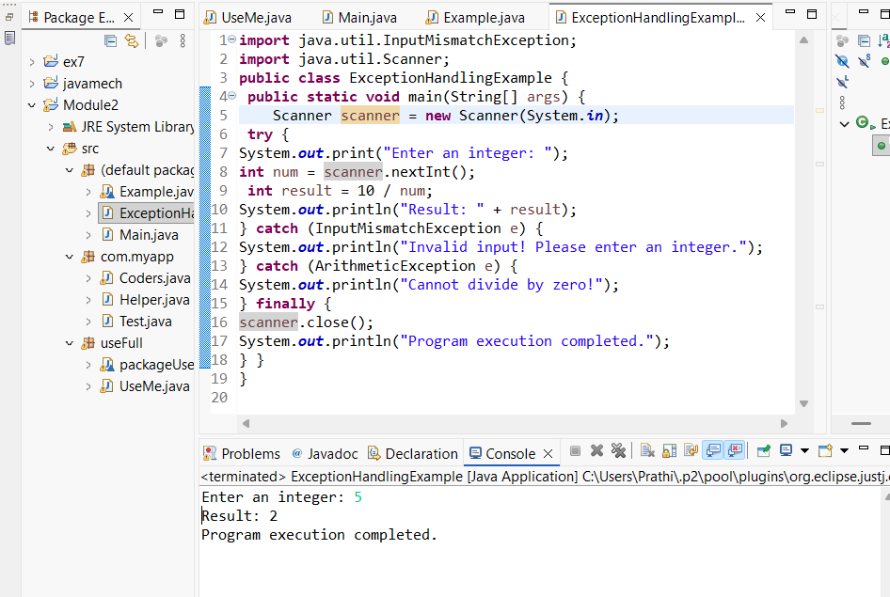

Output 2 (Valid Input - Zero):
Enter an integer: 0
Cannot divide by zero!
Program execution completed.
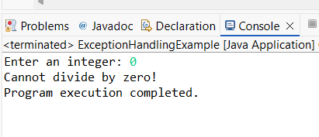

Output 3 (Invalid Input - Non-integer):
Enter an integer: abc
Invalid input! Please enter an integer.
Program execution completed.
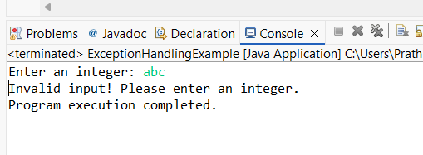

POST LAB EXERCISE
- What is the purpose of the Scanner object in the Java program?
The Scanner class is used to take input from the user at runtime.
It is mainly used to:
- Read input from the keyboard (System.in)
- Accept different data types such as int, float, double, and String
- Make programs interactive
Example:
Scanner sc = new Scanner(System.in);
int num = sc.nextInt();

- What exceptions are expected to be thrown in the code within the try block? Why?

Common exceptions that may occur inside a try block are:
- ArithmeticException – occurs when dividing a number by zero.
- InputMismatchException – occurs when the user enters a wrong data type.
- ArrayIndexOutOfBoundsException – occurs when accessing an invalid array index.
- NullPointerException – occurs when trying to use a null reference.
These exceptions occur due to invalid operations, incorrect input, or accessing memory improperly.

ASSESSMENT

Description | Max Marks | Marks Awarded
Pre Lab Exercise | 5
In Lab Exercise | 10
Post Lab Exercise | 5
Viva | 10
Total | 30
Faculty Signature

Experiment Number : 13 Date: 26/02/2026

Implementation of User-defined Exception in Java

Aim:
Write a java program to implement User-defined Exception.

PRE LAB EXERCISE
QUESTIONS
- What is Java custom exception?

In Java, a custom exception is a user-defined exception created by the programmer to handle specific application-level errors.
Java provides many built-in exceptions, but sometimes application requirements need special error handling. In such cases, we create our own exception class by extending the Exception hierarchy.
Custom exceptions improve:
- Code readability
- Specific error handling
- Application security

- What are the two types of custom exceptions in Java?

There are two types of custom exceptions:
- Checked Custom Exception
  - Extends Exception
  - Must be handled using try-catch or declared using throws
  - Checked at compile time
- Unchecked Custom Exception
  - Extends RuntimeException
  - Not mandatory to handle
  - Occurs at runtime

IN LAB EXERCISE
Objective
To understand and implement Checked and Unchecked custom exceptions.
Source Code
Ex 1: // Custom Checked Exception
class InvalidAgeException extends Exception {
public InvalidAgeException(String m) {
super(m);
}
}
// Using the Custom Exception
public class AgeCheck{
public static void validate(int age)
throws InvalidAgeException {
if (age < 18) {
throw new InvalidAgeException("Age must be 18 or above.");
}
System.out.println("Valid age: " + age);
}
public static void main(String[] args) {
try {
validate(12);
} catch (InvalidAgeException e) {
System.out.println("Caught Exception: " + e.getMessage());
}
}
}

Output 1
Caught Exception: Age must be 18 or above.
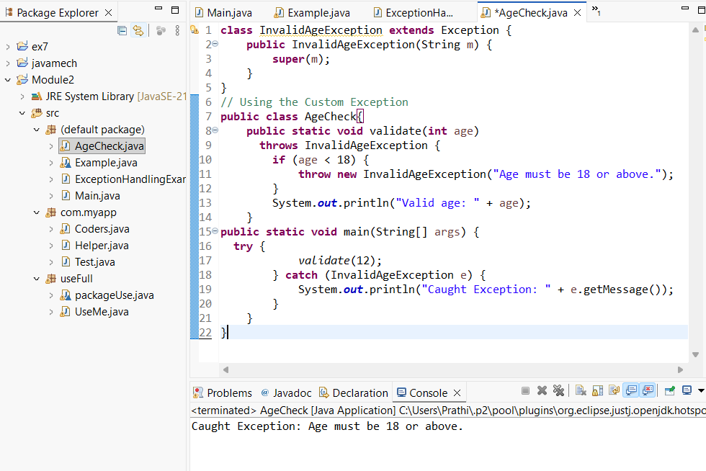

Ex 2: // Custom Unchecked Exception
class DivideByZeroException extends RuntimeException {
public DivideByZeroException(String m) {
super(m);
}
}
// Using the Custom Exception
public class TestSample {
public static void divide(int a, int b) {
if (b == 0) {
throw new DivideByZeroException("Division by zero is not allowed.");
}
System.out.println("Result: " + (a / b));
}

public static void main(String[] args) {
try {
divide(10, 0);
} catch (DivideByZeroException e) {
System.out.println("Caught Exception: " + e.getMessage());
}
}
}

Output 2
Caught Exception: Division by zero is not allowed.
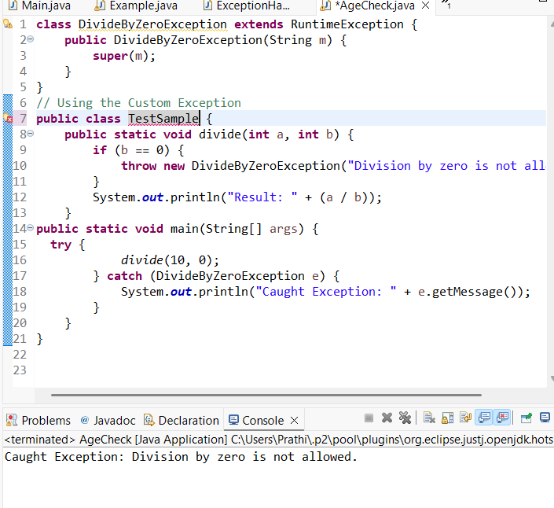

POST LAB EXERCISE
- What is required to create a custom exception in Java?
- Extend the Object class
- Extend the Throwable class
- Extend Exception or RuntimeException
- Implement the Serializable interface
Ans : Extend Exception or RuntimeException
Reason :
To create a custom exception, we must extend either:
- Exception (for checked exception) or
- RuntimeException (for unchecked exception)

- List some use cases for the checked and unchecked exceptions.

Use Cases of Checked Exceptions:
- File handling errors (File not found)
- Database connection failure
- Network communication errors
- Invalid user input validation (mandatory conditions)

Use Cases of Unchecked Exceptions:
- Programming errors (logic mistakes)
- Arithmetic errors (divide by zero)
- Null pointer access
- Array index out of bounds

ASSESSMENT

Description | Max Marks | Marks Awarded
Pre Lab Exercise | 5
In Lab Exercise | 10
Post Lab Exercise | 5
Viva | 10
Total | 30
Faculty Signature

