Experiment Number : 8 Date: 20.02.2026

Implementation of Packages in Java

Aim:
Write a Java program to implement built-in, user-defined packages and accessing all classes in a package.

PRE LAB EXERCISE
QUESTIONS
- What is java.util package and what collection framework does it contain?

ANSWER:
java.util is a built-in package in Java that contains utility classes.
It provides classes for:
- Collections (like List, Set, Map)
- Date and Time
- Scanner (for input)
- Random numbers
- String Tokenizer
- Arrays utilities

Example:
import java.util.Scanner;
import java.util.ArrayList;

The java.util package contains the Java Collection Framework.
The Collection Framework is a set of interfaces and classes used to store and manipulate groups of objects.
It mainly contains:
- List (Ordered, allows duplicates)
ArrayList
LinkedList
Vector
Stack
- Set (No duplicates)
HashSet
LinkedHashSet
TreeSet
- Map (Key-Value pairs)
HashMap
LinkedHashMap
TreeMap
Hashtable
- Queue
PriorityQueue
Deque
- What are the two types of packages in Java?
ANSWER:
There are two types of packages in Java:

1.Built-in Packages (Predefined Packages)
These are already provided by Java.
Examples:
- java.lang
- java.util
- java.io
- java.sql

2️.User-defined Packages
These are created by the programmer using the package keyword.
Example:
package mypackage;
Used to organize related classes.

IN LAB EXERCISE
Objective
To understand and implement the concepts of built-in, user-defined packages and accessing all classes in a package in Java.
Built-in Packages comprise a large number of classes that are part of the Java API. Some of the commonly used built-in packages are:
- java.lang: Contains language support classes(e.g, classes that define primitive data types, math operations). This package is automatically imported.
- java.io: Contains classes for supporting input/output operations.
- java.util: Contains utility classes that implement data structures such as Linked Lists and Dictionaries, as well as support for date and time operations.
- java.applet: Contains classes for creating Applets.
- java.awt: Contains classes for implementing the components for graphical user interfaces (like buttons, menus, etc).
Source Code
import java.util.Random; // built-in package
public class Sample{
public static void main(String[] args) {
// using Random class
Random rand = new Random();
// generates a number between 0–99
int number = rand.nextInt(100);
System.out.println("Random number: " + number);
}
}
Output
Random number: 49
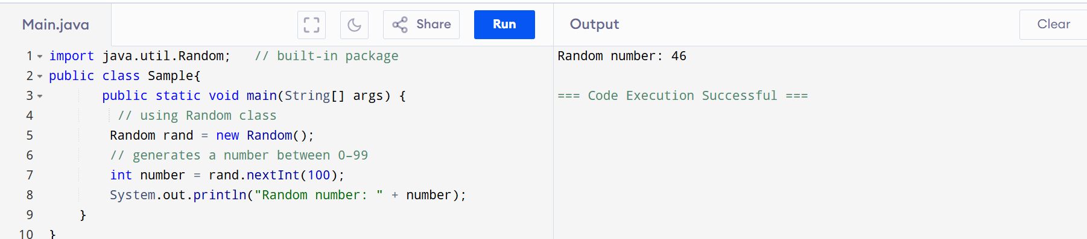

User-defined Packages are the packages that are defined by the user.
Source code
package com.myapp;
public class Helper {
public static void show() {
System.out.println("Hello from Helper!");
}
}
==To use this in another class==
import com.myapp.Helper;
public class Test {
public static void main(String[] args) {
Helper.show();
}
}

Output:
Hello from Helper!
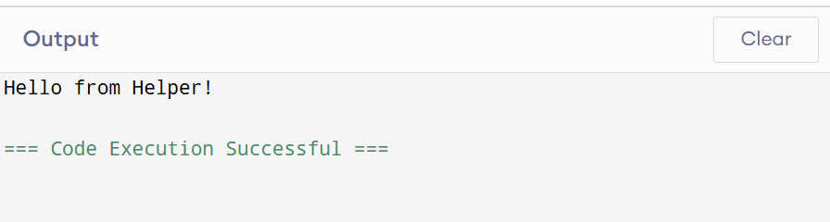
//Importing all classes from a package.
Source code
import java.util.Vector;
public class Coders {
public Coders() {
// java.util.Vector is imported, We are able to access it directly in our code.
Vector v = new Vector();
java.util.ArrayList l = new java.util.ArrayList();
l.add(3);
l.add(5);
l.add(7);
System.out.println(l);
}
public static void main(String[] args) {
new Coders();
}
}
Output
[3,5,7]
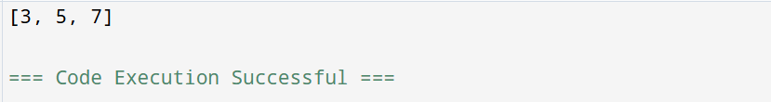
POST LAB EXERCISE
- What will happen if two classes in different packages have the same name and are imported in a Java file?

ANSWER:
If two classes with the same name are imported from different packages, Java will get confused.

Use the fully qualified name:
package1.Student s1 = new package1.Student();
package2.Student s2 = new package2.Student();

- What is the purpose of using packages in Java?

ANSWER:
Packages are used to:
- Organize related classes
- Avoid name conflicts
- Provide access protection
- Make large projects easier to mana

- Which built-in Java package would you use if you want to create a GUI window and display a message?
- java.util
- java.sql
- java.awt
- java.net

ANSWER:

C. java.awt
java.awt (Abstract Window Toolkit) is used to create GUI components like:
- Window
- Button
- Label
- Frame

ASSESSMENT

Description | Max Marks | Marks Awarded
Pre Lab Exercise | 5
In Lab Exercise | 10
Post Lab Exercise | 5
Viva | 10
Total | 30
Faculty Signature

