Experiment Number : 10 Date: 25/02/2026

Implementation of Access Modifiers in Java

Aim:
Write a Java program to implement different access modifiers.

PRE LAB EXERCISE QUESTIONS
- What are the 4 access modifiers available in Java?
- Public
- Private
- Protected
- Default

- Which access modifiers can be used in Java to control access to class members?
The public modifier allows members to be accessed from anywhere in the program.
The private modifier restricts access to within the same class only.
The protected modifier allows access within the same package and to subclasses in other packages.
The default modifier (when no keyword is specified) allows access only within the same package.
IN LAB EXERCISE
Objective
To demonstrate different access modifiers such as Default, Private, Protected and Public using Java programs.
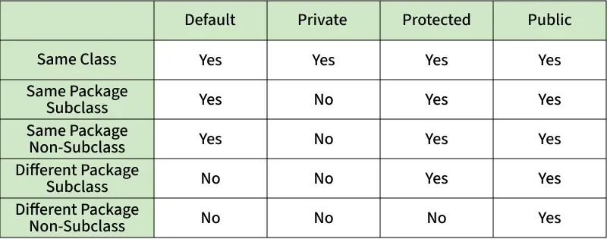
Fig: Comparison table of Access Modifiers in Java
Source Code
// Default Access modifier
class Car {
String model; // default access
}
public class Main {
public static void main(String[] args){
Car c = new Car();
c.model = "Tesla"; // accessible within the same package
System.out.println(c.model);
}
}
Output:
Tesla
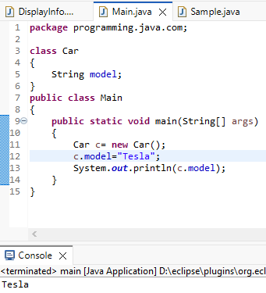

//Private Access Modifier
class Person {
// private variable
private String name;
public void setName(String name) {
this.name = name; // accessible within class
}
public String getName() {
return name;
}
}
public class Geeks {
public static void main(String[] args)
{
Person p = new Person();
p.setName("Alice");

// System.out.println(p.name);
// Error: 'name'
// has private access
System.out.println(p.getName());
}
}
Output
Shankar
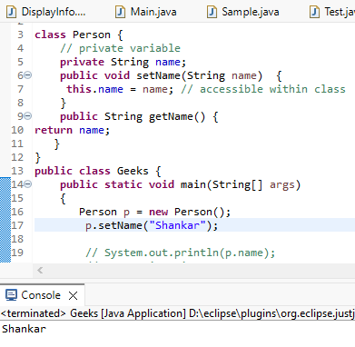

//Protected Access Modifier
class Vehicle {
protected int speed; // protected member
}
class Bike extends Vehicle {
void setSpeed(int s)
{
speed = s; // accessible in subclass
}
int getSpeed()
{
return speed; // accessible in subclass
}
}
public class Main {
public static void main(String[] args){
Bike b = new Bike();
b.setSpeed(100);
System.out.println("Access via subclass method: "+ b.getSpeed());
Vehicle v = new Vehicle();
System.out.println(v.speed);
}
}
Output
Access via subclass method: 70
0
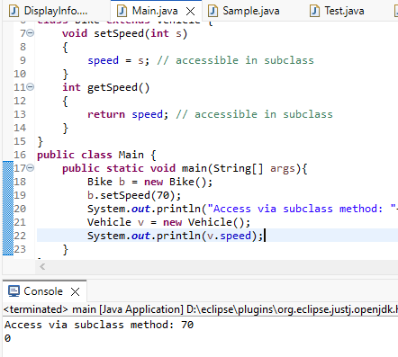

//Public Access Modifier
class MathUtils {
public static int add(int a, int b) {
return a + b;
}
}
public class Main {
public static void main(String[] args) {
System.out.println(MathUtils.add(5, 10)); // accessible anywhere
}
}
Output
12
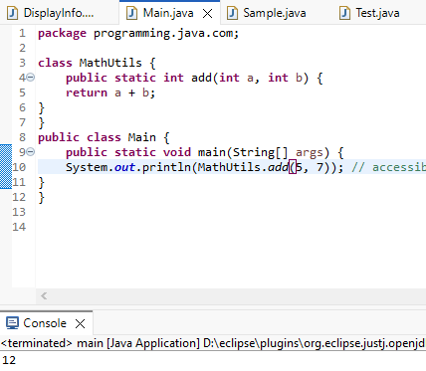

POST LAB EXERCISE
  - Write a Java program to implement Default access modifier which has a default class within the same package and a default class from a different package.

class Print {
void disp () {
System.out.println("Default access inside the same package");
}
}

public class Main {
public static void main(String[] args) {
Print p = new Print();
p.disp ();
}
}

  - Which access modifier provides the highest level of access?

Public is the access modifier that provides the highest level of access.

ASSESSMENT

Description | Max Marks | Marks Awarded
Pre Lab Exercise | 5
In Lab Exercise | 10
Post Lab Exercise | 5
Viva | 10
Total | 30
Faculty Signature

Experiment Number :11 Date: 25/02/2026

Implementation of multiple inheritance in Java using Interface

Aim:
Write a Java program to implement multiple inheritance using Interface.

PRE LAB EXERCISE QUESTIONS
- Why Java does not support multiple inheritance using classes like that of C?
Java does not support multiple inheritance using classes to avoid ambiguity problems like the Diamond Problem.
If two parent classes have the same method, the child class would not know which one to inherit.
To keep the design simple and avoid confusion, Java allows multiple inheritance only through interfaces.

- What is the primary purpose of an interface in Java?
The primary purpose of an interface in Java is to define a contract that classes must follow.
It specifies what methods a class should implement without providing full implementation.
Interfaces support abstraction and allow multiple inheritance in Java.
To define a contract of methods a class must implement

IN LAB EXERCISE
Objective
To demonstrate how an interface in Java defines constants and abstract methods, which are implemented by a class.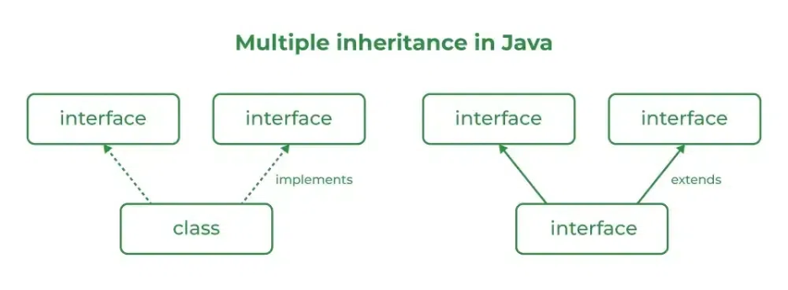

Source Code
import java.io.*;
// Add interface
interface Add{
int add(int a,int b);
}
// Sub interface
interface Sub{
int sub(int a,int b);
}
// Calculator class implementing Add and Sub
class Cal implements Add , Sub
{
// Method to add two numbers
public int add(int a,int b){
return a+b;
}
// Method to sub two numbers
public int sub(int a,int b){
return a-b;
}
}
class Example{
// Main Method
public static void main (String[] args){

// instance of Cal class
Cal x = new Cal();
System.out.println("Addition : " + x.add(2,1));
System.out.println("Substraction : " + x.sub(2,1));
}
}

Outputs
Addition : 3
Subtraction : 1
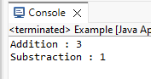
POST LAB EXERCISE
  - Can a functional interface extend another interface?
Yes, a functional interface can extend another interface if it still has only one abstract method.
If more than one abstract method exists after extending, it is no longer a functional interface.
  - Which feature was introduced in interfaces starting from Java 8?
Starting from Java 8, default methods and static methods were introduced in interfaces.
These allow interfaces to have method implementations without breaking existing classes.

ASSESSMENT

Description | Max Marks | Marks Awarded
Pre Lab Exercise | 5
In Lab Exercise | 10
Post Lab Exercise | 5
Viva | 10
Total | 30
Faculty Signature

Experiment Number : 12 Date: 25/02/2026

Implementation of exception handling in Java
Aim:
Write a java program to implement exception handling.

PRE LAB EXERCISE QUESTIONS
- What is exception handling in Java?
Exception handling in Java is a mechanism used to handle runtime errors so that the program does not crash. It allows a program to detect, catch, and manage exceptions using keywords like try, catch, throw, and finally. This helps maintain the normal flow of the program even when errors occur.

- What is the purpose of using try-catch blocks in exception handling?
The try-catch block is used to handle exceptions that may occur during program execution. The try block contains code that might cause an exception, and the catch block handles the error. It prevents the program from crashing and allows it to continue running normally.

IN LAB EXERCISE
Objective
To understand and implement exception handling through try-catch and finally blocks.
Source Code
import java.util.InputMismatchException;
import java.util.Scanner;
public class ExceptionHandlingExample {
public static void main(String[] args) {
Scanner scanner = new Scanner(System.in);
try {
System.out.print("Enter an integer: ");
int num = scanner.nextInt();
int result = 10 / num;
System.out.println("Result: " + result);
} catch (InputMismatchException e) {
System.out.println("Invalid input! Please enter an integer.");
} catch (ArithmeticException e) {
System.out.println("Cannot divide by zero!");
} finally {
scanner.close();
System.out.println("Program execution completed.");
} }
}
Outputs
Output 1 (Valid Input - Non-zero Integer):
Enter an integer: 2
Result: 5
Program execution completed.
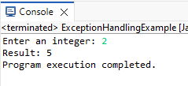
Output 2 (Valid Input - Zero):
Enter an integer: 0
Cannot divide by zero!
Program execution completed.
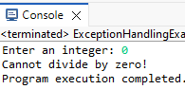

Output 3 (Invalid Input - Non-integer):
Enter an integer: shankar
Invalid input! Please enter an integer.
Program execution completed.
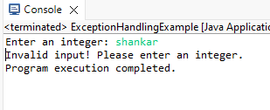

POST LAB EXERCISE
- What is the purpose of the Scanner object in the Java program?
The Scanner object is used to take input from the user at runtime.
It reads data such as integers, strings, and other types from the keyboard.

- What exceptions are expected to be thrown in the code within the try block? Why?
An InputMismatchException may be thrown if the user enters data of the wrong type (e.g., text instead of an integer).
ArithmeticException may also occur if there is an illegal mathematical operation like division by zero.

ASSESSMENT

Description | Max Marks | Marks Awarded
Pre Lab Exercise | 5
In Lab Exercise | 10
Post Lab Exercise | 5
Viva | 10
Total | 30
Faculty Signature

Experiment Number : 13 Date: 26/02/2026

Implementation of User-defined Exception in Java

Aim:
Write a java program to implement User-defined Exception.

PRE LAB EXERCISE QUESTIONS
- What is Java custom exception?
A custom exception in Java is a user-defined exception created by extending the Exception class or RuntimeException class.
It is used to handle application-specific errors according to program requirements.

- What are the two types of custom exceptions in Java?
The two types of custom exceptions are checked exceptions (extend Exception) and unchecked exceptions (extend RuntimeException).

IN LAB EXERCISE
Objective
To understand and implement Checked and Unchecked custom exceptions.
Source Code
Ex 1: // Custom Checked Exception
class InvalidAgeException extends Exception {
public InvalidAgeException(String m) {
super(m);
}
}
// Using the Custom Exception
public class AgeCheck{
public static void validate(int age)
throws InvalidAgeException {
if (age < 18) {
throw new InvalidAgeException("Age must be 18 or above.");
}
System.out.println("Valid age: " + age);
}
public static void main(String[] args) {
try {
validate(12);
} catch (InvalidAgeException e) {
System.out.println("Caught Exception: " + e.getMessage());
}
}
}
Output 1
Caught Exception: Age must be 18 or above.
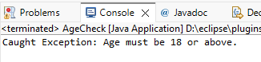

Ex 2: // Custom Unchecked Exception
class DivideByZeroException extends RuntimeException {
public DivideByZeroException(String m) {
super(m);
}
}
public class TestSample {
public static void divide(int a, int b) {
if (b == 0) {
throw new DivideByZeroException("Division by zero is not allowed.");
}
System.out.println("Result: " + (a / b));
}
public static void main(String[] args) {
try {
divide(10, 0);
} catch (DivideByZeroException e) {
System.out.println("Caught Exception: " + e.getMessage());
}
}
}
Output 2
Caught Exception: Division by zero is not allowed.
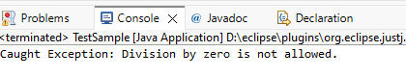

POST LAB EXERCISE
- What is required to create a custom exception in Java?
To create a custom exception in Java, you must create a new class that extends either Exception (for checked) or RuntimeException (for unchecked).
You can also define constructors to pass error messages to the superclass.

- List some use cases for the checked and unchecked exceptions.
• Checked exceptions: File handling, database connections, network operations where recovery is possible.
• Unchecked exceptions: Programming errors like division by zero, null references, or invalid input.

ASSESSMENT

Description | Max Marks | Marks Awarded
Pre Lab Exercise | 5
In Lab Exercise | 10
Post Lab Exercise | 5
Viva | 10
Total | 30
Faculty Signature

