Experiment Number : 10 Date: 22.02.2026

Implementation of Access Modifiers in Java

Aim:
Write a Java program to implement different access modifiers.

PRE LAB EXERCISE
QUESTIONS
- What are the 4 access modifiers available in Java?
ANSWER:
The four access modifiers available in Java are public, private, protected, and default. The public modifier allows access from anywhere. The private modifier allows access only within the same class. The protected modifier allows access within the same package and also in subclasses. The default modifier (when no modifier is specified) allows access only within the same package.

- Which access modifiers can be used in Java to control access to class members?
ANSWER:
The access modifiers used to control access to class members (variables, methods, constructors) are public, private, protected, and default. These modifiers determine where the class members can be accessed, such as within the same class, same package, subclass, or from anywhere in the program

IN LAB EXERCISE
Objective
To demonstrate different access modifiers such as Default, Private, Protected and Public using Java programs.
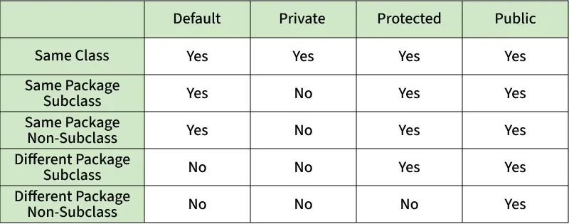
Fig: Comparison table of Access Modifiers in Java
Source Code
// Default Access modifier
class Car {
String model; // default access
}
public class Main {
public static void main(String[] args){
Car c = new Car();
c.model = "Tesla"; // accessible within the same package
System.out.println(c.model);
}
}
Output:
Tesla
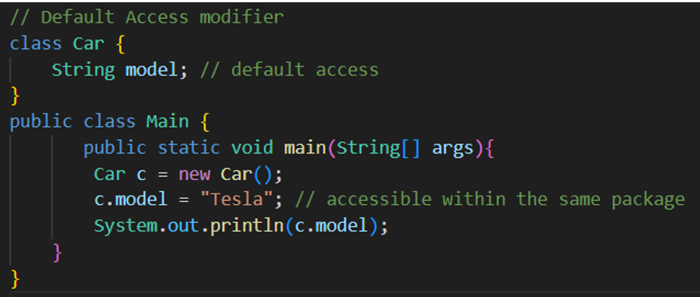

//Private Access Modifier
class Person {
// private variable
private String name;
public void setName(String name) {
this.name = name; // accessible within class
}
public String getName() {
return name;
}
}
public class Geeks {
public static void main(String[] args)
{
Person p = new Person();
p.setName("Alice");

// System.out.println(p.name);
// Error: 'name'
// has private access
System.out.println(p.getName());
}
}
Output
Alice
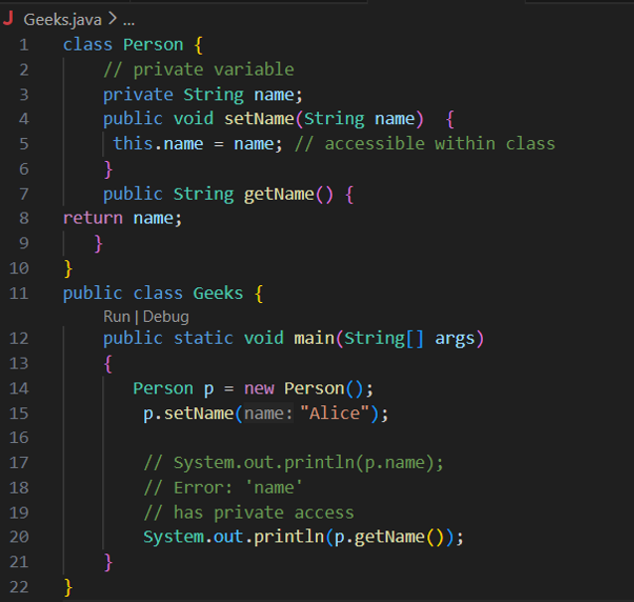

//Protected Access Modifier
class Vehicle {
protected int speed; // protected member
}
class Bike extends Vehicle {
void setSpeed(int s)
{
speed = s; // accessible in subclass
}
int getSpeed()
{
return speed; // accessible in subclass
}
}
public class Main {
public static void main(String[] args){
Bike b = new Bike();
b.setSpeed(100);
System.out.println("Access via subclass method: "+ b.getSpeed());
Vehicle v = new Vehicle();
System.out.println(v.speed);
}
}
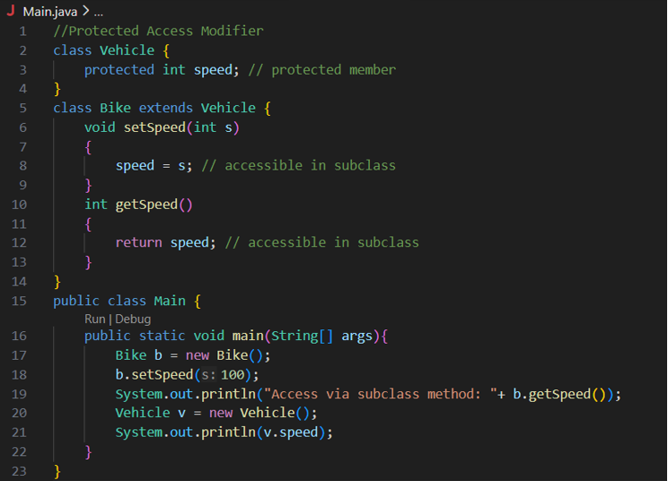
Output
Access via subclass method: 100
0
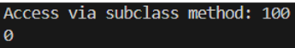

//Public Access Modifier
class MathUtils {
public static int add(int a, int b) {
return a + b;
}
}
public class Main {
public static void main(String[] args) {
System.out.println(MathUtils.add(5, 10)); // accessible anywhere
}
}
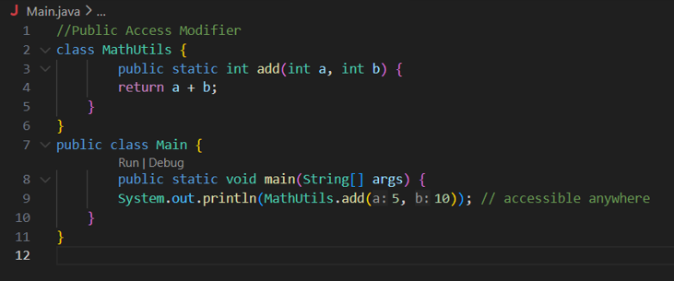
Output
15

POST LAB EXERCISE
  - Write a Java program to implement Default access modifier which has a default class within the same package and a default class from a different package.

ANSWER:
Default access modifier (also called package-private) is used when no access modifier is specified. It allows access only within the same package. If a class or member has default access, it cannot be accessed from a different package. When two classes are in the same package, a default class can be accessed normally. But if we try to access that default class from another package, it gives a compile-time error. Therefore, default access works only inside the same package.
  - Which access modifier provides the highest level of access?

ANSWER:
The access modifier that provides the highest level of access is public. A public class, method, or variable can be accessed from anywhere in the program, whether inside the same package or in a different package.

ASSESSMENT

Description | Max Marks | Marks Awarded
Pre Lab Exercise | 5
In Lab Exercise | 10
Post Lab Exercise | 5
Viva | 10
Total | 30
Faculty Signature

