Experiment Number : 8 Date: 25/02/2026

Implementation of Packages in Java

Aim:
Write a Java program to implement built-in, user-defined packages and accessing all classes in a package.

PRE LAB EXERCISE
QUESTIONS
- What is java.util package and what collection framework does it contain?
java.util is a built-in Java package that contains utility classes such as Scanner, Random, Date, and data structure classes.
It contains the Java Collection Framework, which includes interfaces like List, Set, Queue, Map and classes like ArrayList, LinkedList, HashSet, HashMap, etc.

- What are the two types of packages in Java?
The two types of packages in Java are:
Built-in Packages – Provided by Java API (e.g., java.lang, java.util, java.io).
User-defined Packages – Created by programmers to organize classes.

IN LAB EXERCISE
Objective
To understand and implement the concepts of built-in, user-defined packages and accessing all classes in a package in Java.
Built-in Packages comprise a large number of classes that are part of the Java API. Some of the commonly used built-in packages are:
- java.lang: Contains language support classes(e.g, classes that define primitive data types, math operations). This package is automatically imported.
- java.io: Contains classes for supporting input/output operations.
- java.util: Contains utility classes that implement data structures such as Linked Lists and Dictionaries, as well as support for date and time operations.
- java.applet: Contains classes for creating Applets.
- java.awt: Contains classes for implementing the components for graphical user interfaces (like buttons, menus, etc).
Source Code
import java.util.Random; // built-in package
public class Sample{
public static void main(String[] args) {
// using Random class
Random rand = new Random();
// generates a number between 0–99
int number = rand.nextInt(100);
System.out.println("Random number: " + number);
}
}
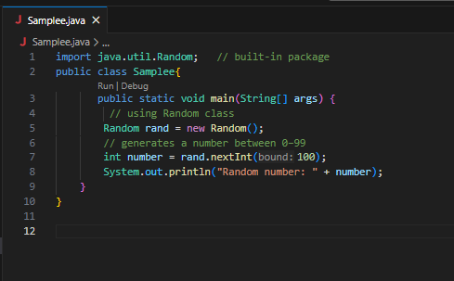
Output
Random number: 49
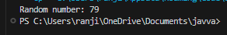

User-defined Packages are the packages that are defined by the user.
Source code
package com.myapp;
public class Helper {
public static void show() {
System.out.println("Hello from Helper!");
}
}
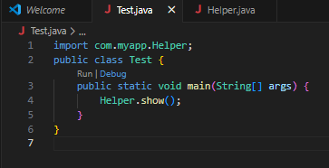
==To use this in another class==
import com.myapp.Helper;
public class Test {
public static void main(String[] args) {
Helper.show();
}
}
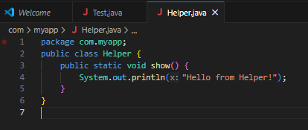

Output:
Hello from Helper!
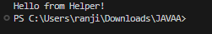
//Importing all classes from a package.
Source code
import java.util.Vector;
public class Coders {
public Coders() {
// java.util.Vector is imported, We are able to access it directly in our code.
Vector v = new Vector();
java.util.ArrayList l = new java.util.ArrayList();
l.add(3);
l.add(5);
l.add(7);
System.out.println(l);
}
public static void main(String[] args) {
new Coders();
}
}
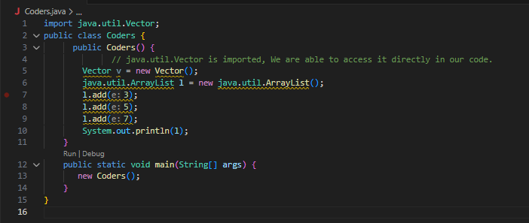
Output
[3,5,7]

POST LAB EXERCISE
- What will happen if two classes in different packages have the same name and are imported in a Java file?
If two classes with the same name from different packages are imported, Java will create an ambiguity error (compile-time error).

- What is the purpose of using packages in Java?
Packages are used to:
- Organize related classes and interfaces
- Avoid name conflicts
- Provide access protection
- Improve code reusability
- Make large projects easier to manage
In simple words:
Packages help in structuring and managing Java programs properly.

- Which built-in Java package would you use if you want to create a GUI window and display a message?
java.awt

ASSESSMENT

Description | Max Marks | Marks Awarded
Pre Lab Exercise | 5
In Lab Exercise | 10
Post Lab Exercise | 5
Viva | 10
Total | 30
Faculty Signature

Experiment Number : 9 Date: 25/02/2026

Implementation of a Java Program to import packages using different methods

Aim:
Write a Java program to import packages using different methods for different use cases.

PRE LAB EXERCISE
QUESTIONS
- How to import a single class and multiple classes from a package in Java?
In Java, we can import one specific class by writing import packageName.ClassName;.
If we want to use all classes from a package, we write import packageName.*;, which makes every class in that package available.

- Which package is always imported by default in every Java class?
The java.lang package is automatically included in every Java program.
It provides basic classes such as System, String, and Math, so we do not need to import it manually.

IN LAB EXERCISE
Objective
To understand and implement the Java packages using different methods and import them.
Problem
Define a package named ‘useFul’ with a class names ‘UseMe’ having following methods:
1) area()- To calculate the area of given shape.
2) salary()- To calculate the salary given basic Salary,da,hRA.
3) percentage()-To calculate the percentage given total marks and marks obtained.
4) Develop a program named ‘Package Use’ to import the above package ‘useFul’ and use the method area().
5) Develop a program named ‘manager’
Source Code
//Package Creation:
package useFull;
import java.util.*;
public class UseMe
{
Scanner obj=new Scanner(System.in);
public static void area()
{
class method{
void aos(int a)
{
System.out.print("\nArea of square with length "+a+" is "+(a*a));
}
void aor(int a,int b)
{
System.out.print("\nArea of reactangle with dimensions "+a+" & "+b+" is "+(a*b));
}
void aoc(int r)
{
double a=3.14*r*r;
}
System.out.print("\nArea of circle with radius "+r+" is "+a);
}
void aot(int a,int b)
{
float ar=(a*b)/2;
System.out.print("\nArea of triangle with dimensions "+a+" &"+b+" is "+ar);
} }
Scanner obj=new Scanner(System.in);
method m=new method();
System.out.print("\n1.Square\n2.Rectangle\n3.Circle\n4.Triangle\nSelect the shape\n");
int ch=obj.nextInt();
UseMe u=new UseMe();
switch(ch)
{
case 1:System.out.print("\nEnter the length of side of square : ");
int s=obj.nextInt();m.aos(s);
break;
case 2:System.out.print("\nEnter the dimensions of rectangle : ");
int l=obj.nextInt();
int b=obj.nextInt();
m.aor(l,b);
break;
case 3:System.out.print("\nEnter the radius of circle : ");
int r=obj.nextInt();
m.aoc(r);
break;
case 4:System.out.print("\nEnter the dimensions of triangle : ");
int ba=obj.nextInt();
int w=obj.nextInt();
m.aot(ba,w);
break; } }
public void salary()
{
int ba,da,hra;
System.out.print("\nEnter the basic salary : ");
ba=obj.nextInt();
System.out.print("\nEnter the dearness allowance :");
da=obj.nextInt();
System.out.print("\nEnter the house rent allowance : ");
hra=obj.nextInt();
System.out.print("\nThe total Gross salary of employee is : "+(ba+da+hra));
}
public void percentage()
{
int n,sum=0;
float p;
System.out.print("\nEnter the total number of subjects : ");
n=obj.nextInt();
int m[]=new int[n];
System.out.print("\nEnter the marks of "+n+" subjects : ");
for(int i=0;i<n;i++)
{
m[n]=obj.nextInt();
}
for(int i=0;i<n;i++)
{
sum=sum+m[i];
}
p=sum/n;
{
System.out.print("\nPercentahe of student : "+p);
}
}
}
//Package Implementation-1:
import useFull.UseMe;
class packageUse
{
public static void main(String args[])
{
UseMe o=new UseMe();o.area();
}
}
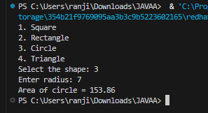
Output
javac packageUse.java
java packageUse
- Square
- Rectangle
- Circle
- Triangle
Select the shape
2

Enter the dimensions of the rectangle: 10 15
Area of the rectangle with dimensions 10&15 is 150
//Package Implementation-2:
import useFull.UseMe;
class manager
{
public static void main(String args[])
{
UseMe obj=new UseMe();obj.salary();
}
}
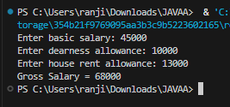
Output
javac manager.java
java manager

Enter the basic salary: 100000
Enter the dearness allowance: 5000
Enter the house rent allowance: 2000
The total Gross salary of employee is: 107000

POST LAB EXERCISE
- Find the key differences between java.util and java.lang packages.
• java.lang
- Automatically imported.
- Contains core classes like String, System, Math, Integer.
java.util
- Must be imported using import java.util.*;
- Contains utility and collection classes like Scanner, ArrayList, HashMap, Date.

- List some of the subpackages of java.util
- java.util.concurrent
- java.util.regex
- java.util.logging
- java.util.stream
- java.util.function
- java.util.zip
- java.util.jar

ASSESSMENT

Description | Max Marks | Marks Awarded
Pre Lab Exercise | 5
In Lab Exercise | 10
Post Lab Exercise | 5
Viva | 10
Total | 30
Faculty Signature

Experiment Number : 10 Date: 25/02/2026

Implementation of Access Modifiers in Java

Aim:
Write a Java program to implement different access modifiers.

PRE LAB EXERCISE
QUESTIONS
- What are the 4 access modifiers available in Java?
The four access modifiers in Java are:
- public
- private
- protected
- default (no keyword)

- Which access modifiers can be used in Java to control access to class members?
The following access modifiers are used to control access to class members (variables and methods):
public → Accessible everywhere
private → Accessible only within the same class
protected → Accessible within the same package and subclasses
default → Accessible only within the same package

IN LAB EXERCISE
Objective
To demonstrate different access modifiers such as Default, Private, Protected and Public using Java programs.
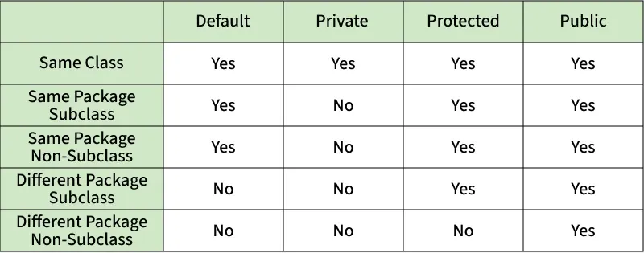
Fig: Comparison table of Access Modifiers in Java
Source Code
// Default Access modifier
class Car {
String model; // default access
}
public class Main {
public static void main(String[] args){
Car c = new Car();
c.model = "Tesla"; // accessible within the same package
System.out.println(c.model);
}
}
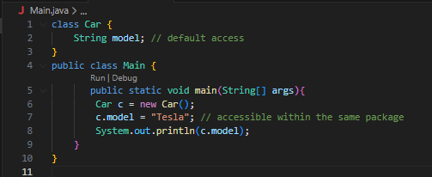
Output:
Tesla
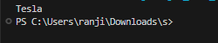
//Private Access Modifier
class Person {
// private variable
private String name;
public void setName(String name) {
this.name = name; // accessible within class
}
public String getName() {
return name;
}
}
public class Geeks {
public static void main(String[] args)
{
Person p = new Person();
p.setName("Alice");

// System.out.println(p.name);
// Error: 'name'
// has private access
System.out.println(p.getName());
}
}
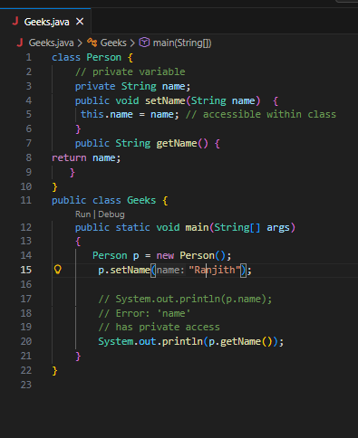
Output
Alice

//Protected Access Modifier
class Vehicle {
protected int speed; // protected member
}
class Bike extends Vehicle {
void setSpeed(int s)
{
speed = s; // accessible in subclass
}
int getSpeed()
{
return speed; // accessible in subclass
}
}
public class Main {
public static void main(String[] args){
Bike b = new Bike();
b.setSpeed(100);
System.out.println("Access via subclass method: "+ b.getSpeed());
Vehicle v = new Vehicle();
System.out.println(v.speed);
}
}
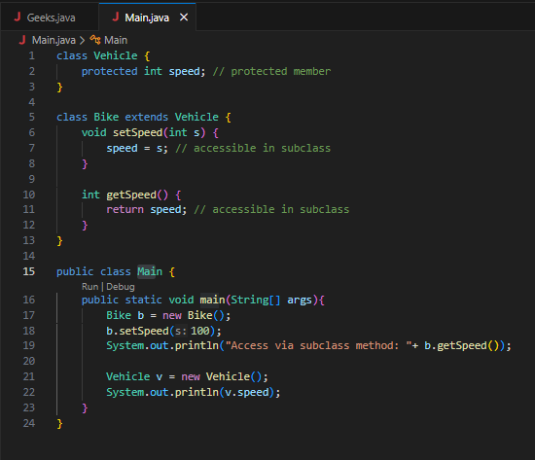
Output
Access via subclass method: 100
0
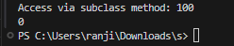

//Public Access Modifier
class MathUtils {
public static int add(int a, int b) {
return a + b;
}
}
public class Main {
public static void main(String[] args) {
System.out.println(MathUtils.add(5, 10)); // accessible anywhere
}
}
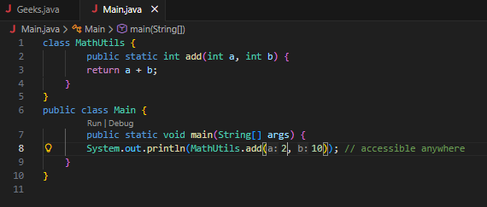
Output
15


POST LAB EXERCISE
  - Write a Java program to implement Default access modifier which has a default class within the same package and a default class from a different package.
Default Access Modifier Program
- A default class (without public) is accessible only within the same package.
- It cannot be accessed from a different package.
Example (Same Package – Works)
class Car {
void display() {
System.out.println("Car Details");
}
}
public class Main {
public static void main(String[] args) {
Car c = new Car();
c.display();
}
}
Runs successfully because both classes are in the same package.

Different Package – Not Accessible
If we try to use the default class in another package, it gives a compile-time error.

  - Which access modifier provides the highest level of access?
public
Because it allows access:
- Within the same class
- Within the same package
- In subclasses
- In different packages

ASSESSMENT

Description | Max Marks | Marks Awarded
Pre Lab Exercise | 5
In Lab Exercise | 10
Post Lab Exercise | 5
Viva | 10
Total | 30
Faculty Signature

Experiment Number :11 Date: 25/02/2026

Implementation of multiple inheritance in Java using Interface

Aim:
Write a Java program to implement multiple inheritance using Interface.

PRE LAB EXERCISE
QUESTIONS
- Why Java does not support multiple inheritance using classes like that of C?
Java does not support multiple inheritance using classes to avoid ambiguity problems (Diamond Problem).
If a class inherits from two parent classes having the same method, the compiler cannot decide which method to use.
To avoid this confusion and complexity, Java does not allow multiple inheritance through classes.
Instead, Java supports multiple inheritance using interfaces.

- What is the primary purpose of an interface in Java?
- To store data using instance variables
- To define a contract of methods a class must implement
- To allow creation of objects
- To improve runtime performance
Correct Answer: B
B. To define a contract of methods a class must implement
Explanation:
An interface defines method declarations without implementation. Any class that implements the interface must provide the implementation of those methods.

IN LAB EXERCISE
Objective
To demonstrate how an interface in Java defines constants and abstract methods, which are implemented by a class.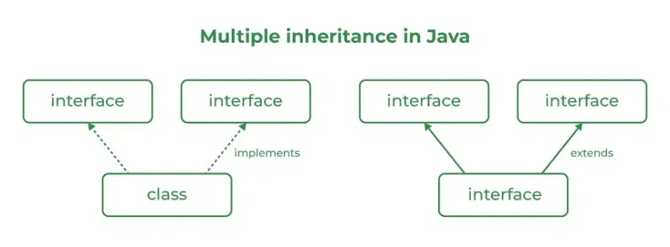

Source Code
import java.io.*;
// Add interface
interface Add{
int add(int a,int b);
}
// Sub interface
interface Sub{
int sub(int a,int b);
}
// Calculator class implementing Add and Sub
class Cal implements Add , Sub
{
// Method to add two numbers
public int add(int a,int b){
return a+b;
}
// Method to sub two numbers
public int sub(int a,int b){
return a-b;
}
}
class Example{
// Main Method
public static void main (String[] args){

// instance of Cal class
Cal x = new Cal();
System.out.println("Addition : " + x.add(2,1));
System.out.println("Substraction : " + x.sub(2,1));
}
}
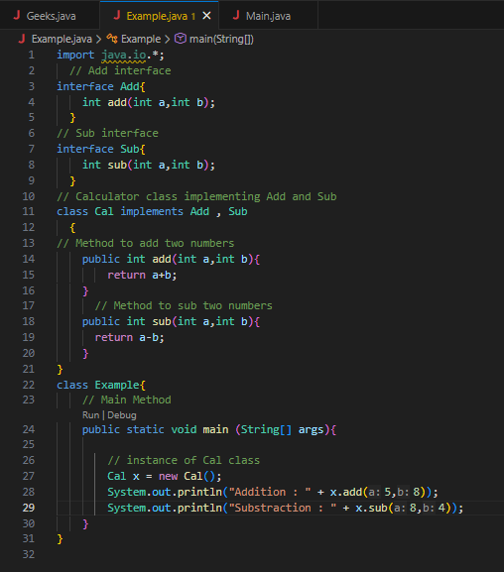
Outputs
Addition : 3
Subtraction : 1
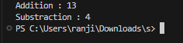
POST LAB EXERCISE
  - Can a functional interface extend another interface?
Yes, a functional interface can extend another interface only if it still contains exactly one abstract method.
If extending another interface adds more abstract methods, then it will no longer remain a functional interface.

  - Which feature was introduced in interfaces starting from Java 8?
- Constructors
- Private methods
- Default and static methods
- Final classes
Correct Answer: C
C. Default and static methods
Explanation:
From Java 8 onwards, interfaces can have:
- Default methods (with method body)
- Static methods
This allows adding new functionality without breaking existing implementations.

ASSESSMENT

Description | Max Marks | Marks Awarded
Pre Lab Exercise | 5
In Lab Exercise | 10
Post Lab Exercise | 5
Viva | 10
Total | 30
Faculty Signature

Experiment Number : 12 Date: 26/02/2026

Implementation of exception handling in Java
Aim:
Write a java program to implement exception handling.

PRE LAB EXERCISE
QUESTIONS
- What is exception handling in Java?
Exception handling in Java is a mechanism used to handle runtime errors so that the normal flow of the program is not interrupted.
It prevents program termination due to unexpected errors.

- What is the purpose of using try-catch blocks in exception handling?
The try-catch block is used to:
- Place risky code inside the try block
- Handle the error inside the catch block
- Prevent program crash
- Maintain normal program execution

IN LAB EXERCISE
Objective
To understand and implement exception handling through try-catch and finally blocks.
Source Code
import java.util.InputMismatchException;
import java.util.Scanner;
public class ExceptionHandlingExample {
public static void main(String[] args) {
Scanner scanner = new Scanner(System.in);
try {
System.out.print("Enter an integer: ");
int num = scanner.nextInt();
int result = 10 / num;
System.out.println("Result: " + result);
} catch (InputMismatchException e) {
System.out.println("Invalid input! Please enter an integer.");
} catch (ArithmeticException e) {
System.out.println("Cannot divide by zero!");
} finally {
scanner.close();
System.out.println("Program execution completed.");
} }
}
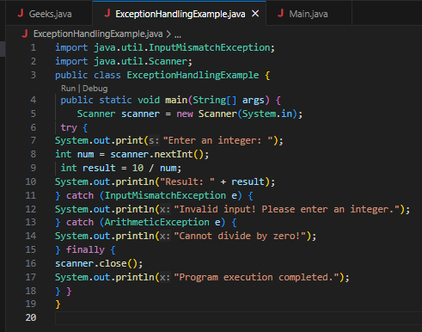
Outputs
Output 1 (Valid Input - Non-zero Integer):
Enter an integer: 5
Result: 2
Program execution completed.
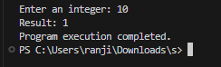

Output 2 (Valid Input - Zero):
Enter an integer: 0
Cannot divide by zero!
Program execution completed.
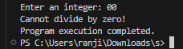

Output 3 (Invalid Input - Non-integer):
Enter an integer: abc
Invalid input! Please enter an integer.
Program execution completed.
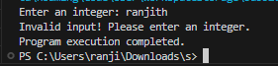

POST LAB EXERCISE
- What is the purpose of the Scanner object in the Java program?
The Scanner object is used to take input from the user during program execution.
It reads different types of input such as:
- Integers
- Strings
- Floats
- Doubles

- What exceptions are expected to be thrown in the code within the try block? Why?
Common exceptions that may occur inside a try block are:
- ArithmeticException → When dividing a number by zero.
- InputMismatchException → When user enters wrong input type (e.g., string instead of integer).
- ArrayIndexOutOfBoundsException → When accessing an invalid array index.
- NullPointerException → When accessing a null object.
These exceptions occur due to invalid input, incorrect operations, or logical errors in the program.

ASSESSMENT

Description | Max Marks | Marks Awarded
Pre Lab Exercise | 5
In Lab Exercise | 10
Post Lab Exercise | 5
Viva | 10
Total | 30
Faculty Signature

Experiment Number : 13 Date: 26/02/2026

Implementation of User-defined Exception in Java

Aim:
Write a java program to implement User-defined Exception.

PRE LAB EXERCISE
QUESTIONS
- What is Java custom exception?
A custom exception is a user-defined exception created by extending the Exception or RuntimeException class.

It is used to define application-specific error conditions.

- What are the two types of custom exceptions in Java?
There are two types:
- Checked Custom Exception
  - Extends Exception
  - Must be handled using try-catch or declared using throws
- Unchecked Custom Exception
  - Extends RuntimeException
  - No need to handle explicitly

IN LAB EXERCISE
Objective
To understand and implement Checked and Unchecked custom exceptions.
Source Code
Ex 1: // Custom Checked Exception
class InvalidAgeException extends Exception {
public InvalidAgeException(String m) {
super(m);
}
}
// Using the Custom Exception
public class AgeCheck{
public static void validate(int age)
throws InvalidAgeException {
if (age < 18) {
throw new InvalidAgeException("Age must be 18 or above.");
}
System.out.println("Valid age: " + age);
}
public static void main(String[] args) {
try {
validate(12);
} catch (InvalidAgeException e) {
System.out.println("Caught Exception: " + e.getMessage());
}
}
}
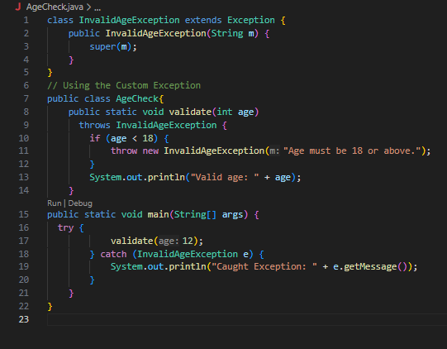
Output 1
Caught Exception: Age must be 18 or above.


Ex 2: // Custom Unchecked Exception
class DivideByZeroException extends RuntimeException {
public DivideByZeroException(String m) {
super(m);
}
}
// Using the Custom Exception
public class TestSample {
public static void divide(int a, int b) {
if (b == 0) {
throw new DivideByZeroException("Division by zero is not allowed.");
}
System.out.println("Result: " + (a / b));
}
public static void main(String[] args) {
try {
divide(10, 0);
} catch (DivideByZeroException e) {
System.out.println("Caught Exception: " + e.getMessage());
}
}
}
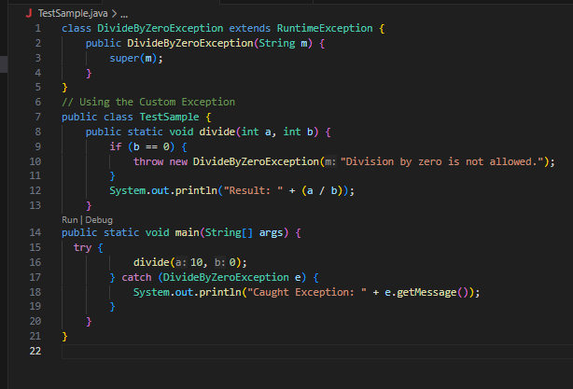

Output 2
Caught Exception: Division by zero is not allowed.
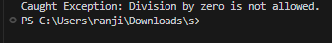

POST LAB EXERCISE
- What is required to create a custom exception in Java?
- Extend the Object class
- Extend the Throwable class
- Extend Exception or RuntimeException
- Implement the Serializable interface

Correct Answer: C
C. Extend Exception or RuntimeException
Explanation:
To create a custom exception, we create a class that extends either:
- Exception → for checked custom exception
- RuntimeException → for unchecked custom exception

- List some use cases for the checked and unchecked exceptions.
Checked Exceptions (Must be handled)

Used when the error is recoverable.
Examples:
- File handling errors (IOException)
- Database connection errors (SQLException)
- Network errors
Used when programmer must handle the exception.

Unchecked Exceptions (Runtime Exceptions)

Used for programming errors.
Examples:
- Divide by zero (ArithmeticException)
- Null object access (NullPointerException)
- Invalid array index (ArrayIndexOutOfBoundsException)
Used when error occurs due to logical mistake in code.

ASSESSMENT

Description | Max Marks | Marks Awarded
Pre Lab Exercise | 5
In Lab Exercise | 10
Post Lab Exercise | 5
Viva | 10
Total | 30
Faculty Signature

