Experiment Number : 8 Date: 18-02-2026

Implementation of Packages in Java

Aim:
Write a Java program to implement built-in, user-defined packages and accessing all classes in a package.

PRE LAB EXERCISE
QUESTIONS
- What is java.util package and what collection framework does it contain?
- A built-in Java package called 1.java.util offers utility classes for managing data and standard operations.
- It contains the Collection Framework, which is used to store and manage groups of objects. It contains classes like Array List, LinkedList, HashSet, HashMap, TreeMap, and interfaces like List, Set, Queue, and Map.
- What are the two types of packages in Java?
- Built-in Packages: Java offers predefined packages, such as java.lang, java.util, and java.io
- .User-defined Packages: These are packages made by programmers who arrange classes using the package keyword.

IN LAB EXERCISE
Objective
To understand and implement the concepts of built-in, user-defined packages and accessing all classes in a package in Java.
Built-in Packages comprise a large number of classes that are part of the Java API. Some of the commonly used built-in packages are:
Many of the classes that make up the Java API are contained in built-in packages. Among the frequently utilized built-in packages are:
Classes that define primitive data types and math operations are among the language support classes found in java.lang. It imports this package automatically.
Classes for facilitating input/output operations are contained in java.io.
Classes for facilitating input/output operations are contained in java.io.
• java.util: Provides date and time operations and utility classes that implement data structures like dictionaries and linked lists.
Classes for making Applets are contained in the java.applet file.
Classes for implementing the elements of graphical user interfaces, such as buttons, menus, etc., are contained in java.awt.

Source Code
import java.util.Random; // built-in package
public class Sample{
public static void main(String[] args) {
// using Random class
Random rand = new Random();
// generates a number between 0–99
int number = rand.nextInt(100);
System.out.println("Random number: " + number);
}
}
Output

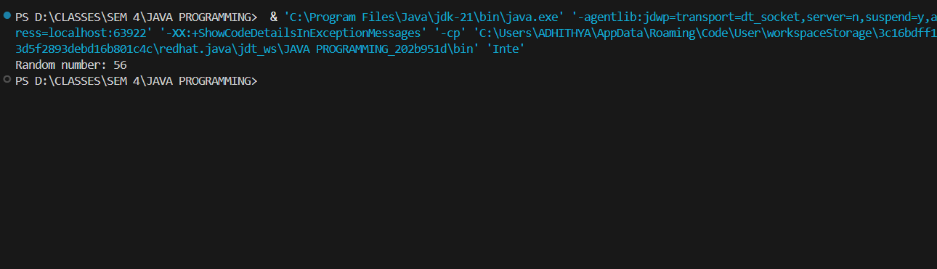
User-defined Packages are the packages that are defined by the user.
Source code
package com.myapp;
public class Helper {
public static void show() {
System.out.println("Hello from Helper!");
}
}
==To use this in another class==
import com.myapp.Helper;
public class Test {
public static void main(String[] args) {
Helper.show();
}
}

Output:
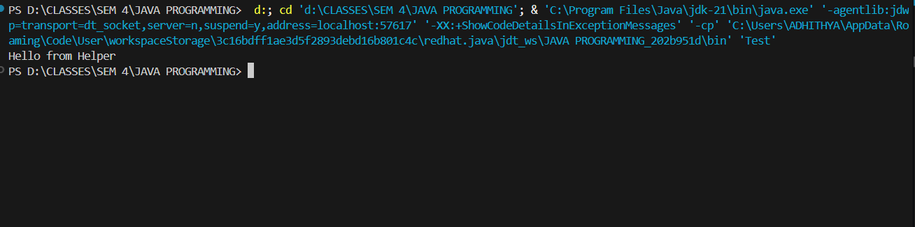
//Importing all classes from a package.
Source code
import java.util.Vector;
public class Coders {
public Coders() {
// java.util.Vector is imported, We are able to access it directly in our code.
Vector v = new Vector();
java.util.ArrayList l = new java.util.ArrayList();
l.add(3);
l.add(5);
l.add(7);
System.out.println(l);
}
public static void main(String[] args) {
new Coders();
}
}
Output
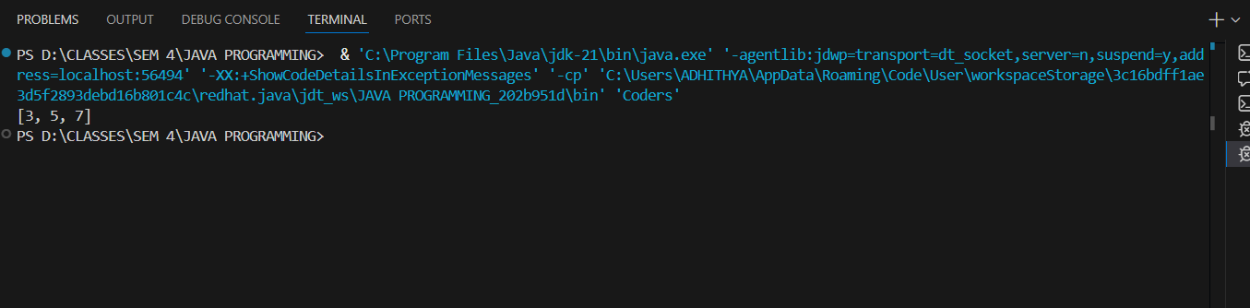
POST LAB EXERCISE
- What will happen if two classes in different packages have the same name and are imported in a Java file?
It creates a compile-time ambiguity error because the compiler cannot decide which class to use.
To resolve this, you must use the fully qualified name (e.g., packageName.ClassName) instead of importing both.
- What is the purpose of using packages in Java?
Packages are used to:
- Organize related classes and interfaces into groups
- Avoid naming conflicts
- Provide better access control
- Improve code management and reusability

- Which built-in Java package would you use if you want to create a GUI window and display a message?
- java.util
java.util package contains utility classes for data structures, date & time, random numbers, and more.
- java.sql
java.sql package provides classes and interfaces for database connectivity (JDBC).
- java.awt
java.awt stands for Abstract Window Toolkit.
It is used for GUI (Graphical User Interface) development.
- java.net
java.net package is used for network programming.
C. java.awt
It contains classes like Frame, Label, and Button used to build GUI applications.

ASSESSMENT

Description | Max Marks | Marks Awarded
Pre Lab Exercise | 5
In Lab Exercise | 10
Post Lab Exercise | 5
Viva | 10
Total | 30
Faculty Signature

Experiment Number : 9 Date: 18-02-26

Implementation of a Java Program to import packages using different methods

Aim:
Write a Java program to import packages using different methods for different use cases.

PRE LAB EXERCISE
QUESTIONS
- How to import a single class and multiple classes from a package in Java?
Import a single class:
import java.util.ArrayList;
Import multiple classes (entire package):
import java.util.*;

- Which package is always imported by default in every Java class?
java.lang
It is imported automatically and has classes that are often used, such as String, System, Math, Integer, and so on.

IN LAB EXERCISE
Objective
To understand and implement the Java packages using different methods and import them.
Problem
Define a package named ‘useFul’ with a class names ‘UseMe’ having following methods:
1) area()—To find the area of a shape.
2) salary()—To figure out the salary based on the basic salary, da, and hRA.
3) percentage()—To figure out the percentage based on the total marks and the marks earned.
4) Create a program called "Package Use" that imports the "useFul" package and uses the area() method.
5) Make a program called "manager" Source Code
//Package Creation:
package useFull;
import java.util.*;
public class UseMe
{
Scanner obj=new Scanner(System.in);
public static void area()
{
class method{
void aos(int a)
{
System.out.print("\nArea of square with length "+a+" is "+(a*a));
}
void aor(int a,int b)
{
System.out.print("\nArea of reactangle with dimensions "+a+" & "+b+" is "+(a*b));
}
void aoc(int r)
{
double a=3.14*r*r;
}
System.out.print("\nArea of circle with radius "+r+" is "+a);
}
void aot(int a,int b)
{
float ar=(a*b)/2;
System.out.print("\nArea of triangle with dimensions "+a+" &"+b+" is "+ar);
} }
Scanner obj=new Scanner(System.in);
method m=new method();
System.out.print("\n1.Square\n2.Rectangle\n3.Circle\n4.Triangle\nSelect the shape\n");
int ch=obj.nextInt();
UseMe u=new UseMe();
switch(ch)
{
case 1:System.out.print("\nEnter the length of side of square : ");
int s=obj.nextInt();m.aos(s);
break;
case 2:System.out.print("\nEnter the dimensions of rectangle : ");
int l=obj.nextInt();
int b=obj.nextInt();
m.aor(l,b);
break;
case 3:System.out.print("\nEnter the radius of circle : ");
int r=obj.nextInt();
m.aoc(r);
break;
case 4:System.out.print("\nEnter the dimensions of triangle : ");
int ba=obj.nextInt();
int w=obj.nextInt();
m.aot(ba,w);
break; } }
public void salary()
{
int ba,da,hra;
System.out.print("\nEnter the basic salary : ");
ba=obj.nextInt();
System.out.print("\nEnter the dearness allowance :");
da=obj.nextInt();
System.out.print("\nEnter the house rent allowance : ");
hra=obj.nextInt();
System.out.print("\nThe total Gross salary of employee is : "+(ba+da+hra));
}
public void percentage()
{
int n,sum=0;
float p;
System.out.print("\nEnter the total number of subjects : ");
n=obj.nextInt();
int m[]=new int[n];
System.out.print("\nEnter the marks of "+n+" subjects : ");
for(int i=0;i<n;i++)
{
m[n]=obj.nextInt();
}
for(int i=0;i<n;i++)
{
sum=sum+m[i];
}
p=sum/n;
{
System.out.print("\nPercentahe of student : "+p);
}
}
}
//Package Implementation-1:
import useFull.UseMe;
class packageUse
{
public static void main(String args[])
{
UseMe o=new UseMe();o.area();
}
}

Output
//Package Implementation-2:
import useFull.UseMe;
class manager
{
public static void main(String args[])
{
UseMe obj=new UseMe();obj.salary();
}
}

Output
POST LAB EXERCISE
- Find the key differences between java.util and java.lang packages.
Feature | java.lang | java.util
Import | Automatically imported | Must be imported manually
Purpose | Basic language support | Utility classes & data structures
Contains | String, System, Math, Wrapper classes | ArrayList, HashMap, Scanner, Collections
Usage | Core Java features | Collection Framework, date, random, etc.

- List some of the subpackages of java.util
· java.util.concurrent
· java.util.function
· java.util.logging
· java.util.regex
· java.util.stream

ASSESSMENT

Description | Max Marks | Marks Awarded
Pre Lab Exercise | 5
In Lab Exercise | 10
Post Lab Exercise | 5
Viva | 10
Total | 30
Faculty Signature

Experiment Number : 10 Date: 25.02.2026

Implementation of Access Modifiers in Java

Aim:
Write a Java program to implement different access modifiers.

PRE LAB EXERCISE
QUESTIONS
- What are the 4 access modifiers available in Java?
- There are four access modifiers in Java that control who can see classes, variables, methods, and constructors.
- These are private, public, protected, and default. The public access modifier lets you get to a class member from anywhere in the program, even from other packages
- The protected modifier lets you access things in the same package and in subclasses, even if they are in different packages. When no access modifier is given, the default one only lets access within the same package. The private modifier is the most limiting because it only lets people in the same class where it is declared. These modifiers help Java hide data and protect it from outside access.

- Which access modifiers can be used in Java to control access to class members?
- Java lets you use public, protected, private, and default access modifiers to control who can access class members like variables, methods, and constructors.
- The public modifier lets other classes see the member. The protected modifier lets you access things in the same package and in subclasses.
- When no access specifier is given, the default modifier only lets you access things in the same package
- The private modifier only lets the class where the member is declared access it,these access modifiers make sure that a Java program is safe and that different parts of it can only interact with each other in certain ways.

IN LAB EXERCISE
Objective
To demonstrate different access modifiers such as Default, Private, Protected and Public using Java programs.
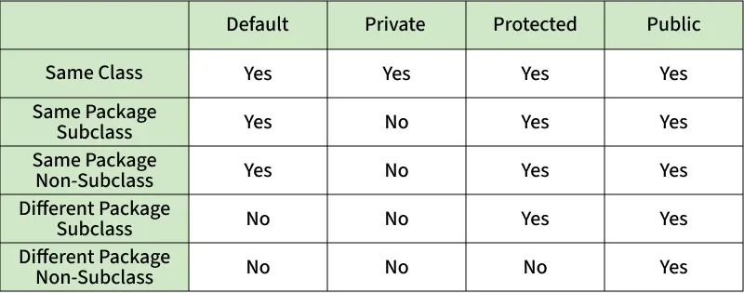
Fig: Comparison table of Access Modifiers in Java
Source Code
// Default Access modifier
class Car {
String model; // default access
}
public class Main {
public static void main(String[] args){
Car c = new Car();
c.model = "Tesla"; // accessible within the same package
System.out.println(c.model);
}
}
Output:
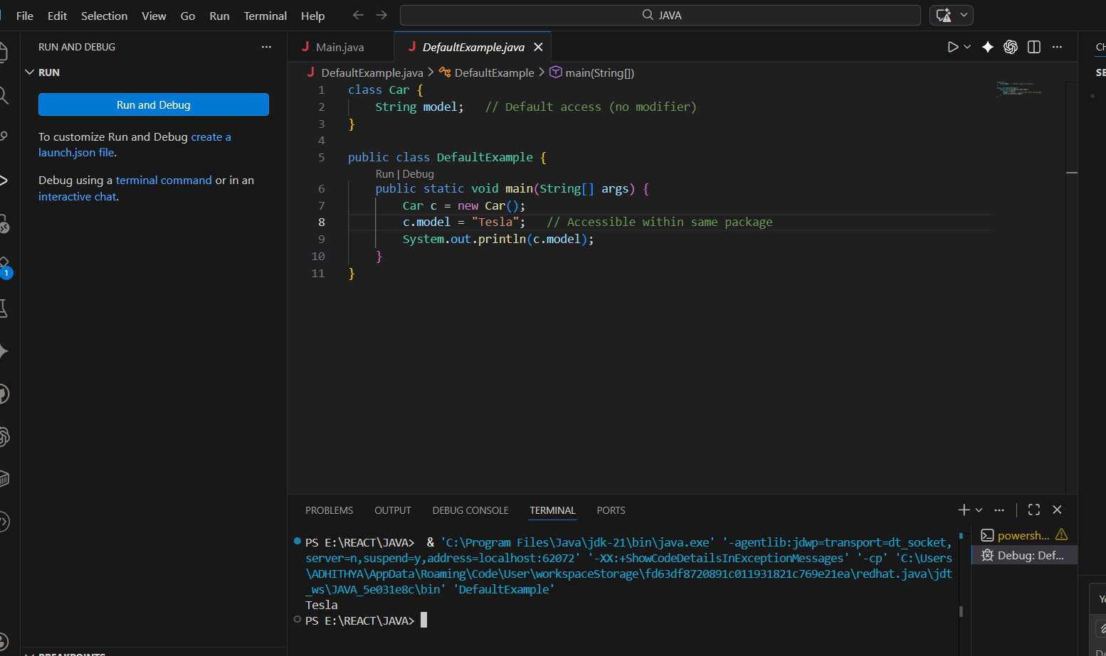
Tesla

//Private Access Modifier
class Person {
// private variable
private String name;
public void setName(String name) {
this.name = name; // accessible within class
}
public String getName() {
return name;
}
}
public class Geeks {
public static void main(String[] args)
{
Person p = new Person();
p.setName("Alice");

// System.out.println(p.name);
// Error: 'name'
// has private access
System.out.println(p.getName());
}
}
Output
Alice
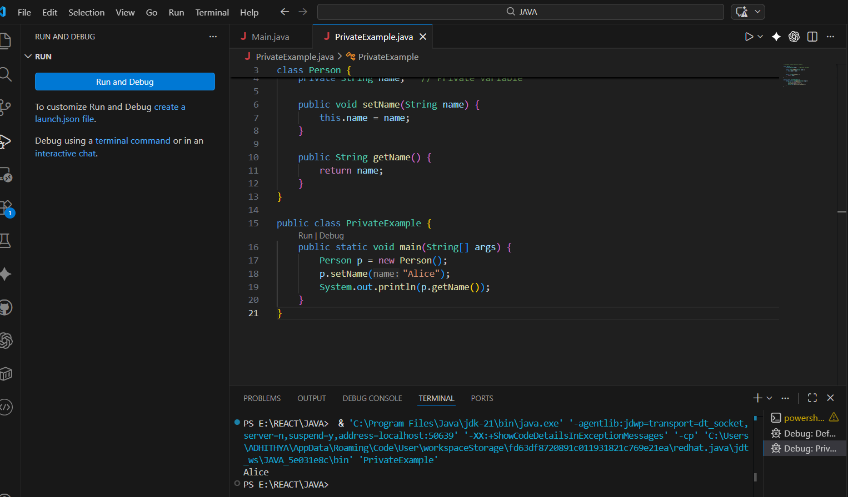

//Protected Access Modifier
class Vehicle {
protected int speed; // protected member
}
class Bike extends Vehicle {
void setSpeed(int s)
{
speed = s; // accessible in subclass
}
int getSpeed()
{
return speed; // accessible in subclass
}
}
public class Main {
public static void main(String[] args){
Bike b = new Bike();
b.setSpeed(100);
System.out.println("Access via subclass method: "+ b.getSpeed());
Vehicle v = new Vehicle();
System.out.println(v.speed);
}
}
Output
Access via subclass method: 100
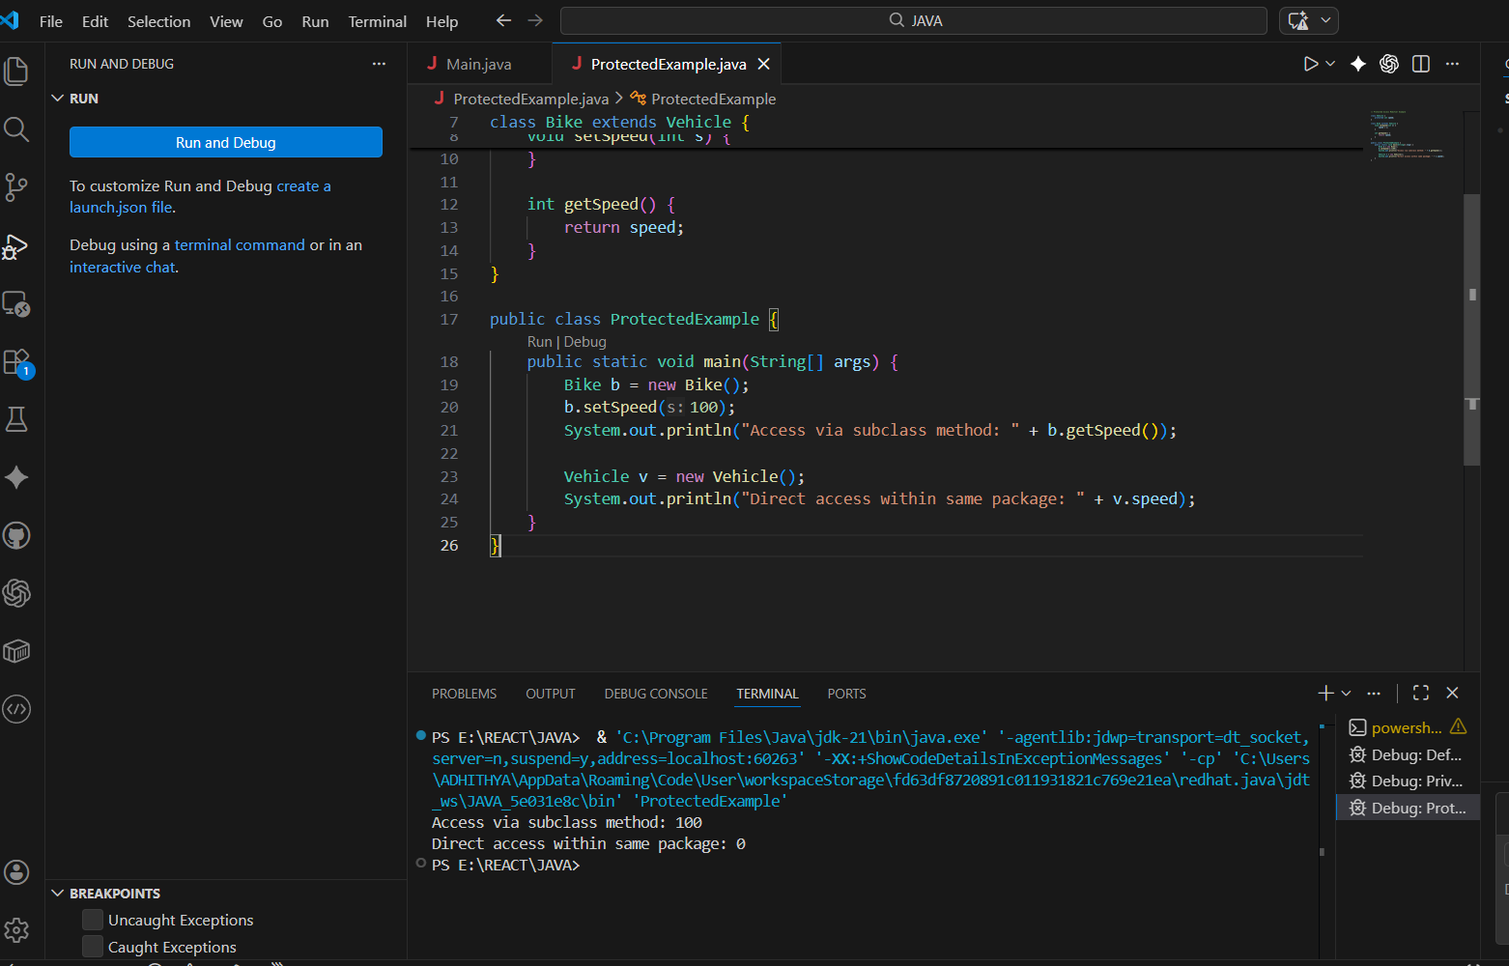
//Public Access Modifier
class MathUtils {
public static int add(int a, int b) {
return a + b;
}
}
public class Main {
public static void main(String[] args) {
System.out.println(MathUtils.add(5, 10)); // accessible anywhere
}
}
Output
15
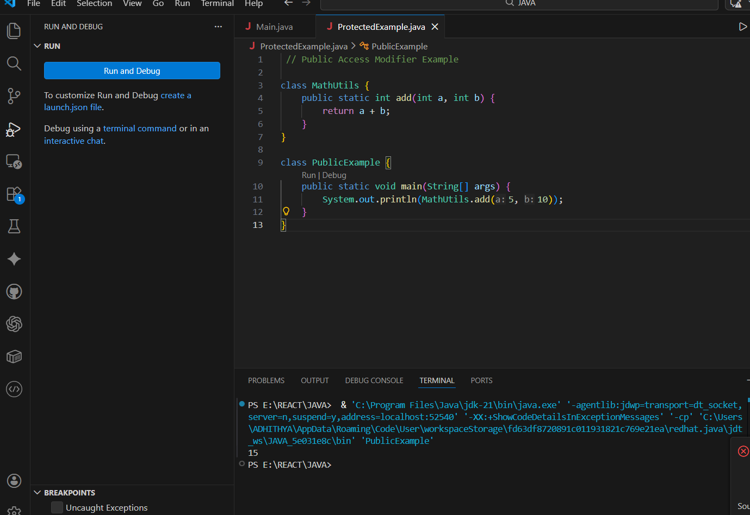

POST LAB EXERCISE
  - Write a Java program to implement Default access modifier which has a default class within the same package and a default class from a different package.
When you don't declare an access specifier for a class, method, or variable in Java, the default access modifier is used. It limits the class or member's visibility to only the same package. The program creates a default class in one package and another class in the same package can access it without any problems. This shows that default access lets you see things inside the package. However, trying to access the same default class from a different package causes a compile-time error because default access doesn't allow access outside of its package. So, the default access modifier makes sure that classes and members can only be accessed within the same package and not outside of it.

  - Which access modifier provides the highest level of access?
The public access modifier in Java gives you the most access. You can get to a public class, method, or variable from anywhere in the program, even if it's in a different package. When you use public, there are no limits on who can see it. It lets all classes and packages in a Java app be fully accessible. So, of all the access modifiers (public, protected, default, and private), public gives the most and best access.

ASSESSMENT

Description | Max Marks | Marks Awarded
Pre Lab Exercise | 5
In Lab Exercise | 10
Post Lab Exercise | 5
Viva | 10
Total | 30
Faculty Signature

Experiment Number :11 Date: 26.02.2026

Implementation of multiple inheritance in Java using Interface

Aim:
Write a Java program to implement multiple inheritance using Interface.

PRE LAB EXERCISE
QUESTIONS
- Why Java does not support multiple inheritance using classes like that of C?
Java doesn't allow multiple inheritance with classes because it can be confusing and lead to problems like the Diamond Problem. In multiple inheritance, if two parent classes have a method with the same name and the child class gets its methods from both, the compiler doesn't know which method to run. This makes it harder to figure out which method to use and adds to the confusion. Java doesn't allow multiple inheritance through classes to keep things simple, easy to read, and dependable. Instead, Java uses interfaces to support multiple inheritance, which makes it easier to handle method implementation conflicts.
- What is the primary purpose of an interface in Java?

1. To use instance variables to save data
2. To set the rules for how a class must use its methods
3. To make it possible to make objects
4. To make the runtime run faster
Answer:
B. To set out the rules for how a class must work

IN LAB EXERCISE
Objective
To demonstrate how an interface in Java defines constants and abstract methods, which are implemented by a class.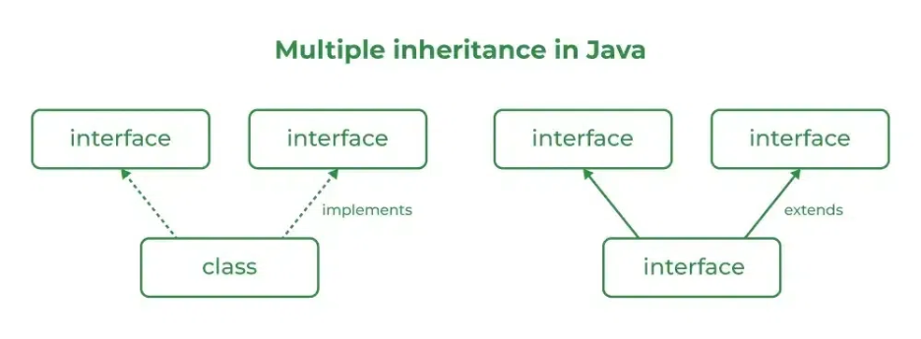

Source Code
import java.io.*;
// Add interface
interface Add{
int add(int a,int b);
}
// Sub interface
interface Sub{
int sub(int a,int b);
}
// Calculator class implementing Add and Sub
class Cal implements Add , Sub
{
// Method to add two numbers
public int add(int a,int b){
return a+b;
}
// Method to sub two numbers
public int sub(int a,int b){
return a-b;
}
}
class Example{
// Main Method
public static void main (String[] args){

// instance of Cal class
Cal x = new Cal();
System.out.println("Addition : " + x.add(2,1));
System.out.println("Substraction : " + x.sub(2,1));
}
}

Outputs
Addition : 3
Subtraction : 1
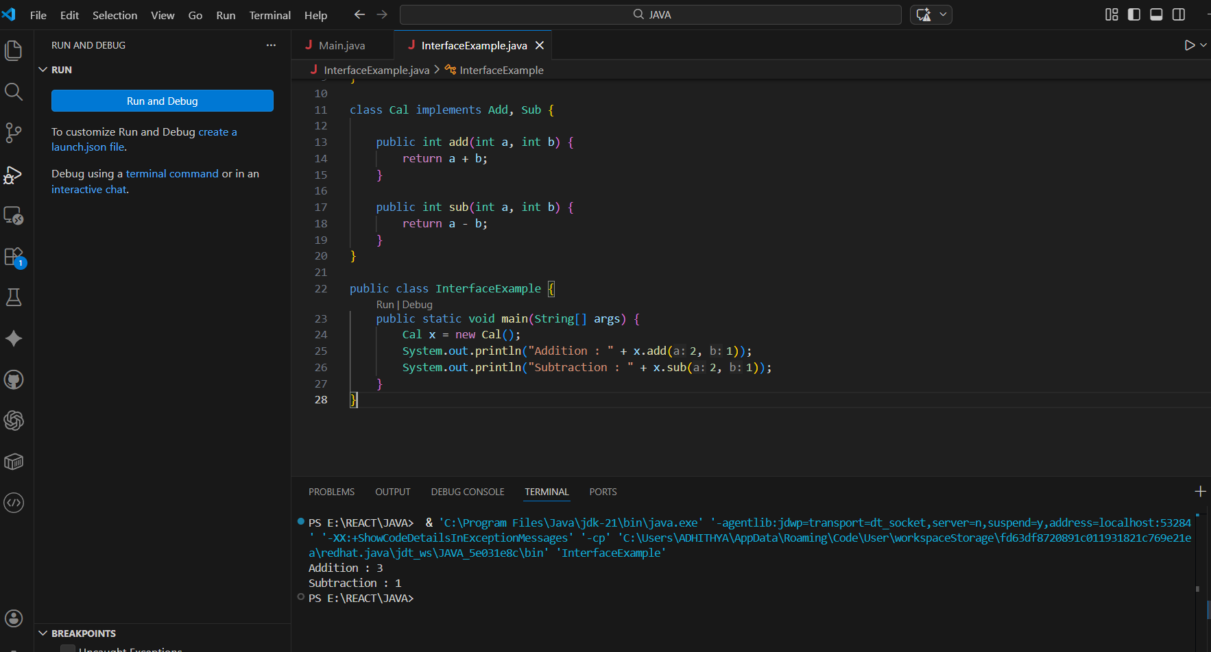

POST LAB EXERCISE
  - Can a functional interface extend another interface?

Yes, a functional interface can add to another interface, as long as the total number of abstract methods stays the same after inheritance. The child interface can still be called a functional interface even if the parent interface only has one abstract method and no more abstract methods are added. But if more than one abstract method is inherited or declared, it won't be a functional interface anymore.

  - Which feature was introduced in interfaces starting from Java 8?
- Constructors
- Private methods
- Default and static methods
- Final classes
C. Default and static methods.
Java 8 added default and static methods to interfaces, which made them better. Default methods let interfaces add method implementations without breaking existing classes, and static methods let the interface itself have utility functions.

ASSESSMENT

Description | Max Marks | Marks Awarded
Pre Lab Exercise | 5
In Lab Exercise | 10
Post Lab Exercise | 5
Viva | 10
Total | 30
Faculty Signature

Experiment Number : 12 Date: 26.02.2026

Implementation of exception handling in Java
Aim:
Write a java program to implement exception handling.

PRE LAB EXERCISE
QUESTIONS
- What is exception handling in Java?
In Java, exception handling is a way to deal with runtime errors so that the program can keep running normally. It lets a program find and handle problems that come up, like dividing by zero or giving bad input, without crashing. To handle exceptions well, Java has keywords like try, catch, finally, throw, and throws.

- What is the purpose of using try-catch blocks in exception handling?
The point of using try-catch blocks is to catch and deal with errors that might happen while the program is running. The code in the try block might throw an exception, and the code in the catch block handles the exception and keeps the program from crashing. This makes sure that mistakes are handled correctly and that the program keeps running smoothly.
IN LAB EXERCISE
Objective
To understand and implement exception handling through try-catch and finally blocks.
Source Code
import java.util.InputMismatchException;
import java.util.Scanner;
public class ExceptionHandlingExample {
public static void main(String[] args) {
Scanner scanner = new Scanner(System.in);
try {
System.out.print("Enter an integer: ");
int num = scanner.nextInt();
int result = 10 / num;
System.out.println("Result: " + result);
} catch (InputMismatchException e) {
System.out.println("Invalid input! Please enter an integer.");
} catch (ArithmeticException e) {
System.out.println("Cannot divide by zero!");
} finally {
scanner.close();
System.out.println("Program execution completed.");
} }
}
Outputs
Output 1 (Valid Input - Non-zero Integer):
Enter an integer: 5
Result: 2
Program execution completed.
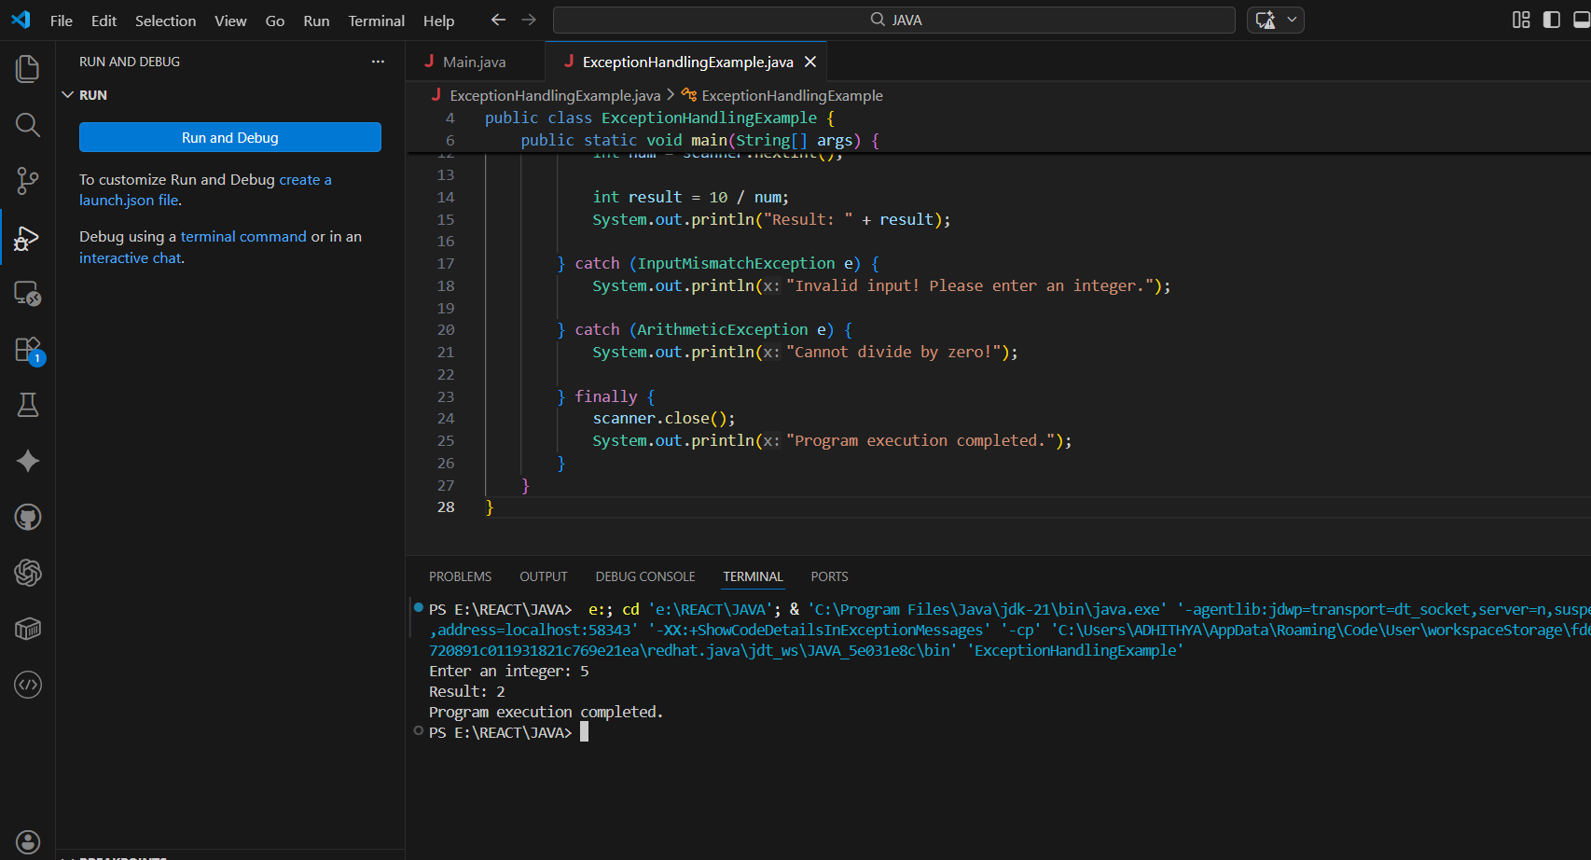

Output 2 (Valid Input - Zero):
Enter an integer: 0
Cannot divide by zero!
Program execution completed.
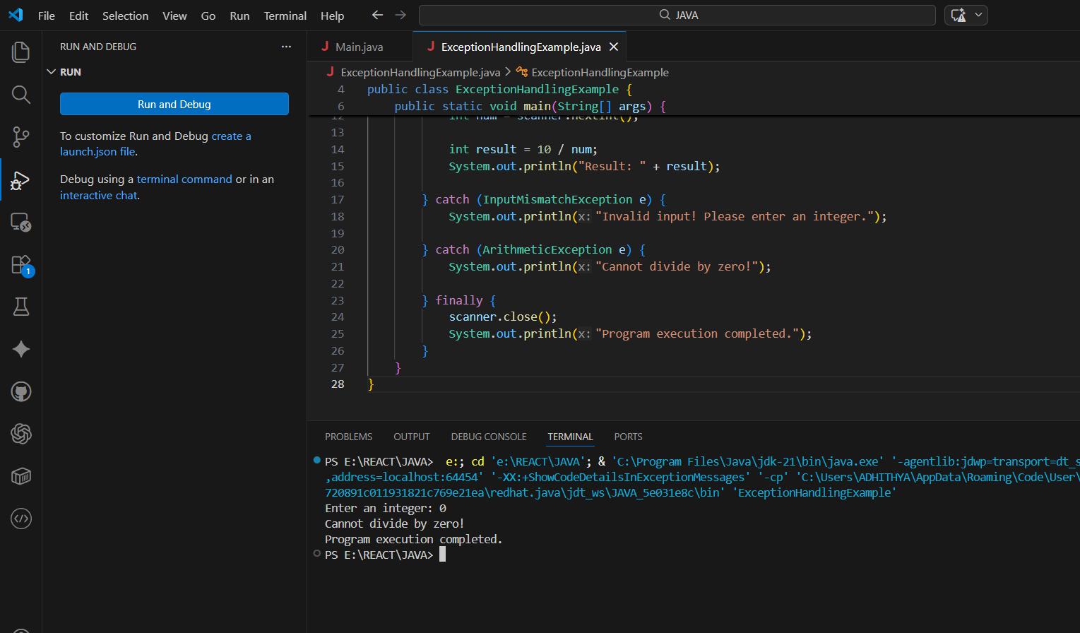

Output 3 (Invalid Input - Non-integer):
Enter an integer: abc
Invalid input! Please enter an integer.
Program execution completed.
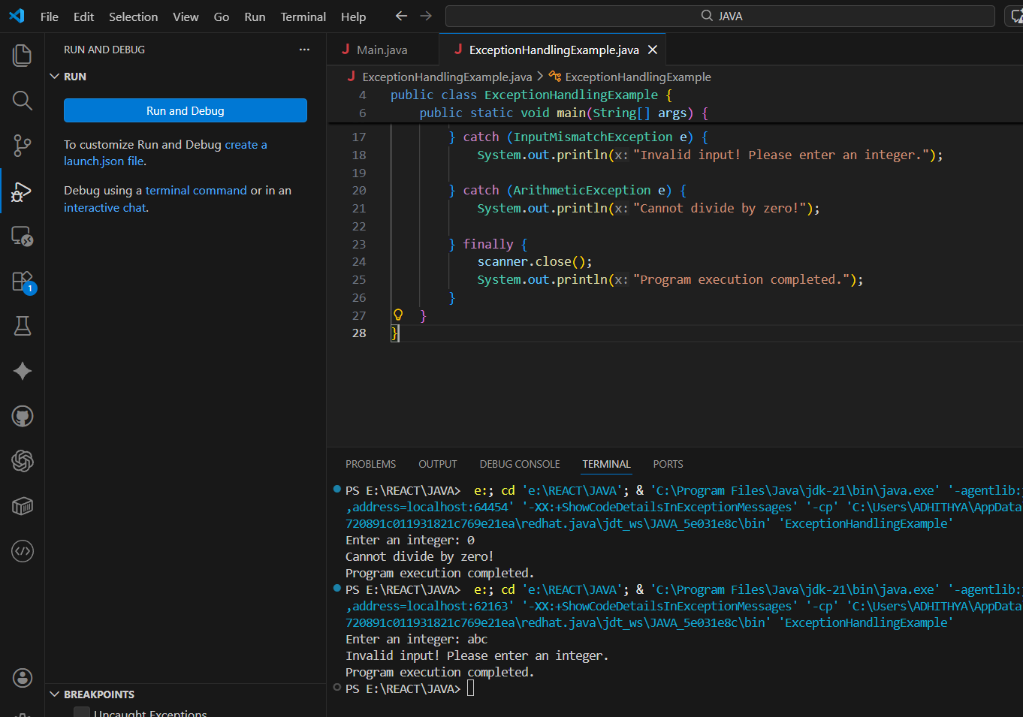

POST LAB EXERCISE
- What is the purpose of the Scanner object in the Java program?
The Scanner object in a Java program is used to get input from the user while the program is running. People often use it to read different kinds of data from the keyboard, like integers, floating-point numbers, and strings. The Scanner class is part of the java.util package and makes it easier to process and parse user input.

- What exceptions are expected to be thrown in the code within the try block? Why?
Depending on the code, the try block should throw either an ArithmeticException or an InputMismatchException. If you divide a number by zero, you might get an ArithmeticException. If you enter the wrong type of data, like a string instead of an integer, you might get an InputMismatchException. These exceptions are handled to prevent the program from crashing and to ensure smooth execution.

ASSESSMENT

Description | Max Marks | Marks Awarded
Pre Lab Exercise | 5
In Lab Exercise | 10
Post Lab Exercise | 5
Viva | 10
Total | 30
Faculty Signature

Experiment Number : 13 Date: 27.02.2026

Implementation of User-defined Exception in Java

Aim:
Write a java program to implement User-defined Exception.

PRE LAB EXERCISE
QUESTIONS
- What is Java custom exception?
A custom exception in Java is an exception that a user makes by extending the built-in Exception or RuntimeException class. It is used to deal with errors that are specific to an application and not covered by built-in exceptions. Custom exceptions make code easier to read and let developers write error messages that make sense based on the needs of the business logic.
- What are the two types of custom exceptions in Java?
In Java, there are two kinds of custom exceptions: checked and unchecked. You can make checked custom exceptions by extending the Exception class. You must handle them with try-catch blocks or declare them with throws. You can make unchecked custom exceptions by extending the RuntimeException class. You don't have to handle them at compile time.
IN LAB EXERCISE
Objective
To understand and implement Checked and Unchecked custom exceptions.
Source Code
Ex 1: // Custom Checked Exception
class InvalidAgeException extends Exception {
public InvalidAgeException(String m) {
super(m);
}
}
// Using the Custom Exception
public class AgeCheck{
public static void validate(int age)
throws InvalidAgeException {
if (age < 18) {
throw new InvalidAgeException("Age must be 18 or above.");
}
System.out.println("Valid age: " + age);
}
public static void main(String[] args) {
try {
validate(12);
} catch (InvalidAgeException e) {
System.out.println("Caught Exception: " + e.getMessage());
}
}
}

Output 1
Caught Exception: Age must be 18 or above.
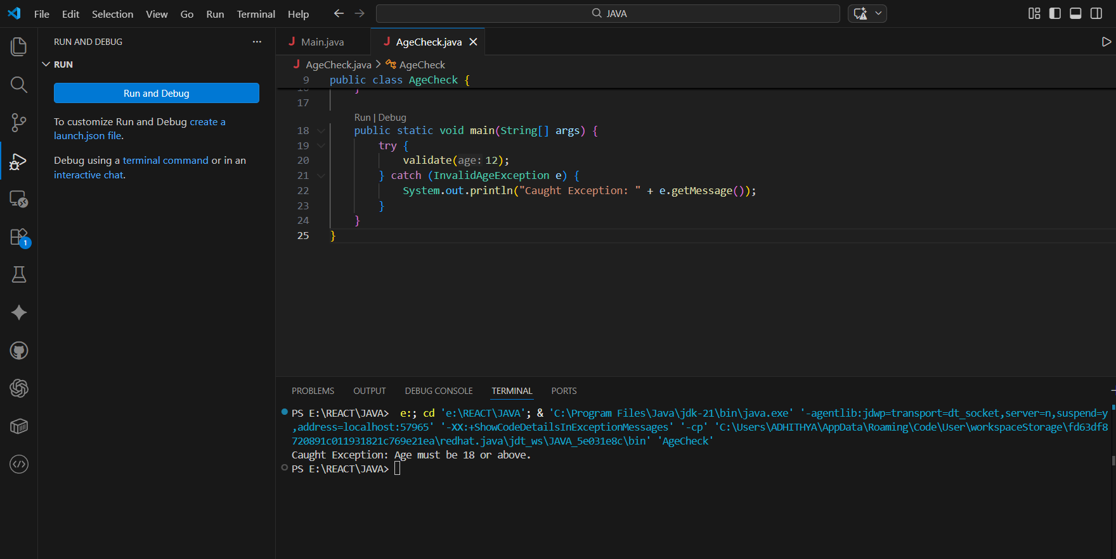

Ex 2: // Custom Unchecked Exception
class DivideByZeroException extends RuntimeException {
public DivideByZeroException(String m) {
super(m);
}
}
// Using the Custom Exception
public class TestSample {
public static void divide(int a, int b) {
if (b == 0) {
throw new DivideByZeroException("Division by zero is not allowed.");
}
System.out.println("Result: " + (a / b));
}
public static void main(String[] args) {
try {
divide(10, 0);
} catch (DivideByZeroException e) {
System.out.println("Caught Exception: " + e.getMessage());
}
}
}

Output 2
Caught Exception: Division by zero is not allowed.
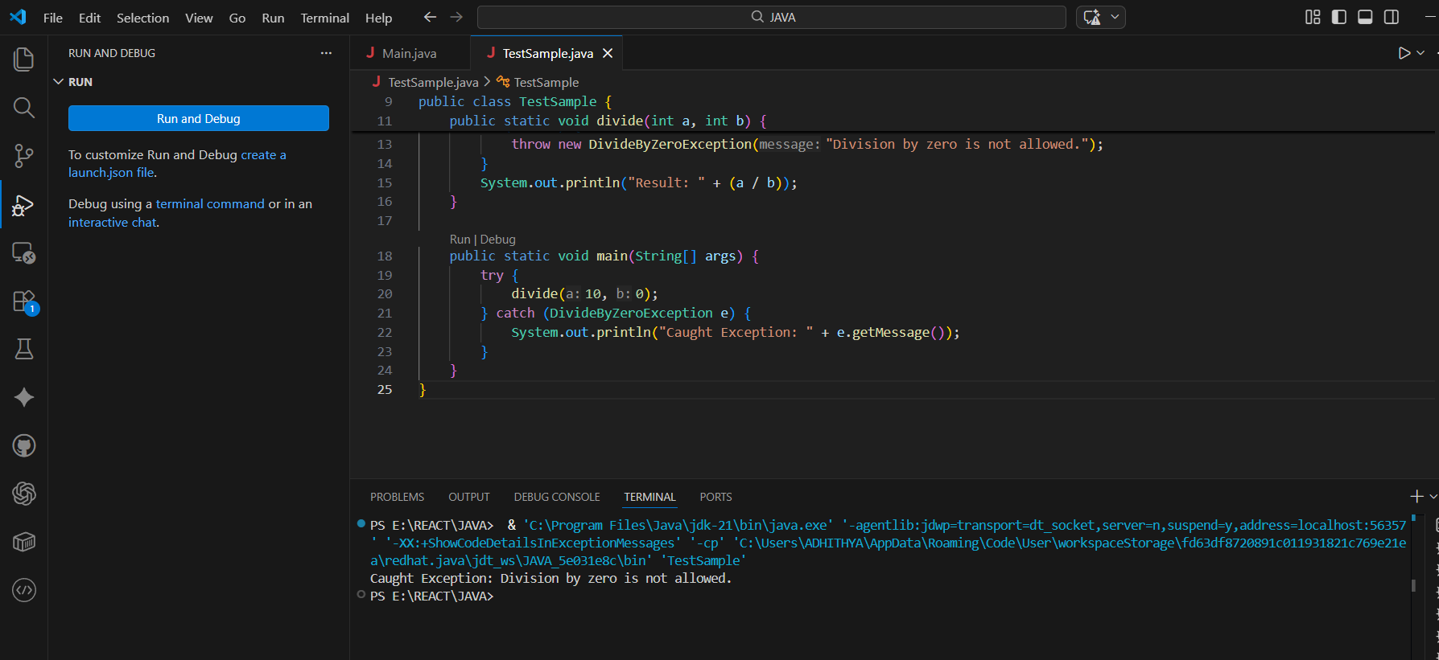

POST LAB EXERCISE
- What is required to create a custom exception in Java?
- Extend the Object class
- Extend the Throwable class
- Extend Exception or RuntimeException
- Implement the Serializable interface
C. Extend Exception or RuntimeException
To make a custom exception in Java, you need to make a class that extends either the Exception class or the RuntimeException class. If it extends Exception, it becomes a checked exception that must be handled or declared with throws. It becomes an unchecked exception that doesn't need to be handled at compile time if it extends RuntimeException.

- List some use cases for the checked and unchecked exceptions.
CHECKED EXCEPTION
When the program can reasonably recover from the error and the developer has to deal with it, checked exceptions are used. File handling operations (like FileNotFoundException), database connections (SQLException), network communication (IOException), and checking user input are all common use cases. These exceptions make sure that important tasks like reading files or getting to external resources are done correctly so that the program doesn't crash.
UNCHECKED EXCEPTION
Unchecked exceptions occur at runtime and are subclasses of runtimeexception or error. They represent programming errors such as invalid arguments or null references. They don’t require explicit handling. Examples include nullpointerexception, arithmeticexception, and arrayindexoutofboundsexception.

ASSESSMENT

Description | Max Marks | Marks Awarded
Pre Lab Exercise | 5
In Lab Exercise | 10
Post Lab Exercise | 5
Viva | 10
Total | 30
Faculty Signature

